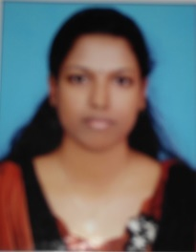

**JIBI JAMES**

Ph.no: 9747058412

E-mail: jibijamesgrace93@gmail.com

**PERSONAL DETAILS**

FATHERS NAME : JAMES DANIEL

MOTHER’S NAME : VALSAMMA JAMES

NATIONALITY : INDIAN

AGE : 28

DATE OF BIRTH : 7 JANUARY 1993

ADDRESS : PARAYIDATHIL VEEDU, CHERUVAKKAL PO, AYOOR,

KOLLAM, 691533

**EDUCATIONAL DETAILS**

|  |  |  |  |
| --- | --- | --- | --- |
| COURSE | SCHOOL/COLLEGE | YEAR OF PASSING | AGGREGATE |
| M.COM | THE CHAPTER,KOLLAM | 2015 | 72.00% |
| B.COM | ST.GREGORIOS COLLEGE ,KOTTARAKARA | 2013 | 78.00% |
| 12th | GOVT. H. S. S  KUZHIMATHIKADU | 2008-2010 | 72.00% |
| 10th | GOVT. H. S. S  KUZHIMATHIKADU | 2008 | 85.00 |

**ADDITIONAL SKILLS/COURSES**

* TALLY
* DFA

**LANGUAGES KNOWN**

* MALAYALAM
* ENGLISH

**EXTRA CURRICULAR**

* READING BOOKS
* ATHLETICS

**OBJECTIVE**

To build a better world using my knowledge and skills attained through my education and experiences, by incorporating with a progressive organization that keeps me constantly challenged and will help me cope with newer technologies. I look forward to be an asset to your company and will strive to do my best.

|  |
| --- |
| **DECLARATION** |

I hereby declare that the above furnished details are true to the best of my knowledge.

Yours faithfully

[JIBI JAMES]