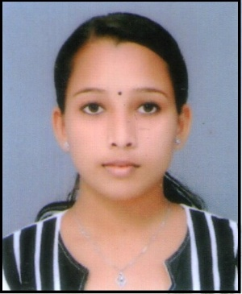**RESUME**

**ATHIRA KRISHNAN**

**Thekkedathuthazhe**

**Kavum Bhagom P O**

**Cheruvally Kottayam Dt.**

Mob-8547229827

Email-athiramalukrishnan2011@gmail.com

**OBJECTIVE**

To pursue a carrier in a reputed organization which provides opportunities for proffessional growth and where I can utilize my full potentials, skills and qualifications for the growth of mine and the organization

**PROFFESSSIONAL EXPERIENCE**

* One year and eight month experienced as Front Office Executive cum Accountant in J&A Group Of Companies, Ulloor.
* 2017 Aug Onwards working as Front Office Executive in Doctors Diagnostics Research Centre in Sasthamangalam Tvm.

**ACADEMIC QUALIFICATION:**

|  |  |  |  |  |  |
| --- | --- | --- | --- | --- | --- |
| **SlNo** | **QUALIFICATION** | **MARKS/CLASS** | YEAR OFCOMPLETION | INSTITUTION | UNIVERSITY |
| 1 | BBA In Airline And Airport Management | 58%  Second Class | 2015 | Aimfill Inter national, Cohin | Bharathiar University |
| 2 | Diploma In AirlineAnd Airport Management | 90%  First Class | 2012 | Aimfill International, Cochin | DGITO Technical SERVICE Pvt Ltd |
| 3 | Plus Two | 67%  First Class | 2011 | Govt.VHSS Ponkunnam | HSE |
| 4 | SSLC | 80%  First Class | 2009 | St.Ephrem’s HS Chirakkadavu | Kerala State Board |

**SOFTWARES KNOWN**

* Basic
* Windows,Internet
* MS Office ,DTP(Malayalam -English)
* Tally ERP- 9

**PERSONAL PROFILE**

Date Of Birth : 19.07.1994

Gender : Female

Nationality : Indian

Marital status : Single

Religion&Caste : Hindu , Nair

Father’s Name : Unnikrishnan nair

Languages Known : Malayalam, English & Hindi

(Speak, Read, Write)

Passport No. : K2273551

Date of Issue : 25/07/2012

Height : 150cm

Weight : 40Kg

Eye sight : Normal

Interest : Listening Music, travelling

Professional Strength: Optimistic, Punctual and sincere

**DECLARATION:**

I hereby declare that all the information provided by me in this application is factual and correct to the best of my knowledge and belief.

**ATHIRA KRISHNAN**

Place: Kottayam

Date: