**Alexander Toschev**

Industrial Artificial Intelligence, Higher Institute of Information Technologies and Information Systems of Kazan Federal University.

sanchis @gmail.com

**Max Talanov**

PhD, Industrial Artificial Intelligence, Higher Institute of Information Technologies and Information Systems of Kazan Federal University.

max.talanov@gmail.com

**Computational emotional thinking model.**

**Keywords**

AI; Machine Cognition; Machine Thinking; Thinking Model; Computational Emotions; Neuromodalation;

**Emotional computing system management**

Roughly we could state that noradrenaline influences overall speed of thinking process, dopamine and serotonin - reward processing and learning.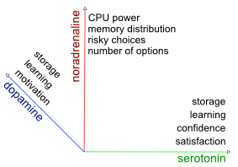

Figure 1. [Computing system parameters mapping].

**Generic:**

**CPU power** (computing processes distribution or load balancing) is influenced by noradrenaline the higher is noradrenaline more computing processes should be concentrated on current activity. **Working memory** (short term) distribution is influenced by noradrenaline as neurotransmitter regulating attention. Learning is impacted by serotonin and dopamine: dopamine plays major role in activation of previously remembered patterns and serotonin in pattern generation. **Storage management** (long term memory) is influenced both by serotonin and dopamine, higher concentrations of both neurotransmitters the better action is remembered(less probability to forget).

**Decision making:**

**Confidence and satisfaction** of the system is directly influenced by serotonin higher serotonin more confident is the system. System is more **motivated** under influence of dopamine. System tends to choose **risky actions** under impact of noradrenaline. Noradrenaline makes system use less **number of options** in width and depth to be processed during reasoning. For example: system is in fear state. Dopamine impacts system at half strength. This makes system choose actions highlighted with high rewards(safest in case of fear). High noradrenaline in rage state causes system to think as quick as possible taking in account as less as possible number of options, implementing first action(usually not really safe) selected "fight or flight" reaction.

**Emotions objective and subjective.**

Objective brain work is described as neuromodulation process with base of three neuromodulatory systems: Nor-adrenaline, Dopamine,Serotonin.

Subjective emotions perception is described via We use Plutchik approach as main psychological model. Plutchik indicated 8 basic emotions: Joy – sorrow, Anger – fear, Acceptance – disgust, Surprise – expectancy.

All thinking processes are developed in levels listed above. We use following assumption: emotions as part of thinking, at least conscious processes, should fit thinking model. This way all emotional processed should be expressed in terms of thinking model.

Inbound stimulus is been processed(transmitted/apprised) via spinal cord, hypothalamus, amygdala and all these neuronal systems take part in neuromodulation.

1. Neuromodulation actually triggers the emotional state of human and all the rest actions are done under the influence of neuromodulatory systems: nor-adrenaline, dopamine, serotonin.
2. Instinctive behavior is processed on instinctive reactions layer that usually is not involved in conscious actions.
3. Result of behavior actions is effect state that influences the system again as stimulus. This second stimulus is been apprised on instinctive reactions layer and triggers neuromodulation again. Neuromodulation in it's turn switches emotional state second time. This way stimulus cognition actions started in first emotional state, at some point could continue in second emotional state.
4. Stimulus cognition is processed in cingulate cortex, frontal cortex (working memory) that we correspond to rest 5 layers of thinking model. Stimulus cognition actions is done in the emotional state under influence of neuromodulation. Stimulus cognition could involve deliberation, further reflection, sef-reflection self-conscious processing (higher emotions) and emotional state switch.
5. Conscious behavior is activated as the result of stimulus cognition.

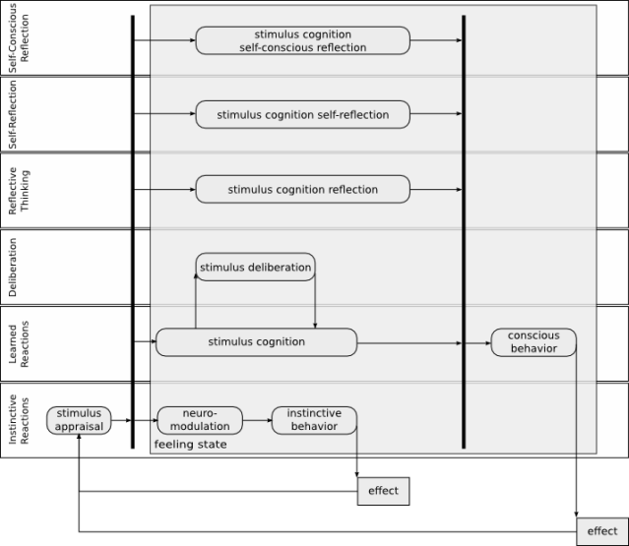

Figure 2. [Computational thinking model Minsky's six thinking levels.]