

Congratulations on your decision to become an Upledger Institute International CranioSacral Therapy Technique Certified! We believe you are taking an important step in your career, as well as supporting the efforts to achieve governmental and insurance recognition for CranioSacral Therapy.

**Your Applicant Data Form follows**. Please type or print legibly in black ink as thoroughly as possible and return it to us.

Upledger Certification is for healthcare professionals who work with humans and a candidate must hold the appropriate licensure or certificate to treat humans.

After we receive and review the completed Applicant Data Form, we will forward the Techniques essay exam for the certification process. This exam will be "open book" and may cover the following topics (including appropriate anatomy, techniques, clinical significance, physiological significance, uses, and/or evaluation and treatment):

Here is a helpful [video](http://upledger.com/therapies/certification-programs.php) with ways to help you prepare for your Certification exams.

**Techniques Exam**

* Palpation
* Listening stations
* Diaphragm releases
* Pressure stat model
* CV-4 and Still Points
* Ten step protocol
* Whole body evaluation
* Energy Cysts
* Sutherland model and techniques
* Contraindications to CST
* Compression triad
* Clinical applications and indications for CST
* Intra Oral Techniques
* Intracranial and dural tube membrane system
* Facilitated segments
* Direction of energy and V-spread
* Cranial pumping
* Techniques’ core intent

We will keep you informed of what you'll need to do next for each step of the certification process. Following a successful review of your essay exam, we will provide you with a list of certified examiners and their contact information so that you can schedule your objective (closed-book multiple choice/true false) and practical (hands-on) exams, which will be given concurrently.

Please be sure to send a photograph and copy of license (if applicable) as requested on the applicant data form. Again, we appreciate your dedication to the profession and look forward to working with you on your certification.

We look forward to hearing from you.

Regards,

The Upledger Institute International

The Upledger Institute International  
*Member: International Alliance of Healthcare Educators*

11211 Prosperity Farms Rd, D325

Palm Beach Gardens, FL  33410

[www.upledger.com](http://www.barralinstitute.com/)

[800.233.5880](tel:800.233.5880)/[561.622.4334](tel:561.622.4334)

**CST Technique Applicant Data Form**

*Instructions*: Please type or print legibly in black ink. Include additional sheets if necessary, clearly marking category headings. This form MUST be used. We recommend that you keep a copy for your records.

Please mail to UII Certification Coordinator, 11211 Prosperity Farms Rd, D325, Palm Beach Gardens, FL 33410 **OR email with all attachments to essay@upledger.com.**

**Name:_Michael Balensiefer______________________________**

**Address:_6300 Stevenson Ave, 315 Alexandria, VA 22304______**

**Email:_sgi2005@gmail.com______________________________**

**Phone:_703-473-3213__________________________________**

**Date of Birth: _12 May 1977___________**

**Website:_michaelbalensiefer.com_______**

*Licenses or Certificates Held that Legally Qualify you to Treat Humans:*

Type/Issued by (state, county, etc) License # *- include scan or copy of license/s:*

Virginia 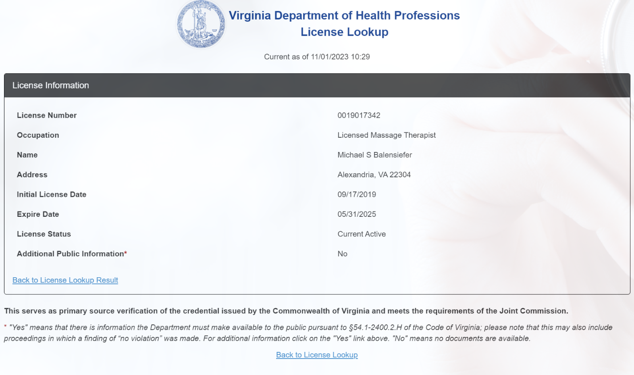

*Education (college and/or vocational):* School name, location, date attended, degree\certificate:

Northern Virginia School of Therapeutic Massage, Arlington Virginia, 2018-2019, LMT

*Continuing education* ***(outside of UII)*** *- location, date, sponsor:*

2024:

* Kinetic Chain of the Shoulder
* Craniosacral 2 (CST2)
* Upper & Lower Nerve Compression
* Touch for Health 2
* Scar Tissue Management
* Touch for Health 1
* Craniosacral (CST1)

2023:

* Lymphatic Drainage

2022:

* TCM Acupressure for Myofascial Pain
* Touch for Health Kinesiology Level 2
* Touch for Health Kinesiology Level 1

2021:

* Level 1 Running Coach
* Active Release Techniques (ART) - Spine
* Active Release Techniques (ART) - Lower Body
* Thai Bodywork Level 2
* Thai Massage Hands Free
* M.A.T. Certified - Full Body Specialist
* CCMA (Certified Clinical Medical Assistant)

2020:

* M.A.T. Certified - Trunk & Spine Specialist
* M.A.T. Certified - Lower Body Master Specialist
* Graston Technique IASTM - Level M1
* Prenatal Massage
* Ashiatsu/FasciAshi Barefoot Massage - ROM
* Ashiatsu/FasciAshi Barefoot Massage - L1 & L2
* M.A.T. Muscle Activation - Cervical, Hand, Foot
* Precision Neuromuscular Upper Body
* Thai Massage
* M.A.T. Certified - Upper Body Specialist
* Precision Neuromuscular (PNMT) Head & Neck
* Hot Stone in Practice
* Rapid Tension Relief - Intro to the Hypervolt
* Sports Massage for the Professional Athlete
* Stretto Method - Total Body Stretch Sequence

2019:

* M.A.T. Certified - Lower Body Specialist
* Precision Neuromuscular Lower Body
* Licensed Massage Therapist (LMT) & (MT)
* Spinal Reflex Therapy (SRT) - Advanced
* Oncology Massage
* Therapeutic Massage School (637 hours)
* Human Anatomy: Dissection
* Myofascial Release Upper Body
* Personal Trainer (PT)

2018:

* Spinal Reflex Therapy (SRT) - Basic

2009:

* Traditional Thai Massage

*Professional experience (last 10 years) - location, specialty, title:*

LMT since 2019

*Professional affiliations (last 10 years) - group name, your function:*

LMT (Licensed Massage Therapist), CCMA (Certified Clinical Medical Associate)

*Client/patient population summary:*  
Any and all willing adults

*CS Goals:*  
I will be adept at providing craniosacral techniques for others

Has any malpractice claim or suit ever been brought against you? __No_ If so, please include description.

Have you been the subject of disciplinary action, reprimanded, refused admission or suspended before any court or administrative agency or otherwise disciplined as a result of an investigation of your professional conduct at the local, state/province or national level? _No__ If so, please include description.

**Enclose or include with email:** A recent photograph and a copy of all Healthcare Related Professional Licenses or equivalent documentation providing the legal ability to practice hands-on therapy for payment.

**Ethics:**

As a practitioner using therapies taught through Upledger Institute International, you are expected to adhere to the highest professional standards. Among these are the commitment to provide quality therapy to all persons without discrimination, to seek educational opportunities to enhance therapeutic skills, to respect each client’s right to privacy, and to accept the responsibility to do no harm to the physical, mental and emotional well-being of self, clients and associates.

**Maintaining Certified Status:**

UII requires that each therapist certified in CranioSacral Therapy through the UII certification program must complete 24 hours every four years of UII-approved continuing education. This may be in the form of UII CST courses (participating or assisting), mentor programs, symposiums, research conferences, or preceptorships. UII reserves the right to revoke certification for actions deemed inappropriate by the certification ethics committee.

I acknowledge that the above information is true and accurate. I hereby apply to The Upledger Institute International CranioSacral Therapy Certification Program and will abide by the rules and regulations thereof. I further acknowledge that this certification, upon awarding, is not intended to be used as a hands-on license.

*As part of a Certification Program, we may collect personal data, such as malpractice or claims brought against you, or you may choose to share other personal data. By completing registering for a Certification Program, you consent to sharing this data, as is necessary for participation in the program.*

*A customer's right to privacy is of paramount importance to us. Your personal data information will not be shared with any nonaffiliated parties and will be maintained based on our Privacy Policy. This information will be shared via Certification Administrators and Ombudsmen at IAHE and applicable Affiliate Administrators.  
  
This information may be stored in your personal data file indefinitely. This information may be stored in the related program file for a minimum of 7 years, after which it will be shredded.  
  
By participating in our programs, you acknowledge and accept Upledger Institute International attendance, refund and related policies - located on-line at* [*https://iahedisk.synology.me:7456/sharing/AuBilbmpR*](https://iahedisk.synology.me:7456/sharing/AuBilbmpR )

*and you acknowledge and consent to Upledger International Privacy Policy - located online at* [*https://www.upledger.com/about/privacy.php*](https://www.upledger.com/about/privacy.php)*.*

Signature:______________________________

Date:__24 October 2024__________________

*For UII Office Use Only: Date Received: / / By:___________*

*Date Verified Pre-Requisites: / / Transfer: / /*