Ref: PWS/LESO/61th/17 Date: August 03, 2017

Quotation Ref No: QT12953
Date: 18.07.2017

To,
LESOSHOPPE SDN BHD
NO 12A, JALAN GITAR 33/3,
ELITE IND ESTATE, SEC 33,
40350 SHAH ALAM, SELANGOR.

Kind Attn: Mr. Andy Goh

Subject: Purchase order for Milwaukee PH Portable Meter, Milwaukee PH /Conductivity/TDS Meter & Center 337 Light Meter.

Dear Mr. Andy,

Please find the below Purchase order.

SL | DESCRIPTION | QTY | UNIT PRICE  (USD) | TOTAL PRICE  (USD)
01 | Milwaukee PH Portable Meter:  Model : MW-100 | 2 Units | 96.00 | 192.00
02 | Milwaukee PH /Conductivity/TDS Meter:  Model : MW-802 | 2 Units | 205.00 | 410.00
03 | Center 337 Light Meter:  Model : CENTER337 | 2 Units | 80.00 | 160.00
 |  | Total Amount (USD) |  | 762.00
 |  | Discount(-) |  | 38.00
 |  | Net Amount(USD) |  | 724.00

In Word: US Dollar Seven Hundred Twenty Four Only.

Thanking you
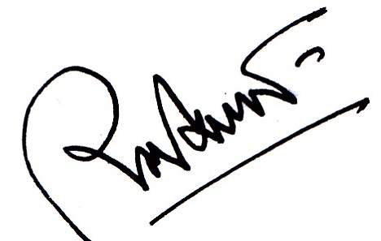

Md. Shafiqul Alam
CEO
Precision Weighing Solution Co.

