RUNTIME TERROR

PeriShift
Project and Technical Dossier
Coordinating time-sensitive perishable surplus and fragile aid under uncertainty

TEAM | TEAM LEADER | TEAM MEMBER
Runtime Terror | Parth Kumbhar | Aaryan Patil

JURY EDITION · OCTOBER 2026
Core idea Make each handoff feasible, accountable, and recoverable—from donation intake through confirmed receipt.

Executive summary
PeriShift is a deadline-aware coordination system for moving perishable surplus and other time-sensitive aid from donors to receiving partners. It connects donors, volunteer riders, shelters, and coordinators through a shared operational view of quantity, time, capacity, destination demand, handling compatibility, and custody.
The central engineering idea is that a match is not enough. Every offer, acceptance, pickup, route change, and delivery must remain feasible as conditions change. The system uses deterministic planning for explainability and database transactions for authoritative state changes. A controlled simulation makes time pressure and failures reproducible for a live demonstration.
Name note The source architecture uses “ZeroSpoil” as a working name. PeriShift is the project name used for this dossier and product identity.

Project at a glance
Field | Description
Project | PeriShift
Team | Runtime Terror
Team leader | Parth Kumbhar
Team member | Aaryan Patil
Challenge problem statement | The Last-Mile Spoilage Trap: Coordinating Perishable Surplus and Fragile Aid Under Uncertainty
Primary users | Donors, volunteer riders, receiving partners, coordinators, and a judge/demo role
Core outcome | A feasible, quantity-accounted handoff with a traceable outcome or an explicit recovery alert
System shape | React web client + FastAPI modular monolith + PostgreSQL + scheduled worker + replayable SSE events

What success looks like
- A donation is split only into quantities that available riders can carry and receiving partners can accept.
- A delivery is not treated as complete until the receiving quantity is confirmed under the configured workflow.
- A silent rider or a closed destination triggers a controlled state transition, not a silent loss or a fictitious success.
- The coordinator can explain why a match was accepted, blocked, rerouted, or marked at risk.

The problem statement
The challenge is the “last-mile spoilage trap”: perishable surplus and fragile aid can become unusable when coordination takes too long or when a plan stops matching reality. Donor availability, rider capacity, shelter demand, travel time, and handling constraints are often recorded in separate places. A volunteer may disappear; a shelter may fill; or the remaining time may become too short for a safe handoff.

Why existing coordination breaks down
Failure source | Operational consequence | PeriShift response
Deadline pressure | A nominally available item may no longer have enough time for pickup and delivery. | Derive a deliver-by cutoff from the declared safe-by time and configured service buffer; reject infeasible actions.
Capacity mismatch | One rider cannot carry an entire large donation. | Propose capacity-sized lots and preserve an explicit unallocated remainder.
Demand changes | A shelter may receive walk-ins or close its intake after a match. | Revalidate commitments and update demand atomically; retarget, release, or raise an at-risk alert.
Volunteer silence | A reservation may remain blocked until recovery is no longer possible. | Track progress with renewable leases and due-work checks; recover only pre-pickup stock.
Handling incompatibility | Some supplies need specific water, equipment, facilities, or qualified receivers. | Apply deterministic hard rules with explicit reason codes; do not let ranking override them.
Unclear custody | Teams may lose track of whether goods remain with the donor, are carried, or were received. | Use mutually exclusive quantity buckets and append-only transition events.

The boundaries of the solution
PeriShift supports safer coordination; it does not certify food safety, guarantee that a rider follows the displayed route, or remove uncertainty from travel estimates. Safety inputs and receiver capabilities must be verified by responsible people. The system prevents knowingly infeasible software commitments and makes unresolved situations visible.

How PeriShift works
The workflow proceeds from an initial donor record to a proposed plan, a committed lease, physical pickup, delivery confirmation, and an auditable final state. Every state-changing command is revalidated against current quantities, demand, time, actor permissions, and versions.
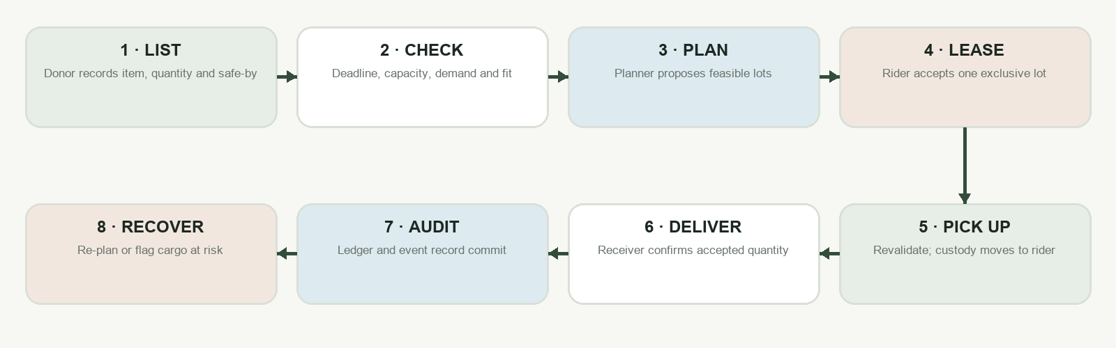
Figure 1. End-to-end handoff flow. Recovery branches depend on custody: donor-held reservations can be released; carried goods remain assigned to the rider.

Role responsibilities
Role | Primary actions | Authority boundary
Donor | Create a batch; declare readiness and handling details; view pickup progress. | Cannot extend expiry or mark a delivery complete.
Rider | View eligible offers; accept/release; heartbeat or report stuck; confirm pickup and delivery quantities. | Cannot claim the same lot twice or override a safety gate.
Receiving partner | Publish item-specific demand and capabilities; record walk-ins; confirm or reject received quantity; close/reopen intake. | Cannot falsify another shelter’s state.
Coordinator | Observe the control tower, audit events, resolve exceptions, and initiate permitted interventions. | Cannot override non-negotiable safety constraints.
Judge/demo operator | Reset a seeded scenario, advance simulated time, and trigger isolated failures. | Chaos controls are demo-scoped and are not ordinary production operations.

System architecture
PeriShift uses a modular monolith. The backend is one deployable FastAPI application with separate API, contract, domain, service, repository, and worker modules. This keeps related inventory, demand, lease, and custody transitions close enough to protect with one PostgreSQL transaction, without the operational burden of microservices.
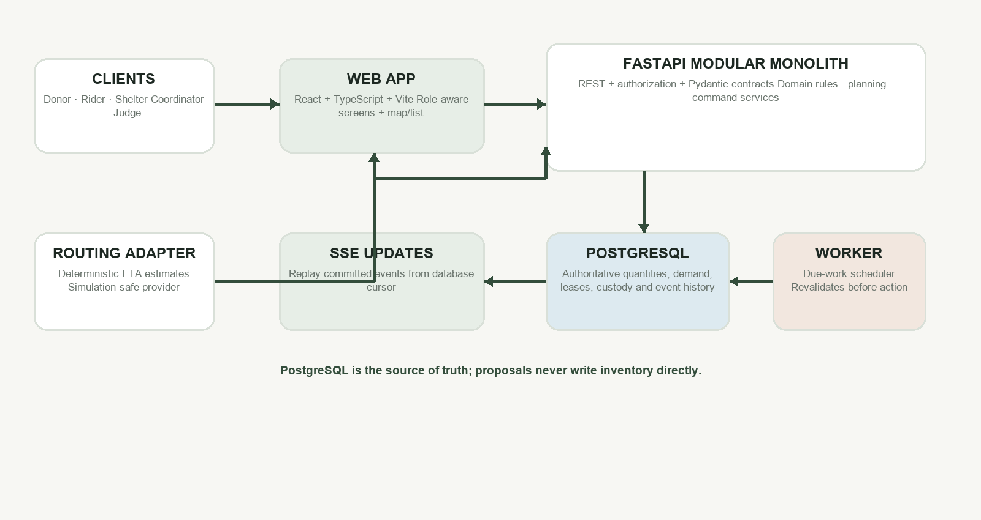
Figure 2. Logical system architecture. The database is authoritative; the decision engine proposes, while transactional services commit.

Architecture responsibilities
Component | Responsibility
React web client | Renders donor, rider, shelter, and coordinator experiences; fetches snapshots and consumes event updates.
FastAPI API layer | Validates requests, authenticates/authorizes actors, maps domain outcomes to versioned API responses, and exposes health endpoints.
Domain and decision modules | Pure feasibility, compatibility, allocation, deadline, and recovery calculations. Return proposals and reason codes; do not write authoritative state.
Transactional command services | Own lifecycle writes: acceptance, pickup, delivery, cancellation, demand reconciliation, and reroute commits.
PostgreSQL | Source of truth for batches, balances, demands, assignments, leases, scenario jobs, and append-only events.
Worker | Executes durable due work and rechecks current state/time before acting. A timeout job is never trusted without revalidation.
Routing adapter | Returns deterministic ETA estimates for reproducible scenarios. A map visualization does not establish safety or prove GPS location.
SSE event stream | Replays committed event records by cursor so clients can reconnect and a separate worker can publish visible changes through the database.

Why a modular monolith instead of microservices
The most important operations update related records together: physical quantity, demand commitment, assignment, rider occupancy, and audit event. A modular monolith lets the team enforce these changes in one database transaction. Modules provide code ownership and test boundaries; they do not require separate network services. Additional infrastructure should be introduced only after measured load or operational needs justify it.

Domain model and invariants

The core records
Record | Meaning
Batch | A donor’s original quantity of one item class and unit, with readiness and safe-by information.
Lot | A discrete portion of a batch that can follow one custody lifecycle.
Offer | A nonbinding notification. Multiple riders may see it; it does not grant pickup rights or consume shelter demand.
Lease | An exclusive, time-limited accepted claim for one unpicked lot.
Assignment | The committed rider, lot, and destination relationship.
Demand row | A shelter’s need for one item class and service window, including received, reserved, and in-transit amounts.
Operational flag | A risk or status signal such as SUSPECT, AT_RISK, LOCATION_STALE, or REROUTE_PENDING. It is not a custody transfer.
Event | An append-only record of a decision or lifecycle transition, written with the transaction that changes authoritative state.

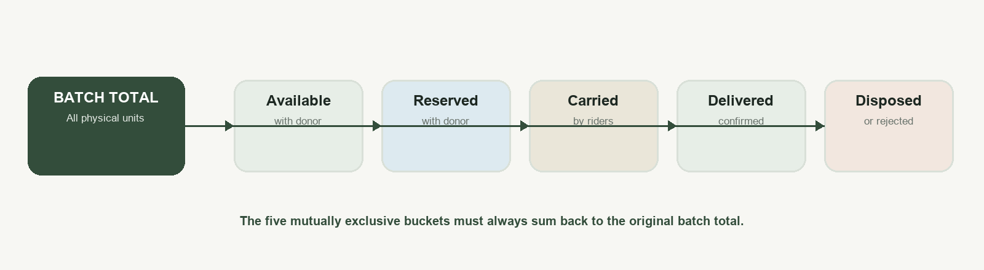
Figure 3. Inventory conservation. These physical buckets are mutually exclusive and always reconcile to the original batch total.

Consistency rules that protect the handoff
- At most one active pickup lease exists per lot; an active rider cannot accept overlapping cargo assignments.
- Offers are nonbinding; reservation and demand consumption occur only at the appropriate committed transition.
- All mutations check current versions and use idempotency keys so retries do not create duplicate effects.
- Conflicting updates lock affected aggregates in one documented order; unrelated deliveries are not globally serialized.
- Events commit with the state change. A reconnecting client replays events by ID or refreshes its snapshot if it detects a gap.
- Scenario data, idempotency entries, scheduled jobs, and event streams are isolated by execution scope and reset together.

Deadline and feasibility logic
The declared safe-by time is a donor-provided input, not a sensor-verified freshness result. PeriShift subtracts a configured serving/handling buffer to obtain deliver-by. The planner then evaluates pickup and route estimates plus handover time against that cutoff. The ETA is labeled as an estimate unless calibrated evidence supports a stronger statistical claim.
Feasibility is rechecked at important boundaries—planning, acceptance, pickup, reroute, and delivery confirmation—because the route, demand, rider progress, or receiving conditions may have changed since the last screen refresh.

Renewable leases and time boundaries
Plan 2 clarifies that there are three separate deadlines: (1) the primary rider’s hard physical feasibility cutoff; (2) a short renewable heartbeat/progress lease; and (3) the backup-rescue opportunity cutoff. These are not interchangeable. A healthy rider can renew a lease while still able to finish safely. Missing progress may trigger suspicion and recovery before pickup. The fact that a backup window has passed does not by itself justify canceling a progressing primary rider.
Custody rule Before pickup, stock is still donor-held and may be released if the lease is safely revoked. After pickup, cargo stays assigned to the rider until it is delivered, transferred, or explicitly disposed.

Matching and recovery logic

Feasibility-first planning
01 Build candidate rider–lot–destination combinations from current records.
02 Apply hard eligibility and compatibility rules. A failure produces a reason code, not a lower score.
03 Estimate travel and handling time; reject options that cannot meet deliver-by.
04 Check rider capacity, shelter’s uncommitted item-specific demand, service window, and intake status.
05 Rank the remaining feasible options using a deterministic policy, then propose capacity-respecting lots.
06 Return assigned proposals and a truthful unallocated balance; commit only through a transactional command.
The P0 baseline is deterministic greedy planning because judges and teammates can inspect why each candidate was selected. Optional CP-SAT can compare allocations later, but the project does not call the greedy result globally optimal or let optimization override hard safety constraints.

Compatibility examples
Example rule | Illustrative requirement | If not met
Raw ration kit | Verified water plus suitable cooking fuel/facility at the destination. | Reject with a compatibility reason; do not route based on a soft preference.
Powdered formula | Appropriate safe-water/handling evidence and authorized context. | Fail closed unless required capability is verified.
Cold-chain medicine | Suitable temperature equipment and a qualified receiving partner. | Reject; a map or fast ETA cannot compensate for missing capability.
Declared allergen restriction | Receiving site must satisfy the declared hard constraint. | Exclude incompatible destinations.

How recovery works
A fallback is a candidate, not a reserved destination. When demand shrinks, intake closes, or a rider stops progressing, the system reevaluates current feasibility and capacity. A successful change must update the old and new demand commitments together. If no feasible recovery exists, PeriShift records an at-risk state and gives the coordinator an honest exception to resolve.

Plan 2 corrections built into the design
Plan 2 is an amendment to plan 1, not a competing architecture. Its purpose is to close edge cases where prose requirements could otherwise disagree with database states, endpoints, event contracts, or tests.
Risk found in review | Design correction | Why it matters
Healthy riders falsely treated as ghosts after time jumps | Deterministic simulated rider/shelter actors generate their due actions, progress, and positions on the scenario timeline. | Time-warp tests model healthy behavior as well as failure.
A fixed short lease kills a progressing rider | Renewable progress lease, separate hard physical cutoff, separate backup-rescue window. | The lease detects no-progress without forcing unsafe or unnecessary cancellations.
Risk state accidentally releases cargo or rider | AT_RISK and related conditions are flags; assignment and custody remain active while cargo is carried. | The system cannot silently reassign the same physical goods.
Shelter closes before pickup without a defined path | Revalidate; transactionally retarget a safe reservation or revoke/release it if no destination remains feasible. | The donor-held case has an explicit state transition.
Reset reuses stale requests or scheduled work | Unique scenario execution scope for mutations, idempotency, jobs, and events. | A prior run cannot mutate a freshly seeded run.
Separate worker cannot push in-process SSE callbacks | Persist events and have SSE read committed rows by cursor; optional database notifications only wake the poller. | Updates survive process boundaries and reconnects.
Different commands acquire database locks in different orders | Define one lock order and use bounded whole-transaction retries for serialization/deadlock conditions. | Reduces race and deadlock risk without one global lock.
Simulated demo buttons bypass real logic | Auto actors call the same command services and obey the same domain rules. | The demo proves business transitions, not animation-only state.

Technology stack
Layer | Selected technology | Reason for selection
Web | React + TypeScript + Vite | Fast frontend iteration, typed component model, and responsive demo UI.
UI system | Tailwind CSS + shadcn/ui (planned shared component approach) | Consistent accessible components and reusable design conventions.
API | Python 3.12+ + FastAPI + Pydantic v2 + Uvicorn | Typed request validation, OpenAPI support, and quick iteration around Python domain logic.
Persistence | PostgreSQL 16+ + SQLAlchemy 2 + Psycopg 3 + Alembic | ACID transactions, row locking, uniqueness constraints, and versioned schema migrations.
Map | Leaflet (P0 decision) with list/table fallback | Geographic context without making map rendering a dependency for core operations.
Realtime | Server-Sent Events (SSE) with PostgreSQL event cursor | Simple server-to-client update stream with replay after reconnect.
Scheduled work | PostgreSQL due-work records + one worker process | Durable simulation and timeout work without a mandatory Redis broker.
Planning | Deterministic feasibility-first greedy baseline; optional OR-Tools CP-SAT | Explainable baseline first; solver comparison only after correctness gates.
Testing | pytest; targeted domain, API, database, and scenario acceptance tests | Validate invariants, transitions, concurrency races, and demo repeatability.
Deployment | Docker Compose + GitHub Actions (CI plan) | Reproducible local startup and continuous integration without distributed deployment overhead.

Explicitly deferred from the first release
Kafka, Kubernetes, Redis-backed queues, multiple independently deployed services, mandatory PostGIS, live paid routing APIs, multi-stop/relay delivery, multi-trip optimization, and ML/LLM safety decisions are not prerequisites. They can be considered only when measured scale, validated data, or an operational requirement supports the extra complexity.

Implementation phases
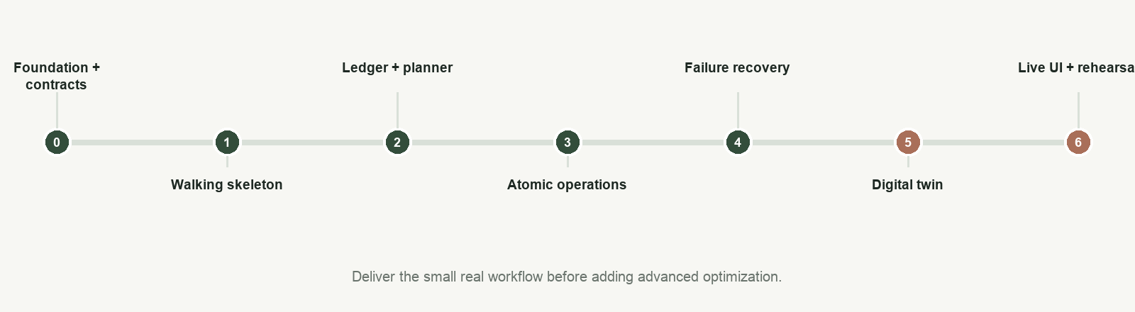
Figure 4. Relative implementation roadmap from foundation through a rehearsed end-to-end demo. The plan prioritizes an early working slice.
Phase | Build focus | Exit evidence
0 · Foundation | Freeze API/domain contracts, project skeleton, configuration, database bootstrap, shared reason/status codes. | Web/API startup path and schema contracts agree; migrations and local setup are ready.
1 · Walking skeleton | One batch → one offer → one lease → pickup → delivery, persisted end to end. | A clean reset and run records conserved quantities and a complete event trail.
2 · Resources + planner | Donor/rider/shelter resources, item-specific demand, compatibility, deadlines, capacity split proposals. | Planner returns explainable feasible lots and truthful remainder.
3 · Transactional operations | Versioned command services, exclusive lease, pickup/delivery ledger, idempotency, audit events. | Concurrent commands cannot double-claim or corrupt balances.
4 · Recovery | Progress watchdog, shelter closure and walk-in reconciliation, reroute/at-risk policy. | Failure scenarios preserve custody and either commit a safe recovery or show an exception.
5 · Digital twin | Isolated simulated clock, deterministic actors, simulated location, chaos controls, repeatable reset. | Same seed/actions reproduce the same transitions; healthy riders survive time advancement.
6 · Live UI + hardening | Role flows, map/list control tower, SSE replay, accessibility, smoke tests, demo rehearsal. | The judge can trigger and observe real backend transitions without relying on hidden screens or fake success.

Novelty and differentiation
Feature | What is different | How to explain it to the jury
Feasibility-protected adaptive leases | An acceptance is an exclusive short-lived promise that can renew on real progress, but remains bounded by physical feasibility. | “We distinguish a rider being briefly silent from the cargo becoming impossible to deliver.”
Recovery-aware dispatch | The system plans for destination/rider changes and maintains explicit fallback candidates that are revalidated before commitment. | “A backup is not a hidden reservation; we recheck its capacity and timing before changing the assignment.”
Hard, explainable compatibility | Handling rules are deterministic and return reasons. A higher optimization score cannot override them. | “If a destination lacks a required capability, it is ineligible, not merely less preferred.”
Custody-preserving state model | Operational risk labels do not mutate physical custody or free a rider carrying goods. | “AT_RISK means we need attention; it does not mean the food has teleported back to stock.”
Controlled logistics digital twin | Server-owned scenario time, actor behavior, event timeline, and chaos actions make failures repeatable. | “We can replay the same scenario and inspect actual transitions, not just play a pre-recorded animation.”
Transactional quantity conservation | A set of mutually exclusive balances reconciles to the original batch, including rejected/disposed quantities. | “Every unit stays accounted for throughout the handoff.”

Safety, security, and honest limits

Safety and uncertainty
- A donor-declared safe-by time is an input, not proof that the food is safe. Policies and human verification remain necessary.
- Estimated routes are not a guarantee of arrival time and should not be described as a statistically validated P90 unless calibrated evidence exists.
- Simulated GPS and temperature values are demonstration inputs; they do not independently establish physical location or product safety.
- The prototype uses explicit compatibility rules and fail-closed decisions for the modeled categories. Real medical distribution requires qualified domain and regulatory review.
- When no safe destination is known, show at-risk quantities and a reason. Do not claim “zero spoilage” or fictional successful delivery.

Security and operational controls
- Actor authentication uses signed bearer tokens, with server-side role authorization on every protected operation.
- Demo and chaos endpoints are gated by demo mode and coordinator/judge permissions.
- Request validation checks item/unit consistency, UTC-aware timestamps, positive quantities, and state versions.
- Idempotency keys make retried mutations safe; scenario-scoped namespaces prevent collisions between demo runs.
- Sensitive rider location should be minimized in logs and exposed only to roles that need it.

Graceful degradation
The list/table view remains usable if map tiles are unavailable. The routing adapter can be deterministic and local for judging. If an SSE connection drops, the interface should show a stale/reconnecting state and refresh a consistent snapshot rather than implying that old data is live.

Judge demonstration walkthrough
01 Reset to a known scenario and show its simulated clock, current batches, riders, destinations, and event cursor.
02 Create or inspect a time-sensitive donation and show safe-by, deliver-by, item class, quantity, and the serving buffer.
03 Preview dispatch. Explain one feasible candidate and one rejection reason such as capacity, deadline, closed intake, or missing handling capability.
04 Commit nonbinding offers, accept one as a rider, and show the exclusive lease and current state.
05 Confirm pickup. Point to the ledger transition from reserved stock into rider custody.
06 Advance simulated time while healthy riders continue their scheduled progress. Then silence one rider and show only that rider entering the recovery path.
07 Close a shelter or add walk-in demand. Show a transactional retarget if a destination remains feasible, or a truthful at-risk alert if none does.
08 Confirm the delivered and rejected quantities. Reconcile the batch buckets and inspect the corresponding audit events.
09 Reset and run the same seeded scenario again to demonstrate reproducibility.
Demo discipline Every displayed outcome should come from the API/domain state. Label auto-acceptance, simulated movement, route estimates, and simulated receiver confirmation as demo behavior.

Likely jury questions and strong answers
What problem are you solving?
We coordinate time-sensitive surplus and fragile aid across donors, riders, and receiving partners. The hard part is keeping quantity, deadline, capacity, handling, and custody aligned as the situation changes.
How do you prevent double assignment?
Acceptance is revalidated and committed transactionally. The database backs it with active-assignment uniqueness and version checks; retries use idempotency keys.
How do you decide whether a delivery is feasible?
We compare the current time plus estimated travel and handling time against an earlier deliver-by cutoff. We also check current rider capacity, shelter demand, intake status, and hard compatibility conditions.
Is the ETA guaranteed?
No. It is a deterministic estimate for reproducibility in the prototype, not a guarantee or a validated P90 unless we have calibrated data to support that claim.
What happens when a volunteer stops responding?
Before pickup, we use progress and feasibility deadlines to suspect or revoke the lease and reoffer stock only if it remains safe to move. After pickup, the cargo remains in rider custody; we do not release it back into donor stock.
What if a shelter closes after pickup?
We revalidate alternatives against current demand, time, and compatibility. If one works, the old and new demand commitments change together. If not, the cargo remains with the rider and is marked at risk for coordinator action.
Why not use AI for matching?
The first version needs deterministic, auditable decisions. A greedy feasibility-first planner is easy to test and explain. An optimizer can be compared later, but no model should override safety rules.
Why not use microservices?
Inventory, demand, leases, and custody change together. A modular monolith makes those transactions simpler to enforce and deploy during the hackathon; we can split modules only if measured scale justifies it.
How is the demo repeatable?
A server-owned simulated clock, scenario-scoped state, deterministic actor actions, and resettable seed data let the same inputs produce the same event sequence.
Does PeriShift guarantee zero food spoilage?
No. It cannot control physical handling or eliminate route uncertainty. It aims to avoid knowingly infeasible coordination and to surface risks early with quantities and reasons.
What is the strongest evidence that it works?
Executed acceptance scenarios: conserved batch balances, no duplicate active leases under contention, healthy time-warp behavior, targeted ghost recovery, and a valid shelter-closure recovery or explicit at-risk outcome. We report only results actually run.

Glossary
Term | Meaning
Batch | The original donation record and physical total for an item class.
Lot | A separately assignable quantity slice from a batch.
Offer | Nonbinding invitation to accept a lot.
Lease | Exclusive, expiring rider claim before pickup.
Assignment | Committed rider, lot, and destination.
Safe-by | Declared/policy cutoff for the item; not independently verified by the software.
Deliver-by | Earlier operational deadline after applying service/handling buffer.
ETA | Estimated travel time from a routing adapter.
Custody | Who physically controls goods: donor, rider, receiver, or verified disposition.
Operational flag | A warning/state signal such as AT_RISK that does not itself change custody.
Idempotency | A retry-safety mechanism that prevents one intended command from being applied twice.

Source plans
This dossier combines the unified master architecture and implementation plan (plan1) with its corrective architecture amendment (plan2). Where the amendment identifies a gap or clarifies a state transition, its corrected contract is reflected here. The plans define intended behavior; performance or field-safety claims require separate evidence.

