Ques-1 what is the problem?
Ans-
1. Lack of Digital Infrastructure
- Many monasteries are in remote areas with poor internet connectivity and limited access to digital equipment.
- Digitization (3D scanning, VR, AR, websites) becomes challenging.
2. Preservation vs. Tourism Balance
- Too much exposure can disturb the sanctity and peace of monasteries.
- Tourism growth needs to be balanced with spiritual and cultural preservation.
3. Data Collection Challenges
- Accurate documentation (photos, videos, 3D scans, manuscripts, oral histories) requires expertise and permissions.
- Monks and local communities may be hesitant due to cultural sensitivities.
4. Funding and Resources
- Digitization projects (VR tours, 3D mapping, heritage archiving) are expensive.
- Sustaining digital platforms long-term needs consistent funding.
5. Cultural Sensitivity & Permissions
- Monasteries are sacred places, not just tourist attractions.
- Need to respect rituals, restricted areas, and local traditions during digitization.
6. Lack of Skilled Manpower
- Shortage of experts in 3D digitization, heritage conservation, and content creation in remote Sikkim.
- Local capacity-building is required.
7. Awareness & Accessibility
- Even if digitized, showcasing must reach people effectively (websites, VR apps, AR-based tourism).
- Need multilingual content (English, Nepali, local languages) for tourists and researchers.
👉 Main Problem in one line:
The biggest challenge is digitizing monasteries while maintaining cultural sensitivity and ensuring accessibility despite limited infrastructure and resources.

Ques-2 how to solve this problem?
Ans –
1. Virtual Reality (VR) & 360° Tours
- Create immersive 3D/VR experiences of monasteries.
- Tourists and researchers can “visit” remotely without disturbing monks or fragile structures.
- Can be hosted on websites, apps, or even VR kiosks at tourist centers.

2. Augmented Reality (AR) for On-site Visitors
- Use an AR mobile app where visitors can scan a monastery or mural and see extra layers of information (history, stories, rituals, translations).
- AR guided tours enhance learning without needing physical guides everywhere.

3. Digital Archives & Documentation
- High-resolution photography, drone mapping, and 3D laser scanning of monasteries.
- Digitize manuscripts, thangkas (paintings), and oral histories.
- Store in a centralized digital heritage repository accessible for research.

4. Multilingual Interactive Website & App
- A tourism platform showcasing all monasteries with maps, history, images, and videos.
- Content in English, Hindi, Nepali, and local languages for accessibility.
- Include visitor info (timings, etiquette, festivals).

5. AI-Powered Cultural Assistant
- An AI chatbot/guide for tourists that explains monastery significance, local legends, and etiquette.
- Could also provide voice-based translations for foreign visitors.

6. Digital Storytelling & Gamification
- Story-based digital experiences (e.g., animated history of Guru Rinpoche and Buddhism in Sikkim).
- Gamified quizzes or AR treasure hunts to attract younger audiences.

7. Community Participation Platform
- Train local monks and youth in basic digitization & content creation.
- Create a community-led platform to keep data updated (festivals, events, rituals).
- Ensures sustainability and cultural sensitivity.

8. Sustainable Tourism Integration
- Smart visitor management system (QR codes, online passes).
- Promote eco-friendly tourism through digital platforms, reducing physical strain on monasteries.

✨ In short:
A hybrid solution combining VR/AR experiences, digital archives, multilingual platforms, and AI-powered cultural guidance can preserve monasteries digitally while promoting tourism in a respectful, sustainable way.

Ques-3 breifing
Ans –

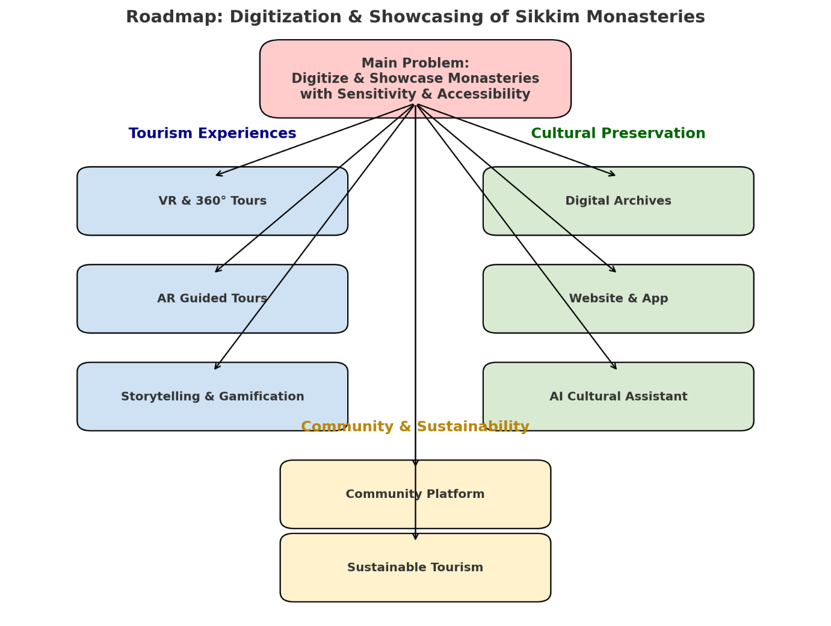

Ques – 4 Uniqueness
Ans –
To show uniqueness, you need to highlight how these solutions go beyond generic tourism apps and directly address Sikkim’s monasteries, culture, and preservation needs.
Here’s how each solution is unique:

🌐 Tourism Experiences
- VR & 360° Tours
  - Unique because it allows remote cultural immersion for monasteries located in hard-to-reach mountains.
  - Unlike normal travel videos, this preserves sacred spaces digitally while minimizing tourist pressure.
- AR Guided Tours
  - Goes beyond basic signboards by giving live cultural explanations (ritual meaning, mural stories) through AR.
  - Respectful: visitors don’t need to disturb monks by asking repeated questions.
- Storytelling & Gamification
  - Makes ancient Buddhist stories and legends interactive for younger audiences.
  - Not just education, but engagement — keeps culture alive in the digital generation.

📚 Cultural Preservation
- Digital Archives
  - Focuses on rare manuscripts, thangkas, and oral histories that are at risk of being lost.
  - Unlike standard archives, integrates visual + spiritual context for holistic preservation.
- Multilingual Website & App
  - Unique because it caters to global tourists (English), Indian visitors (Hindi), and locals (Nepali, Bhutia, Lepcha).
  - This multilingual bridge is rarely done in heritage projects.
- AI Cultural Assistant
  - Not just a tourist chatbot. It’s trained on Buddhist scriptures, monastery histories, and rituals.
  - Provides voice translations + cultural etiquette guidance → helping foreigners respect local customs.

🌱 Community & Sustainability
- Community Platform
  - Instead of outsiders controlling digitization, monks and local youth create and update content.
  - This ensures cultural authenticity and self-representation.
- Sustainable Tourism System
  - QR-based smart passes limit overcrowding during festivals.
  - Promotes eco-friendly digital awareness campaigns (respect silence, no littering, dress code).
  - Balances tourism with preservation — not common in regular tourism apps.

✨ In summary:
These solutions are unique because they are:
- Culture-specific (designed around Sikkim’s monasteries, not generic tourism).
- Respectful & inclusive (balance between tourism and spiritual preservation).
- Tech + Community hybrid (VR/AI + local participation).
- Sustainability-focused (reducing physical strain on heritage sites).

Ques-5 Technologies
Ans –
🌐 Tourism Experiences
- VR & 360° Tours
  - Technologies:
    - 360° cameras (Insta360, GoPro Max)
    - Drone imaging for aerial monastery shots
    - Unity/Unreal Engine for VR environment
    - WebVR/Three.js for browser-based VR
- AR Guided Tours
  - Technologies:
    - ARCore (Android) / ARKit (iOS)
    - Marker-based AR (QR codes on monastery walls for digital info)
    - 3D modeling (Blender, SketchUp) for artifact overlays
- Storytelling & Gamification
  - Technologies:
    - Mobile app (Flutter / React Native)
    - Game engines (Unity for interactive storytelling)
    - Animation tools (Adobe Animate, Toon Boom)

📚 Cultural Preservation
- Digital Archives
  - Technologies:
    - 3D laser scanning & photogrammetry (RealityCapture, Autodesk ReCap)
    - High-res photography (DSLR, Gigapixel AI)
    - OCR + NLP (for digitizing Tibetan/Nepali scripts)
    - Cloud storage (AWS S3, Google Cloud, DigitalOcean)
- Multilingual Website & App
  - Technologies:
    - Web development (HTML, CSS, JavaScript, React.js, Node.js)
    - Mobile (Flutter / React Native)
    - Translation APIs (Google Translate API, Indic NLP libraries)
    - GIS mapping (Leaflet, Mapbox, Google Maps API)
- AI Cultural Assistant
  - Technologies:
    - NLP & Chatbot frameworks (Rasa, Dialogflow, GPT-based models)
    - Speech-to-text & Text-to-speech (Google Speech API, OpenAI Whisper, Amazon Polly)
    - Custom dataset trained on monastery scripts + history

🌱 Community & Sustainability
- Community Platform
  - Technologies:
    - CMS (WordPress, Drupal, or Headless CMS like Strapi)
    - Mobile-first content apps (React Native)
    - Collaborative tools (GitHub-like versioning for digital content)
- Sustainable Tourism System
  - Technologies:
    - QR-code & NFC-based ticketing (Zebra API, QR generator libraries)
    - Cloud database (Firebase, MongoDB)
    - IoT sensors (optional, for monitoring visitor count/footfall)

✨ In short:
- Imaging & Capture → 360° cameras, drones, 3D scanning, OCR
- Development → Unity, Unreal, React Native, Flutter, WebVR
- AI & AR → NLP, ARCore/ARKit, AI chatbots, translation APIs
- Infrastructure → Cloud hosting, databases, CMS, GIS maps

Ques -6 Method of Implementation
Ans -6
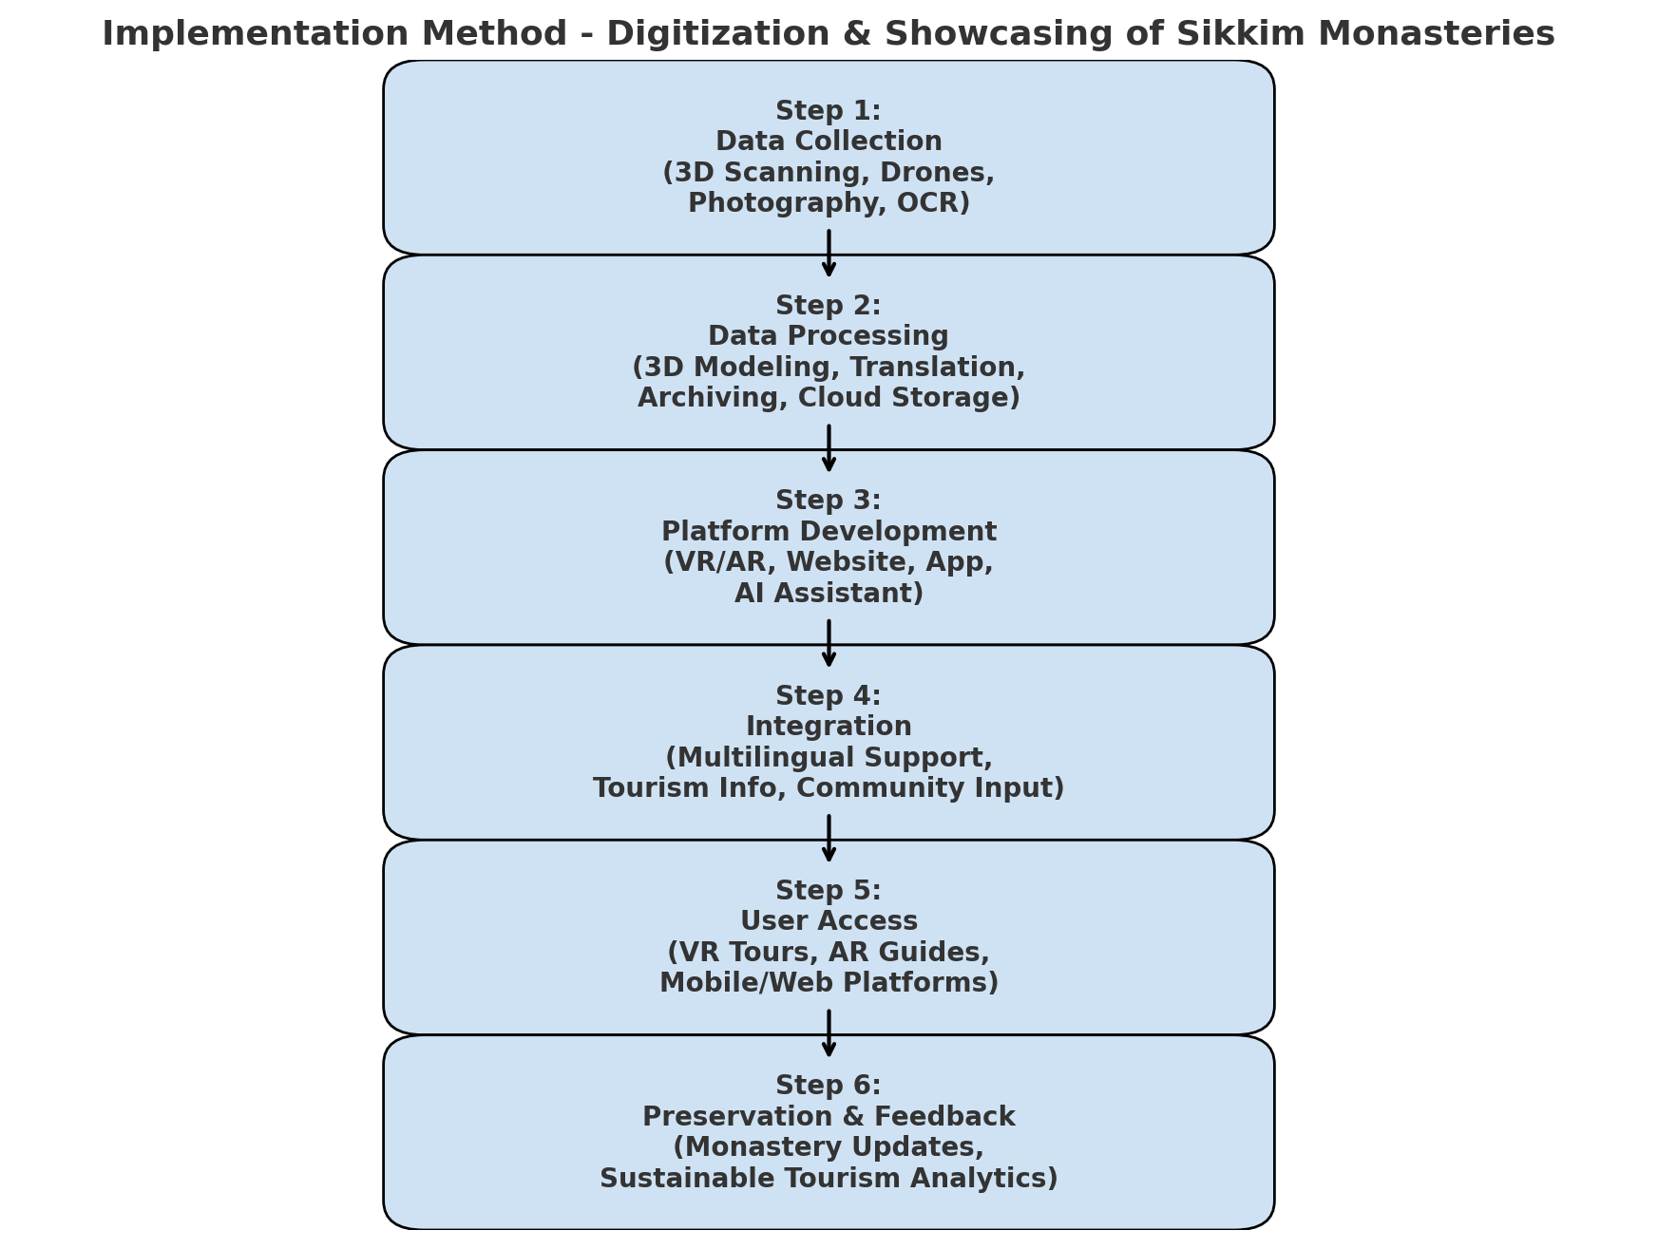

Here’s the flowchart of implementation ✅ showing how the project would move step by step:
- Data Collection → scanning, drones, photos, OCR
- Data Processing → modeling, translation, archiving
- Platform Development → VR/AR apps, websites, AI assistant
- Integration → multilingual support, tourism info, community updates
- User Access → tourists & researchers use VR tours, AR guides, apps
- Preservation & Feedback → updates from monasteries, sustainable analytics

Ques -7 Feasibility, potential challenges and solution to them
Ans-7
✅ Feasibility of the Solution
- Technical Feasibility
  - 360° imaging, VR/AR apps, OCR, and AI assistants are already established technologies.
  - Tools like Unity, ARKit, and cloud platforms are accessible and scalable.
  - Internet penetration in Sikkim is improving, making digital outreach realistic.
- Operational Feasibility
  - Collaboration possible with tourism boards, monasteries, and local communities.
  - Local youth can be trained in basic digitization → ensures sustainability.
- Economic Feasibility
  - Initial costs (VR equipment, drones, 3D scanning) are moderate compared to long-term value.
  - Can be funded through government heritage grants, tourism initiatives, and NGOs.
  - Revenue streams: virtual tickets, digital tours, cultural education platforms.
- Cultural Feasibility
  - Respectful digitization ensures monasteries are preserved without mass tourism pressure.
  - Monks and cultural experts can guide what to digitize (and what not to).

⚠️ Potential Challenges & Mitigation
- Limited Infrastructure (Internet, Power in Remote Areas)
  - Challenge: Poor connectivity in monasteries hampers real-time digitization.
  - Solution:
    - Use offline-first mobile apps with later synchronization.
    - Employ portable power banks & solar charging kits during scanning.
- High Costs of Equipment & Skilled Manpower
  - Challenge: VR/3D scanning & app development can be expensive.
  - Solution:
    - Partner with universities, startups, and NGOs for tech support.
    - Train local students in affordable digitization methods (photogrammetry with phones).
- Cultural Sensitivity & Permissions
  - Challenge: Monks may be reluctant to allow photography/scanning of sacred spaces.
  - Solution:
    - Conduct community workshops to explain benefits.
    - Allow monasteries to control access rights (e.g., which areas can be digitized).
    - Offer private archives for sensitive content (restricted access).
- Data Preservation & Security
  - Challenge: Risk of losing data or misuse of cultural heritage.
  - Solution:
    - Use secure cloud platforms with backup policies.
    - Blockchain or watermarking to protect digital heritage.
- User Adoption
  - Challenge: Locals may not be familiar with AR/VR or apps.
  - Solution:
    - Simple, multilingual interfaces (English, Hindi, Nepali, Bhutia).
    - Kiosks in tourist centers with guided use.
- Sustainability & Maintenance
  - Challenge: Once built, systems may become outdated without updates.
  - Solution:
    - Create a community-led digital council (youth + monks + tourism dept.).
    - Encourage periodic content updates (festivals, rituals).

🌟 Summary
- Feasibility: High (technically possible, culturally adaptable, fundable).
- Main Challenges: Infrastructure, cost, cultural sensitivity, and sustainability.
- Overcoming Strategy: Community involvement, affordable tech, phased rollout, partnerships with government + NGOs.
Ques 8 Impact on target audience
Ans 8
🎯 Target Audiences & Impact
1. Tourists (Domestic & International)
- Impact:
  - Access monasteries digitally through VR/AR before or instead of physical travel.
  - Gain cultural insights, etiquette guidance, and stories in multiple languages.
  - More responsible tourism → respectful behavior, reduced cultural clashes.

2. Local Communities (Monks, Youth, Residents)
- Impact:
  - Monasteries get global recognition without being overcrowded.
  - Youth employment through training in digitization, tourism services, and app management.
  - Cultural pride → locals see their heritage preserved and valued.

3. Researchers & Academics
- Impact:
  - Easy access to digital archives of manuscripts, art, and oral histories.
  - Reduces dependency on physical visits, protecting fragile materials.
  - Enables comparative studies with other Himalayan Buddhist sites worldwide.

4. Government & Tourism Department
- Impact:
  - Boosts tourism economy with innovative digital attractions.
  - Promotes Sikkim as a global spiritual tourism hub.
  - Provides data analytics (visitor trends, digital engagement) to plan sustainable tourism policies.

5. Global Audience (Diaspora, Culture Enthusiasts)
- Impact:
  - People worldwide can experience Sikkim’s monasteries remotely.
  - Encourages cross-cultural understanding of Buddhism and Himalayan traditions.
  - Builds global respect for Sikkim’s unique heritage.

🌟 Overall Impact
- Cultural Preservation: Safeguards monasteries from over-tourism and physical degradation.
- Education: Makes Buddhist knowledge and heritage accessible globally.
- Sustainable Tourism: Reduces strain on monasteries, ensures eco-friendly growth.
- Economic Growth: Creates new jobs in digitization, tourism tech, and cultural content creation.
- Community Empowerment: Locals become custodians and narrators of their own culture.
Ques 9 Benefits of the solution
Ans 9
🌟 Benefits of the Solution
1. Cultural Preservation
- Digitally safeguards monasteries, manuscripts, murals, and oral traditions.
- Protects fragile heritage from natural disasters, aging, or over-tourism.
- Creates a permanent digital archive for future generations.

2. Tourism Enhancement
- Offers immersive VR/AR monastery tours → attracts global visitors.
- Multilingual apps/websites make tourism more inclusive.
- Promotes responsible tourism by educating visitors about etiquette and rituals.

3. Economic Growth
- Generates new income streams through virtual tours, apps, and cultural content.
- Creates jobs for local youth in digitization, content creation, and tourism services.
- Increases footfall of high-value cultural tourists (who spend more, but travel responsibly).

4. Community Empowerment
- Monks and locals actively involved in digitization → ensures authenticity.
- Builds digital skills in rural communities.
- Strengthens cultural pride and identity among local residents.

5. Education & Research
- Researchers worldwide can study monasteries without needing physical access.
- Schools and universities can use VR/AR monastery content for interactive learning.
- Preserves rare Buddhist knowledge for academic study.

6. Sustainability
- Reduces overcrowding in fragile monasteries by offering digital alternatives.
- Promotes eco-friendly tourism practices through awareness campaigns.
- Ensures long-term preservation while still enabling tourism growth.

7. Global Cultural Exchange
- Puts Sikkim on the world heritage tourism map.
- Fosters cross-cultural understanding between visitors and local traditions.
- Builds Sikkim’s image as a center of peace, spirituality, and culture.

✨ In summary:
The solution benefits all stakeholders — monasteries (preservation), locals (empowerment), tourists (better experiences), government (tourism revenue), and researchers (knowledge access).

