**Step 1:**

**Run CCDC_Select_Training_v0-1.py**

This script select training sample from LandCover Trends and creates **Xs_gridxx.npy** and **Ys_gridxx.npy** files that would be used for random forest fit model. There are 5 required parameters to run this script:

1. **Full path of file directory**. This would be location of desired grid, which will have ANC folder (all ancillary data including Fmask_stats), TSFitMap folder, and example_img file (this is envi format file of mosaicked Land Cover Trends)
2. **Ground truth Start time**. We need to pass this date as yyyy-mm-dd. (This date tells us start of base traning data, which is 1999-01-01 for Land Cover Trends data. As we used three years 1999, 2000, and 2001 of Trends data and mosaicked for current purpose)
3. **Ground truth end time**. We need to pass this date as yyyy-mm-dd. (This date tells us end of base training data, which is 2001-12-31 for LandCover Trends data. As we used three years 1999, 2000, and 2001 of Trends data and mosaicked for current purpose)
4. **Number of Coefficient.** Current coefficient number is 8 and it is default to the script. If we chose to use different Coefficient value in future, we can pass that to the script.
5. **Number of Band.** Current band number of 8 and it is default to the script. If we chose to use different band number in future, we can pass that to the script.

How to run the script. Some examples.

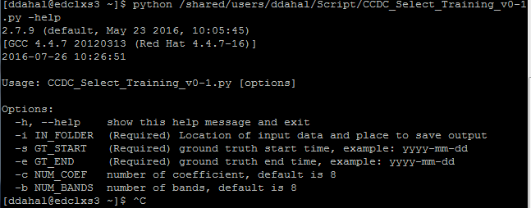

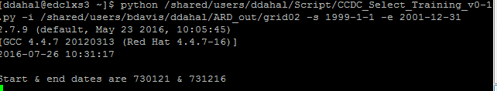

**Step 2:**

**Run Merge_ARD_samples_train_v0-1.py**

We need to have output of previous script for multiple grids before running this script. This script will take **Xs_gridxx.npy** & **Ys_gridxx.npy** from all available neighboring grids of the targeted grid and merge to create 'Mrg_Xs_gridxx.npy' & 'Mrg_Ys_gridxx.npy', use these merged npy files to fit random forest and save as **'modelRF_py.dump'** & **'modelRF_py.npy'.** It takes two parameter to run the script, which are input directory path and number of tree for random forest model. Input directory would be the parent directory, where all of the grid folders are located. As of number of tree, 500 is set as default.

Example below:

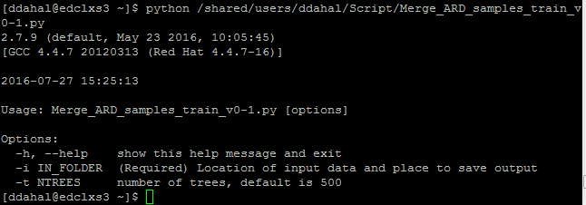

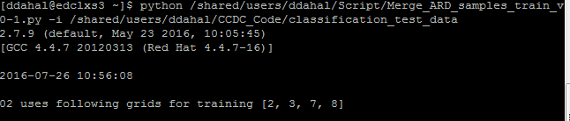

This script will sequencely go to the each grid and merge the training data, perform model fit, and save the merged training data and modelRF files in the target grid folder.

**Step 3:**

**Run CCDC_main_classification_v0-1.py**

This script takes all of the ancillary layers read line at a time, run random forest predict model for land cover classes for each line and updates the record_change##.mat files with class and classQA information.

Example below to run the script.

