Tic Tac Toe
- Instance Factory vs Static Factory
Instance Factory - Helps in caching, Helps in Injecting , Helps Reading Configs
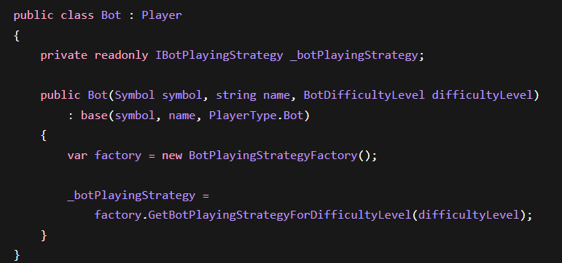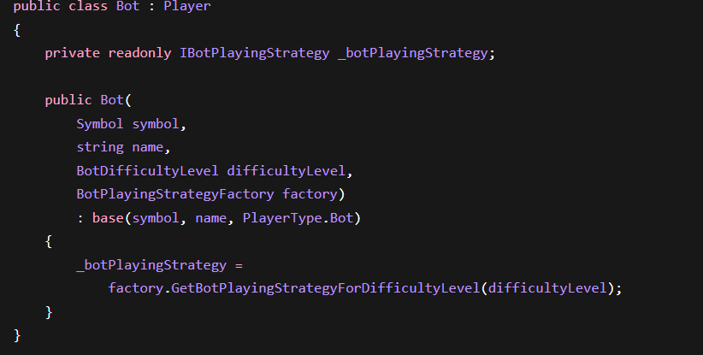

- JWT
Header.Payload.Signature
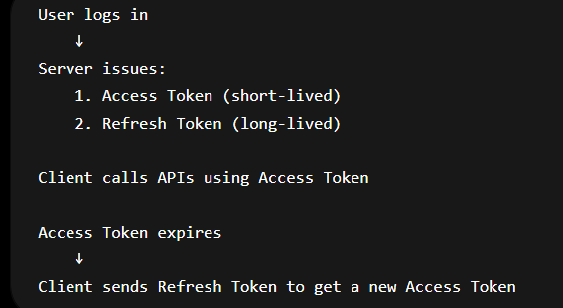
Beacon
- Paged List
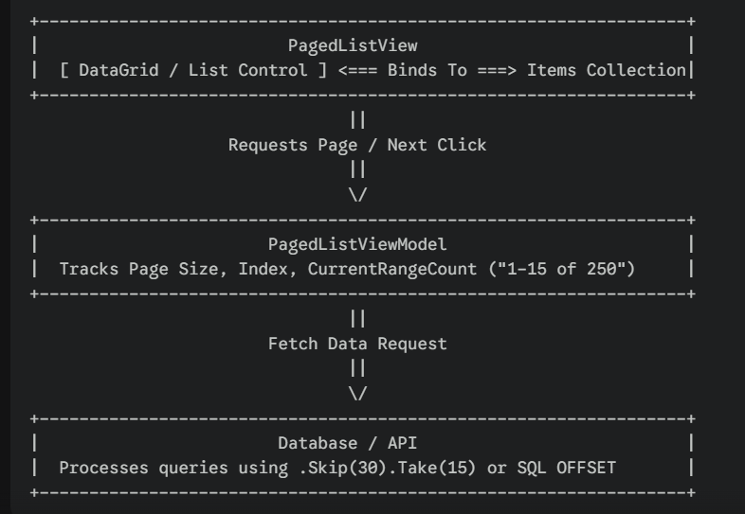
- ViewList
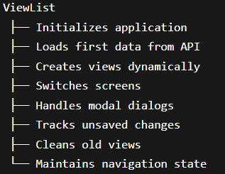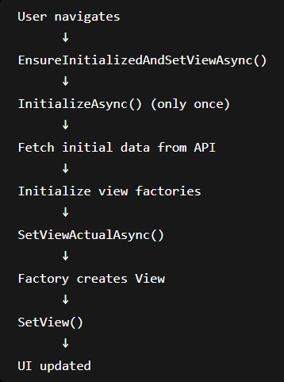

Dependency Injection
- Constructor Injection
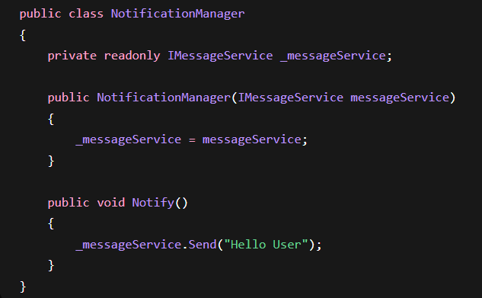
Message Service can be used
Email Service can be used
It can help testing without sending a mail or a message
Transient – Normal Object
Scoped - DBs
Singleton – Logs

