Regular Language Closure Operations Simulator
Milestone 1 – Simulator Design Review | CSET302 Automata Theory and Computability | Topic 15
Group members: [add names and roll numbers] | Tutorial batch: [add]

1. Problem Definition & Automata Specification

1.1 Problem statement
Regular languages are closed under union, intersection, complement and difference. This is a core theorem of Automata Theory, but it is usually taught as symbolic constructions on paper, which makes it hard to see why the constructions work. Students have to build product automata by hand, track pairs of states, and decide which pair-states are accepting, and mistakes are easy to make and hard to spot.
This project builds an interactive simulator that takes two user-defined Deterministic Finite Automata (DFAs), applies a chosen closure operation, constructs the resulting DFA automatically using the textbook algorithm, draws it, and lets the user test strings against it.

1.2 Objectives
- Let the user define two DFAs (Machine A and Machine B): states, alphabet, start state, final states and transition table.
- Validate the input and report understandable errors.
- Construct A ∪ B, A ∩ B, A̅ and A − B using mathematically correct algorithms.
- Visualise the resulting DFA (circles, double circles for final states, start arrow, labelled arrows, self-loops) and show its transition table.
- Let the user test any string, including the empty string ε, and see the exact state-by-state path and the accept/reject verdict.
- Validate the implementation against the theoretical definition of each operation on many strings.

1.3 Scope and assumptions
- Only DFAs are supported as input (not NFAs or ε-NFAs).
- Both machines must use the same alphabet Σ. Each symbol is a single character.
- A DFA must have exactly one transition per state and symbol. If the user leaves a transition empty, the simulator adds a non-accepting trap (dead) state so that the machine becomes complete. This does not change the language.
- Complement is taken relative to the specified alphabet Σ, that is, Σ* − L(A).

1.4 Inputs and outputs
Item | Description
Input 1 | Machine A: Q, Σ, δ, q0, F
Input 2 | Machine B: Q, Σ, δ, q0, F (not needed for complement)
Input 3 | Operation: union, intersection, complement or difference
Input 4 | Test string over Σ (may be empty)
Output 1 | Resulting DFA (states, transition table, start state, final states)
Output 2 | Drawing of the resulting DFA
Output 3 | Path taken by the test string and ACCEPTED / REJECTED verdict
Output 4 | Error messages for invalid input; a note when a trap state was added

1.5 Formal specification
DFA. A DFA is a 5-tuple M = (Q, Σ, δ, q0, F) where Q is a finite set of states, Σ is a finite alphabet, δ : Q × Σ → Q is the transition function, q0 ∈ Q is the start state and F ⊆ Q is the set of final (accepting) states. The extended function δ*(q, ε) = q and δ*(q, wa) = δ(δ*(q, w), a). The language is L(M) = { w ∈ Σ* | δ*(q0, w) ∈ F }.
Product automaton. For A = (QA, Σ, δA, qA, FA) and B = (QB, Σ, δB, qB, FB), define P = (QA × QB, Σ, δ, (qA, qB), F) with
δ((p, q), a) = (δA(p, a), δB(q, a))
The only thing that changes between the three binary operations is the set F of final states:
Operation | Language | Final states of the product
Union | L(A) ∪ L(B) | (p, q) with p ∈ FA or q ∈ FB
Intersection | L(A) ∩ L(B) | (p, q) with p ∈ FA and q ∈ FB
Difference | L(A) − L(B) | (p, q) with p ∈ FA and q ∉ FB
Complement. For a complete DFA A, the complement DFA is A' = (Q, Σ, δ, q0, Q − F). Only the final states change.
Completion (trap state). If some δ(q, a) is missing, add a state d with δ(d, a) = d for every a ∈ Σ, d ∉ F, and set every missing δ(q, a) to d.
Why the product works. By induction on |w|, δ*((p, q), w) = (δA*(p, w), δB*(q, w)). So the product is in state (δA*(qA, w), δB*(qB, w)) after reading w, and w is accepted exactly when the chosen rule holds for "A accepts w" and "B accepts w". This gives OR for union, AND for intersection and A AND NOT B for difference.
Why completeness matters. Complement is only correct for a complete DFA. If a string runs into a missing transition, the original machine rejects it, but the flipped machine would also have no run and could not accept it, so the language would not be Σ* − L(A). Completion with a trap state fixes this. The trap state becomes a final state in the complement, which is correct because every string that falls into it was rejected by the original.

2. Existing Tools & Feasibility

2.1 Review of existing tools
The table below summarises tools and teaching material we reviewed. Each team member should open the tools below, try a closure operation, and add a screenshot and one personal observation before the review.
Tool / resource | What it is | Relevance to closure operations | Limitation for our goal
JFLAP | Desktop Java tool for creating and simulating finite automata and other models. Its Convert menu includes Combine Automata, and course labs use it to draw and test DFAs. | Students draw machines and test strings. Course lab sheets that use it ask students to build product-style constructions by the textbook method (for example, a union of two simpler languages) rather than by an automatic closure-operation builder. | Needs installation; the product construction is typically carried out manually in the exercises; no explanation of why a pair-state is accepting.
Automata Tutor (v1–v3) | Online tool for learning automata, used in many courses. It grades automata that students draw and gives feedback. Version 3 extended this to regular expressions, grammars, PDAs, Turing machines and conversions. | Practice exercises such as building a product automaton exist in course material that uses it. | Its focus is grading and feedback on student answers, not showing the construction of A ∪ B, A ∩ B, A̅ and A − B from two user-defined machines.
Lecture notes and course exercises | Illinois, Coventry, UPC and EPFL material describes the product construction, the complement construction and exercises on them. | Correct theory; the basis of our algorithms. | Static pen-and-paper explanations without an interactive tool.
Teaching-tool proposals | A university project proposal for a finite-automata teaching tool lists union, concatenation, star, intersection and complement among the operations such a tool should compute. | Shows there is a real need for this functionality. | A proposal, not a finished tool.
Gap our simulator fills. It focuses on one thing: take two DFAs, apply one of the four closure operations automatically, show the generated machine as a diagram and table, and let the user test strings. It runs locally in a browser with Python, needs no installation of a separate application, and reports errors and automatic completion in plain language.

2.2 Feasibility
Aspect | Assessment
Technical | The algorithms are small (product construction with BFS, complement, string run). Python's standard library is enough for the logic and the local server; the interface uses HTML, CSS, JavaScript and SVG. No external libraries are needed.
Skills | The whole team knows Python, so all automata logic is in one readable Python file. JavaScript is only used for drawing the interface.
Time | Core logic and interface are already prototyped; the remaining time to M2 is for testing, refinement and the report.
Risks | Large products (up to

3. Simulator Design & Methodology

3.1 Architecture
The simulator has three layers that communicate through a small JSON interface.
Layer | File(s) | Responsibility
Presentation (browser) | index.html, style.css, script.js, graph.js | Machine editors, operation selection, drawing the DFA as SVG, transition table display, string-test animation
Interface (server) | app.py | Local HTTP server (Python standard library). Serves the page and exposes the JSON endpoints below
Logic | dfa_logic.py | All automata logic: validation, trap-state completion, product construction, complement, string run, transition-table generation
Verification | test_dfa.py | Automated tests comparing every operation with its theoretical definition

Endpoint | Method | Purpose
/api/examples | GET | Predefined example DFAs
/api/build | POST | Input: machines A, B and the operation. Output: resulting DFA, table, notes or error list
/api/run | POST | Input: resulting DFA and a string. Output: path and accept/reject
A machine is stored as a plain dictionary: states, alphabet, start, accept (list) and delta (state → symbol → state).

3.2 Input–processing–output workflow
- Input: the user edits Machine A and Machine B and selects an operation.
- Validation: check the alphabet, that a start state is selected and that every transition target exists. Show all errors at once.
- Completion: add a trap state to any machine with missing transitions and show a note.
- Algorithm: run complement or the product construction with the rule for the chosen operation.
- Visualisation: draw the resulting DFA and fill the transition table.
- String test: run the string on the resulting DFA, animate the path and give the verdict.
- Validation: automated tests compare the simulator with the theoretical result.
The flowchart, the module diagram and the sequence diagram for this workflow are in Appendix A.

3.3 User interface design
The interface is a light-theme, minimal educational application with these screens. Add your screenshots or wireframes under each heading.
- Home: title, short description, four operation cards with explanations, and a Start Simulator button. [Insert screenshot]
- Input automata: Machine A and Machine B editors with alphabet, state rows, start and final selectors, a transition table with drop-downs, example loader and reset. [Insert screenshot]
- Operation and messages: operation selector, description of the chosen operation, validation errors or notes. [Insert screenshot]
- Result: statistics (states, final states, alphabet, start), scrollable diagram and transition table. [Insert screenshot]
- String tester: input box, sample strings, step-by-step path and verdict. [Insert screenshot]
- Theory: summary and comparison table of the four operations. [Insert screenshot]

3.4 Design decisions
- Python for the logic. All algorithms are in one file, dfa_logic.py, so every member can read and explain them. The browser only draws.
- Single product routine. Union, intersection and difference share one function and differ only in the final-state rule, which avoids duplicated code and mirrors the theory.
- BFS from the start state. Only reachable product states are generated, which keeps diagrams small.
- Visible completion. Missing transitions are never silently ignored; the user is told when a trap state was added.

4. Algorithm Selection & Correctness

4.1 Pseudocode
Completion
function COMPLETE(M):
missing = { (q, a) : q in Q, a in Σ, δ(q, a) undefined }
if missing is empty: return M
add new state d to Q // d not in F
for each a in Σ: δ(d, a) = d
for each (q, a) in missing: δ(q, a) = d
return M
Product construction (union, intersection, difference)
function PRODUCT(A, B, op):
start = (A.start, B.start)
queue = [start]; seen = { start }
while queue is not empty:
(p, q) = dequeue(queue)
for each a in Σ:
t = (δA(p, a), δB(q, a))
δ((p, q), a) = t
if t not in seen: add t to seen; enqueue t
for each (p, q) in seen:
inA = p in FA; inB = q in FB
if op = union: accept if inA or inB
if op = intersection: accept if inA and inB
if op = difference: accept if inA and not inB
return (seen, Σ, δ, start, accepting pairs)
Complement
function COMPLEMENT(A): // A must be complete
return (Q, Σ, δ, q0, Q − F)
String test
function RUN(M, w):
state = M.start; path = [state]
for each symbol c in w: // w = ε gives an empty loop
if c not in Σ: return error "symbol not in alphabet"
state = δ(state, c); append state to path
return (path, state in F)

4.2 Complexity
- Product: at most |QA| × |QB| states and |QA| × |QB| × |Σ| transitions, so O(|QA| · |QB| · |Σ|) time.
- Complement: O(|Q|) time and no new states.
- String test: O(|w|) time.

4.3 Manually validated example
Machine A (strings ending in 0): states q0 (start), q1 (final); Σ = {0, 1}.
State | on 0 | on 1
→ q0 | q1 | q0
* q1 | q1 | q0
Machine B (even number of 1s): states e (start, final), o.
State | on 0 | on 1
→ * e | e | o
o | o | e
Step 1 – start state. (q0, e).
Step 2 – BFS and transitions. δ((p, q), a) = (δA(p, a), δB(q, a)).
Pair-state | on 0 | on 1
(q0, e) | (q1, e) | (q0, o)
(q1, e) | (q1, e) | (q0, o)
(q0, o) | (q1, o) | (q0, e)
(q1, o) | (q1, o) | (q0, e)
All four pairs are reachable, so the product has 4 states (from 2 × 2 = 4 possible).
Step 3 – final states for each rule.
Pair-state | A accepts? | B accepts? | Union (OR) | Intersection (AND) | Difference (A and not B)
(q0, e) | no | yes | final | not final | not final
(q1, e) | yes | yes | final | final | not final
(q0, o) | no | no | not final | not final | not final
(q1, o) | yes | no | final | not final | final
Hence F(union) = {(q0,e), (q1,e), (q1,o)}, F(intersection) = {(q1,e)}, F(difference) = {(q1,o)}. For the complement of A, F' = {q0} with the same transitions as A.
Step 4 – check strings by hand. The path in the product is computed from the transitions above, and compared with running A and B separately.
Input | A | B | Path in product | A ∪ B | A ∩ B | A − B | A̅ | Case
ε | reject | accept | (q0,e) | accept | reject | reject | accept | only B, empty string
1 | reject | reject | (q0,e) → (q0,o) | reject | reject | reject | accept | neither
10 | accept | reject | (q0,e) → (q0,o) → (q1,o) | accept | reject | accept | reject | only A
110 | accept | accept | (q0,e) → (q0,o) → (q0,e) → (q1,e) | accept | accept | reject | reject | both
01 | reject | reject | (q0,e) → (q1,e) → (q0,o) | reject | reject | reject | accept | neither, longer string
11 | reject | accept | (q0,e) → (q0,o) → (q0,e) | accept | reject | reject | accept | only B
In every row, union follows OR, intersection follows AND, difference follows A AND NOT B and complement is the opposite of A. We then ran the same strings in the implemented algorithm, and all verdicts and final states matched this table.
Example with a missing transition. Let X have states A (start) and B (final), Σ = {0, 1}, with only δ(A, 0) = B defined, so L(X) = {0}. Completion adds a state dead. Then δ(A, 1) = dead and δ(B, 0) = δ(B, 1) = dead, and dead loops to itself. The complement has final states {A, dead}: it accepts ε and every string except "0".

4.4 Test plan for M2
The automated tests compare each construction with the theoretical definition on every binary string up to length 7 (including ε), over all pairs of four example DFAs (ends in 0, even number of 1s, starts with 1, contains 00). The test plan also includes:
Test category | Expected result
Both machines accept / only A / only B / neither | OR, AND, A and not B follow the definitions
Empty string ε | Accepted exactly when the start state is final
Single-symbol and long strings | Same as running A and B separately
Self-loops | Handled by the transition table without special cases
Multiple final states | Final-state rule applied to each pair
Machines of different sizes | Product has at most
Invalid input symbol | Clear error message, no crash
Missing transition | Trap state added and a note shown
Different alphabets | Rejected with an explanation

5. Plan to M2
Dates | Work
2–6 Nov (M1) | Present design, algorithms and the manual example. Show the preliminary prototype
9–13 Nov | Refinement, more test cases, review of limitations
16–20 Nov | Final testing, screenshots and technical report
23–27 Nov (M2) | Live demonstration, source code, report and individual contribution details
Individual contributions: [add each member's name and responsibility].

6. Limitations and future work
- Only DFAs are supported. NFA and ε-NFA inputs would need subset construction first.
- Symbols are single characters and both machines need the same alphabet.
- The result is not minimised, so it can contain equivalent states.
- Very large products produce large diagrams.

7. References
- JFLAP tutorial, finite automata: https://www.jflap.org/tutorial/fa/createfa/fa.html
- Automata Tutor: https://www.automatatutor.com and D'Antoni, Weaver, Weinert and Alur, "Automata Tutor and what we learned from building an online teaching tool": https://www.cis.upenn.edu/~alur/BEATCS15.pdf
- D'Antoni et al., "Automata Tutor v3" (2020): https://www.muni.cz/en/research/publications/2484790
- CS 373 lecture 3, University of Illinois (closure under complement and the product automaton): https://courses.grainger.illinois.edu/cs373/sp2009/lectures/lect_03.pdf
- Coventry University lab sheet, intersection, union and difference of DFAs: https://github.coventry.ac.uk/pages/ab3735/5002CEM/pdf/labs/lab2.pdf
- UPC problem set, product construction and complement: https://www.cs.upc.edu/tc/en/PS1.pdf
- University of Minnesota Morris lab using JFLAP for product constructions: https://personal.morris.umn.edu/~elenam/3501fall2016/psets/lab8.html
- Heriot-Watt project proposal, teaching tool for finite automata: https://projects.hw.ac.uk/Proposals/Details/88CPBFAKOQZ7
- M. Sipser, Introduction to the Theory of Computation (closure of regular languages).

Appendix A. Diagrams

A.1 Workflow flowchart
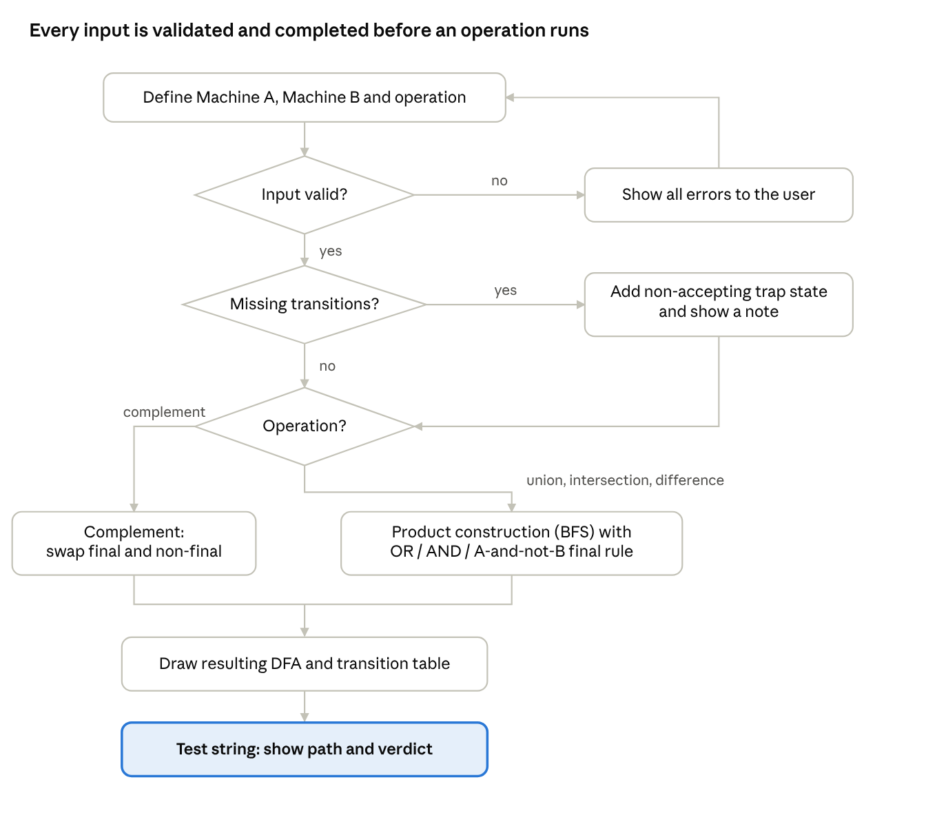
workflow flowchart · 3 decisions
A machine is validated first, completed with a trap state if needed, then routed to complement or the product construction.

A.2 Module diagram
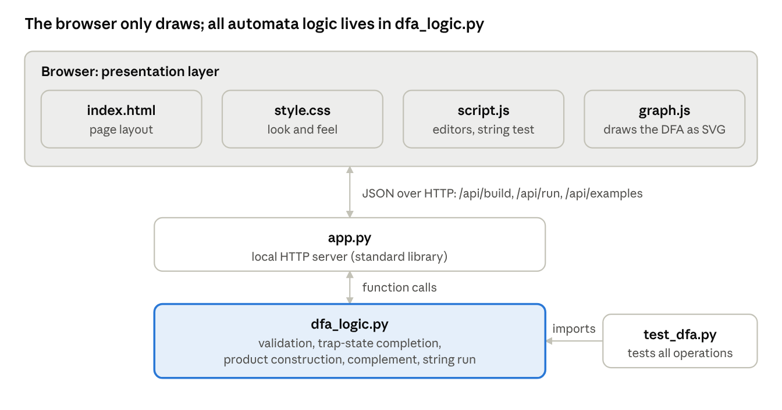
module diagram · 3 layers
All algorithm code sits in dfa_logic.py; the browser only sends machines and draws results.

A.3 Sequence diagram
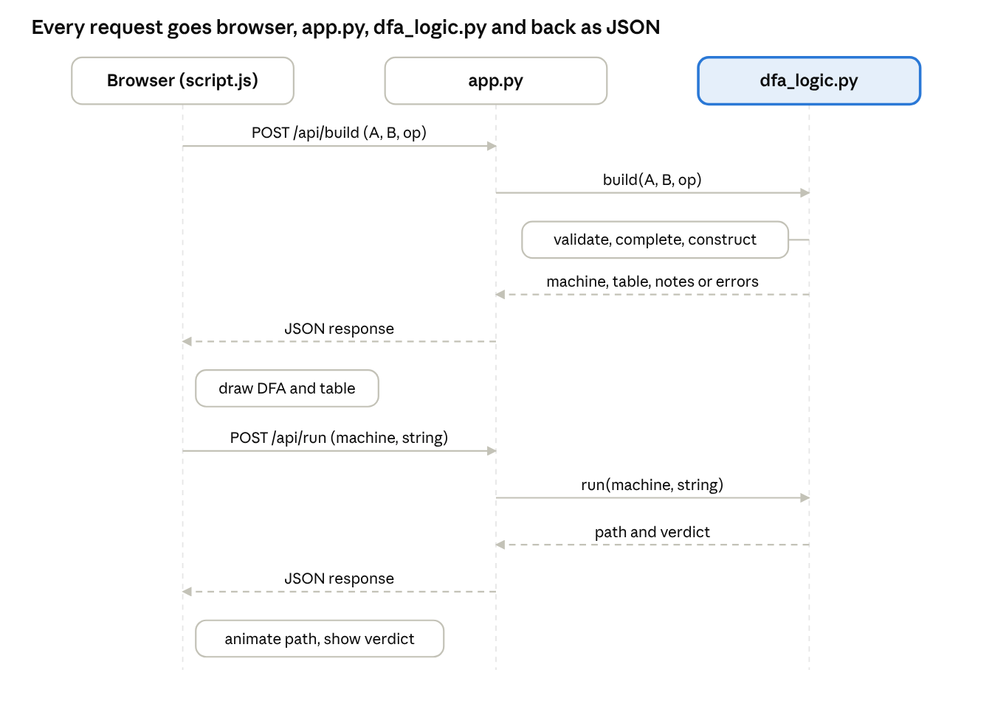
sequence diagram · build and run requests
Building the DFA and testing a string are two separate requests to the same Python server.

