Name – Devender Singh Shekhawat
Enrollment – S24CSEU2213
Git link - https://github.com/devendersinghshekh/SCSE3040-Lab
Date – 25 / 08 / 26

Before vs After refactor :
MAE 1.92
MAE 1.92 minutes
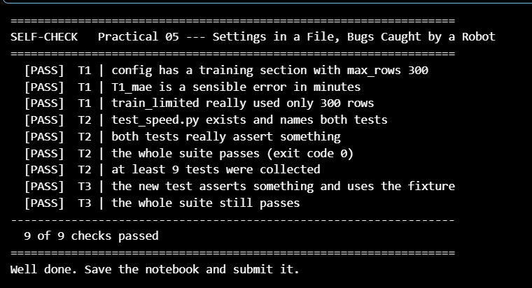
content of config file :
# Settings for the delivery-time model.
# Change values here, never in the code.
data:
path: ../data/delivery_times.csv
features:
- distance_km
- prep_time_min
- traffic_level
- rain
target: delivery_min
split:
test_size: 0.2
seed: 42

model:
name: linear_regression

