|  |
| --- |
| **Scenario** |
| Login with valid Creditional |
| Test Steps |
| 1.Click cintinue with google |
| 2.Choose gmail or create new |
| 3.click to continue |
| 4.Entered in page |
| 5.Click to let's go |
| 6.Shows your name |
| 7.Click |
| 8.Pick an option |
| 9.Click any |
| 10.Skip |
| 11.Click |

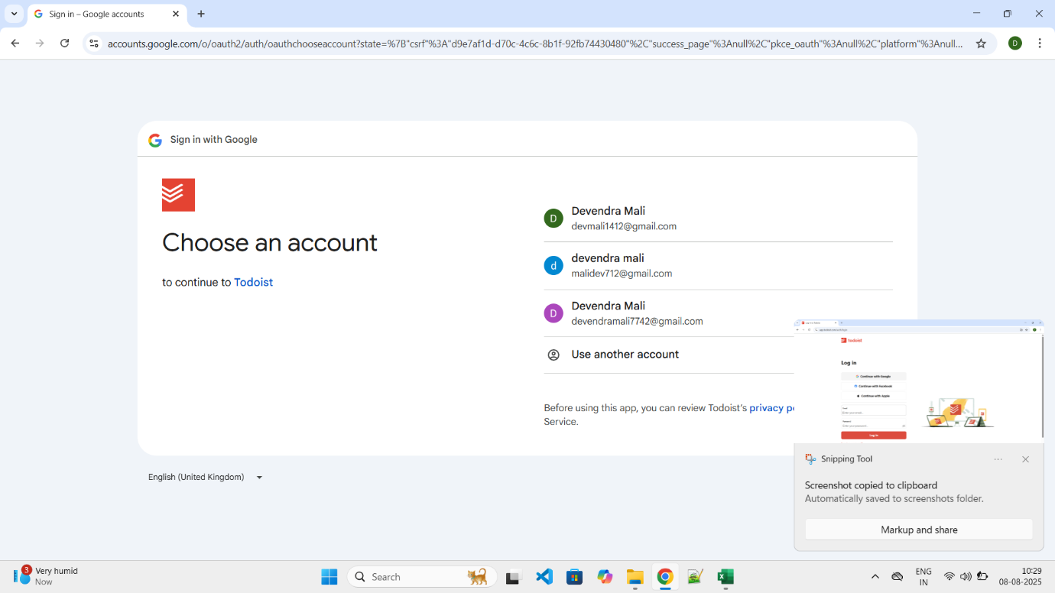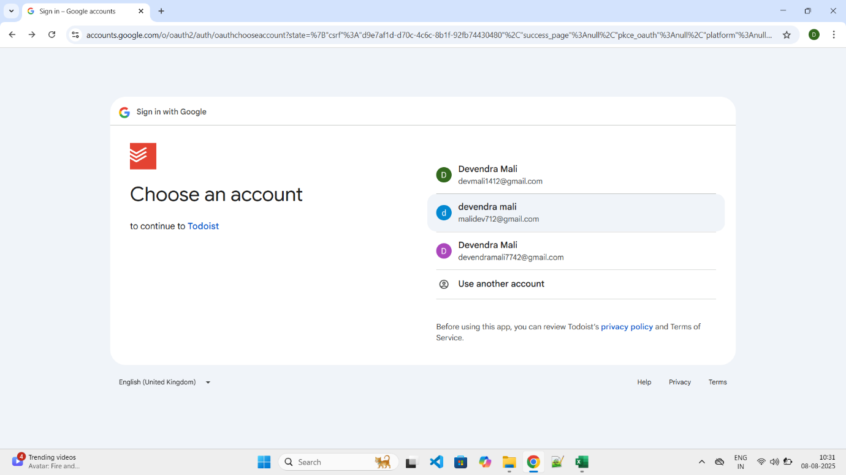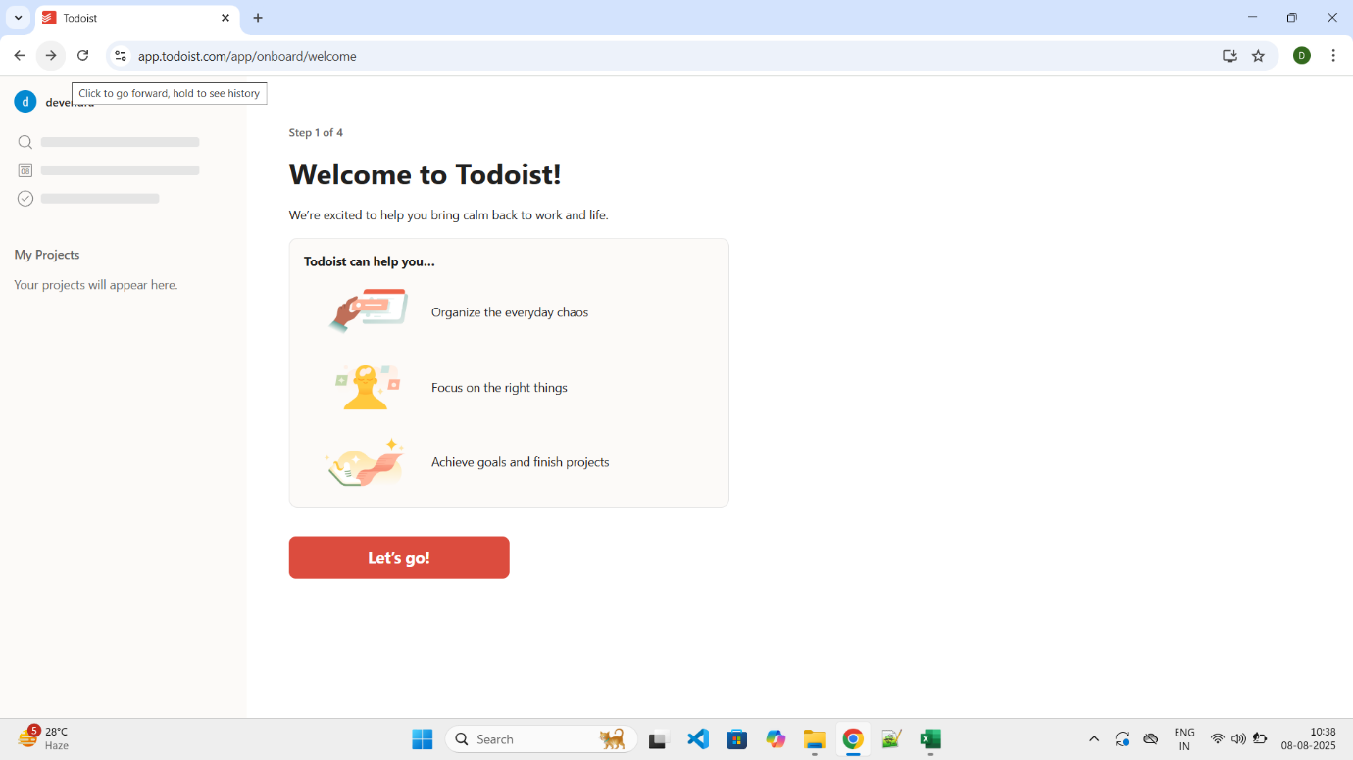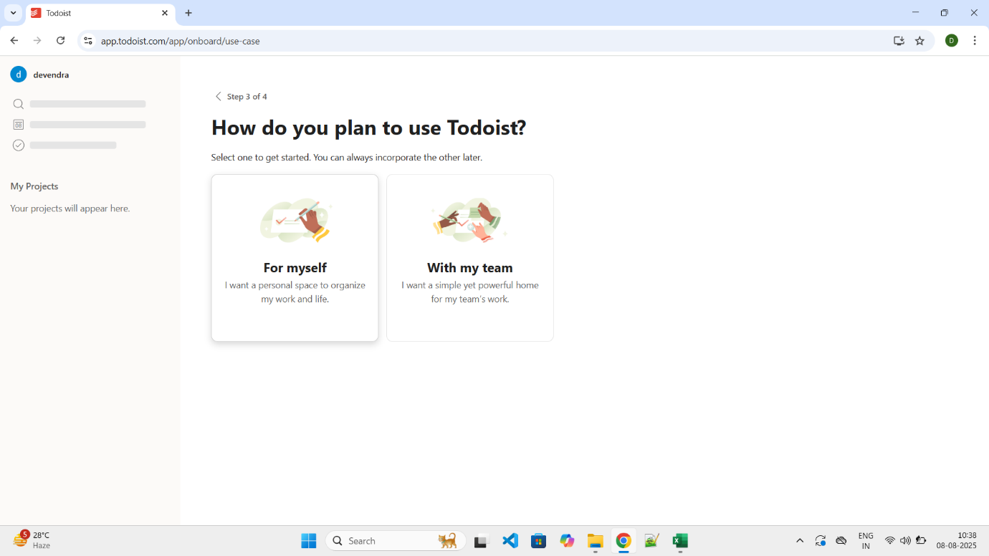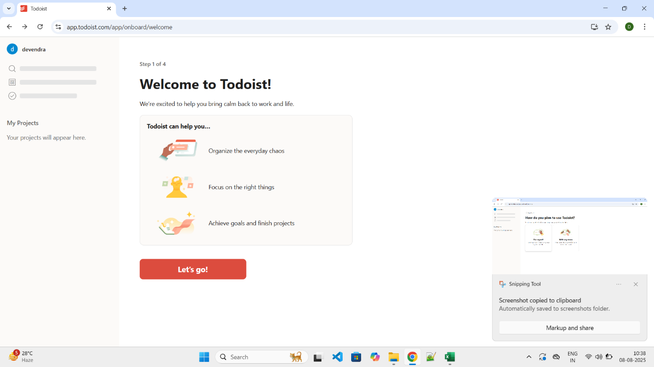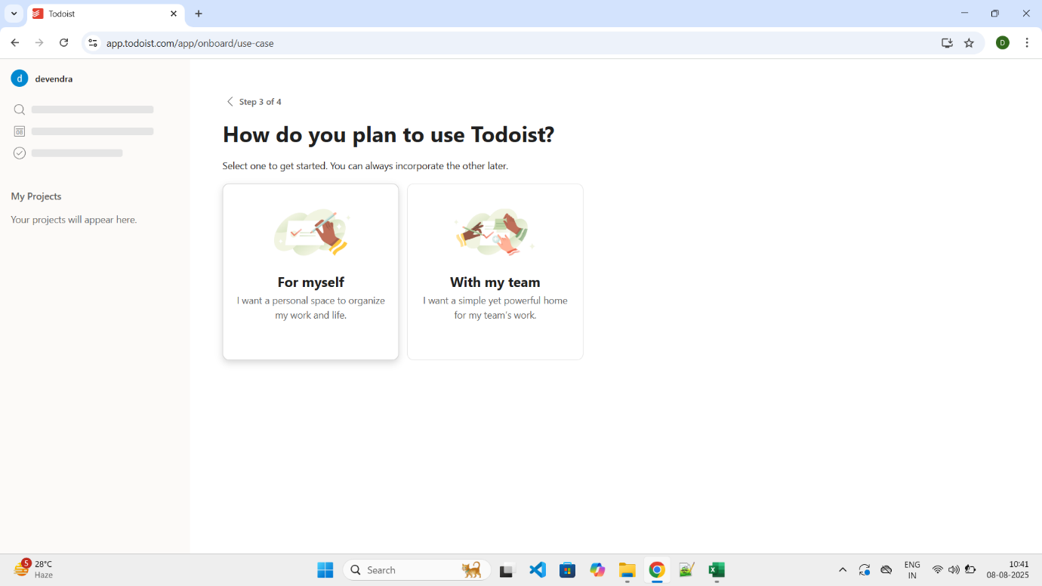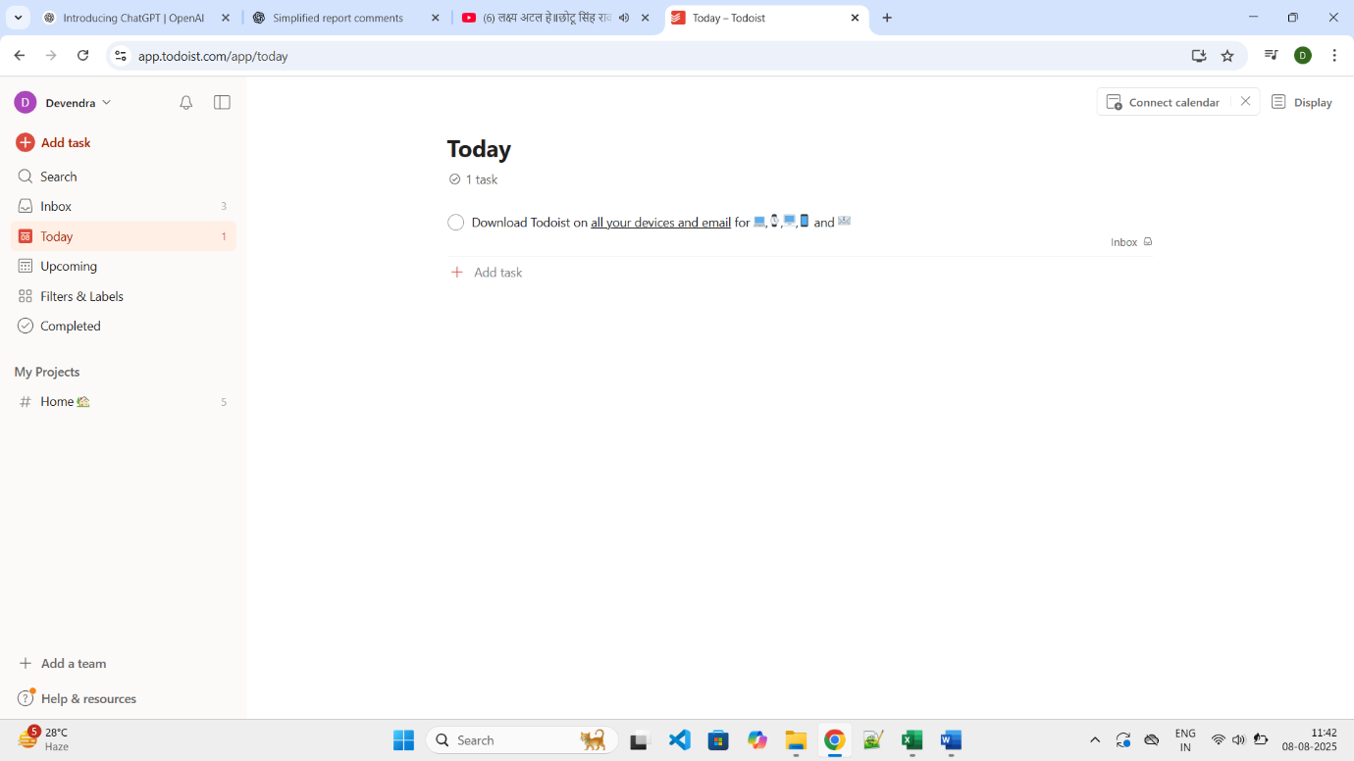

Summary Of Test Results:   
Total Test Cases- 11 Passed- 11 Failed- 0 Pass %- 100%   
● Conclusion and Recommendations: Pass Rate: 100%, No Need Improvement  
● Issues Found 0   
Bug Reports:   
1. Field Description Bug ID BUG-3   
 1. Click on Sign Up   
2. Enter existing Email  
 3. Fill all fields   
  
4. Click on Sign Up the cursor show the name of attempt