Q5.a)Create an android application using a grid view layout and insert 6 images of different animals as the items. Toast the animal name when an image is clicked. (Recycler View)
Aim: To Create an android application using a grid view layout and insert 6 images of different animals as the items. Toast the animal name when an image is clicked. (Recycler View) for jet pack
Program:
package com.example.practical1a
import android.os.Bundle
import android.widget.Toast
import androidx.activity.ComponentActivity
import androidx.activity.compose.setContent
import androidx.compose.foundation.Image
import androidx.compose.foundation.clickable
import androidx.compose.foundation.layout.*
import androidx.compose.foundation.lazy.grid.GridCells
import androidx.compose.foundation.lazy.grid.LazyVerticalGrid
import androidx.compose.foundation.lazy.grid.items
import androidx.compose.material3.Card
import androidx.compose.material3.MaterialTheme
import androidx.compose.material3.Surface
import androidx.compose.material3.Text
import androidx.compose.runtime.Composable
import androidx.compose.ui.Alignment
import androidx.compose.ui.Modifier
import androidx.compose.ui.platform.LocalContext
import androidx.compose.ui.res.painterResource
import androidx.compose.ui.unit.dp
// Place the Data Class at the top (outside the Activity)
data class Animal(val name: String, val imageRes: Int)
class MainActivity : ComponentActivity() {
override fun onCreate(savedInstanceState: Bundle?) {
super.onCreate(savedInstanceState)
setContent {
MaterialTheme {
Surface(color = MaterialTheme.colorScheme.background) {
AnimalGridApp()
}
}
}
}
}
@Composable
fun AnimalGridApp() {
val context = LocalContext.current
val animalList = listOf(
Animal("Lion", R.drawable.lion),
Animal("Tiger", R.drawable.tiger),
Animal("Elephant", R.drawable.elephant),
Animal("Panda", R.drawable.panda),
Animal("Fox", R.drawable.fox),
Animal("Koala", R.drawable.bear)
)
LazyVerticalGrid(
columns = GridCells.Fixed(2),
contentPadding = PaddingValues(16.dp),
verticalArrangement = Arrangement.spacedBy(16.dp),
horizontalArrangement = Arrangement.spacedBy(16.dp),
modifier = Modifier.fillMaxSize()
) {
items(animalList) { animal ->
AnimalItem(animal) {
Toast.makeText(context, animal.name, Toast.LENGTH_SHORT).show()
}
}
}
}
@Composable
fun AnimalItem(animal: Animal, onClick: () -> Unit) {
Card(
modifier = Modifier
.fillMaxWidth()
.clickable { onClick() }
) {
Column(
horizontalAlignment = Alignment.CenterHorizontally,
modifier = Modifier.padding(8.dp)
) {
Image(
painter = painterResource(id = animal.imageRes),
contentDescription = animal.name,
modifier = Modifier.size(120.dp).padding(8.dp)
)
Text(text = animal.name)
}
}
}

output:-
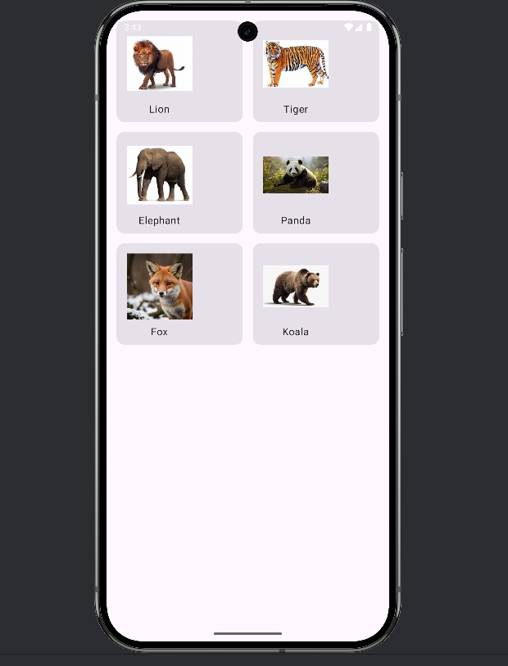
5.b Create the media API in android to play a video file.
Aim: To Create the media API in android to play a video file.
package com.example.practical1a
import android.net.Uri
import android.os.Bundle
import androidx.activity.ComponentActivity
import androidx.activity.compose.setContent
import androidx.annotation.OptIn
import androidx.compose.foundation.layout.fillMaxSize
import androidx.compose.material3.MaterialTheme
import androidx.compose.material3.Surface
import androidx.compose.runtime.Composable
import androidx.compose.runtime.DisposableEffect
import androidx.compose.runtime.remember
import androidx.compose.ui.Modifier
import androidx.compose.ui.platform.LocalContext
import androidx.compose.ui.viewinterop.AndroidView
import androidx.media3.common.MediaItem
import androidx.media3.common.util.UnstableApi
import androidx.media3.exoplayer.ExoPlayer
import androidx.media3.ui.PlayerView
class MainActivity : ComponentActivity() {
override fun onCreate(savedInstanceState: Bundle?) {
super.onCreate(savedInstanceState)
setContent {
MaterialTheme {
Surface(modifier = Modifier.fillMaxSize(), color = MaterialTheme.colorScheme.background) {
// Sample video URL
val videoUrl = "https://storage.googleapis.com/gtv-videos-bucket/sample/BigBuckBunny.mp4"
VideoPlayerScreen(videoUrl)
}
}
}
}
}
@OptIn(UnstableApi::class)
@Composable
fun VideoPlayerScreen(videoUrl: String) {
val context = LocalContext.current
// 1. Initialize ExoPlayer
val exoPlayer = remember {
ExoPlayer.Builder(context).build().apply {
val mediaItem = MediaItem.fromUri(Uri.parse(videoUrl))
setMediaItem(mediaItem)
prepare()
playWhenReady = true
}
}
// 2. Clean up the player when the Composable is destroyed
DisposableEffect(Unit) {
onDispose {
exoPlayer.release()
}
}
// 3. Display the Video using AndroidView
AndroidView(
factory = { ctx ->
PlayerView(ctx).apply {
player = exoPlayer
useController = true
}
},
modifier = Modifier.fillMaxSize()
)
}

Output:
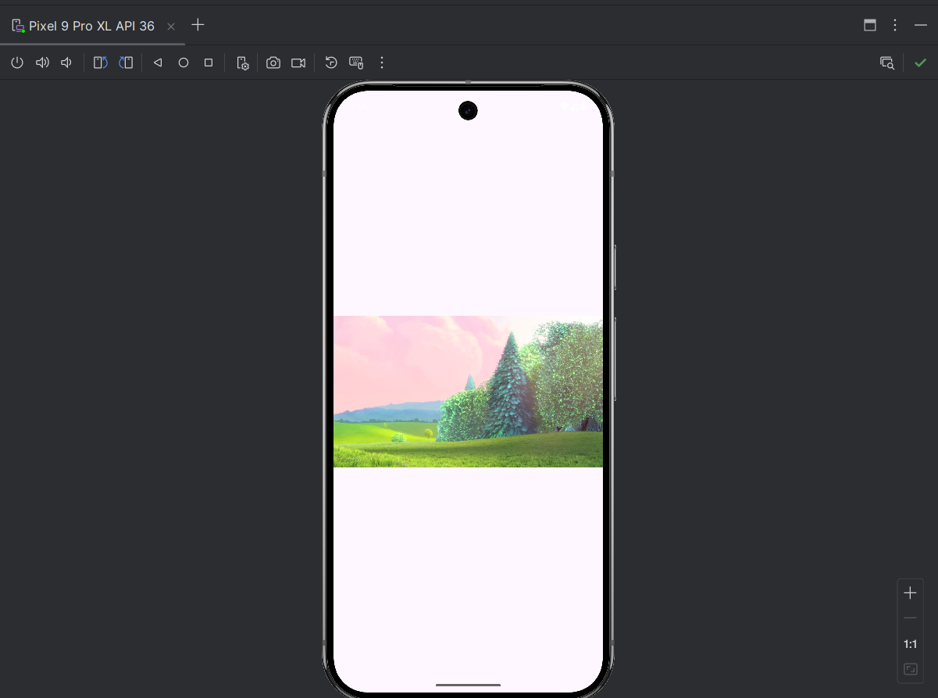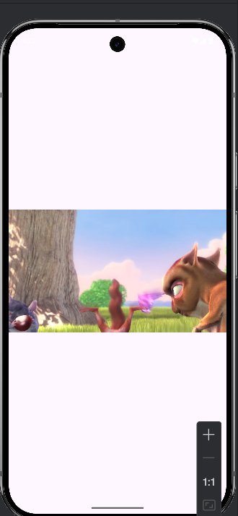

5.c Create the media API in android to play an audio file with a seekbar
Aim: To Create the media API in android to play an audio file with a seekbar
package com.example.audioplayer

import android.net.Uri
import android.os.Bundle
import androidx.activity.ComponentActivity
import androidx.activity.compose.setContent
import androidx.compose.foundation.layout.*
import androidx.compose.material3.*
import androidx.compose.runtime.*
import androidx.compose.ui.Alignment
import androidx.compose.ui.Modifier
import androidx.compose.ui.platform.LocalContext
import androidx.compose.ui.unit.dp
import androidx.media3.common.MediaItem
import androidx.media3.exoplayer.ExoPlayer
import kotlinx.coroutines.delay

class MainActivity : ComponentActivity() {
override fun onCreate(savedInstanceState: Bundle?) {
super.onCreate(savedInstanceState)
setContent {
MaterialTheme {
Surface(modifier = Modifier.fillMaxSize()) {
// Replace with your audio URL or local file URI
val audioUrl = "https://www.soundhelix.com/examples/mp3/SoundHelix-Song-1.mp3"
AudioPlayerScreen(audioUrl)
}
}
}
}
}

@Composable
fun AudioPlayerScreen(audioUrl: String) {
val context = LocalContext.current

// 1. Initialize ExoPlayer
val exoPlayer = remember {
ExoPlayer.Builder(context).build().apply {
val mediaItem = MediaItem.fromUri(Uri.parse(audioUrl))
setMediaItem(mediaItem)
prepare()
}
}

// 2. State for SeekBar and Time
var currentPosition by remember { mutableLongStateOf(0L) }
var totalDuration by remember { mutableLongStateOf(0L) }
var isPlaying by remember { mutableStateOf(false) }

// 3. Update SeekBar position every 500ms
LaunchedEffect(isPlaying) {
while (isPlaying) {
currentPosition = exoPlayer.currentPosition
totalDuration = exoPlayer.duration.coerceAtLeast(0L)
delay(500)
}
}

// Clean up player on dispose
DisposableEffect(Unit) {
onDispose { exoPlayer.release() }
}

Column(
modifier = Modifier.fillMaxSize().padding(20.dp),
verticalArrangement = Arrangement.Center,
horizontalAlignment = Alignment.CenterHorizontally
) {
Text(text = "Now Playing", style = MaterialTheme.typography.headlineMedium)

Spacer(modifier = Modifier.height(32.dp))

// 4. The SeekBar (Slider)
Slider(
value = currentPosition.toFloat(),
valueRange = 0f..totalDuration.toFloat().coerceAtLeast(1f),
onValueChange = { newPos ->
currentPosition = newPos.toLong()
exoPlayer.seekTo(currentPosition)
},
modifier = Modifier.fillMaxWidth()
)

Row(modifier = Modifier.fillMaxWidth(), horizontalArrangement = Arrangement.SpaceBetween) {
Text(text = formatTime(currentPosition))
Text(text = formatTime(totalDuration))
}

Spacer(modifier = Modifier.height(24.dp))

// 5. Play/Pause Button
Button(onClick = {
if (exoPlayer.isPlaying) {
exoPlayer.pause()
isPlaying = false
} else {
exoPlayer.play()
isPlaying = true
}
}) {
Text(if (isPlaying) "Pause" else "Play")
}
}
}

// Helper to format milliseconds to MM:SS
fun formatTime(ms: Long): String {
val seconds = (ms / 1000) % 60
val minutes = (ms / (1000 * 60)) % 60
return "%02d:%02d".format(minutes, seconds)
}
Output:
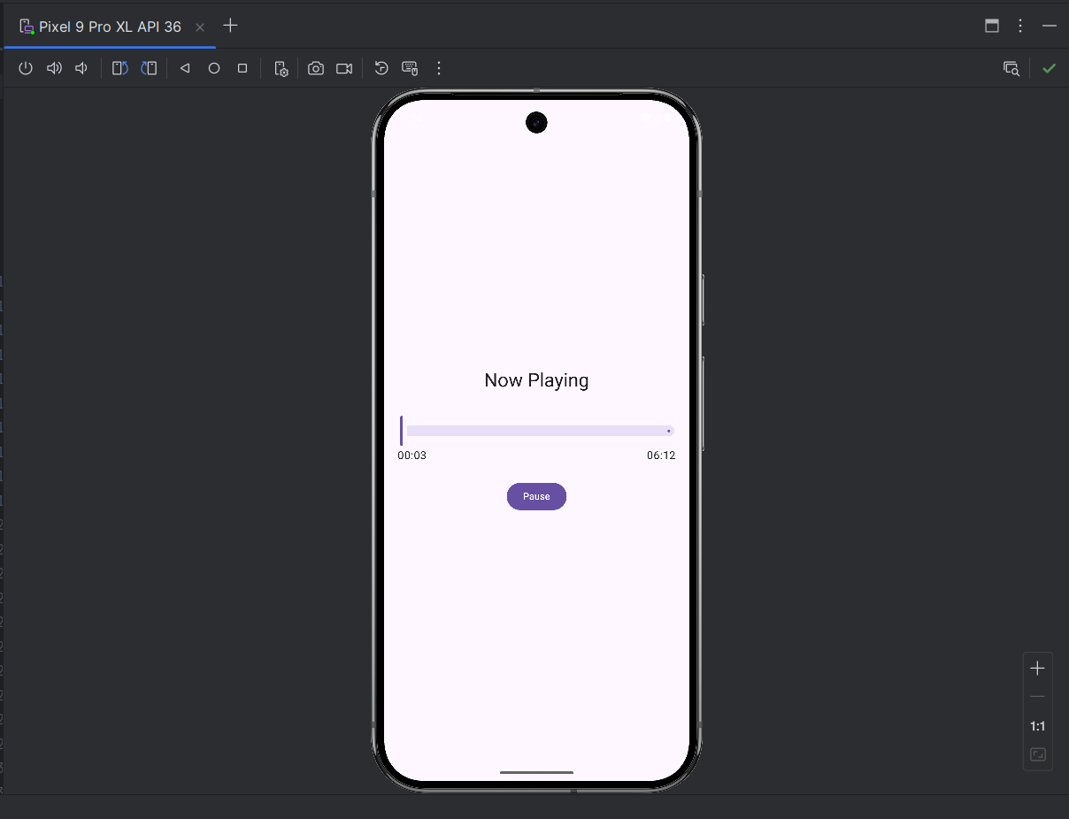

Q6Create an android application with two Fragments and load them on the click of Buttons. Display two Buttons and a FrameLayout in our Activity and perform setOnClickListener event on both Buttons. On the click of First Button replace the First Fragment and on click of Second Button replace the Second Fragment with the layout FrameLayout. In both Fragments display a TextView and a Button, and on click of Button, display the name of the Fragment with the help of Toast

Aim: To Create an android application with two Fragments and load them on the click of Buttons. Display two Buttons and a FrameLayout in our Activity and perform setOnClickListener event on both Buttons. On the click of First Button replace the First Fragment and on click of Second Button replace the Second Fragment with the layout FrameLayout. In both Fragments display a TextView and a Button, and on click of Button, display the name of the Fragment with the help of Toast.
Program:
import android.os.Bundle
import android.widget.Toast
import androidx.activity.ComponentActivity
import androidx.activity.compose.setContent
import androidx.compose.foundation.layout.*
import androidx.compose.material3.*
import androidx.compose.runtime.Composable
import androidx.compose.ui.Alignment
import androidx.compose.ui.Modifier
import androidx.compose.ui.platform.LocalContext
import androidx.compose.ui.unit.dp
import androidx.navigation.NavHostController
import androidx.navigation.compose.NavHost
import androidx.navigation.compose.composable
import androidx.navigation.compose.rememberNavController
class MainActivity : ComponentActivity() {
override fun onCreate(savedInstanceState: Bundle?) {
super.onCreate(savedInstanceState)
setContent {
MaterialTheme {
Surface(
modifier = Modifier.fillMaxSize(),
color = MaterialTheme.colorScheme.background
) {
MainScreen()
}
}
}
}
}
@Composable
fun MainScreen() {
val navController = rememberNavController()
Column(modifier = Modifier.fillMaxSize()) {
Row(
modifier = Modifier
.fillMaxWidth()
.padding(16.dp),
horizontalArrangement = Arrangement.SpaceEvenly
) {
Button(onClick = { navController.navigate("fragment1") }) {
Text("Load Fragment 1")
}
Button(onClick = { navController.navigate("fragment2") }) {
Text("Load Fragment 2")
}
}
Box(
modifier = Modifier
.fillMaxSize()
.weight(1f) // Takes up remaining space
) {
FragmentNavigationHost(navController)
}
}
}
@Composable
fun FragmentNavigationHost(navController: NavHostController) {
NavHost(navController = navController, startDestination = "fragment1") {
composable("fragment1") {
FragmentScreen(name = "team")
}
composable("fragment2") {
FragmentScreen(name = "Second Fragment")
}
}
}
@Composable
fun FragmentScreen(name: String) {
val context = LocalContext.current
Column(
modifier = Modifier.fillMaxSize(),
verticalArrangement = Arrangement.Center,
horizontalAlignment = Alignment.CenterHorizontally
) {
Text(text = "This is $name", style = MaterialTheme.typography.headlineMedium)
Spacer(modifier = Modifier.height(16.dp))
Button(onClick = {
Toast.makeText(context, name, Toast.LENGTH_SHORT).show()
}) {
Text("Show Toast")
}
}
}

Output:
