1.a Implementing UI Controls Create an android application for registration page, the registration information must include name, age, gender, date of birth, username and password. The input fields must take only the required data in a proper manner and the information must be stored. Create another page for login and the user must login earlier registration information.

Program:
package com.example.a1a
import android.content.Context
import android.os.Bundle
import android.widget.Toast
import androidx.activity.ComponentActivity
import androidx.activity.compose.setContent
import androidx.compose.foundation.layout.*
import androidx.compose.foundation.selection.selectable
import androidx.compose.foundation.text.KeyboardOptions
import androidx.compose.material3.*
import androidx.compose.runtime.*
import androidx.compose.ui.Alignment
import androidx.compose.ui.Modifier
import androidx.compose.ui.platform.LocalContext
import androidx.compose.ui.text.input.KeyboardType
import androidx.compose.ui.text.input.PasswordVisualTransformation
import androidx.compose.ui.unit.dp
class MainActivity : ComponentActivity() {
override fun onCreate(savedInstanceState: Bundle?) {
super.onCreate(savedInstanceState)
setContent {
AppNavigation()
}
}
}
enum class Screen {
Registration, Login
}
@Composable
fun AppNavigation() {
var currentScreen by remember { mutableStateOf(Screen.Registration) }
when (currentScreen) {
Screen.Registration -> RegistrationScreen(onNavigateToLogin = { currentScreen = Screen.Login })
Screen.Login -> LoginScreen()
}
}
@Composable
fun RegistrationScreen(onNavigateToLogin: () -> Unit) {
val context = LocalContext.current
var name by remember { mutableStateOf("") }
var age by remember { mutableStateOf("") }
var gender by remember { mutableStateOf("Male") }
var dob by remember { mutableStateOf("") }
var username by remember { mutableStateOf("") }
var password by remember { mutableStateOf("") }
val genderOptions = listOf("Male", "Female")
Column(
modifier = Modifier.fillMaxSize().padding(16.dp),
verticalArrangement = Arrangement.Center,
horizontalAlignment = Alignment.CenterHorizontally
) {
OutlinedTextField(value = name, onValueChange = { name = it }, label = { Text("Name") }, modifier = Modifier.fillMaxWidth())
Spacer(modifier = Modifier.height(8.dp))
OutlinedTextField(value = age, onValueChange = { age = it }, label = { Text("Age") }, keyboardOptions = KeyboardOptions(keyboardType = KeyboardType.Number), modifier = Modifier.fillMaxWidth())
Spacer(modifier = Modifier.height(8.dp))
Row(modifier = Modifier.fillMaxWidth(), verticalAlignment = Alignment.CenterVertically) {
genderOptions.forEach { text ->
Row(
Modifier.selectable(selected = (text == gender), onClick = { gender = text }).padding(8.dp),
verticalAlignment = Alignment.CenterVertically
) {
RadioButton(selected = (text == gender), onClick = { gender = text })
Text(text = text, modifier = Modifier.padding(start = 8.dp))
}
}
}
Spacer(modifier = Modifier.height(8.dp))
OutlinedTextField(value = dob, onValueChange = { dob = it }, label = { Text("Date of Birth (DD/MM/YYYY)") }, modifier = Modifier.fillMaxWidth())
Spacer(modifier = Modifier.height(8.dp))
OutlinedTextField(value = username, onValueChange = { username = it }, label = { Text("Username") }, modifier = Modifier.fillMaxWidth())
Spacer(modifier = Modifier.height(8.dp))
OutlinedTextField(value = password, onValueChange = { password = it }, label = { Text("Password") }, visualTransformation = PasswordVisualTransformation(), keyboardOptions = KeyboardOptions(keyboardType = KeyboardType.Password), modifier = Modifier.fillMaxWidth())
Spacer(modifier = Modifier.height(16.dp))
Button(
onClick = {
if (username.isEmpty() || password.isEmpty()) {
Toast.makeText(context, "Please fill required fields", Toast.LENGTH_SHORT).show()
} else {
val sharedPreferences = context.getSharedPreferences("UserPrefs", Context.MODE_PRIVATE)
sharedPreferences.edit().apply {
putString("name", name)
putString("age", age)
putString("gender", gender)
putString("dob", dob)
putString("username", username)
putString("password", password)
apply()
}
Toast.makeText(context, "Registered Successfully", Toast.LENGTH_SHORT).show()
onNavigateToLogin()
}
},
modifier = Modifier.fillMaxWidth()
) {
Text("Register")
}
}
}
@Composable
fun LoginScreen() {
val context = LocalContext.current
var username by remember { mutableStateOf("") }
var password by remember { mutableStateOf("") }
Column(
modifier = Modifier.fillMaxSize().padding(16.dp),
verticalArrangement = Arrangement.Center,
horizontalAlignment = Alignment.CenterHorizontally
) {
OutlinedTextField(value = username, onValueChange = { username = it }, label = { Text("Username") }, modifier = Modifier.fillMaxWidth())
Spacer(modifier = Modifier.height(8.dp))
OutlinedTextField(value = password, onValueChange = { password = it }, label = { Text("Password") }, visualTransformation = PasswordVisualTransformation(), keyboardOptions = KeyboardOptions(keyboardType = KeyboardType.Password), modifier = Modifier.fillMaxWidth())
Spacer(modifier = Modifier.height(16.dp))
Button(
onClick = {
val sharedPreferences = context.getSharedPreferences("UserPrefs", Context.MODE_PRIVATE)
val registeredUser = sharedPreferences.getString("username", "")
val registeredPass = sharedPreferences.getString("password", "")
if (username == registeredUser && password == registeredPass && username.isNotEmpty()) {
Toast.makeText(context, "Login Successful!", Toast.LENGTH_SHORT).show()
} else {
Toast.makeText(context, "Invalid Credentials", Toast.LENGTH_SHORT).show()
}
},
modifier = Modifier.fillMaxWidth()
) {
Text("Login")
}
}
}

file:-AndroidManifest.xml
program:
<?xml version="1.0" encoding="utf-8"?>
<manifest xmlns:android="http://schemas.android.com/apk/res/android"
xmlns:tools="http://schemas.android.com/tools" >
<application
android:allowBackup="true"
android:dataExtractionRules="@xml/data_extraction_rules"
android:fullBackupContent="@xml/backup_rules"
android:icon="@mipmap/ic_launcher"
android:label="@string/app_name"
android:roundIcon="@mipmap/ic_launcher_round"
android:supportsRtl="true"
android:theme="@style/Theme._1a" >
<activity
android:name=".MainActivity"
android:exported="true">
<intent-filter>
<action android:name="android.intent.action.MAIN" />
<category android:name="android.intent.category.LAUNCHER" />
</intent-filter>
</activity>
</application>
</manifest>

Output:

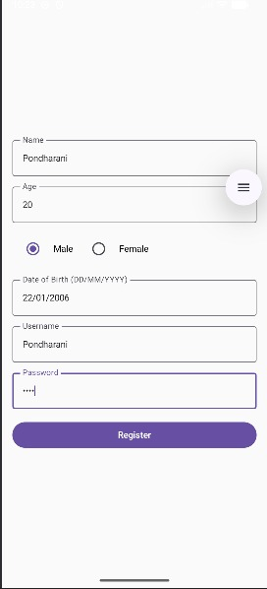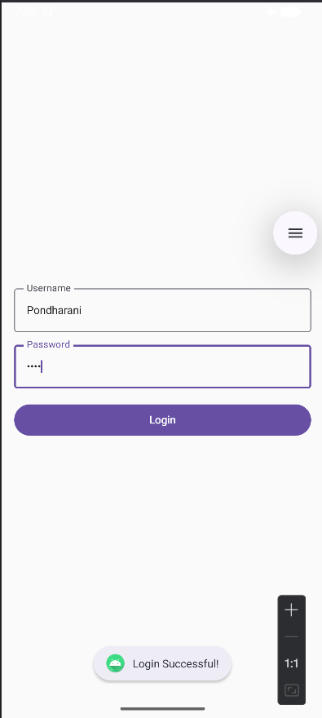

1.b Creating a Registration and Login Page (Linear Layout) Design a registration page to store user credentials and a login page for authentication. Upon login, the user's profile image should be displayed. Create an android application to pass the data from current application to another application using intent. Insert the new contents in the following resources and demonstrate their uses in the android application: Android Resources: (Color, Theme, String, Drawable, Dimension, Image)

Program:

package com.example.a1b
import android.content.Context
import android.content.Intent
import android.os.Bundle
import android.widget.Toast
import androidx.activity.ComponentActivity
import androidx.activity.compose.setContent
import androidx.compose.foundation.Image
import androidx.compose.foundation.background
import androidx.compose.foundation.layout.*
import androidx.compose.material.icons.Icons
import androidx.compose.material.icons.filled.Person
import androidx.compose.material3.*
import androidx.compose.runtime.*
import androidx.compose.ui.Alignment
import androidx.compose.ui.Modifier
import androidx.compose.ui.graphics.Color
import androidx.compose.ui.graphics.ColorFilter
import androidx.compose.ui.platform.LocalContext
import androidx.compose.ui.text.font.FontWeight
import androidx.compose.ui.text.input.PasswordVisualTransformation
import androidx.compose.ui.unit.dp
import androidx.compose.ui.unit.sp
// --- Pure Compose Resources (Replacing XML) ---
val MyPrimaryColor = Color(0xFF6200EE)
val MyBackgroundColor = Color(0xFFF5F5F5)
val PaddingStandard = 16.dp
val PaddingLarge = 32.dp
val ImageSize = 120.dp
val AppStrings = mapOf(
"title_register" to "Create Account",
"title_login" to "Welcome Back",
"prompt_username" to "Username",
"prompt_password" to "Password",
"btn_register" to "Register",
"btn_login" to "Login",
"btn_share" to "Share Profile to Another App"
)
// ----------------------------------------------
class MainActivity : ComponentActivity() {
override fun onCreate(savedInstanceState: Bundle?) {
super.onCreate(savedInstanceState)
setContent {
MaterialTheme {
AppNavigator()
}
}
}
}
enum class ScreenState {
REGISTER, LOGIN, PROFILE
}
@Composable
fun AppNavigator() {
var currentScreen by remember { mutableStateOf(ScreenState.REGISTER) }
var loggedInUser by remember { mutableStateOf("") }
when (currentScreen) {
ScreenState.REGISTER -> RegistrationScreen(
onNavigateToLogin = { currentScreen = ScreenState.LOGIN }
)
ScreenState.LOGIN -> LoginScreen(
onLoginSuccess = { username ->
loggedInUser = username
currentScreen = ScreenState.PROFILE
}
)
ScreenState.PROFILE -> ProfileScreen(
username = loggedInUser,
onLogout = { currentScreen = ScreenState.LOGIN }
)
}
}
@Composable
fun RegistrationScreen(onNavigateToLogin: () -> Unit) {
val context = LocalContext.current
var username by remember { mutableStateOf("") }
var password by remember { mutableStateOf("") }
Column(
modifier = Modifier
.fillMaxSize()
.background(MyBackgroundColor)
.padding(PaddingLarge),
verticalArrangement = Arrangement.Center,
horizontalAlignment = Alignment.CenterHorizontally
) {
Text(
text = AppStrings["title_register"] ?: "",
fontSize = 24.sp,
fontWeight = FontWeight.Bold,
color = MyPrimaryColor
)
Spacer(modifier = Modifier.height(PaddingStandard))
OutlinedTextField(
value = username,
onValueChange = { username = it },
label = { Text(AppStrings["prompt_username"] ?: "") },
modifier = Modifier.fillMaxWidth()
)
Spacer(modifier = Modifier.height(PaddingStandard))
OutlinedTextField(
value = password,
onValueChange = { password = it },
label = { Text(AppStrings["prompt_password"] ?: "") },
visualTransformation = PasswordVisualTransformation(),
modifier = Modifier.fillMaxWidth()
)
Spacer(modifier = Modifier.height(PaddingLarge))
Button(
onClick = {
if (username.isNotEmpty() && password.isNotEmpty()) {
val prefs = context.getSharedPreferences("AuthPrefs", Context.MODE_PRIVATE)
prefs.edit().putString(username, password).apply()
Toast.makeText(context, "Registered!", Toast.LENGTH_SHORT).show()
onNavigateToLogin()
} else {
Toast.makeText(context, "Fill all fields", Toast.LENGTH_SHORT).show()
}
},
colors = ButtonDefaults.buttonColors(containerColor = MyPrimaryColor),
modifier = Modifier.fillMaxWidth()
) {
Text(AppStrings["btn_register"] ?: "")
}
TextButton(onClick = onNavigateToLogin) {
Text("Already have an account? Login here.", color = MyPrimaryColor)
}
}
}
@Composable
fun LoginScreen(onLoginSuccess: (String) -> Unit) {
val context = LocalContext.current
var username by remember { mutableStateOf("") }
var password by remember { mutableStateOf("") }
Column(
modifier = Modifier
.fillMaxSize()
.background(MyBackgroundColor)
.padding(PaddingLarge),
verticalArrangement = Arrangement.Center,
horizontalAlignment = Alignment.CenterHorizontally
) {
Text(
text = AppStrings["title_login"] ?: "",
fontSize = 24.sp,
fontWeight = FontWeight.Bold,
color = MyPrimaryColor
)
Spacer(modifier = Modifier.height(PaddingStandard))
OutlinedTextField(
value = username,
onValueChange = { username = it },
label = { Text(AppStrings["prompt_username"] ?: "") },
modifier = Modifier.fillMaxWidth()
)
Spacer(modifier = Modifier.height(PaddingStandard))
OutlinedTextField(
value = password,
onValueChange = { password = it },
label = { Text(AppStrings["prompt_password"] ?: "") },
visualTransformation = PasswordVisualTransformation(),
modifier = Modifier.fillMaxWidth()
)
Spacer(modifier = Modifier.height(PaddingLarge))
Button(
onClick = {
val prefs = context.getSharedPreferences("AuthPrefs", Context.MODE_PRIVATE)
val savedPassword = prefs.getString(username, null)
if (savedPassword != null && savedPassword == password) {
Toast.makeText(context, "Login Success", Toast.LENGTH_SHORT).show()
onLoginSuccess(username)
} else {
Toast.makeText(context, "Invalid credentials", Toast.LENGTH_SHORT).show()
}
},
colors = ButtonDefaults.buttonColors(containerColor = MyPrimaryColor),
modifier = Modifier.fillMaxWidth()
) {
Text(AppStrings["btn_login"] ?: "")
}
}
}
@Composable
fun ProfileScreen(username: String, onLogout: () -> Unit) {
val context = LocalContext.current
Column(
modifier = Modifier
.fillMaxSize()
.padding(PaddingLarge),
verticalArrangement = Arrangement.Center,
horizontalAlignment = Alignment.CenterHorizontally
) {
// Utilizing Compose built-in Icons instead of a Drawable XML
Image(
imageVector = Icons.Default.Person,
contentDescription = "Profile Image",
modifier = Modifier.size(ImageSize),
colorFilter = ColorFilter.tint(MyPrimaryColor)
)
Spacer(modifier = Modifier.height(PaddingStandard))
Text(text = "Hello, $username!", fontSize = 28.sp, fontWeight = FontWeight.Medium)
Spacer(modifier = Modifier.height(PaddingLarge))
Button(
onClick = {
val sendIntent: Intent = Intent().apply {
action = Intent.ACTION_SEND
putExtra(Intent.EXTRA_TEXT, "Hello! My username on the new app is $username.")
type = "text/plain"
}
val shareIntent = Intent.createChooser(sendIntent, "Share your profile via...")
context.startActivity(shareIntent)
},
colors = ButtonDefaults.buttonColors(containerColor = MyPrimaryColor),
modifier = Modifier.fillMaxWidth()
) {
Text(AppStrings["btn_share"] ?: "")
}
Spacer(modifier = Modifier.height(8.dp))
TextButton(onClick = onLogout) {
Text("Logout", color = MyPrimaryColor)
}
}
}

Output:

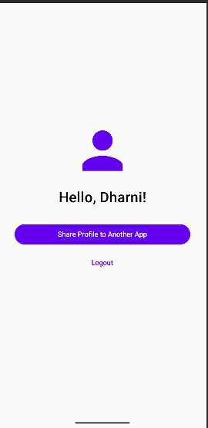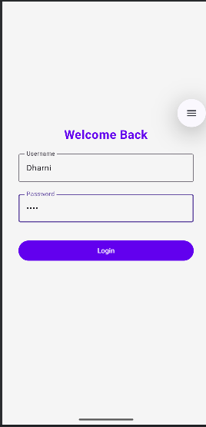
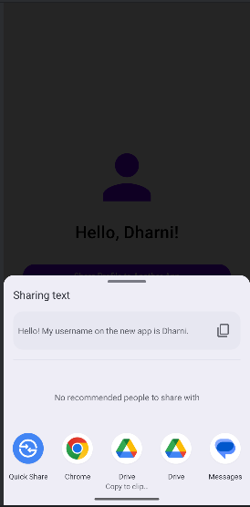

2.a Programs related to different Layouts
Create the standard calculator application in android using Grid Layout with following design
Program:
package com.example.a2a // Remember to keep your own package name!
import android.os.Bundle
import androidx.activity.ComponentActivity
import androidx.activity.compose.setContent
import androidx.compose.foundation.background
import androidx.compose.foundation.layout.*
import androidx.compose.foundation.lazy.grid.GridCells
import androidx.compose.foundation.lazy.grid.GridItemSpan
import androidx.compose.foundation.lazy.grid.LazyVerticalGrid
import androidx.compose.foundation.lazy.grid.items
import androidx.compose.material3.*
import androidx.compose.runtime.*
import androidx.compose.ui.Alignment
import androidx.compose.ui.Modifier
import androidx.compose.ui.graphics.Color
import androidx.compose.ui.text.font.FontWeight
import androidx.compose.ui.text.style.TextAlign
import androidx.compose.ui.unit.dp
import androidx.compose.ui.unit.sp
class MainActivity : ComponentActivity() {
override fun onCreate(savedInstanceState: Bundle?) {
super.onCreate(savedInstanceState)
setContent {
MaterialTheme {
CalculatorGridUI()
}
}
}
}
@Composable
fun CalculatorGridUI() {
var displayText by remember { mutableStateOf("0") }
var equationText by remember { mutableStateOf("") } // NEW: Shows the operator and first number
var operand1 by remember { mutableStateOf("") }
var operator by remember { mutableStateOf("") }
var isNewOp by remember { mutableStateOf(true) }
val calculatorButtons = listOf(
"DEL", "C", "%", "+",
"1", "2", "3", "/",
"4", "5", "6", "-",
"7", "8", "9", "X",
"0", ".", "="
)
fun calculateResult() {
if (operand1.isNotEmpty() && operator.isNotEmpty() && !isNewOp) {
val num1 = operand1.toDoubleOrNull() ?: 0.0
val num2 = displayText.toDoubleOrNull() ?: 0.0
var result = 0.0
when (operator) {
"+" -> result = num1 + num2
"-" -> result = num1 - num2
"X" -> result = num1 * num2
"/" -> result = if (num2 != 0.0) num1 / num2 else Double.NaN
}
// Remove decimal if it's a whole number
displayText = if (result % 1.0 == 0.0) {
result.toLong().toString()
} else {
result.toString()
}
operand1 = ""
operator = ""
equationText = "" // Clear the sub-screen after equals
isNewOp = true
}
}
Column(
modifier = Modifier
.fillMaxSize()
.padding(16.dp),
verticalArrangement = Arrangement.Bottom
) {
// --- THE DISPLAY SCREEN ---
Column(
modifier = Modifier
.fillMaxWidth()
.weight(1f)
.background(Color(0xFFB0BEC5))
.padding(16.dp),
verticalArrangement = Arrangement.Bottom,
horizontalAlignment = Alignment.End
) {
// Sub-display for showing the operator (e.g., "12 +")
Text(
text = equationText,
fontSize = 24.sp,
color = Color.DarkGray.copy(alpha = 0.7f), // Slightly faded
textAlign = TextAlign.End,
modifier = Modifier.fillMaxWidth()
)
Spacer(modifier = Modifier.height(8.dp))
// Main display for current numbers
Text(
text = displayText,
fontSize = 48.sp,
color = Color.DarkGray,
textAlign = TextAlign.End,
modifier = Modifier.fillMaxWidth()
)
}
Spacer(modifier = Modifier.height(16.dp))
// --- THE BUTTON GRID ---
LazyVerticalGrid(
columns = GridCells.Fixed(4),
horizontalArrangement = Arrangement.spacedBy(8.dp),
verticalArrangement = Arrangement.spacedBy(8.dp),
modifier = Modifier.fillMaxWidth()
) {
items(calculatorButtons, span = { button ->
if (button == "=") GridItemSpan(2) else GridItemSpan(1)
}) { buttonText ->
Button(
onClick = {
when (buttonText) {
"C" -> {
displayText = "0"
equationText = ""
operand1 = ""
operator = ""
isNewOp = true
}
"DEL" -> {
// FIXED: Now it always deletes the last character
if (displayText != "0") {
displayText = if (displayText.length > 1) displayText.dropLast(1) else "0"
if (displayText == "0") isNewOp = true
}
}
"%" -> {
val currentNum = displayText.toDoubleOrNull() ?: 0.0
displayText = (currentNum / 100).toString()
isNewOp = true
}
"+", "-", "X", "/" -> {
// Chain calculations if they press 5 + 5 +
if (operator.isNotEmpty() && !isNewOp) {
calculateResult()
}
operand1 = displayText
operator = buttonText
equationText = "$operand1 $operator" // Updates the sub-screen!
isNewOp = true
}
"=" -> {
calculateResult()
}
"." -> {
if (isNewOp) {
displayText = "0."
isNewOp = false
} else if (!displayText.contains(".")) {
displayText += "."
}
}
else -> { // When a number is pressed
if (isNewOp || displayText == "0") {
displayText = buttonText
isNewOp = false
} else {
displayText += buttonText
}
}
}
},
modifier = Modifier.height(64.dp),
colors = ButtonDefaults.buttonColors(containerColor = Color(0xFFE0E0E0)),
shape = MaterialTheme.shapes.small
) {
Text(
text = buttonText,
fontSize = 20.sp,
color = Color.Black,
fontWeight = FontWeight.Bold
)
}
}
}
}
}
Output:-
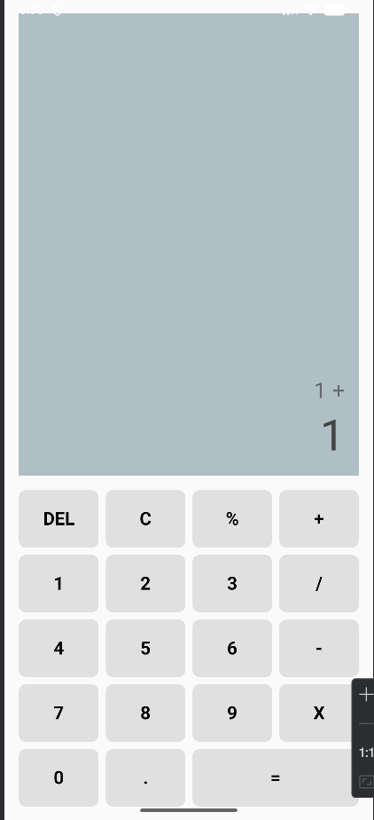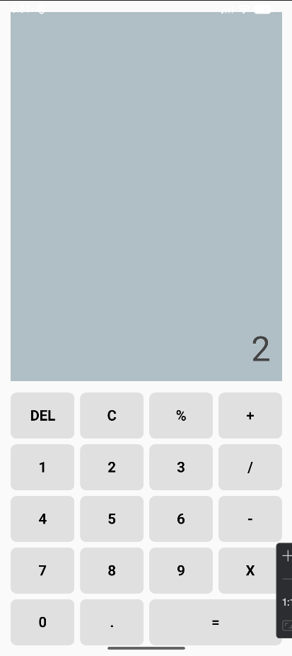

2.b Implementing a Shopping Cart (Grid Layout) Create a shopping cart that displays product images, descriptions, and a quantity selector. The total amount should update dynamically based on selected products.
Program:
package com.example.b2
import android.os.Bundle
import androidx.activity.ComponentActivity
import androidx.activity.compose.setContent
import androidx.compose.foundation.Image
import androidx.compose.foundation.background
import androidx.compose.foundation.layout.*
import androidx.compose.foundation.lazy.grid.GridCells
import androidx.compose.foundation.lazy.grid.LazyVerticalGrid
import androidx.compose.foundation.lazy.grid.items
import androidx.compose.foundation.shape.RoundedCornerShape
import androidx.compose.material3.*
import androidx.compose.runtime.*
import androidx.compose.ui.Alignment
import androidx.compose.ui.Modifier
import androidx.compose.ui.draw.clip
import androidx.compose.ui.graphics.Color
import androidx.compose.ui.layout.ContentScale
import androidx.compose.ui.res.painterResource
import androidx.compose.ui.text.font.FontWeight
import androidx.compose.ui.text.style.TextAlign
import androidx.compose.ui.text.style.TextOverflow
import androidx.compose.ui.unit.dp
import androidx.compose.ui.unit.sp
data class Product(
val id: Int,
val name: String,
val description: String,
val price: Double,
val imageResId: Int,
val quantity: Int = 0
)
class MainActivity : ComponentActivity() {
override fun onCreate(savedInstanceState: Bundle?) {
super.onCreate(savedInstanceState)
setContent {
MaterialTheme {
ShoppingCartScreen()
}
}
}
}
@OptIn(ExperimentalMaterial3Api::class)
@Composable
fun ShoppingCartScreen() {
val products = remember {
mutableStateListOf(
Product(1, "VR Headset", "Zero-gravity training simulator gear", 299.99, R.drawable.vr, 0),
Product(2, "Riding Gloves", "Protective gear for motorcycle riding", 45.50, R.drawable.gloves, 0),
Product(3, "2.5kg Dumbbells", "Pair of hex weights", 15.00, R.drawable.weights, 0),
Product(4, "USB-C Adapter", "Multi-port hub for laptops", 32.99, R.drawable.usb, 0)
)
}
val totalAmount = products.sumOf { it.price * it.quantity }
Scaffold(
topBar = {
TopAppBar(
title = { Text("Shopping Cart") },
colors = TopAppBarDefaults.topAppBarColors(
containerColor = Color(0xFF6200EE),
titleContentColor = Color.White
)
)
},
bottomBar = {
Surface(
color = Color(0xFFF5F5F5),
shadowElevation = 8.dp
) {
Row(
modifier = Modifier
.fillMaxWidth()
.padding(16.dp),
horizontalArrangement = Arrangement.SpaceBetween,
verticalAlignment = Alignment.CenterVertically
) {
Text("Total:", fontSize = 24.sp, fontWeight = FontWeight.Bold)
Text(
text = String.format(java.util.Locale.US, "$%.2f", totalAmount),
fontSize = 24.sp,
fontWeight = FontWeight.Bold,
color = Color(0xFF6200EE)
)
}
}
}
) { paddingValues ->
LazyVerticalGrid(
columns = GridCells.Fixed(2),
contentPadding = PaddingValues(8.dp),
modifier = Modifier
.fillMaxSize()
.padding(paddingValues)
) {
items(products) { product ->
ProductCard(
product = product,
onQuantityChange = { newQuantity ->
val index = products.indexOf(product)
if (index != -1) {
products[index] = product.copy(quantity = newQuantity)
}
}
)
}
}
}
}
@Composable
fun ProductCard(product: Product, onQuantityChange: (Int) -> Unit) {
Card(
modifier = Modifier
.padding(8.dp)
.fillMaxWidth(),
elevation = CardDefaults.cardElevation(defaultElevation = 4.dp),
colors = CardDefaults.cardColors(containerColor = Color.White)
) {
Column(
modifier = Modifier.padding(12.dp),
horizontalAlignment = Alignment.CenterHorizontally
) {
Image(
painter = painterResource(id = product.imageResId),
contentDescription = product.name,
contentScale = ContentScale.Crop,
modifier = Modifier
.size(100.dp)
.clip(RoundedCornerShape(8.dp))
.background(Color(0xFFE0E0E0))
)
Spacer(modifier = Modifier.height(8.dp))
Text(
text = product.name,
fontWeight = FontWeight.Bold,
fontSize = 16.sp,
maxLines = 1,
overflow = TextOverflow.Ellipsis
)
Text(
text = product.description,
fontSize = 12.sp,
color = Color.Gray,
maxLines = 2,
overflow = TextOverflow.Ellipsis,
textAlign = TextAlign.Center,
modifier = Modifier.height(36.dp)
)
Spacer(modifier = Modifier.height(8.dp))
Text(
text = String.format(java.util.Locale.US, "$%.2f", product.price),
fontWeight = FontWeight.Bold,
color = Color(0xFF6200EE)
)
Spacer(modifier = Modifier.height(8.dp))
Row(
verticalAlignment = Alignment.CenterVertically,
horizontalArrangement = Arrangement.SpaceEvenly,
modifier = Modifier.fillMaxWidth()
) {
OutlinedButton(
onClick = { if (product.quantity > 0) onQuantityChange(product.quantity - 1) },
modifier = Modifier.size(36.dp),
contentPadding = PaddingValues(0.dp)
) {
Text("-", fontSize = 18.sp)
}
Text(
text = product.quantity.toString(),
fontSize = 18.sp,
fontWeight = FontWeight.Bold,
modifier = Modifier.padding(horizontal = 12.dp)
)
OutlinedButton(
onClick = { onQuantityChange(product.quantity + 1) },
modifier = Modifier.size(36.dp),
contentPadding = PaddingValues(0.dp)
) {
Text("+", fontSize = 18.sp)
}
}
}
}
}
Output:
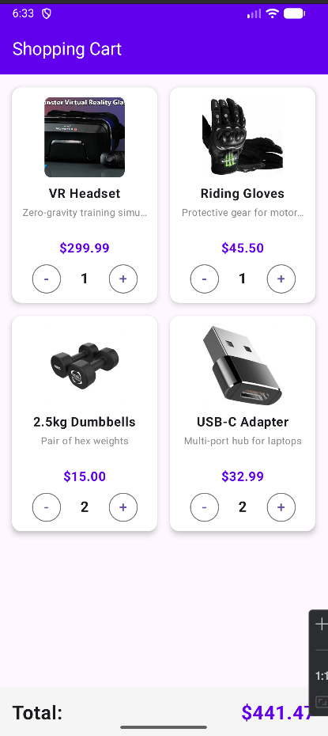
3. Notifications, Programming Security, permissions, and Telephone API 3.a Create an android application which automatically notify the user when Aeroplane mode is turned on or off using broadcast receiver.
Program:

package com.example.a3
import android.content.BroadcastReceiver
import android.content.Context
import android.content.Intent
import android.content.IntentFilter
import android.os.Bundle
import android.widget.Toast
import androidx.activity.ComponentActivity
import androidx.activity.compose.setContent
import androidx.compose.foundation.layout.*
import androidx.compose.material.icons.Icons
import androidx.compose.material.icons.filled.Warning
import androidx.compose.material3.*
import androidx.compose.runtime.*
import androidx.compose.ui.Alignment
import androidx.compose.ui.Modifier
import androidx.compose.ui.graphics.Color
import androidx.compose.ui.platform.LocalContext
import androidx.compose.ui.text.font.FontWeight
import androidx.compose.ui.unit.dp
import androidx.compose.ui.unit.sp
class MainActivity : ComponentActivity() {
override fun onCreate(savedInstanceState: Bundle?) {
super.onCreate(savedInstanceState)
setContent {
MaterialTheme {
Surface(
modifier = Modifier.fillMaxSize(),
color = MaterialTheme.colorScheme.background
) {
AirplaneModeScreen()
}
}
}
}
}
@Composable
fun AirplaneModeScreen() {
val context = LocalContext.current
// State to hold the current status so the UI updates automatically
var airplaneModeStatus by remember { mutableStateOf("Waiting for changes...") }
// DisposableEffect handles the lifecycle of the BroadcastReceiver
DisposableEffect(context) {
// 1. Create the BroadcastReceiver
val airplaneModeReceiver = object : BroadcastReceiver() {
override fun onReceive(context: Context, intent: Intent) {
if (intent.action == Intent.ACTION_AIRPLANE_MODE_CHANGED) {
// The intent contains a boolean "state" indicating if it was turned on or off
val isTurnedOn = intent.getBooleanExtra("state", false)
airplaneModeStatus = if (isTurnedOn) "Turned ON" else "Turned OFF"
// Automatically notify the user via a Toast message
Toast.makeText(
context,
"Airplane Mode is $airplaneModeStatus",
Toast.LENGTH_SHORT
).show()
}
}
}
// 2. Register the receiver to listen specifically for Airplane Mode changes
val filter = IntentFilter(Intent.ACTION_AIRPLANE_MODE_CHANGED)
context.registerReceiver(airplaneModeReceiver, filter)
// 3. Clean up the receiver when the composable leaves the screen
onDispose {
context.unregisterReceiver(airplaneModeReceiver)
}
}
// --- Simple UI to display the status ---
Column(
modifier = Modifier.fillMaxSize(),
verticalArrangement = Arrangement.Center,
horizontalAlignment = Alignment.CenterHorizontally
) {
Icon(
imageVector = Icons.Default.Warning,
contentDescription = "Status Icon",
modifier = Modifier.size(64.dp),
tint = Color(0xFF6200EE)
)
Spacer(modifier = Modifier.height(16.dp))
Text(
text = "Airplane Mode Status:",
fontSize = 20.sp,
color = Color.Gray
)
Spacer(modifier = Modifier.height(8.dp))
Text(
text = airplaneModeStatus,
fontSize = 28.sp,
fontWeight = FontWeight.Bold,
color = if (airplaneModeStatus.contains("ON")) Color.Red else Color.DarkGray
)
Spacer(modifier = Modifier.height(32.dp))
Text(
text = "Pull down your quick settings and toggle Airplane Mode to test this.",
fontSize = 14.sp,
color = Color.Gray,
modifier = Modifier.padding(horizontal = 32.dp),
textAlign = androidx.compose.ui.text.style.TextAlign.Center
)
}
}
Output:
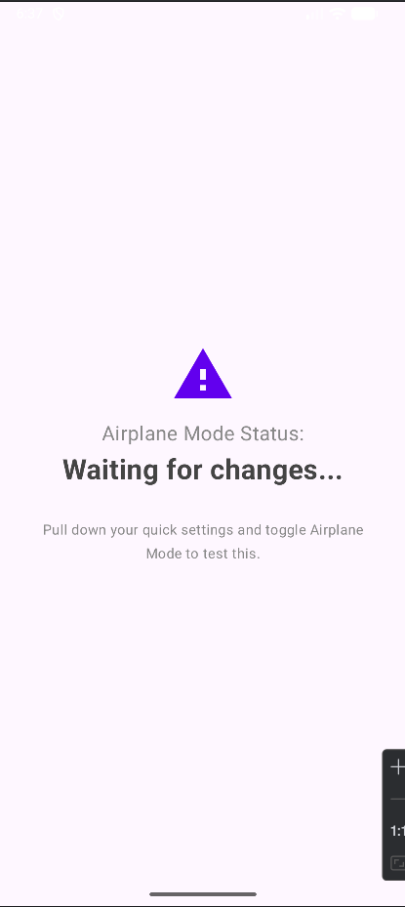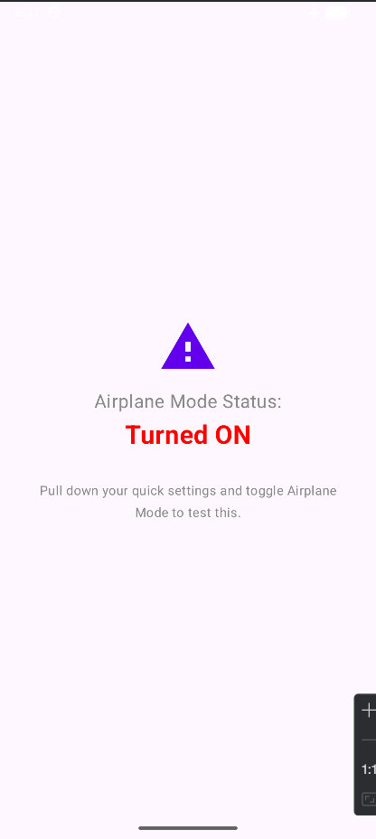

3.b Create an android application to display Alert Dialog on pressing the Back button.
package com.example.b3
import android.app.Activity
import android.os.Bundle
import androidx.activity.ComponentActivity
import androidx.activity.compose.BackHandler
import androidx.activity.compose.setContent
import androidx.compose.foundation.layout.*
import androidx.compose.material3.*
import androidx.compose.runtime.*
import androidx.compose.ui.Alignment
import androidx.compose.ui.Modifier
import androidx.compose.ui.platform.LocalContext
import androidx.compose.ui.text.font.FontWeight
import androidx.compose.ui.unit.dp
import androidx.compose.ui.unit.sp
class MainActivity : ComponentActivity() {
override fun onCreate(savedInstanceState: Bundle?) {
super.onCreate(savedInstanceState)
setContent {
MaterialTheme {
Surface(
modifier = Modifier.fillMaxSize(),
color = MaterialTheme.colorScheme.background
) {
BackButtonAlertScreen()
}
}
}
}
}
@Composable
fun BackButtonAlertScreen() {
var showDialog by remember { mutableStateOf(false) }
val activity = (LocalContext.current as? Activity)
BackHandler(enabled = true) {
showDialog = true
}
if (showDialog) {
AlertDialog(
onDismissRequest = { showDialog = false },
title = {
Text(text = "Exit Application", fontWeight = FontWeight.Bold)
},
text = {
Text(text = "Are you sure you want to exit the app?")
},
confirmButton = {
TextButton(onClick = {
showDialog = false
activity?.finish()
}) {
Text("Yes")
}
},
dismissButton = {
TextButton(onClick = {
showDialog = false
}) {
Text("No")
}
}
)
}
Column(
modifier = Modifier.fillMaxSize(),
verticalArrangement = Arrangement.Center,
horizontalAlignment = Alignment.CenterHorizontally
) {
Text(
text = "Press the Back Button",
fontSize = 24.sp,
fontWeight = FontWeight.Medium
)
Spacer(modifier = Modifier.height(16.dp))
Text(
text = "An alert dialog will appear before exiting.",
color = MaterialTheme.colorScheme.onSurfaceVariant
)
}
}
Output:
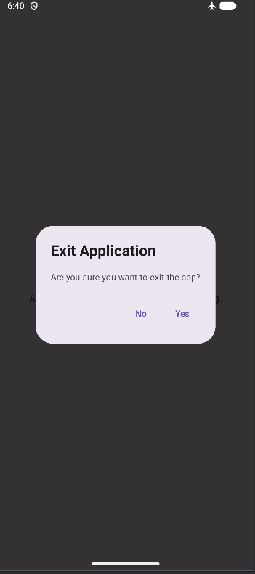
3.c Create an android application with four buttons and each will request permission to access the device data such as user's contact, calendar, camera, and media gallery.
Program:
package com.example.c3
import android.Manifest
import android.os.Bundle
import android.widget.Toast
import androidx.activity.ComponentActivity
import androidx.activity.compose.rememberLauncherForActivityResult
import androidx.activity.compose.setContent
import androidx.activity.result.contract.ActivityResultContracts
import androidx.compose.foundation.layout.*
import androidx.compose.material3.*
import androidx.compose.runtime.Composable
import androidx.compose.ui.Alignment
import androidx.compose.ui.Modifier
import androidx.compose.ui.platform.LocalContext
import androidx.compose.ui.unit.dp
import androidx.compose.ui.unit.sp
class MainActivity : ComponentActivity() {
override fun onCreate(savedInstanceState: Bundle?) {
super.onCreate(savedInstanceState)
setContent {
MaterialTheme {
Surface(
modifier = Modifier.fillMaxSize(),
color = MaterialTheme.colorScheme.background
) {
PermissionsScreen()
}
}
}
}
}
@Composable
fun PermissionsScreen() {
val context = LocalContext.current
val contactsLauncher = rememberLauncherForActivityResult(
ActivityResultContracts.RequestPermission()
) { isGranted ->
val msg = if (isGranted) "Contacts Permission Granted" else "Contacts Permission Denied"
Toast.makeText(context, msg, Toast.LENGTH_SHORT).show()
}
val calendarLauncher = rememberLauncherForActivityResult(
ActivityResultContracts.RequestPermission()
) { isGranted ->
val msg = if (isGranted) "Calendar Permission Granted" else "Calendar Permission Denied"
Toast.makeText(context, msg, Toast.LENGTH_SHORT).show()
}
val cameraLauncher = rememberLauncherForActivityResult(
ActivityResultContracts.RequestPermission()
) { isGranted ->
val msg = if (isGranted) "Camera Permission Granted" else "Camera Permission Denied"
Toast.makeText(context, msg, Toast.LENGTH_SHORT).show()
}
val galleryLauncher = rememberLauncherForActivityResult(
ActivityResultContracts.RequestPermission()
) { isGranted ->
val msg = if (isGranted) "Gallery Permission Granted" else "Gallery Permission Denied"
Toast.makeText(context, msg, Toast.LENGTH_SHORT).show()
}
Column(
modifier = Modifier.fillMaxSize(),
verticalArrangement = Arrangement.Center,
horizontalAlignment = Alignment.CenterHorizontally
) {
Text(
text = "Request Device Permissions",
fontSize = 20.sp,
modifier = Modifier.padding(bottom = 32.dp)
)
Button(
onClick = { contactsLauncher.launch(Manifest.permission.READ_CONTACTS) },
modifier = Modifier.fillMaxWidth(0.7f).padding(8.dp)
) {
Text("Request Contacts")
}
Button(
onClick = { calendarLauncher.launch(Manifest.permission.READ_CALENDAR) },
modifier = Modifier.fillMaxWidth(0.7f).padding(8.dp)
) {
Text("Request Calendar")
}
Button(
onClick = { cameraLauncher.launch(Manifest.permission.CAMERA) },
modifier = Modifier.fillMaxWidth(0.7f).padding(8.dp)
) {
Text("Request Camera")
}
Button(
onClick = { galleryLauncher.launch(Manifest.permission.READ_EXTERNAL_STORAGE) },
modifier = Modifier.fillMaxWidth(0.7f).padding(8.dp)
) {
Text("Request Gallery")
}
}
}

File2:Andorid manifest.xml:

<?xml version="1.0" encoding="utf-8"?>
<manifest xmlns:android="http://schemas.android.com/apk/res/android"
xmlns:tools="http://schemas.android.com/tools">
<uses-permission android:name="android.permission.READ_CONTACTS" />
<uses-permission android:name="android.permission.READ_CALENDAR" />
<uses-permission android:name="android.permission.CAMERA" />
<uses-permission android:name="android.permission.READ_EXTERNAL_STORAGE" />
<uses-permission android:name="android.permission.READ_MEDIA_IMAGES" />
<application
android:allowBackup="true"
android:dataExtractionRules="@xml/data_extraction_rules"
android:fullBackupContent="@xml/backup_rules"
android:icon="@mipmap/ic_launcher"
android:label="@string/app_name"
android:roundIcon="@mipmap/ic_launcher_round"
android:supportsRtl="true"
android:theme="@style/Theme.C3">
<activity
android:name=".MainActivity"
android:exported="true"
android:label="@string/app_name"
android:theme="@style/Theme.C3">
<intent-filter>
<action android:name="android.intent.action.MAIN" />
<category android:name="android.intent.category.LAUNCHER" />
</intent-filter>
</activity>
</application>
</manifest>

Output:
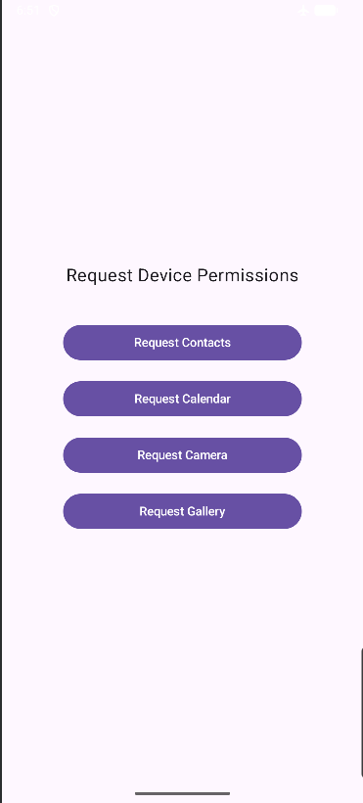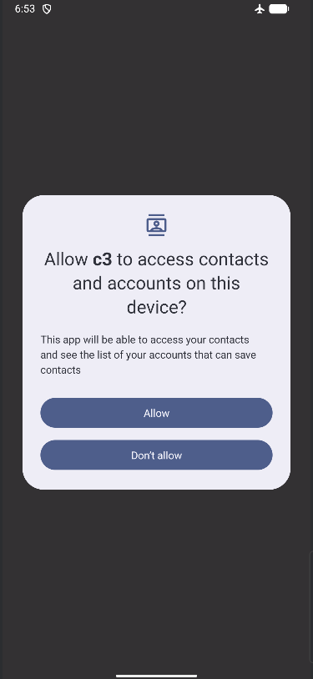

3.d Create the Telephone API in android application to make a call in predefined 15 contact numbers (the contact number is inserted through the code, do not import the contact from user's contact list).
package com.example.d3 // Change to your actual package name
import android.content.Intent
import android.net.Uri
import android.os.Bundle
import androidx.activity.ComponentActivity
import androidx.activity.compose.setContent
import androidx.compose.foundation.layout.*
import androidx.compose.foundation.lazy.LazyColumn
import androidx.compose.foundation.lazy.items
import androidx.compose.material.icons.Icons
import androidx.compose.material.icons.filled.Call
import androidx.compose.material3.*
import androidx.compose.runtime.Composable
import androidx.compose.ui.Alignment
import androidx.compose.ui.Modifier
import androidx.compose.ui.graphics.Color
import androidx.compose.ui.platform.LocalContext
import androidx.compose.ui.text.font.FontWeight
import androidx.compose.ui.unit.dp
import androidx.compose.ui.unit.sp
import androidx.compose.foundation.background
import androidx.compose.foundation.shape.CircleShape
// 1. Data class to hold our contact structure
data class Contact(val id: Int, val name: String, val phoneNumber: String)
class MainActivity : ComponentActivity() {
override fun onCreate(savedInstanceState: Bundle?) {
super.onCreate(savedInstanceState)
setContent {
MaterialTheme {
Surface(
modifier = Modifier.fillMaxSize(),
color = MaterialTheme.colorScheme.background
) {
TelephoneScreen()
}
}
}
}
}
@OptIn(ExperimentalMaterial3Api::class)
@Composable
fun TelephoneScreen() {
val context = LocalContext.current
// 2. The 15 hardcoded, predefined contacts
val contactList = listOf(
Contact(1, "Alice Smith", "+15550100001"),
Contact(2, "Bob Johnson", "+15550100002"),
Contact(3, "Charlie Brown", "+15550100003"),
Contact(4, "Diana Prince", "+15550100004"),
Contact(5, "Evan Davis", "+15550100005"),
Contact(6, "Fiona Garcia", "+15550100006"),
Contact(7, "George Miller", "+15550100007"),
Contact(8, "Hannah Wilson", "+15550100008"),
Contact(9, "Ian Moore", "+15550100009"),
Contact(10, "Julia Taylor", "+15550100010"),
Contact(11, "Kevin Anderson", "+15550100011"),
Contact(12, "Laura Thomas", "+15550100012"),
Contact(13, "Michael Jackson", "+15550100013"),
Contact(14, "Nina White", "+15550100014"),
Contact(15, "Oliver Harris", "+15550100015")
)
Scaffold(
topBar = {
TopAppBar(
title = { Text("Predefined Contacts") },
colors = TopAppBarDefaults.topAppBarColors(
containerColor = Color(0xFF1976D2),
titleContentColor = Color.White
)
)
}
) { paddingValues ->
// 3. Displaying the contacts in a scrollable list
LazyColumn(
contentPadding = PaddingValues(16.dp),
verticalArrangement = Arrangement.spacedBy(8.dp),
modifier = Modifier
.fillMaxSize()
.padding(paddingValues)
) {
items(contactList) { contact ->
ContactCard(contact = contact) {
// 4. The Telephone API Intent
// ACTION_DIAL opens the dialer with the number pre-filled.
val intent = Intent(Intent.ACTION_DIAL).apply {
data = Uri.parse("tel:${contact.phoneNumber}")
}
context.startActivity(intent)
}
}
}
}
}
@Composable
fun ContactCard(contact: Contact, onCallClick: () -> Unit) {
Card(
modifier = Modifier.fillMaxWidth(),
elevation = CardDefaults.cardElevation(defaultElevation = 2.dp),
colors = CardDefaults.cardColors(containerColor = Color.White)
) {
Row(
modifier = Modifier
.fillMaxWidth()
.padding(16.dp),
verticalAlignment = Alignment.CenterVertically,
horizontalArrangement = Arrangement.SpaceBetween
) {
Column {
Text(
text = contact.name,
fontSize = 18.sp,
fontWeight = FontWeight.Bold
)
Spacer(modifier = Modifier.height(4.dp))
Text(
text = contact.phoneNumber,
fontSize = 14.sp,
color = Color.Gray
)
}
// The Call Button
IconButton(
onClick = onCallClick,
modifier = Modifier
.size(48.dp)
.background(Color(0xFFE3F2FD), shape = CircleShape)
) {
Icon(
imageVector = Icons.Default.Call,
contentDescription = "Call ${contact.name}",
tint = Color(0xFF1976D2)
)
}
}
}
}

Output:
