JSP

1. Introduction
2. JSP Lifecycle
3. JSP Elements
4. JSP Directives
5. JSP Page Directive
6. JSP Include Directive
7. JSP Taglib Directive
8. JSP Scripting elements
9. Declarations
10. Scriptlets
11. Expression
12. JSP Implicit Objects
13. JSP Scopes
14. page scope
15. request scope
16. session scope
17. application scope
18. JSP Actions
19. JSP Standard Actions
20. JSP Custom Actions
21. JSTL (JSP Standard Tag Library)
22. Core Tag
23. Formatted Tags[I18N Tags]
24. SQL Tags
25. Functions Tags
26. XML Tags
27. Expression Language
28. **Introduction:**

* In web applications, two types of responses.

1. Static Response
2. Dynamic Response
3. **Static Response:**

* If we generate any response from server without performing any action or without executing any response at server machine then response is called as Static Response.

Ex:- If we submit request to Server for an HTML file then Server will send the Content of the respective HTML file as response to the respective client with out executing any resource or with out performing any action at server machine.

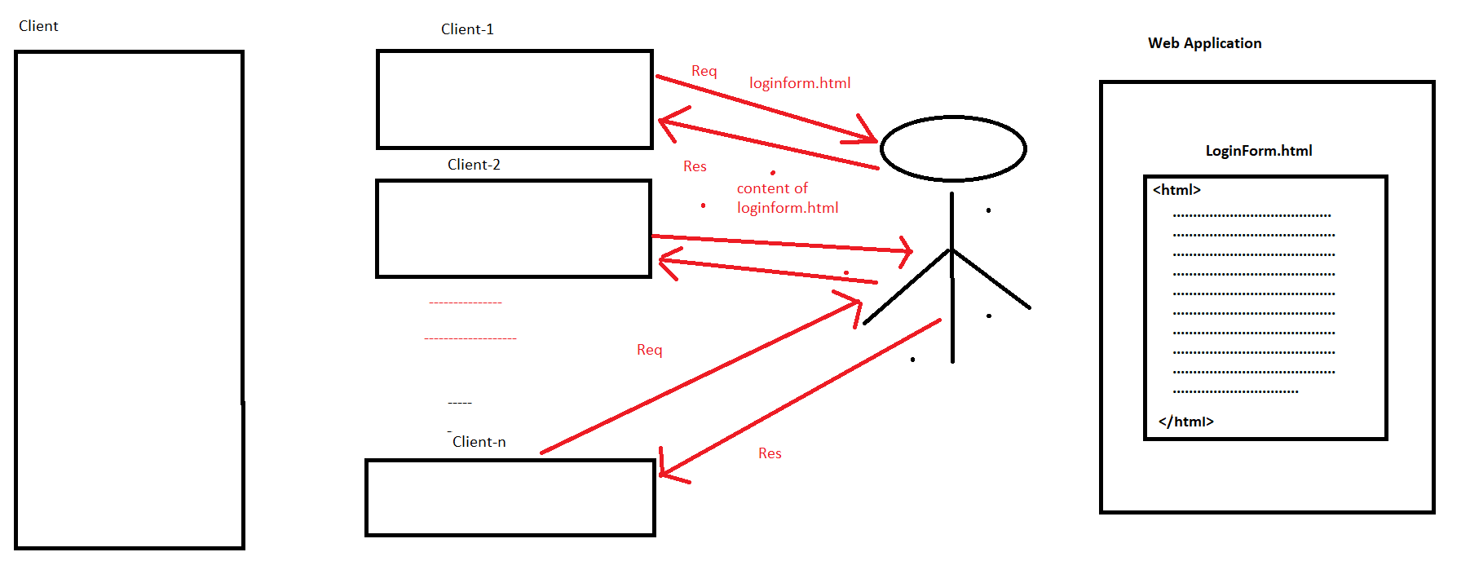

1. **Dynamic Response:**

* If we generate any response from Server by executing a particular resource at server machine and by performing a particular action at server machine then that response is called as Dynamic response.

Ex:- If we submit any request to a servlet or a filter or JSP page then server will execute them at machine and server will generate response to the respective client.

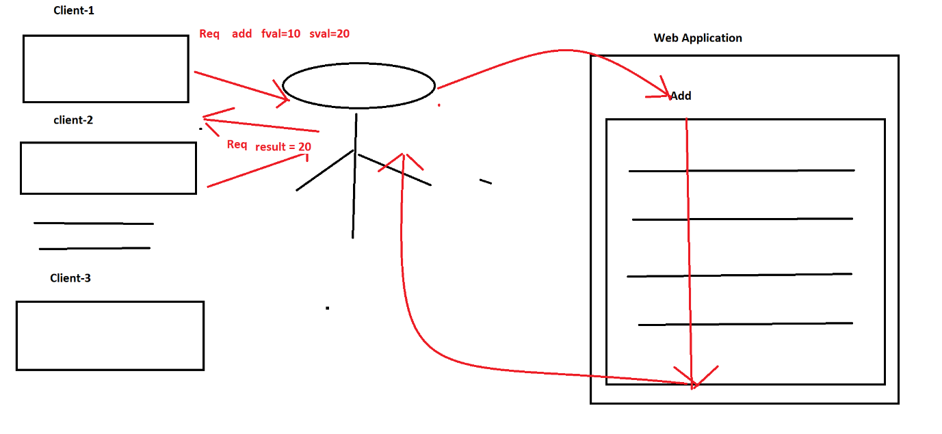

**Web Tech:-**

* CGI, Servlets, JSP, PHP,……..

Q) To design web applications inorder to generate dynamic response from server we have already CGI tech then what is the requirement to go for servlet?

**Ans:-**

CGI:- C Programming Language and Some Scripting Languages.

C is Procedure Oriented PL-🡪 CGI is also Procedure Oriented PL.