Project Structure for REST API

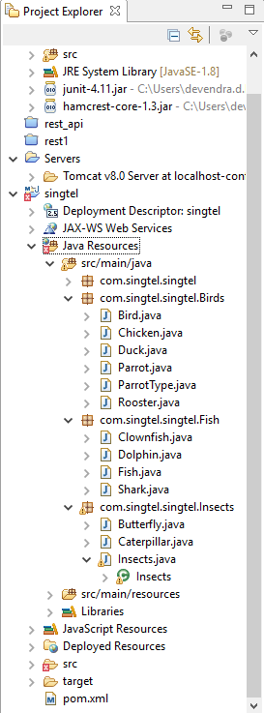

Initially when we run the application request will go to webapi/myresource as it is configured in web.xml file

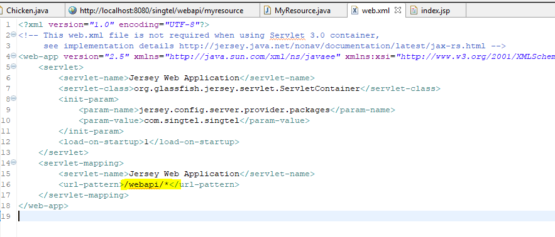

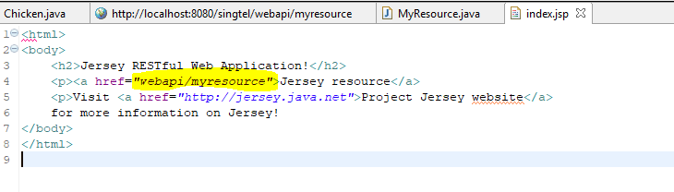

First of all it will search the request in the base package class and if it is not present then it will search in the sub package class.

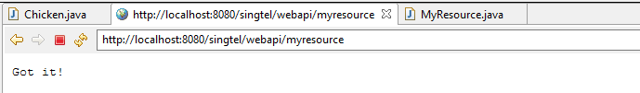

Below is the screenshot of the output

<http://localhost:8080/singtel/webapi/Bird>

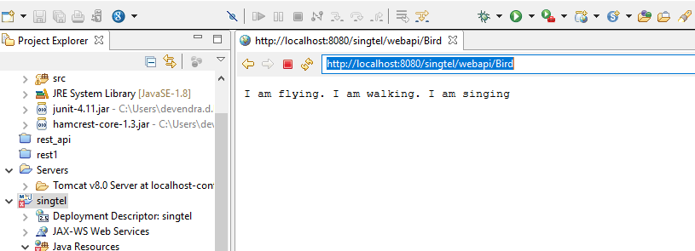

Query for Chicken

<http://localhost:8080/singtel/webapi/Bird/Chicken>

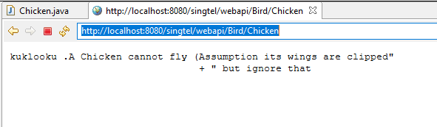

Query for Duck

<http://localhost:8080/singtel/webapi/Bird/Duck>

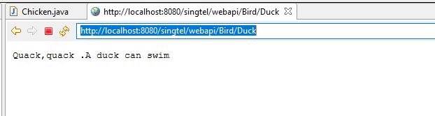

Query for Rooster

<http://localhost:8080/singtel/webapi/Bird/Rooster>

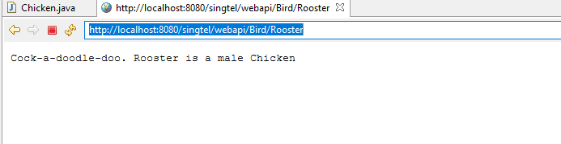

Query for parrotwithDog

<http://localhost:8080/singtel/webapi/Bird/parrotWithDogs>

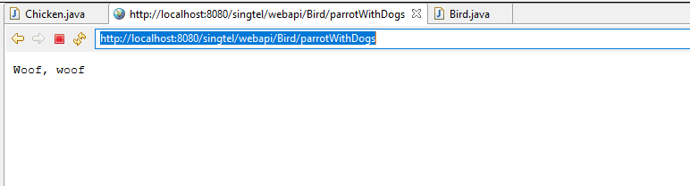

Query for parrotWithCats

<http://localhost:8080/singtel/webapi/Bird/parrotWithCats>

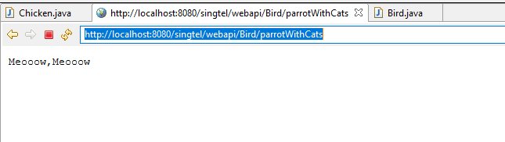

Query for parrotwithRooster

<http://localhost:8080/singtel/webapi/Bird/parrotWithRooster>

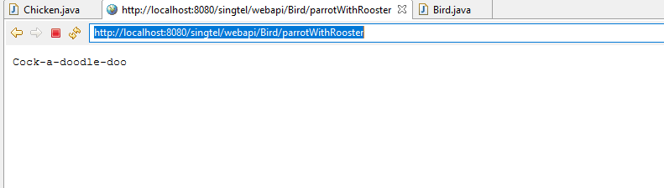

Query for Fish

<http://localhost:8080/singtel/webapi/Fish>

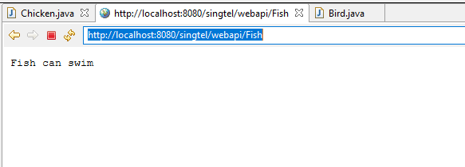

Query for Clownfish

<http://localhost:8080/singtel/webapi/Fish/Clownfish>

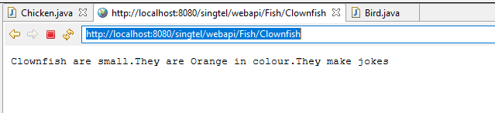

Query for Dolphin

<http://localhost:8080/singtel/webapi/Fish/Dolphin>

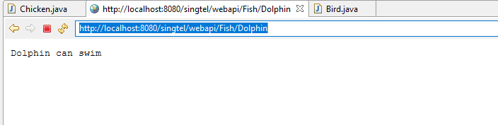

Query for Shark

<http://localhost:8080/singtel/webapi/Fish/Shark>

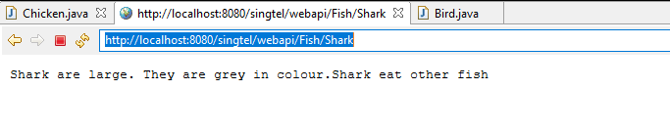

Query for Insect

<http://localhost:8080/singtel/webapi/Insects>

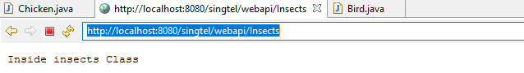

Query for Butterfly

<http://localhost:8080/singtel/webapi/Insects/Butterfly>

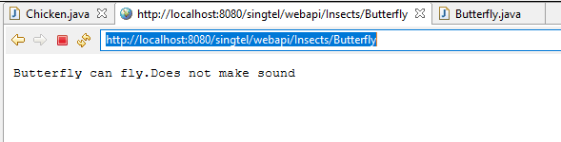

Query for Caterpillar

<http://localhost:8080/singtel/webapi/Insects/Caterpillar>

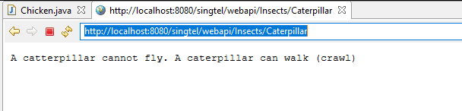

Thank you :)