A
1. Can you implement the sing() method for the bird?
package com.test;

package Animal;

public class Animal
{
public static int count_canfly;
public static int count_canwalk;
public static int count_cansing;
public static int count_canswim;
}

package Animal;

public interface movement
{
//movement
public String walk();
public String swim();
public String fly();
}

package Animal;

public class Bird extends Animal implements movement
{
public Bird()
{
count_canfly++;
count_cansing++;
count_canwalk++;
}

public String swim()
{
return"";
}

public String fly()
{
return "I am flying";
}

public String walk()
{
return "I am walking";
}

public String sing()
{
return "I am singing";
}
}

public class Solution {
public static void main(String[] args) {
Bird bird = new Bird();
bird.walk();
bird.fly();
bird.sing();
}
}

A)How did you unit test it.

Two test case has been created for each method inside a class.
One test case for PASS and another test case for fail.
Same process has been followed for all the methods of the class.

Example

package Animal;

import static org.junit.Assert.*;
import org.junit.Test;
public class BirdTest {

public BirdTest()
{
}

@Test
public void flyTestPass() {
Bird bird = new Bird();
assertTrue("I am flying".equals(bird.fly()));
}

@Test
public void flyTestFail() {
Bird bird = new Bird();
assertTrue("I am flying ...".equals(bird.fly()));
}

@Test
public void walkTestPass() {
Bird bird = new Bird();
assertTrue("I am walking".equals(bird.walk()));
}

@Test
public void walkTestFail() {
Bird bird = new Bird();
assertTrue("I am walking ...".equals(bird.walk()));
}

@Test
public void singTestPass() {
Bird bird = new Bird();
assertTrue("I am singing".equals(bird.sing()));
}

@Test
public void singTestFail() {
Bird bird = new Bird();
assertTrue("I am singing zzz".equals(bird.sing()));
}
}package Animal;

import static org.junit.Assert.*;
import org.junit.Test;
public class BirdTest {

public BirdTest()
{
}

@Test
public void flyTestPass() {
Bird bird = new Bird();
assertTrue("I am flying".equals(bird.fly()));
}

@Test
public void flyTestFail() {
Bird bird = new Bird();
assertTrue("I am flying ...".equals(bird.fly()));
}

@Test
public void walkTestPass() {
Bird bird = new Bird();
assertTrue("I am walking".equals(bird.walk()));
}

@Test
public void walkTestFail() {
Bird bird = new Bird();
assertTrue("I am walking ...".equals(bird.walk()));
}

@Test
public void singTestPass() {
Bird bird = new Bird();
assertTrue("I am singing".equals(bird.sing()));
}

@Test
public void singTestFail() {
Bird bird = new Bird();
assertTrue("I am singing zzz".equals(bird.sing()));
}
}

- How would you optimize the code maintainability

We have created interface having different method.

package Animal;

public interface movement
{
//movement
public String walk();
public String swim();
public String fly();
}

package Animal;

public interface Parrot {
public String parrotWithDogs();
public String parrotWithCats();
public String parrotWithRooster();

/*public void parrotwithDuck();
public void parrotnearPhone();*/

}

package Animal;

public interface sound
{
//sound
public String can_sound();
public String sing();
}

package fish;

public interface colour
{

//colour
public String orange();
public String grey();
public String colourful();
}

package fish;

public interface size
{
//size
public String small();
public String large();
}

The class which need this behaviour, we are implementing these methods in those class

2. Now, we have 2 special kinds of birds: the Duck and the Chicken... Can you
implement them to make their own special sound?

package Animal;

public class Chicken extends Bird
{
//Aggregation
Rooster robj;

public Chicken()
{

robj= new Rooster();
count_cansing++;
}

public String can_sound()
{
System.out.println("Cluck,Cluck");
//Regional sound
return "kuklooku";
}

public String fly()
{
System.out.println("A Chicken cannot fly (Assumption its wings are clipped\"\r\n" +
" + \" but ignore that");
return "I cannot fly";

}

}

package Animal;

public class Duck extends Bird
{
public Duck()
{
count_canswim++;

}

public String can_sound()
{

System.out.println("Quack,quack");
//regional
return "Quack,quack";
}

public String swim()
{

return "A duck can swim";
}

}

3. Now how would you model a rooster?
a. A rooster says: “Cock-a-doodle-doo”
c. Can you think of other ways to model a rooster without using inheritance?

Ans using aggregation

package Animal;

public class Chicken extends Bird
{
//Aggregation
Rooster robj;

public Chicken()
{

robj= new Rooster();
count_cansing++;
}

public String can_sound()
{
System.out.println("Cluck,Cluck");
//Regional sound
return "kuklooku";
}

public String fly()
{
System.out.println("A Chicken cannot fly (Assumption its wings are clipped\"\r\n" +
" + \" but ignore that");
return "I cannot fly";

}

}

package Animal;

public class Rooster
{
public Rooster()
{

}

public String can_sound()
{
System.out.println("Cock-a-doodle-doo");
//regional
return"Cock-a-doodle-doo";
}

public void rel_with_chicken()
{
System.out.println("Rooster is a male Chicken");
}
}

4. Can you model a parrot? We are specifically interested in three parrots, one that
lived in a house with dogs one in a house with cats, the other lived on a farm next to
the rooster.

How do you keep the parrot maintainable? What if we need another parrot
lives near a Duck? Or near a phone that rings frequently?

Ans If there are any changes in the future ,new methods can be added in the parrot interface

package Animal;

public interface Parrot {
public String parrotWithDogs();
public String parrotWithCats();
public String parrotWithRooster();

/*public void parrotwithDuck();
public void parrotnearPhone();*/

}

package Animal;

public class ParrotType extends Animal implements Parrot{

@Override
public String parrotWithDogs() {
// TODO Auto-generated method stub
count_canfly++;
count_cansing++;
System.out.println("Woof, woof");
//regional
return"Woof, woof";
}

@Override
public String parrotWithCats() {
// TODO Auto-generated method stub
count_canfly++;
count_cansing++;
// System.out.println("Meow");
//regional
return"Meooow,Meooow";
}

@Override
public String parrotWithRooster() {
// TODO Auto-generated method stub
count_canfly++;
count_cansing++;
System.out.println("Cock-a-doodle-doo");
//regional
return"Cock-a-doodle-doo";
}

/* @Override
public void parrotwithDuck() {
// TODO Auto-generated method stub
System.out.println("Quack, Quack");
}

@Override
public void parrotnearPhone() {
// TODO Auto-generated method stub
System.out.println("Ring,ring");
}
*/

}

B Model fish as well as other swimming animals

package fish;

import Animal.Animal;
import Animal.movement;

public class Fish extends Animal implements size, colour
{

public Dolphin dobj;
public Fish()
{
count_canswim++;
dobj= new Dolphin();

}

public String swim()
{
// count_canswim++;
return "Fish can swim";
}

@Override
public String small() {
// TODO Auto-generated method stub
return "";
}

@Override
public String large() {
// TODO Auto-generated method stub
return "";
}

@Override
public String orange() {
// TODO Auto-generated method stub
return "";
}

@Override
public String grey() {
// TODO Auto-generated method stub
return "";
}

@Override
public String colourful() {
// TODO Auto-generated method stub
return "";
}

}

Specialize fish as Shark and Clownfish

package fish;

public class Shark extends Fish
{
public String large()
{
return "Shark are large";
}

public String grey()
{
return "they are grey in colour";
}

public String eat()
{
return "Shark eat other fish";
}

}

package fish;

public class Clownfish extends Fish
{

public String small()
{
return "Clownfish are small";
}

public String colourful()
{
return "they are Orange in colour";
}

public void behaviour()
{
System.out.println("they make jokes");
}
}

//Dolphin are not exactly fish but are good swimmer
package fish;

public class Dolphin
{

public String swim()
{
return "Dolphin can swim";
}

}

D Model animal which changes there behaviour over time.

package insects;

import Animal.Animal;
import Animal.movement;
import Animal.sound;

public class Insects extends Animal implements movement, sound
{

@Override
public String can_sound() {
// TODO Auto-generated method stub
return "";
}

@Override
public String sing() {
// TODO Auto-generated method stub
return "";
}

@Override
public String walk() {
// TODO Auto-generated method stub
return "";
}

@Override
public String swim() {
// TODO Auto-generated method stub
return "";
}

@Override
public String fly() {
// TODO Auto-generated method stub
return "";
}

}

package insects;

import Animal.Animal;
import Animal.movement;

public class Butterfly extends Insects
{
public Caterpillar caterpillar_obj;

public Butterfly()
{

caterpillar_obj= new Caterpillar();
count_canwalk++;
}

public String fly()
{
count_canfly++;
return "Butterfly can fly";
}

public String can_sound()
{
return "Does not make sound";
}

}

package insects;

public class Caterpillar
{
public Caterpillar()
{

}

public String fly()
{
return "A catterpillar cannot fly";
}

public String walk()
{
return "A caterpillar can walk (crawl)";
}

}

E count to there animals

package Animal;

import insects.Butterfly;
import fish.Clownfish;
import fish.Fish;
import fish.Shark;

public class Solution
{

public static void main(String[] aqrgs)
{
Bird obj= new Bird();
Duck obj1= new Duck();
Chicken obj2= new Chicken();
Rooster obj3=new Rooster();
//Parrot
Parrot pobj= new ParrotType();
pobj.parrotWithCats();
Fish obj4= new Fish();
Shark obj5= new Shark();
Clownfish obj6= new Clownfish();
//dolphin
//Frog Dog
Butterfly obj7= new Butterfly();

System.out.println(obj.count_canwalk);
System.out.println(obj.count_canfly);
System.out.println(obj.count_cansing);
System.out.println(obj.count_canswim);
}
}

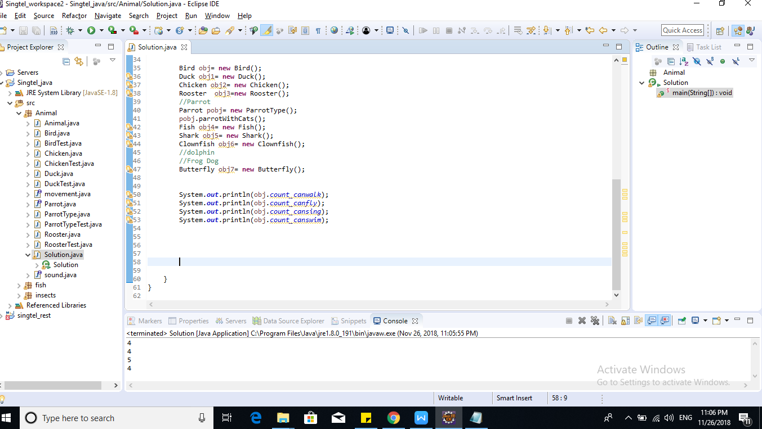

Bonus

Can you add second language.
Yes it has been added (local animal sound)

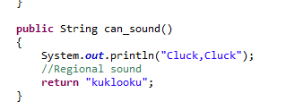

Can you design a restful API for Querying these animal.

Yes code has been shared and another document will be having detailed explanation with screenshot

Code has also been shared in github

