W3D2_solution

Q1

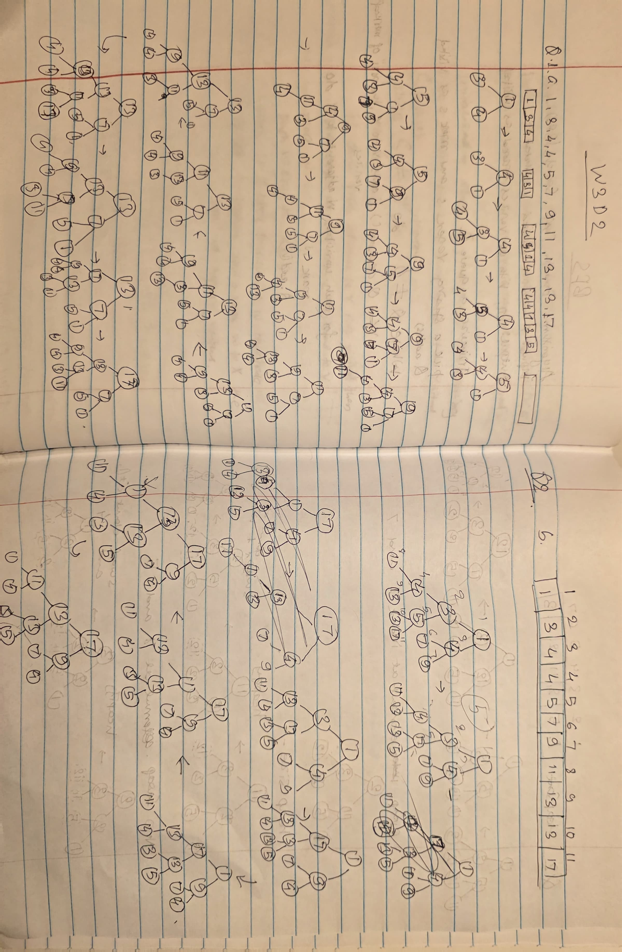

Q2

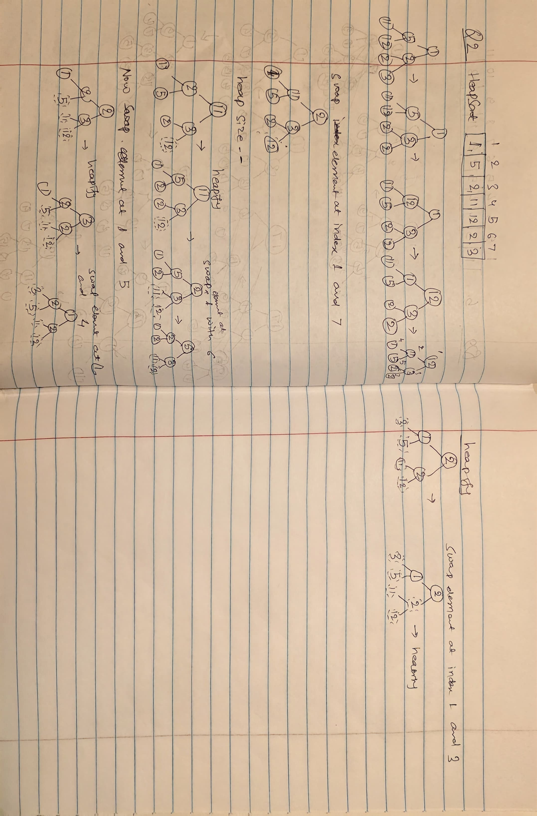

Q3

Efficient Algorithm to Fuse Two Heaps of the Same Height
Assume:
- You have two binary heaps $H_{1}$and $H_{2}$.
- Both heaps have the same height $h$.
- You want to merge them into a single valid heap.

Efficient Approach
The standard efficient method is:
- Concatenate the arrays of the two heaps (placing all elements into one array).
- Run BUILD-HEAP on the combined array.
BUILD-HEAP works in linear time, $O(n)$, where $n$is the number of items.
Since the heaps have the same height,
each has roughly $2^{h+1}-1$nodes ⇒ total is about $2^{h+2}-2$.

(a) Best Case
In the best case, one of the heaps’ elements can simply be attached as a child subtree without violating the heap property.
Example best case:
- All elements in $H_{1}$are ≤ root of $H_{2}$(for min-heap).
Then you may attach $H_{1}$as a subtree of $H_{2}$without further fixing.

Best-case time
Only a constant number of pointer/array operations.
➡️ Best case time: Θ(1)

(b) Worst Case
In the worst case, every element of one heap violates the heap property when placed with the other.
Thus the combined structure must be completely rebuilt as a heap.
This happens when, for example:
- In a min-heap, all keys of $H_{1}$are large while all keys of $H_{2}$are small, or vice-versa.
- After concatenation, nearly every node must be sifted down.

(c) Worst-Case Time Complexity
The worst case requires reconstructing the heap, done by:

BUILD-HEAP on $2n$elements
The BUILD-HEAP algorithm has time:
$$O(n)$$
where $n$is the number of elements in the combined heap.
Let each heap have size $n$.
Total size after fusion: $2n$.
So the time remains:
➡️ Worst-case time complexity: Θ(n)
Part | Answer
(a) Best case | $Θ(1)$— simply attach one heap to the other with no violations
(b) Worst case | Must rebuild the entire heap (full reheapification)
(c) Worst-case time complexity | $Θ(n)$where $n$is the number of elements in the final heap

Algorithm in Pseudocode
FUSE-HEAPS(H1, H2):

1. Let A1 be the array representation of heap H1
2. Let A2 be the array representation of heap H2

3. Create a new array A of size |A1| + |A2|

4. Copy all elements of A1 into the beginning of A
5. Copy all elements of A2 into the remainder of A

6. BUILD-HEAP(A)

7. return A // A is now a valid heap containing all elements

BUILD-HEAP(A) (for reference)
BUILD-HEAP(A):

1. n = length(A)

2. for i = floor(n/2) down to 1:
HEAPIFY(A, i)

3. return A

HEAPIFY(A, i) (standard)
HEAPIFY(A, i):

1. left = 2*i
2. right = 2*i + 1
3. smallest = i

4. if left ≤ n and A[left] < A[smallest]:
smallest = left

5. if right ≤ n and A[right] < A[smallest]:
smallest = right

6. if smallest != i:
swap A[i], A[smallest]
HEAPIFY(A, smallest)

- Concatenation: Θ(n)
- BUILD-HEAP: Θ(n)

