Q1.
a.
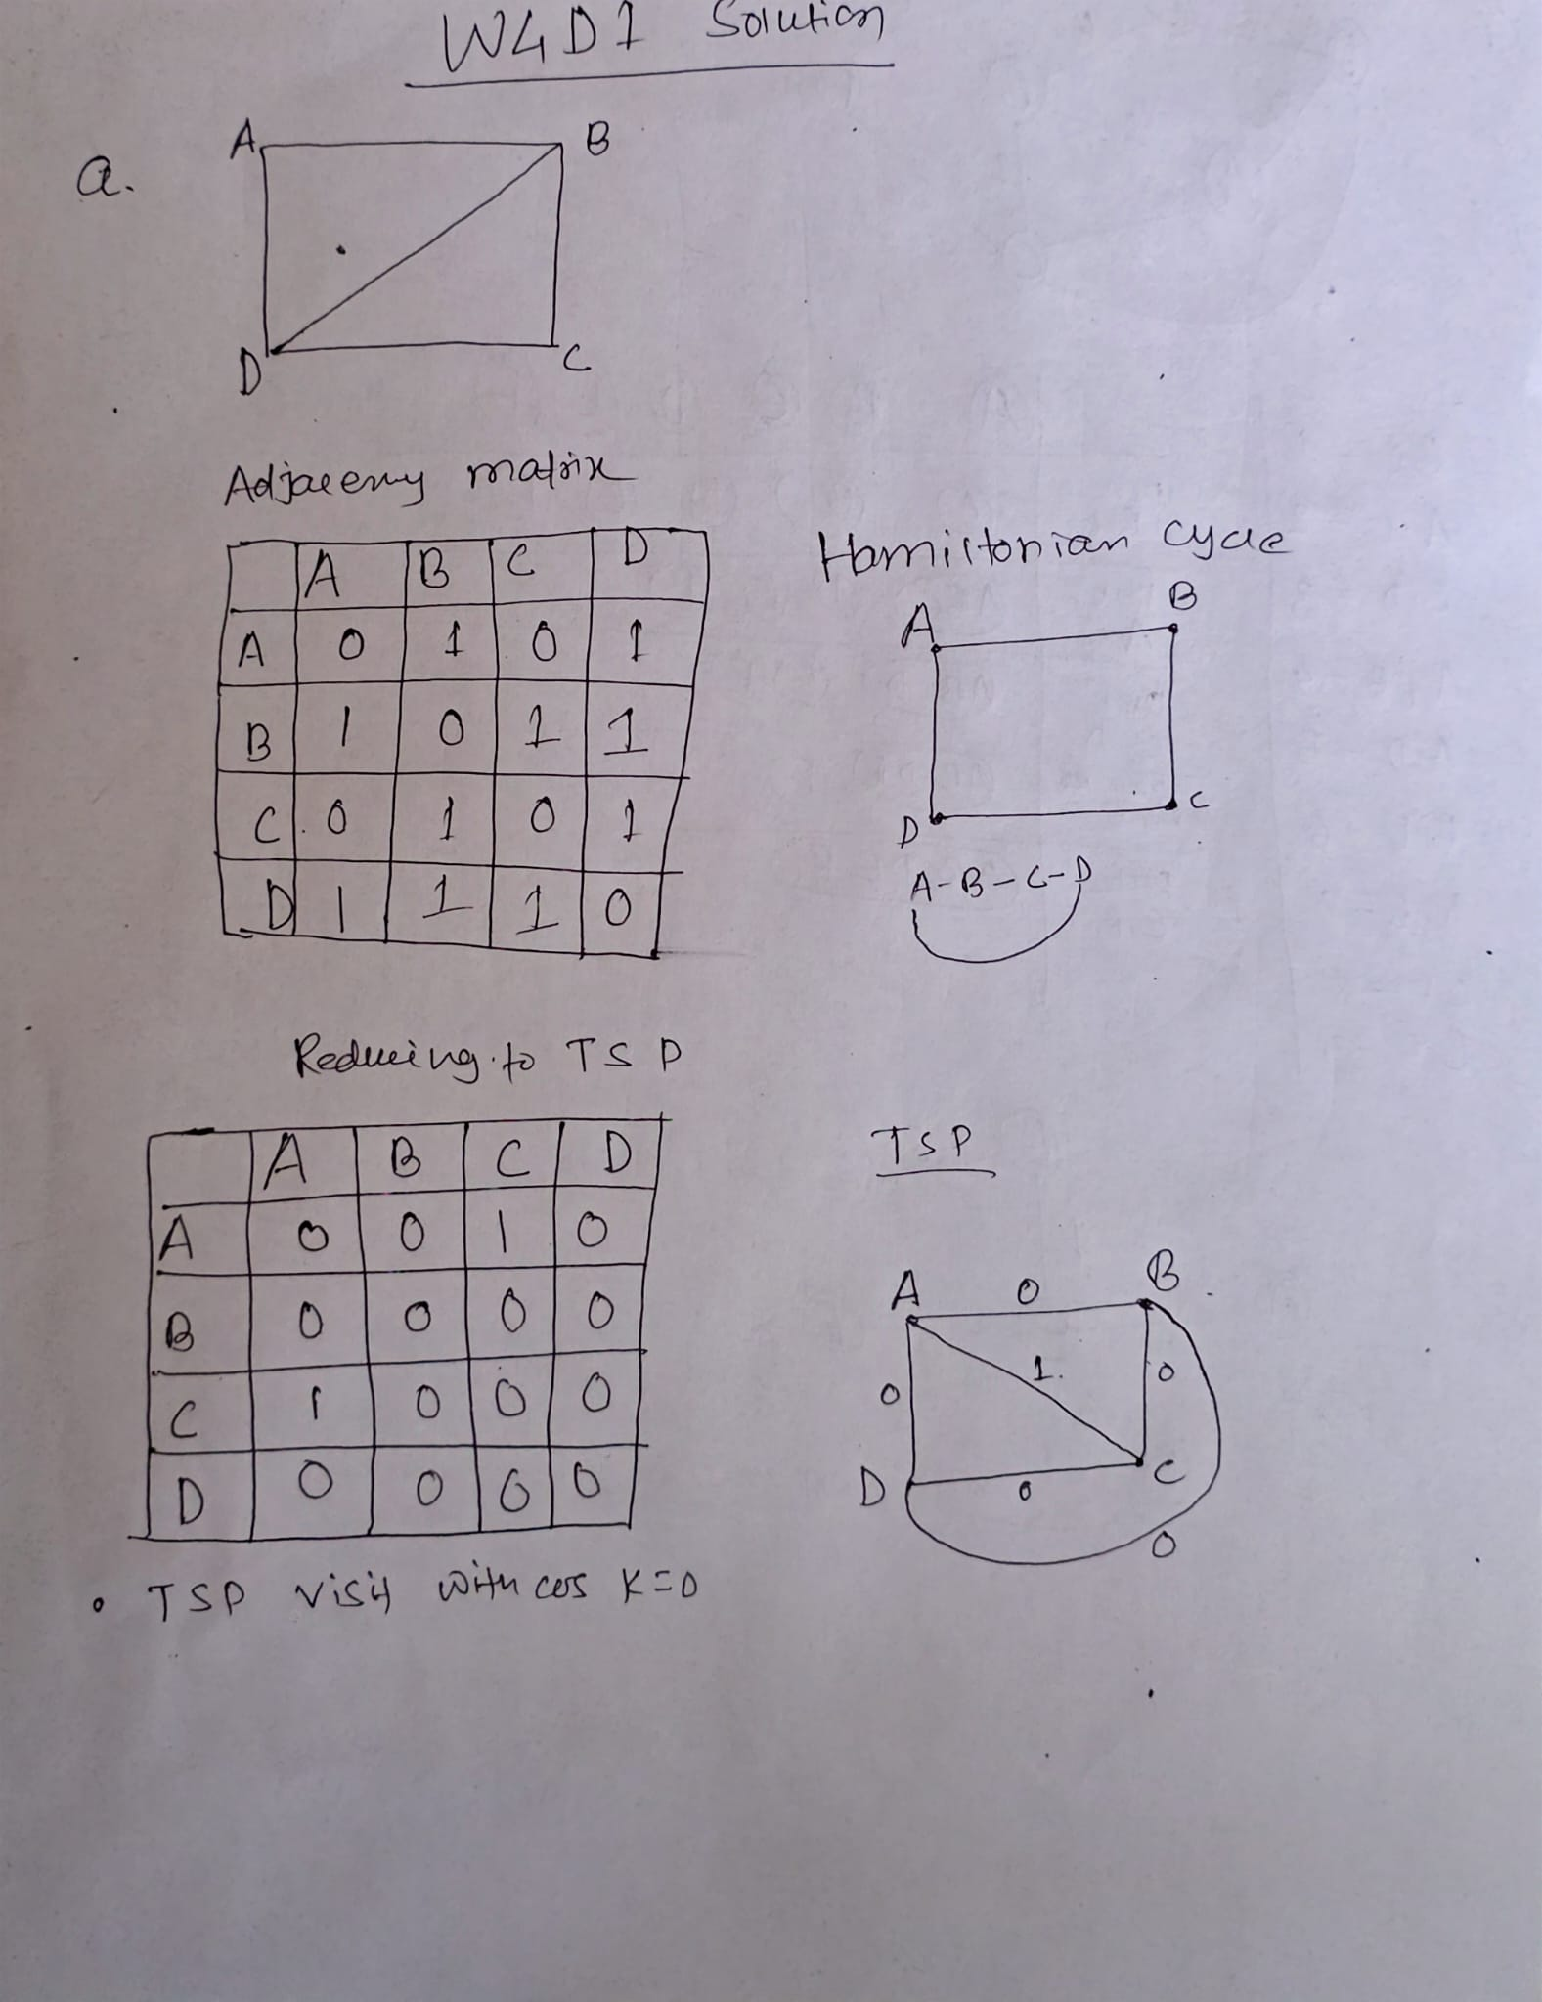
b.
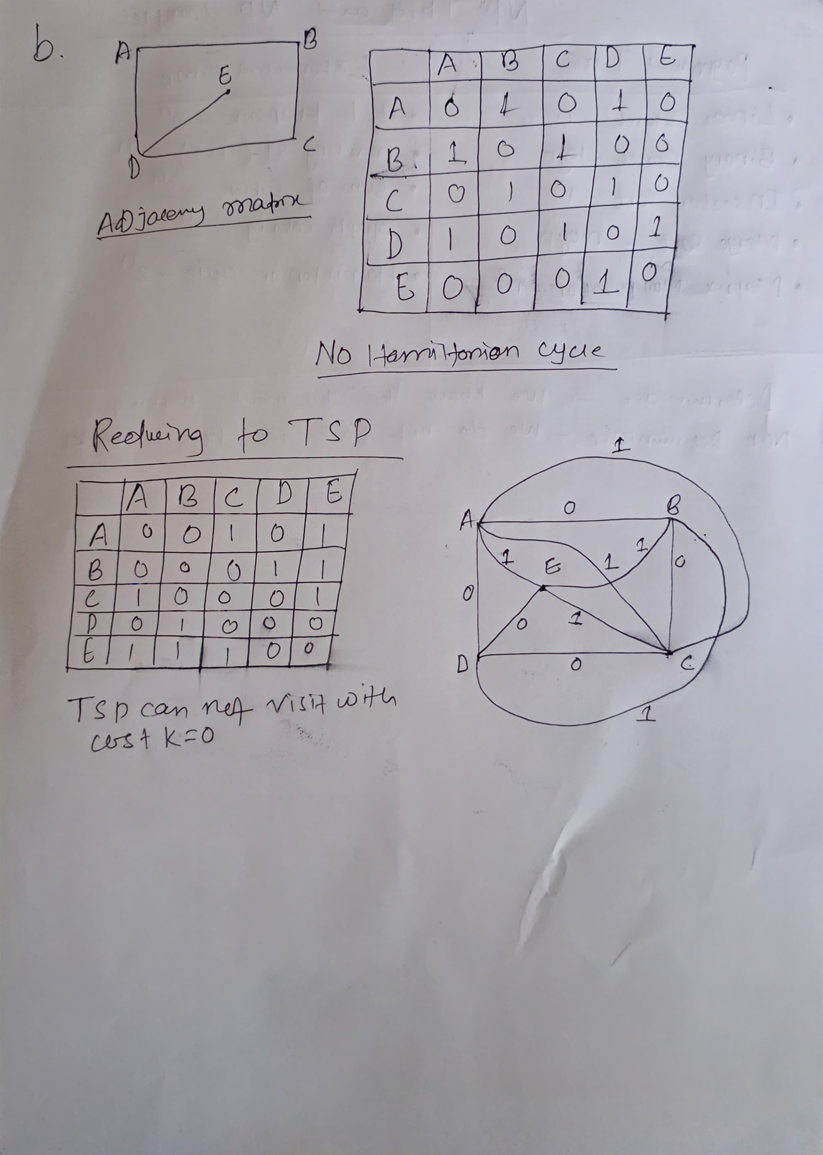
Q2.
Problems.
- HamiltonianCycle (HC): Given an (undirected) graph $G=(V,E)$, does $G$contain a Hamiltonian cycle?
- TSP (decision version): Given a complete weighted graph $K=(V,E^{'})$with integer edge weights $w(⋅,⋅)$and a bound $B$, is there a Hamiltonian cycle of total weight $≤B$?
(We use the usual fact that TSP is in NP because a proposed tour can be checked in polynomial time.)

Reduction $f$from HC to TSP
Input to HC: graph $G=(V,E)$with $∣V∣=n$.
Construct a complete graph $K=(V,E^{'})$on the same vertex set and define weights
$$w(u,v)=\left\{\begin{matrix}1 & \text{if }\{u,v\}∈E\text{ (edge of }G), \\ 2 & \text{if }\{u,v\}∉E\text{ (non-edge of }G).\end{matrix}\right.$$
Set the TSP bound $B=n$. Output the TSP instance $\left(K , w , B\right)$.
This transformation is clearly computable in polynomial time (just examine each pair of vertices and set weight 1 or 2).

Correctness
- If $G$has a Hamiltonian cycle.
Then that cycle uses only edges of $G$. In $K$those edges each have weight $1$, so the corresponding Hamiltonian cycle in $K$has total weight $n$. Thus $\left(K , w , B\right)$is a YES instance of TSP (weight $≤B$).
- If $\left(K , w , B\right)$is a YES instance of TSP (there is a tour of weight $≤n$).
Any Hamiltonian cycle in $K$has exactly $n$edges. If the tour has weight $≤n$, every edge in it must have weight $1$(because if even one edge had weight $2$the sum $≥(n-1)⋅1+2=n+1>n$). Hence all edges of the tour are edges of $G$, so that tour is a Hamiltonian cycle of $G$. Therefore $G$has a Hamiltonian cycle.
So $G$has a Hamiltonian cycle iff the constructed TSP instance has a tour of weight $≤n$. That proves HC $≤_{p}$TSP.

Conclusion
- TSP is in NP (certificate = tour, verify sum in polynomial time).
- HC is NP-complete by assumption and we have shown a polynomial-time reduction HC $≤_{p}$TSP, so TSP is NP-hard.
- Therefore TSP is NP-complete.

