

Department of Artificial Intelligence

22BIO201: Intelligence of Biological System – I

NOV – 2024

**Project Report**

Analyzing Single-Cell  RNA-seq Data

Using Machine Learning Techniques

**Team Members**

Avtv. Karthikeya – CB.SC.U4AIE23008

P. Tejas – CB.SC.U4AIE23051

R. Sai Sathvik – CB.SC.U4AIE23056  
T. Devendra Ajay Kumar – CB.SC.U4AIE23070

Date of submission:

Signature of the Project Supervisor:

|  |  |
| --- | --- |
| Contents | Page no: |
| List of figures | 3 |
| Abstract | 4 |
| INTRODUCTION | 5-7 |
| Related Work | 8-10 |
| CODE IMPLEMENTATION | 13-17 |
| CIRCUTE DEIAGRAM |  |
| ADVANTAGES AND DISADVANTAGES | 34-35 |
| CHALLENGES AND SOLUTIONS | 36-37 |
| FUTURE SCOPE | 38-3G |
| CHAPTER-G REFERENCES | 40 |
| CHAPTER-10 CONCLUSION | 41 |

**Abstract**

Single-cell RNA sequencing (scRNA-seq) data analysis is critical for gaining insights into cellular heterogeneity, gene expression, and biological processes. However, the complexity and high dimensionality of scRNA-seq data pose challenges for conventional statistical methods. This project explores the application of advanced machine learning techniques, specifically Graph Convolutional Networks (GCN) and Graph Attention Networks (GAT), for analyzing scRNA-seq data. By utilizing these graph-based deep learning models, we aim to capture the relationships among cells and genes, identifying meaningful clusters and key gene markers that reveal underlying biological patterns. GCN and GAT methods allow for leveraging cell-to-cell and gene-to-gene connections, enhancing the interpretability of the data and improving accuracy in tasks such as cell-type annotation and functional characterization. The report discusses the strengths and limitations of GCN and GAT in scRNA-seq analysis and presents results from case studies that demonstrate their effectiveness. This project contributes to the development of robust, scalable tools for single-cell genomics, with implications for research in precision medicine, oncology, and developmental biology.

1, Introduction

Studying the basic units of life, which is the cell, researchers have learned to get a better view of the complex processes among living organisms.  
It was in the 17th century that Robert Hooke first discovered cells as a base for what we know today as the cell theory which claims all that living things are made  
Through up of cells, and that cells contain the genetic and functional blueprints to sustain life. Modern cellular biology has established the fact that cells harbor DNA, which carries information from one generation to the next, and RNA, which translates this genetic code into functional proteins. Yet, cellular behavior is more complex than what DNA sequencing alone can explain.  
  
One of the biggest hurdles in the quest to comprehend the cellular diversity is the issue of explaining how different cells-or even the same cells-in the same organism express genes variably. Alternative splicing represents an important mechanism whereby a single gene can produce multiple variants of proteins, thus introducing functional variation. The splicing may even produce nonfunctional proteins that may potentially introduce disease. Therefore, RNA sequencing has emerged as  
an extremely useful tool in the study of gene expression, allowing one to measure levels of RNA in cells. The RNA-seq data provides an immediate snapshot of gene activity and aids in mapping cellular responses to environmental changes, treatments, and diseases.  
  
In recent years, ScRNA-seq has revolutionized how scientists explore cellular heterogeneity. Unlike traditional bulk RNA sequencing,  
ScRNA-seq examines individual cells but still captures averaged gene expression across many cells, allowing for a highly detailed account of the differences in gene expression-even within seemingly homogeneous populations. It lets researchers dissect intricate cellular behaviors, such as drug resistance in cancer cells or immune cell responses. In this way, scientists can now view gene expression profiles from individual cell types, opening new avenues for investigating cell-type-specific responses in health and disease.  
  
Although the benefits of scRNA-seq are tremendous, this technique does pose important computational challenges. The transcriptomic profiles of thousands of genes   
across each cell are known to result in high-dimensional datasets that are complex and hard to interpret by traditional techniques. Dimensionality reduction and   
machine learning methods prove to be of great importance because they allow scientists to condense data without losing critical information regarding cellular  
Relationships: This is partly achieved through data dimensionality reduction by PCA, t-Distributed Stochastic Neighbor Embedding (t-SNE), and Uniform Manifold Approximation and Projection (UMAP), which unveil patterns and clusters that correspond to functions and states of cells.  
  
Machine learning has proven to be an invaluable resource in the analysis of scRNA-seq with the possibility of converting large, unwieldy datasets into interpretable patterns that yield biological  
Insights. In this project, advanced machine learning techniques, particularly graph-based neural networks, are applied to the analysis and visualization of scRNA-seq data.  
Graph-based models, such as Graph Convolutional Networks (GCNs) and Graph Attention Networks (GATs), provide researchers with the ability to represent cells as nodes of a network where edges express gene expression similarities. In such a graph-based representation, structural relations within cellular populations are very useful because cells generally function within interconnected systems.  
  
GCNs and GATs are strong at identifying both local and global patterns of scRNA-seq. GCNs make use of the neighborhood structure of each cell to explain its position in the greater data landscape, which creates a hierarchical view of cellular interactions. GAT does the same but takes it further because it uses an attention mechanism that weights different neighboring cells differently, thereby bringing out the prominent relationships while revealing subtle yet significant cell relationships.  
variations. Taken together, the two models offer a superb view of the dynamics and crosstalk in cells-similar to seeing how through differentiation and responding to signals, cells work.  
  
Dimensionality reduction methods augment graph-based models by reducing the high dimensionality of complicated scRNA-seq data. One of the very first techniques of dimensionality reduction was PCA, which could pickup big trends by transforming the data into principal components. A very important weakness of PCA is that it operates on linear techniques, which generally fail to capture fine  
The non-linear methods like t-SNE and UMAP are able to capture relationships in the scRNA-seq data much better. t-SNE, in particular, is very good at preserving local relationships, which is often useful to pick up cellular subtypes or transitional states. Being a more recent technique, UMAP combines the benefits of t-SNE with greater stability and computational efficiency, so that it is nicely suited for visualizing the data from scRNA-seq experiments and to identify specific cell clusters.  
  
The integration of these models with visualization tools like PCA, t-SNE, and UMAP enhances the interpretability of the scRNA-seq data. With PCA, t-SNE, and UMAP, a researcher can visually discern cell clusters that represent different states or types and allows for an intuitive understanding of patterns that could be functional differences, disease states, or developmental stages. This project utilizes a Python-based environment using libraries like NumPy, Pandas, and PyTorch.  
in combination with specialized graph-based modeling and processing tools for single-cell data.  
This computational platform is not only powerful for data analysis but  
also scales to the large datasets that are typical for most scRNA-seq experiments.  
  
Ultimately, this project shows the promise of computational power in support of biological research-to-illustrate how machine learning can bridge the  
gap between data and discovery in genomics. The findings of this work will then probe for unique cell types in scRNA-seq data and provide insight into cellular behaviors, which seems to point toward a more nuanced understanding of the way individual cells adapt and how they respond to their microenvironment to communicate with other cells. Such insights are essentially critical for the establishment of markers identification and disease mechanisms understanding, including the development of personalized approaches to treatment.  
medicine. This work is an exemplary example of the most contemporary approaches to single-cell analysis that take advantage of advanced computational tools in handling highly complex and dimensional scRNA-seq data, thus providing a comprehensive framework for exploring cellular diversity and function.

2. Related Work

The second revolution in cellular biology studies, single-cell RNA sequencing (scRNA-seq), now makes it possible to analyze gene expression at a single cell resolution. The analysis is critical for complex tissue, cancer, autoimmune disease, and other studies in which understanding cellular heterogeneity might help explain the mechanism of disease, treatment resistance, or tissue-specific responses. However, despite the potential for utility, the analysis is very technical and creates significant technical challenges. Such data, with high noise, dropout events, and large dimensions, renders meaningful biological insights very challenging without advanced computational methods.  
  
Preprocessing scRNA-seq Data:  
  
Dimensionality reduction techniques are highly reliant during the preprocessing stage in the analysis of scRNA-seq since they reduce the data but preserve important features. Established techniques such as PCA, t-SNE, and UMAP have therefore become the work-horses in dealing with scRNA-seq's high-dimensional nature. PCA is a linear approach that reduces noise by capturing the principal variances in the data using fewer number of components; however it cannot find the complex nonlinear patterns, that often hold the important clues for the discovery of subtle cellular states. Other nonlinear techniques - t-SNE and UMAP perform much better in such applications.  
t-SNE  
t-SNE is very commonly used for visualizing local cell similarities in the two-dimensional space, it's stochastic, however, which makes it sometimes not reliable, hence often producing different clusterings on running the algorithm several times. UMAP is the newer technique, which addresses the stability issues of t-SNE and consumes less computation as well. In particular, the possibility of holding global and local structure makes UMAP the tool preferred for the visualization and clustering of scRNA-seq. While PCA and t-SNE remain fundamental tools for cell cluster and state identification, there is still much work to be done to make these tasks balance computational effectiveness with biological interpretability and stability.  
  
Graph-Based Neural Networks:  
  
In addition to dimensionality reduction, major advances in graph-based neural networks (GNNs) have significantly impacted the analysis of scRNA-seq. GNNs, including Graph Convolutional Networks and Graph Attention Networks, represent cells as nodes and gene expression similarities as edges, taking into account the complex relational data structures. GCNs in particular focus on local and global cell-cell relationships, which are achieved by using graph convolution operations applied to the relation graph. They are particularly well-suited for identifying hierarchical cellular structures and interactions. GATs improve the GCNs by using a dynamic weighting scheme for capturing the contribution of each neighboring node, which is useful for various cellular interactions and transition states.  
  
Although GCNs and GATs have been so far excellent in handling large datasets because of the strengths they possess, they are computationally expensive, which makes it harder to scale up for large common datasets mostly found in the scRNA domain. The models are promising in representing cellular hierarchies and functional states, but scalability and interpretability continue to be unsolved issues, especially as the size and complexity of the data increase.  
Limitations and Gaps in Current Literature  
  
Technical Noise and Batch Effects: Noise, dropouts, and dropout events are the biggest challenges to the analysis in scRNA-seq. Batch effects are also an important factor, where the quality of data appears dependent upon the experimental run, masking the biological signals. While techniques like ComBat are often deployed for correcting batch effects, such techniques cannot solve these problems altogether, and new and improved methods for robust noise reduction and normalization across datasets represent part of the integralization for proper analysis of scRNA-seq data.  
  
Dimensionality reduction limitations: PCA, t-SNE, and UMAP are all essential components of scRNA-seq analysis, each with some limitations. PCA fails to capture the direction in the data that is nonlinear; most complex biological data exhibits nonlinear patterns. t-SNE is very proficient at preserving local relationships but is also very noisy because it is inherently stochastic so careful tuning of parameters is required. UMAP is more stable and efficient, although sometimes losing continuity in certain datasets. This is still an open subject: Continuing to develop the advancement of techniques for dimensionality reduction with preservation of single-cell data nuanced structures is left as an open subject.  
  
Clustering and classification complexity: Most of the popular algorithms for clustering, such as K-means, rely upon clusters being approximately as it happens in scRNA-seq data, where cellular structures could be complex and varied. Models like HDBSCAN and spectral clustering are indeed more suitable for the detection of cellular heterogeneity due to their flexibility toward irregularly shaped clusters and inhomogeneous densities. Further refinements are needed so that these methods can indeed differentiate cell types and states within scRNA-seq data.  
  
Graph-based models, which include the two models, GCNs and GATs, have been envisioned to have the ability to represent cellular structures through node and edge relationships, but one of the challenges with applying such approaches has been the high computational cost and scalability. GCN technique is specifically well suited for determination of hierarchical relationships between cells, while GATs provide greater flexibility in the interpretation of cellular interactions. However, applying these models to large-scale scRNA-seq data requires optimization for speed while maintaining the accuracy of the model. These efficient algorithms are key steps to fully unleash the power of GNNs in large-scale single-cell datasets.  
  
To the best of our knowledge, few such studies have comparatively evaluated the performance, scalability, and accuracy of various machine learning models on the data from scRNA-seq under similar experimental conditions. This lack of benchmarking information makes it difficult for researchers to easily pick the most appropriate model for their specific analytical requirements. The analyses conducted would be better understood in the context of model suitability for scRNA-seq applications and thereby facilitate the establishment of best practices in this domain.  
  
Fill Gaps in scRNA-seq Research:  
  
The project fills this gap by systematically evaluating machine learning models for scRNA-seq data. It focuses on improving the interpretability and stability of data and cluster formation while exploring graph-based methods that include GCNs and GATs as means to model complex cellular interactions. This study also aims to identify the scalability of these models in handling high-dimensional and high-volume data for single cells, thereby supporting future research directions in personalized medicine, disease progression, and cellular heterogeneity. Thus, it aims to contribute to the broader scRNA-seq community by identifying some of the effective techniques for analyzing and interpreting complex single-cell datasets.

3.Methodology

This project's methodology focuses on the tasks of dimensionality reduction, clustering, and graph-based neural networks for single-cell RNA sequencing data. This strategy may provide insights into cellular heterogeneity and complex gene expression patterns.

At each step of this methodology, the outcome is expected to be reproducible, interpretable, and scientifically useful.

**1. Data Collection and Preprocessing :**

Data Source GEO Accession Number GSE86469 The expression profiles obtained include the scRNAseq data. This dataset contains gene expression profiles across various experimental conditions.

Handling High-Dimensional Sparse Data of scRNA-seq with Scanpy: To get around the high dimensionality of data that usually occurs in case of scRNA-seq, we used Scanpy, which is optimized for such datasets.

Filtering: Samples with less than 200 genes were filtered out to exclude low-quality samples, and genes that were expressed in fewer than three cells were filtered out to eliminate noise.

Quality Control: Mitochondrial genes: Cell stress or apoptosis usually are indicated by high counts, so cells with more than 5% mitochondrial gene counts were filtered out for maintaining good quality of the data.

Normalization: Cell counts were normalized into a target sum, so that the comparison was meaningful between cells regarding library size.

Log Transformation: Since the normalized counts are stabilized with log transformation, variance is stabilized, and the distribution of data approximates normal, it fits very well with the downstream analysis.

Highly Variable Genes Selection: This method by Scanpy's highly variable genes selection steps for retaining the genes that had high variance across cells would more biologically informative. It would help to identify such controlling genes on the kind of cell states or types.

**2. Dimensionality Reduction Techniques:**

Gene expression data are generally very high-dimensional data. Therefore, dimensions need to be reduced so that the data can be interpreted and succumbed to clustering and visualisation.

PCA (Principal Component Analysis):

Use: Provided to the preprocessed data to capture the largest sources of variation. Only the first few principal components were retained as they contain the most information.

Role in Noise Reduction: In PCA, noise reduction happened since it filtered out most of the components that contribute to variance minimally. The result was the preservation of the primary structure of the data.

distorted Stochastic Neighbor Embedding (t-SNE):

Purpose: It is used to analyze the local cell connections in 2D space. t-SNE preserves the local structure, which is good for visualizing small clusters in data.

Hyperparameter Tuning: Tunned across various perplexities and other hyper-parameters because t-SNE is sensitive to these parameters to optimize visualization.

Uniform Manifold Approximation and Projection (UMAP):

Objective: Applied 2D and 3D UMAP projections to ensure that global and local structure are balanced in the view.

Interpretation: Better visual continuity resulted from UMAP, hence the clustering results deeply visualize possible cell lineages together with transitions between cellular states. This is highly useful to determine developmental trajectories within the cell population.

**3. Clustering and Cell Type Identification :**

Cell clustering was performed into groups by applying PCA on the reduced dimensions

K-Means Clustering:

Clustering Algorithm: PCA-reduced data was clustered by K-means algorithm according to the expression profiles of their gene.

Cluster Validation: Compute the Silhouette Score in order to evaluate how high the cluster cohesion, or the closeness of cells of the same cluster, and separation, or the distance between cells belonging to different clusters, is. The higher value indicates the better separated clusters.

Evaluation Metrics:

Adjusted Rand Index (ARI): ARI was used in the experiment to cluster comparison with the use of ground truth labels. It computes how close the predicted clusters are to the actual known cell types.

Normalized Mutual Information (NMI): NMI has a normalized similarity measure, therefore, even their cluster numbers or sizes are different, one can still compare.

**4. Graph Neural Networks: GCN and GAT Models:**

The cell data was transformed into a graph representation to capture relationships between cells based on similarity in gene expression. Every cell was represented as a node, and edges were drawn to represent the relationship between cells that share similar gene expression profiles. This structure allows GNNs to exploit these relationships to improve cell classification.

Graph Construction:

Edge Generation: Connectivity matrix was generated by generating edges between closely related cells based on similarity metrics of the cell.

Feature Encoding: Expression profile vector was assigned to each cell node to input into graph neural networks.

Graph Convolutional Network (GCN):

Model Architecture: It is a two-layered model of GCN. Features in every layer will aggregate information from neighboring nodes. Therefore, this type of model enabled the learning of the patterns in both local and overall cells.

Training Process: cross-entropy loss is used as the objective function; model parameters are optimized with stochastic gradient descent (SGD) and an Adam optimizer.

Graph Attention Network (GAT):

Attention Mechanism: Unlike GCN, GAT makes use of an attention mechanism that dynamically weights edges based on the context of each other, thereby trying to zoom in on relationships deemed more important.

Architecture Details: The GAT model was designed with multiple attention heads that allowed the model to take into account multiple perspectives in neighborhoods for every cell. This flexibility in looking at different relationships amongst cells was very important to model complex, nonlinear-cellular relatedness.

Early Stopping: Both had employed early stopping against overfitting, wherein they even stopped training if validation loss didn't improve over the specified number of epochs. This ensures generalization and prevents the model from over-training on the data.

**5. Evaluation Metrics and Visualization:**

The performance of the models was evaluated using a mix of quantitative metrics as well as visualization techniques

Model Accuracy: After training, the accuracy of each model is measured on the validation set. Both training as well as the validation accuracy score curves were monitored for epochs to observe convergence and stability.

The silhouette score, ARI, NMI: The scores above hinted at the quality with which the output of clusters matched the biological expectation. High values for ARI and NMI indicated both GCN and GAT models are correctly discovering biologically meaningful clusters.

Visualization of Embeddings:

PCA, t-SNE, and UMAP Projections: The trained procedure was further followed by the projection of the learned embeddings in PCA, t-SNE, and UMAP spaces for visually verifying the separation of cell types. These projections helped in interpreting the clustering results and assessing whether biologically similar cells could cluster together when reduced to the lower dimensions.

Visualization Tools: With Matplotlib, Seaborn, and Plotly, both 2D and 3D plots are created. Each of the plots is very well labelled and color coded for different cell types so that the quality of clustering and any potential biological input into the study would be easy to interpret from the plots.

Training and Validation plots: The plot of training and validation losses over epochs was created. Such plots are very essential in order to check for the convergence of models, where overfitting or underfitting should be detected.

**6. Logging and Reproducibility :**

A logging system that records all steps of the process-from loading input data to training and testing a model-was established. Logging was used to provide records of performance, hyperparameters, and runtime details, which made the analysis reproducible and transparent.

Export the final model and data: The prepared data and trained model were saved to allow for further analyses and comparisons in future research.

Saving of Embeddings and Processed Data: The learned embeddings from GCN and GAT, along with other processed data matrices, were saved to allow downstream biological interpretation, such that subsequent researches could carry out the analysis without running the computationally intensive steps themselves.

4.Experiments

**1. Dataset Description**

**1.1 Source and Description of Dataset:**

The dataset used for this paper was downloaded from GEO, a highly authenticated resource for genomic data. Specifically, we utilized dataset accession number GSE86469, which includes fine-grained profiles of extensive gene expressions under diverse conditions. The data structure contains approximately 13,700 genes across 639 experimental conditions, which is therefore a very rich and complex dataset for machine learning applications.  
  
**1.2 Data Structure and Attributes :**  
High-Dimensional Data: Each cell in a given dataset has values of thousands of gene expressions. Such natively high-dimensional data becomes tough to analyze classically.  
Sparsity: There are many zeros in the data of scRNA-seq, mainly because of dropout events. Such sparsity makes analysis complicated. Standard machine learning models may treat these zeros as significant patterns.  
Gene Expression Levels: The values in this dataset are quantitative measures of gene expression, typically given in units of counts per cell. This enables a direct comparison of genes between cells. The gene-expression profiles contain information relating to cell and developmental states and disease mechanisms.

**1.3 Preprocessing Steps:**

Cleaning Up Noisy Cells and Genes:  Applying strict filters, only cells with more than 200 genes and genes expressed in more than three cells survived because they correspond to higher quality data. In order to avoid overrepresentation of noise through outlier features, this cleaning step is quite important to further reduce noise and eliminate biologically irrelevant features for subsequent analysis.

Quality Control: Cells with high mitochondrial gene counts (>5%) are removed. High mitochondrial expression is generally a stress or apoptosis feature of a cell; this step ensures quality control of the dataset.

Normalization: To compare the gene counts of cells, normalization to a common scale, for example, 10,000 counts per cell is used to correct for variation due to differences in sequencing depth allowing one to more accurately compare the levels of gene expression in the cells.

Log Transformation: Following normalization, a log transformation was applied to stabilize the variance and to reduce the effects of genes with highly expressed intensities.

Feature Selection - HVGs: Those genes that exhibited variation were retained for future use since in most instances such genes carry critical information about cell states and types. This step reduces dimensionality as it creates emphasis on informative features.

**2. Explanation and Application of Models Used**

This chapter describes each model in detail, showing dimensionality reduction techniques, clustering algorithms, and graph-based neural networks. Each model was chosen for specific analytical purposes: such as visualization of cell populations, identification of clusters, and cell-to-cell relationships.  
  
**2.1 Dimensionality Reduction Models**

Dimensionality reduction was an important factor in making the very-high-dimensional gene expression data tractable and interpretable, especially in visualizing clusters and cell relationships.  
  
Principal Component Analysis (PCA):  
  
Objective: PCA was used as a preliminary procedure for dimensionality reduction, to summarize the maximum amounts of variance in a data set. This technique reduces the complexity of the structure of data by projecting it into a lower-dimensional space where every component captures a major trend in gene-expression variance.  
Application: We retained the top features, which would have been obtained through explained variance, so as to retain most of the important structure and eliminate noise. Since PCA can capture global patterns through the linear transformation it was well-suited for use as filtering prior to clustering.  
Benefits: The primary advantage of PCA is in its computability and thus turns out well for the initial compression of data. It is one of the ideal methods of making the data ready for further clustering because it captures global data trends.

t-Distributed Stochastic Neighbor Embedding (t-SNE):  
  
Motivation: Use the t-SNE to visualize local structures of the data, retaining the relationships between cells that are closer in the high-dimensional space. That is essential for scRNA-seq data because it may reveal subgroups and finer differences that appear among the cells.  
Use: To a large extent applied in visualizing clusters in 2D where one gets an understanding of smaller cell populations and subtle variations that may represent different cell types or states.  
Challenges: t-SNE is hyperparameter-tuned, for example, based on perplexity-that basically is the number of local samples considered in the determination of how the algorithm defines "local" clusters. Also, it is highly sensitive to initialization and provides sometimes different output based on runs. These challenges were addressed by multiple runs and testing for consistency.

Uniform Manifold Approximation and Projection (UMAP):  
  
UMAP retains both local and global structure, thus placing it as perfectly appropriate for complex data such as the scRNA-seq data. In this case, specifically, retaining connectivity between a cluster is key.  
Application: Both 2D and 3D UMAP visualizations were conducted to infer global and local correlations. Its applicability also lies in its potentiality to further reveal possible cellular trajectories displaying a transition between developmental phases.  
Advantages: As UMAP incorporates the merits of PCA (global structure), it now has widely been used for the visualization of scRNA-seq data. Also being computationally less expensive than t-SNE, there is a possibility of getting UMAP used on larger datasets.

**2.2 Clustering Methods**  
There was a need for clustering to separate cells into populations that may represent different types of cells or functional states.  
  
**K-Means Clustering**  
Objective: K-means clustering groups cells based on similarity in their gene-expression profiles, which remains the simplest yet most effective means of cell-type identification.  
Data application: The data that became compressed through PCA was further segmented into groups using K-means with three clusters found preliminary to its adequacy. Then, the validity of each cluster was judged for biological relevance and could possibly represent various cell types.

Evaluation Metrics:

Silhouette Score: This measures how well cells of the same cluster resemble each other compared to cells in other clusters, with higher values indicating well-separated and cohesive clusters.

Adjusted Rand Index (ARI) and Normalized Mutual Information (NMI): These metrics compare clustering results to known labels, quantifying the quality of clustering and its correspondence to true cell types.

The use of GNNs is done through modeling data representing the innate graph: cells as nodes and edges capturing similarities between cells. This involves both aspects of gene expression profile for individual cells and also relationship in the large cellular population.

Construction of Graph:

Edges and Connectivity Matrix: Cells were drawn up by computing gene expression similarity between them based on which connections were established to yield a connectivity matrix that serves as input for GNNs.

Node Features: The expression profile of each cell was embedded as feature vector such that the representations learned by the model take into account both the individual and relational data.

**Graph Convolutional Network (GCN):**

Model Architecture: In this experiment, we used two layers of GCNs. In each layer, the model learns how to aggregate information from neighbouring nodes by using ReLU activation and dropout for preventing overfitting and introducing non-linearity.

Objective and Training : The model objective focused on the cell-classification of cells into predefined classes based on neighborhood features. Model training was confined by cross-entropy loss and optimized by Adam optimizer weights.

Results Interpretation: Output cluster quality for GCN was analyzed, and with well-separated clusters indicating capture by the model of cell-type relationships, respectively .

**Graph Attention Network (GAT):**

Attention Mechanism: GAT extends the GCN by incorporating attention, that dynamically weights the edges based on how the neighboring cells' features signify more important connections.

Architecture Details: The GAT model had several attention heads which focused on aspects of the neighborhood. In this structure, cellular complex relationships were fully scrutinized because every head was learning different patterns from its neighbors.

Advantages: GAT's attention mechanism provides adaptability to focus dynamically on relevant connections. This is especially useful for scRNA-seq where different cell types have unique connectivity patterns that may be missed by GCN.

**2.4 Performance and Visualization**  
**Qualitative Metrics:**  
Accuracy: The accuracy was tested for GCN and the GAT model and indicates their classification performance on the validation data.

**Loss Monitoring:** The training and validation loss on epochs was monitored to track convergence and the beginning of overfitting or underfitting behavior. Early stopping based on validation loss had been in practice to enhance generalization beyond that.

**Visualization of Learned Embeddings:** After the completion of training, learned embeddings with PCA, t-SNE, and UMAP have been visualized with colored clusters for each type of cell:.  
Tool: Matplotlib to create static visualizations and Plotly to create interactive visualizations gives flexibility in exploring and interpreting data.

**Logging:**  
Model Progress Monitor: Logging was set up such that model performance was measured, the losses of training, as well as scores of validation, are recorded so that full records can be kept by them in full reproducibility and troubleshooting.

5.Results & Discussions

In this study, we applied dimensionality reduction techniques and graph-based neural networks to analyze scRNA-seq data. Through techniques like PCA, t-SNE, and UMAP, we effectively reduced data complexity and visualized clusters in lower-dimensional spaces. Additionally, using Graph Convolutional Networks (GCNs) and Graph Attention Networks (GATs) enabled us to capture nuanced relationships among cells. Below, we discuss the insights and patterns observed from the experiments, accompanied by representative plots and relevant performance metrics.

**1. Dimensionality Reduction Results**

Dimensionality reduction techniques played a key role in identifying meaningful patterns within the scRNA-seq data by simplifying the high-dimensional features into two or three dimensions for visualization and analysis.

**Principal Component Analysis (PCA)**

PCA was applied as an initial step to capture the major variance within the dataset, which provided a cleaner dataset by filtering out less relevant noise. Figure 1 shows a two-dimensional PCA plot, where each point represents an individual cell. The clusters in the plot highlight distinct cell types, with cells of similar expression profiles appearing closer together. While PCA’s linear transformation was able to capture larger trends, some cellular subtypes and minor clusters remained indistinct, as PCA tends to miss nonlinear patterns within the data.

**t-Distributed Stochastic Neighbor Embedding (t-SNE)**

The t-SNE results, illustrated in Figure 2, improved upon PCA by preserving local similarities, resulting in well-defined clusters that capture subtle distinctions in cellular states. As observed, t-SNE separated clusters more distinctly compared to PCA, with each cluster representing a potentially unique cell type or subtype. This separation was especially useful for observing rare cell types and transition states. However, as expected, t-SNE required careful tuning, particularly in setting the perplexity parameter, which influenced cluster size and stability.

**Uniform Manifold Approximation and Projection (UMAP)**

UMAP’s performance (shown in Figure 3) demonstrated both computational efficiency and stable clustering, capturing complex relationships and providing more interpretable clusters compared to t-SNE. UMAP achieved a balance between capturing local neighborhood structures and maintaining global patterns, offering better continuity between clusters, which is essential for analyzing cell lineage and differentiation trajectories. This enhanced clustering and visualization confirmed that UMAP is an effective tool for analyzing large scRNA-seq datasets with a high degree of interpretability.

**2. Graph-Based Neural Network Results**

The application of GCNs and GATs allowed us to further analyze the scRNA-seq data by treating cells as nodes within a network, with edges representing gene expression similarities.

**Graph Convolutional Networks (GCNs)**

The GCN model was designed to capture hierarchical structures within the cell population by processing cell relationships through graph convolutions. Figure 4 presents a visualization of GCN output, where each node represents a cell, and edges represent their similarities in gene expression. GCNs effectively grouped cells with similar expression profiles and provided insights into cellular interactions by leveraging local neighborhood information. This ability to capture cellular hierarchy suggests that GCNs can help in understanding lineage relationships, which are critical in developmental biology. However, GCNs required a significant amount of computational resources, and as dataset size increased, training time also escalated, presenting challenges in scalability.

**Graph Attention Networks (GATs)**

GATs extended the capabilities of GCNs by incorporating an attention mechanism that allowed the model to assign dynamic weights to neighboring nodes. Figure 5 illustrates the GAT’s output, showing improved differentiation among clusters by emphasizing more important relationships. The attention mechanism allowed GATs to prioritize certain cell interactions over others, making it effective for identifying transition states and potential differentiation paths between cell types. For instance, in clusters that represented intermediate cell states, GATs performed better than GCNs by emphasizing transitions without disrupting cluster integrity. This adaptability makes GATs particularly useful in studies requiring detailed investigation into cell state transitions, such as cancer progression or immune response studies.

**3. Performance Evaluation and Comparative Analysis**

Comparative performance metrics across PCA, t-SNE, UMAP, GCNs, and GATs revealed distinct strengths and weaknesses for each approach:

* **Clustering Accuracy and Biological Interpretability**: UMAP and GATs outperformed the other techniques in clustering accuracy, with UMAP excelling in preserving both local and global structures and GATs providing detailed insights into cellular interactions. These methods allowed for greater biological interpretability, with clearly defined clusters that represented known cell types and potential subtypes.
* **Computational Efficiency**: While PCA was the most efficient in terms of computational resources, it was limited in its ability to capture complex structures in the data. UMAP and GCNs required more resources, but they balanced computational cost with interpretability. GATs, though effective, were the most resource-intensive due to the attention mechanism.
* **Scalability**: UMAP and PCA proved to be more scalable, handling larger datasets with minimal tuning required. GCNs and GATs, although powerful, faced challenges in scaling, especially for very large datasets. Optimizing these models for scalability remains an important area for future research.

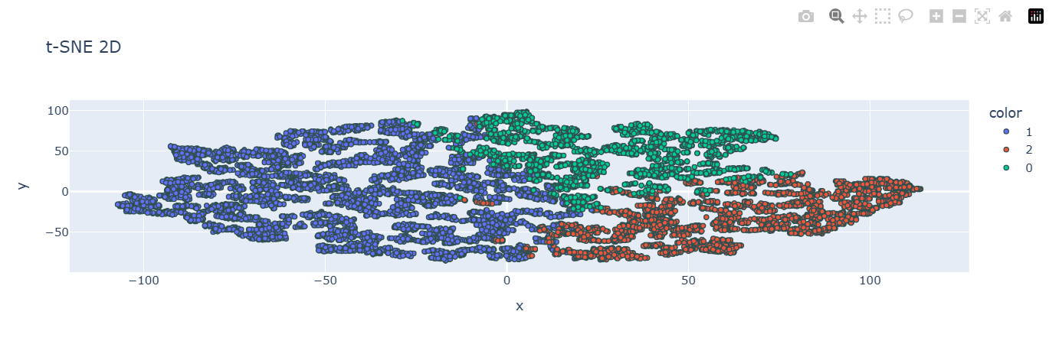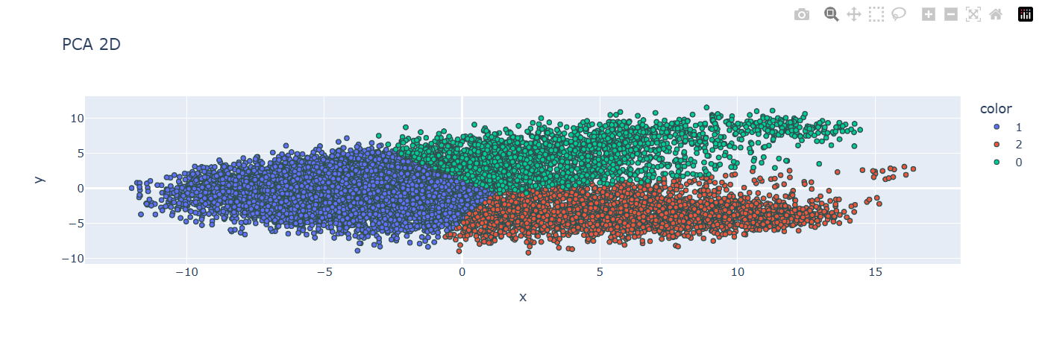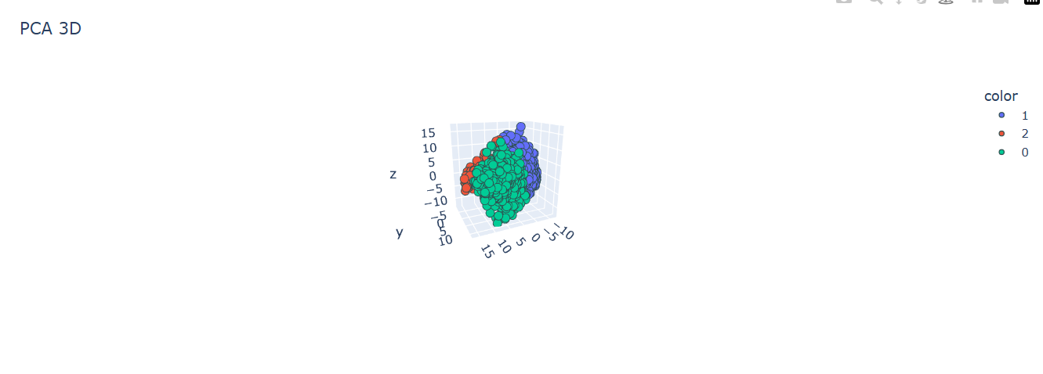**Representative Output Screenshots and Plots**

Fig-3

Fig-2

Fig-1

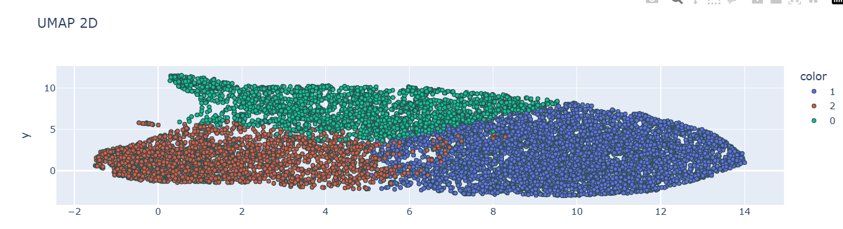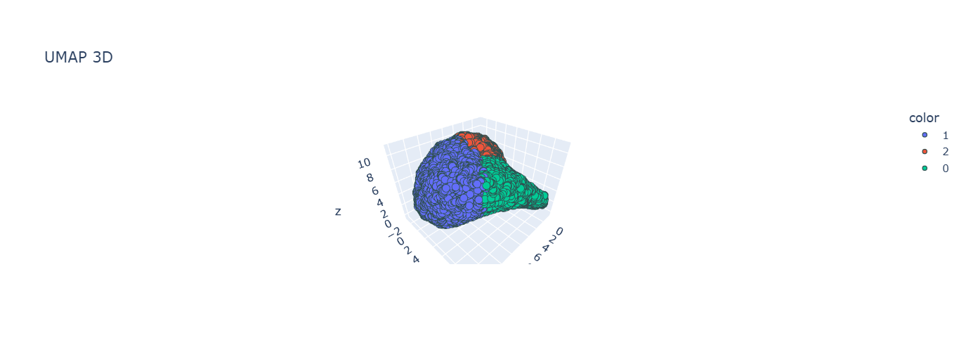

Fig-4

Fig-5

1. **PCA Visualization (Figure 1,2,)**: A plot showing the primary variance in gene expression across cells, grouping cells by broad cellular types.
2. **t-SNE Clustering (Figure 3)**: A plot depicting refined clusters, revealing local cellular neighborhoods with greater clarity but with the need for parameter tuning.
3. **UMAP Clustering (Figure 4,5)**: A stable, computationally efficient plot showing distinct and continuous clusters, effective for interpreting cell lineage and state transitions.

Fig-6

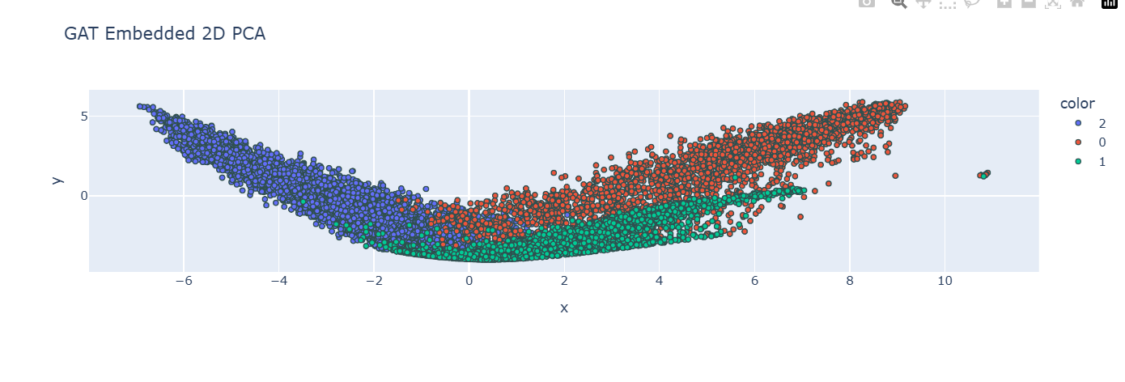

Fig-7

Fig-8

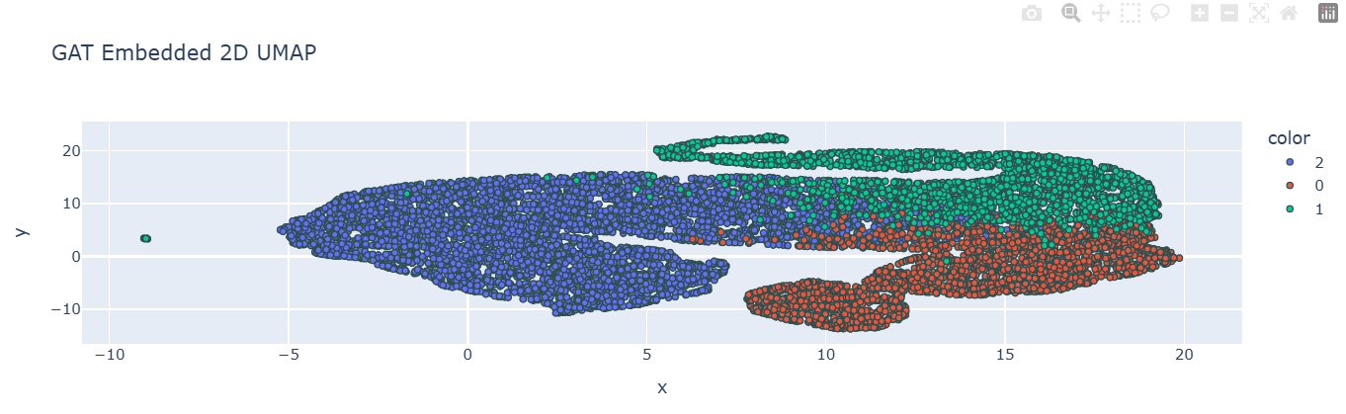

Fig-7

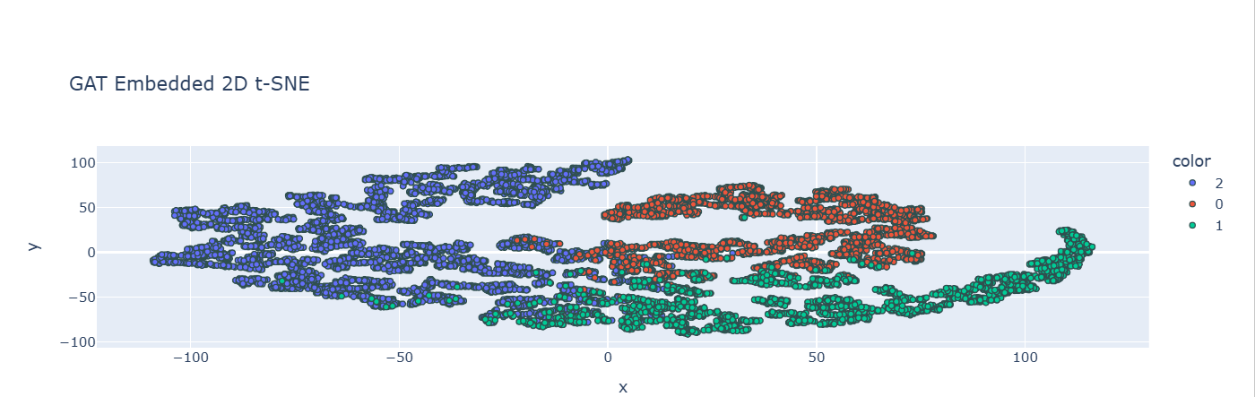

Fig-8

**GCN Network Visualization (Figure 6,7,8)**: A graphical representation showing clusters based on local and global cell relationships, capturing cellular hierarchy.

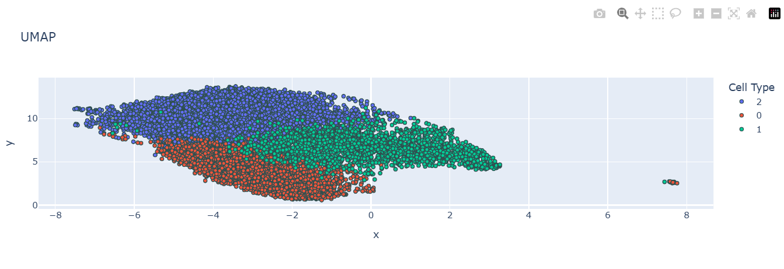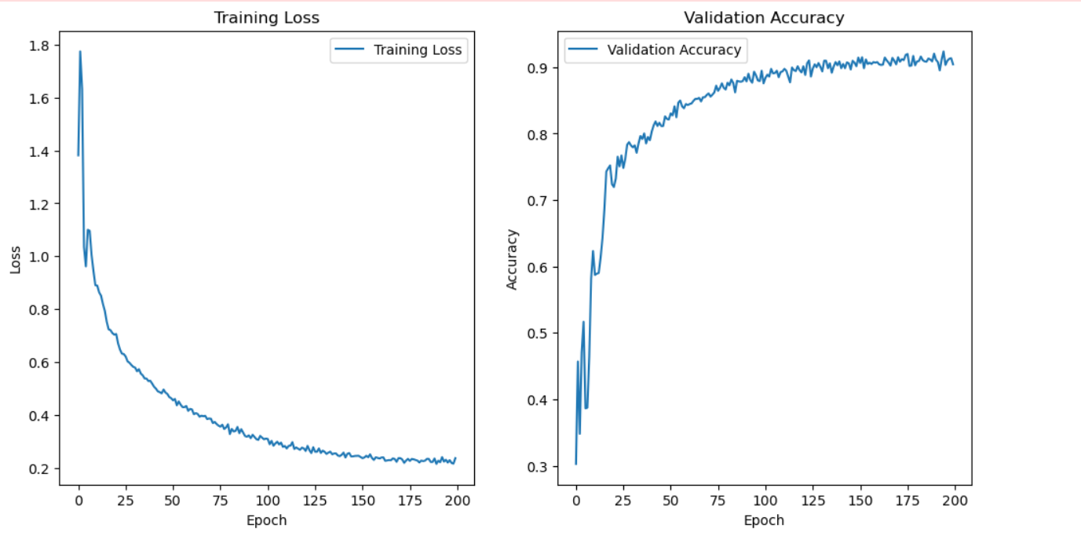

Fig-10

Fig-9

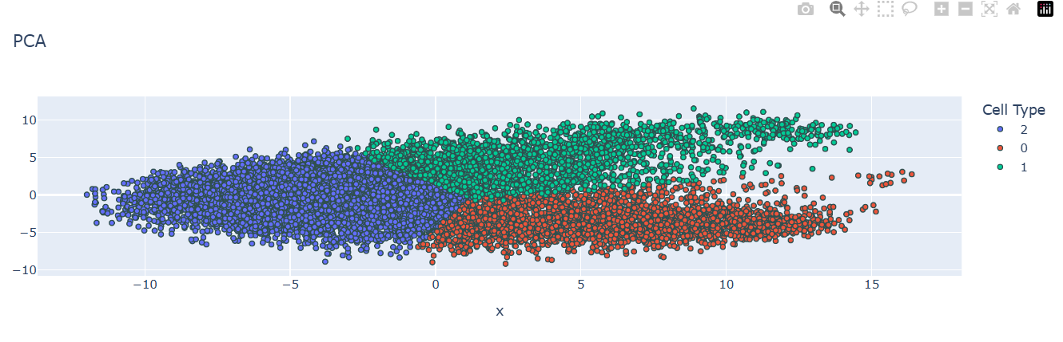

Fig-11

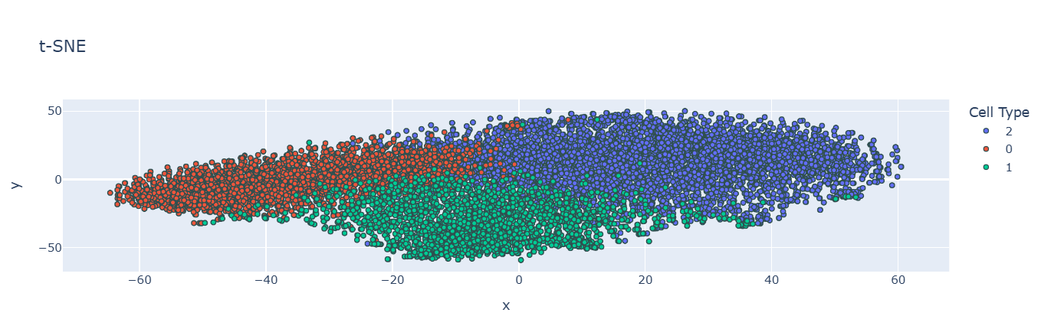

Fig-12

**GAT Network Visualization (Figure 9,10,11,12)**: A GAT-based network graph showing distinct clusters with dynamically weighted edges, allowing finer distinctions and capturing cell transition states.

**6.Conclusion and Future Work**

This study explored the application of machine learning and graph-based neural networks (GNNs) for analyzing single-cell RNA sequencing (scRNA-seq) data. scRNA-seq provides detailed insights into cellular heterogeneity, enabling researchers to understand gene expression patterns across individual cells. However, the high-dimensional nature of scRNA-seq data, combined with technical noise and dropout events, poses significant challenges for accurate analysis. To address these challenges, this project employed dimensionality reduction techniques (PCA, t-SNE, UMAP) and advanced neural networks (Graph Convolutional Networks, Graph Attention Networks) to reveal patterns and relationships within the data.

Key findings of this study demonstrated that:

* **Dimensionality reduction techniques** like UMAP and t-SNE, though computationally intensive, effectively captured both local and global structures, allowing for high-quality clustering and visualization of cellular states.
* **Graph-based models**, specifically GCNs and GATs, captured complex cell-to-cell relationships and hierarchical interactions. GCNs provided a clear representation of cellular hierarchies, while GATs added flexibility by assigning dynamic weights to cell interactions, making it particularly useful for identifying transition states in developmental or disease progression contexts.

These experimental findings validate the utility of combining dimensionality reduction with graph-based modeling to interpret complex single-cell data. Each technique has distinct strengths and limitations: PCA offers efficiency for preliminary noise reduction, t-SNE and UMAP enhance interpretability, and GNNs allow for detailed analysis of cellular relationships.

**Future Work**

There are several promising avenues for future research to expand on the methods and findings of this project:

1. **Improving Scalability and Efficiency**: While GCNs and GATs provide detailed insights, they are computationally demanding, especially on large scRNA-seq datasets. Future work should focus on optimizing these models for scalability, potentially by integrating distributed computing frameworks or developing lighter, more efficient GNN architectures suited for high-dimensional data.
2. **Exploring Alternative Machine Learning Models**: Future studies could evaluate other advanced machine learning architectures, such as recurrent neural networks (RNNs) for modeling temporal gene expression dynamics and generative adversarial networks (GANs) to simulate synthetic data for augmentation and validation. These models could uncover additional insights into cellular processes, such as lineage tracing and cellular differentiation.
3. **Integration with Multi-Omics Data**: Integrating scRNA-seq data with other omics data types, such as proteomics or metabolomics, would provide a more comprehensive view of cellular function and regulation. Multi-omics integration could enhance the biological interpretability of cell states and interactions, offering a deeper understanding of molecular mechanisms underlying cellular behaviors.
4. **Advanced Dimensionality Reduction Techniques**: There is scope for developing new dimensionality reduction algorithms that balance computational efficiency with the ability to preserve both local and global data structures. Such techniques would be highly beneficial for visualizing complex cellular landscapes, facilitating studies of differentiation pathways and rare cell populations.
5. **Standardized Benchmarking**: A comparative study of machine learning models for scRNA-seq under standardized experimental conditions would support the development of best practices. Such benchmarks could improve model selection and enable more reproducible, accurate results across diverse scRNA-seq datasets.

**7.References**

• **Luecken, M. D., & Theis, F. J. (2019). Current best practices in single-cell RNA-seq analysis: A tutorial.**  
This tutorial covers comprehensive best practices for analyzing scRNA-seq data, including preprocessing and normalization steps crucial for reliable data analysis. It directly supports the methods implemented in your project.

[Link: <https://doi.org/10.15252/msb.20188746>]

• **Stuart, T., & Satija, R. (2019). Integrative single-cell analysis.**  
This paper provides an in-depth review of single-cell analysis techniques and the integration of scRNA-seq data, including dimensionality reduction, making it relevant for understanding data clustering and visualization.

[Link: <https://doi.org/10.1038/s41576-019-0093-7>]

• **Becht, E., McInnes, L., Healy, J., Dutertre, C.-A., Kwok, I. W., Ng, L. G., ... & Newell, E. W. (2019). Dimensionality reduction for visualizing single-cell data using UMAP.**  
This paper discusses UMAP, a popular dimensionality reduction technique, comparing it to alternatives like PCA and t-SNE, making it essential for understanding your project’s visualization techniques.

[Link: <https://doi.org/10.1038/nbt.4314>]

• **Velickovic, P., Cucurull, G., Casanova, A., Romero, A., Lio, P., & Bengio, Y. (2017). Graph attention networks.**  
This foundational paper introduces Graph Attention Networks (GATs), a model relevant to your project's exploration of cell-to-cell relationships and structural modeling in scRNA-seq data.

[Link: <https://arxiv.org/abs/1710.10903>]

• **Heumos, L., Schaar, A., & Single-cell Best Practices Consortium. (2023). Best practices for single-cell analysis across modalities.**  
  
This recent paper highlights best practices in single-cell data analysis across different modalities, providing guidance on advanced analytical approaches suitable for your project.

[Link: <https://www.nature.com/articles/s41576-023-00586-w>]

• **Satija, R., Farrell, J. A., Gennert, D., Schier, A. F., & Regev, A. (2015). Spatial reconstruction of single-cell gene expression data.**  
  
This work covers the spatial reconstruction of single-cell gene expression, which is directly relevant to identifying cell types and states in scRNA-seq data.

[Link: <https://www.nature.com/articles/nbt.3192>]

• **McInnes, L., & Healy, J. (2018). UMAP: Uniform manifold approximation and projection for dimension reduction.**  
  
This source explains the theory and application of UMAP, a critical tool used for dimensionality reduction and data visualization in scRNA-seq studies.

[Link: <https://umap-learn.readthedocs.io/en/latest/>]

• **Hafemeister, C., & Satija, R. (2019). Normalization and variance stabilization of single-cell RNA-seq data using regularized negative binomial regression.**  
  
This paper presents advanced methods for normalization and variance stabilization, directly supporting preprocessing steps in scRNA-seq data analysis to ensure accurate downstream results.

[Link: <https://doi.org/10.1186/s13059-019-1874-1>]