Solution

Docker File

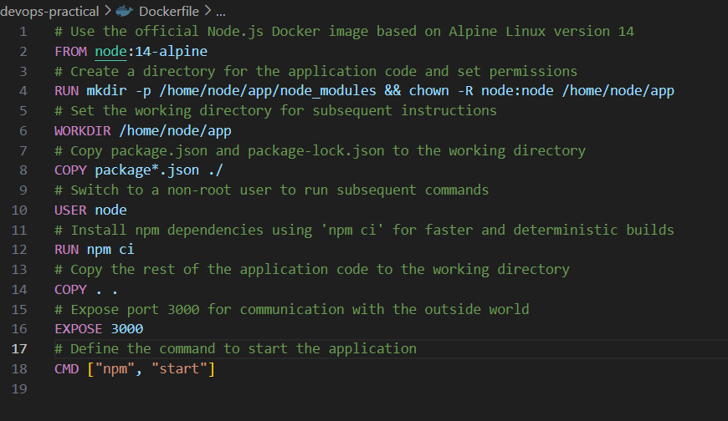

And also created Docker compose for the local test

**Docker commands**

Docker build –t nodesjsapp .

Docker images screenshot

Docker tag devendraazure/nodejsapp:v1.1.0 nodesjsapp

Pushing image to dockerhub

Docker push devendraazure/nodejsapp:v1.1.0

**Kubernetes yaml files**

Please refer the repo K8s with kustimazation

1) frontend for nodeJs application

2) mongo DB folder for Mongo DB Database

Yaml deployment command

Kubectl apply –k .

**Terraform**

Terraform script Referred the terraform official website for EKS cluster creation and deploy the terraform script on AWS to provision cluster quickly.

Please refer the folder. Terraform script created below resources

1)#Create a custom VPC

2)#Create Subnets

3)#Creating Internet Gateway IGW

4)#Creating Route Table

5)#Adding security group

6)#Create a Route in the Route Table with a route to IGW

7)#Associate Subnets with the Route Table

8)#Creating IAM role for EKS

9)#Creating EKS Cluster

Screen shot

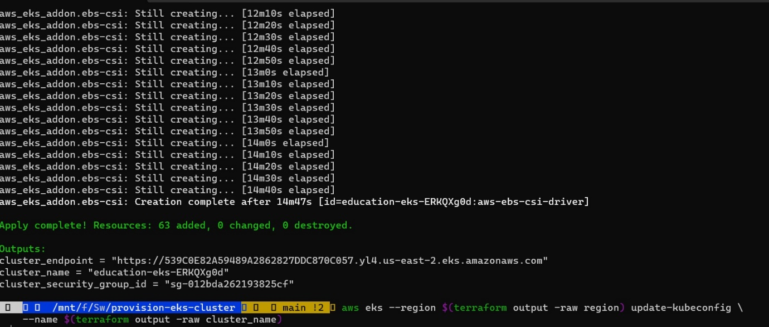

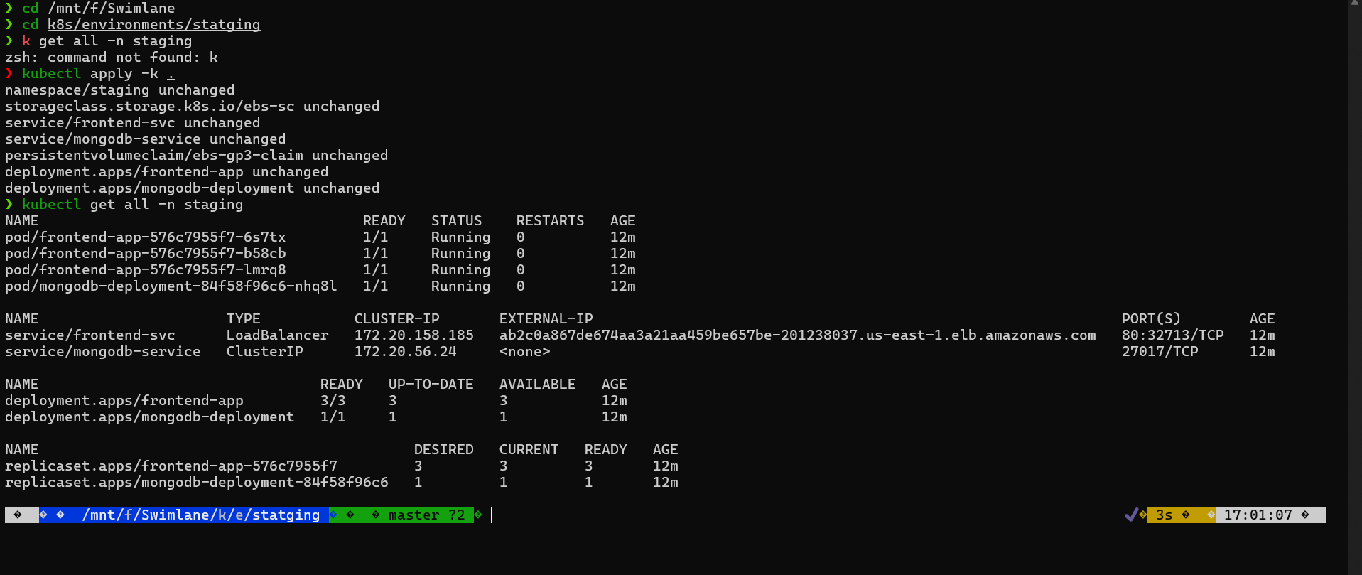

Application screen shot 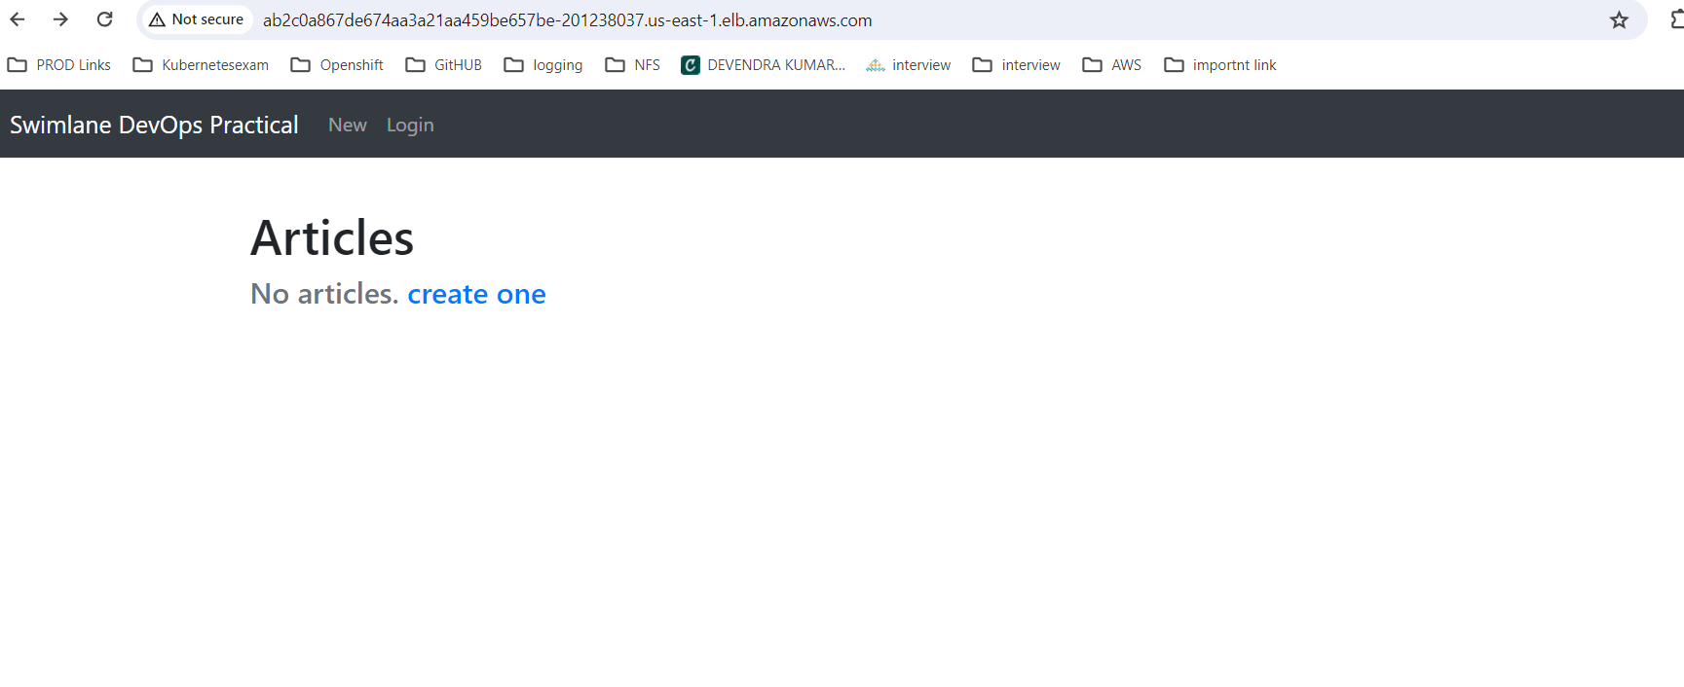

2 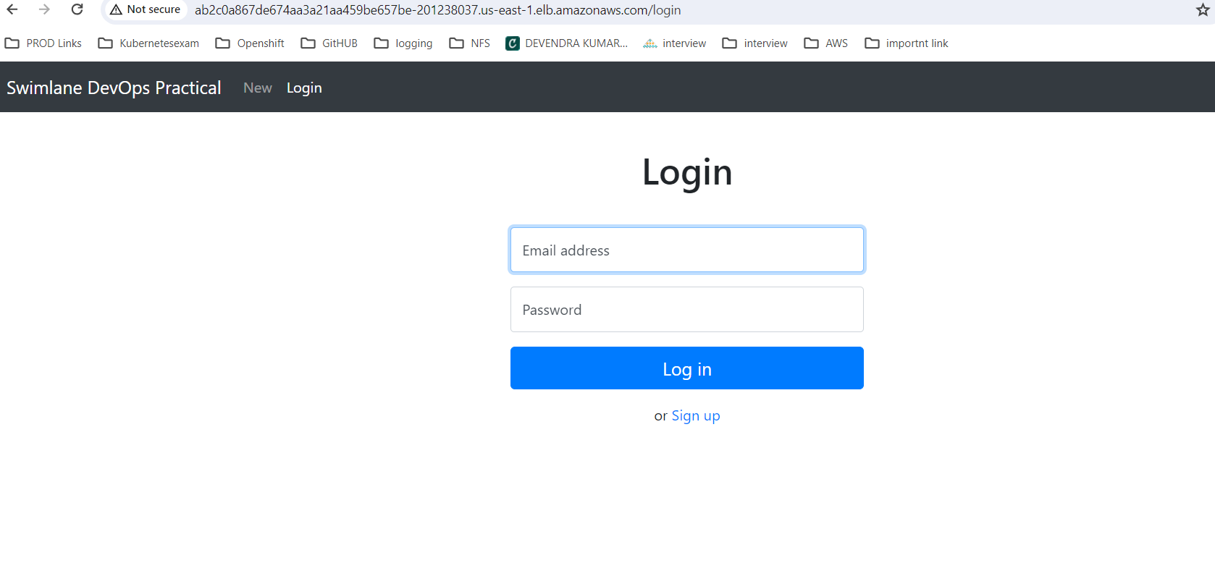

3

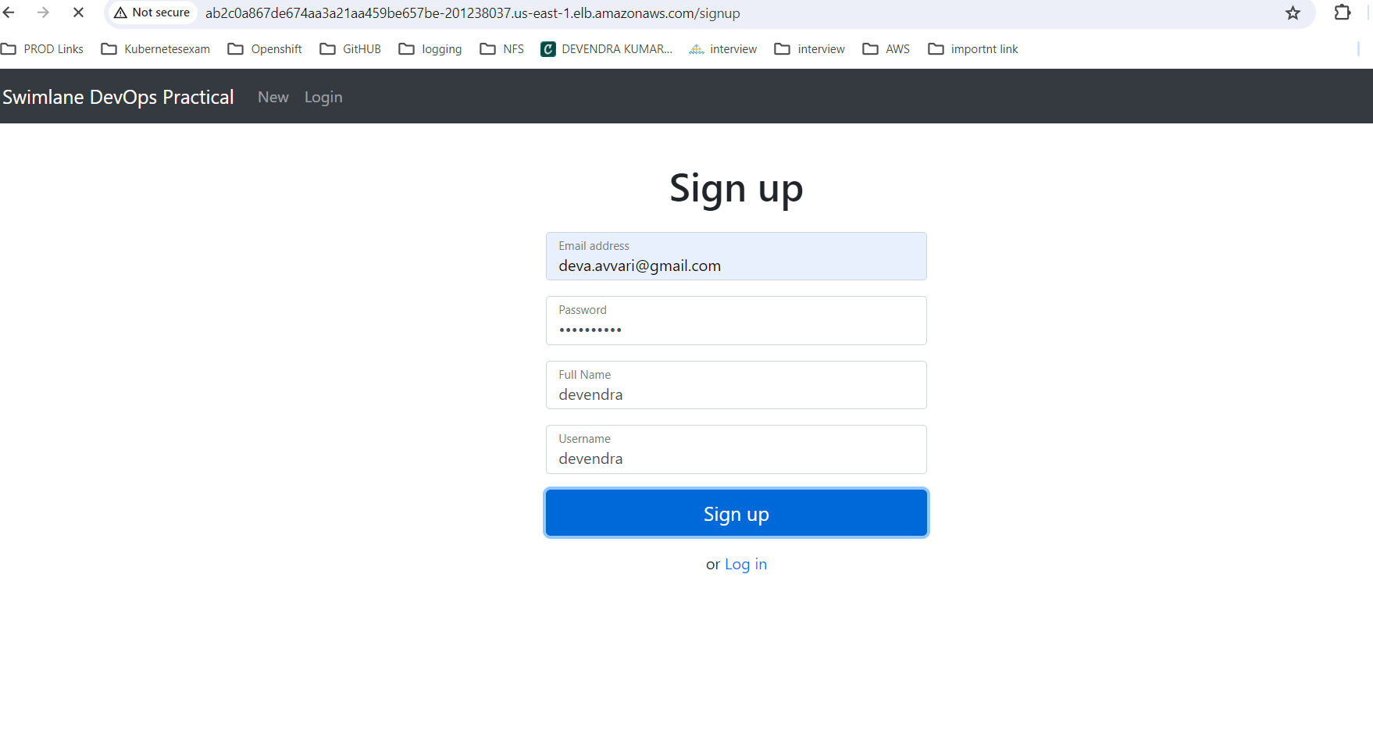

4

