Experiment Design Document
Client-level synthetic A/B test | Salon Experiment & Causal Analysis
DESIGN FOR METHOD PRACTICE ONLY — all participants, outcomes, and treatment effects are synthetic.

1. Purpose and design summary
This document describes the analysis plan for the fictional service-revenue A/B experiment; no real business test took place. The generator assigns 24,000 synthetic clients once, in equal groups, for the two-month period from September 1 through October 31, 2026.
Design item | Specification
Randomization unit | Client ID; one assignment per client
Allocation | 12,000 Control / 12,000 Treatment
Assignment date | 2026-08-15
Experiment period | 2026-09-01 through 2026-10-31 inclusive
Primary estimand | ITT difference in mean total net service revenue per randomized client
Analysis population | All 24,000 assigned clients, including zero-outcome clients
Primary test | Two-sided Welch t-test; alpha 0.05; report 95% CI
Policy context | Separate regional policy begins 2026-07-01; it overlaps the A/B period

2. Hypothesis and intervention
Null hypothesis (H0): Treatment and Control have equal mean client-level service revenue during the experiment window.
Alternative (H1): The mean client-level service revenue differs between groups (two-sided).
Treatment: Assignment to the synthetic Treatment group; assignment itself defines exposure for ITT.
Control: Assignment to the synthetic Control group.
The generator injects a 1.06 gross service-revenue multiplier for appointments belonging to Treatment-assigned clients during September–October only, before discounts. This is an artificial implementation parameter, not an assumed observed effect in the statistical analysis. It is not designed to directly alter visit volume, retention, appointment status, or product revenue.

3. Outcomes and guardrails
Role | Metric and definition | Interpretive note
Primary | Sum of appointment_revenue per assigned client, Sep-Oct 2026 | Net service revenue; zero if no linked experiment-period service revenue
Secondary | Appointment rows and completed/cancelled/no-show events per client | Descriptive guardrails; appointment rows are aggregated by client
Secondary | Period engagement / retention proxy | At least one completed appointment during the two-month period; not long-term retention
Secondary | Product revenue per randomized client | Only linked client sales; anonymous walk-in sales cannot be assigned to a client

The intention-to-treat analysis uses one row per randomized client. Repeated appointment rows from one person are not independent randomized observations. All assigned clients—including no-visit clients—must remain in the primary cohort with zero service revenue when applicable.

4. Power and sample-size planning
The executed notebook used the May–June 2026 client-level baseline service-revenue standard deviation (125.69), two-sided alpha=0.05, target power=0.80, equal allocation, and a two-sample t-test framework. The planning MDE is 0.10 SD, equivalent to 12.57 synthetic currency units per client. This is a deliberately small standardized benchmark for illustration, not a stakeholder-derived minimum worthwhile effect and not the injected multiplier.
Planning quantity | Result
Baseline mean / SD (May-June) | 68.97 / 125.69
Illustrative MDE | 0.10 SD = 12.57 per client
Approx. required sample at MDE | 1,571 clients per group
Observed sample | 12,000 clients per group
Approx. 80%-power detectable effect at observed n | 0.036 SD = 4.55 per client

This is an approximate parametric power calculation for a zero-inflated, skewed client outcome. Power depends on the specified effect, variance, model, and assumptions; the result is not a guarantee of sensitivity or a business threshold.

5. Assignment, SRM, and baseline balance
Assignment is read from experiment_assignments.csv and validated for unique client IDs, valid labels, fixed assignment date, and expected experiment dates. The observed cohort contains exactly 24,000 clients, 12,000 per arm. The 1:1 chi-square SRM diagnostic returned statistic 0.00 and p=1.00; this indicates no observed ratio mismatch, not that every other aspect of implementation is valid.
Baseline balance was described at client level using pre-experiment revenue, appointment counts, signup age, retention segment, and preferred region. The largest absolute SMD among the reported features was 0.027. SMDs summarize observed differences; small values do not prove correct randomization or absence of unmeasured differences.
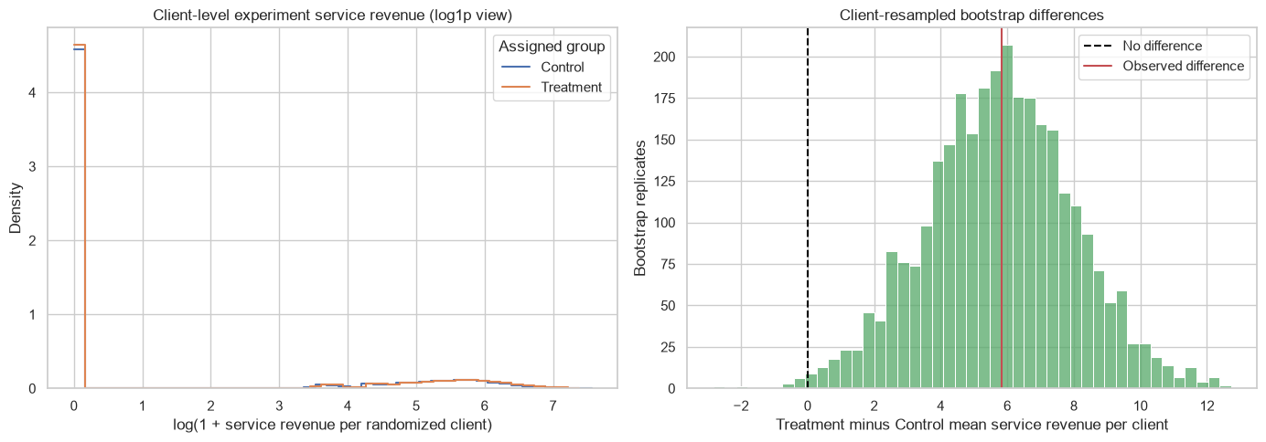
Client-level outcome distribution from the executed analysis notebook.

6. Primary estimation plan
- Construct the assignment roster with exactly one row per randomized client.
- Sum client-linked net service revenue over September 1–October 31, 2026; assign zero to clients with no experiment-period revenue.
- Compare assigned Treatment and Control means using a two-sided Welch t-test, an unequal-variance 95% confidence interval, and percentage lift relative to Control mean.
- Use a client-resampled bootstrap confidence interval as a distributional robustness summary; resample clients within group, not appointment rows.
- Report sample sizes, group means, absolute effect, percentage lift, interval, and p-value. Interpret statistical uncertainty separately from business value.
Executed A/B result | Estimate
Control mean / Treatment mean | 65.02 / 70.85 per client
ITT difference / relative lift | +5.83 / +8.96%
Welch 95% CI / p-value | [1.55, 10.11] / 0.0076
Client bootstrap 95% CI | [1.33, 10.20]
Zero experiment-period revenue clients | 18,384 retained

7. CUPED and regression plan
CUPED uses client-level pre-experiment service revenue X and the estimator Y_adjusted = Y − theta(X − mean(X)), theta = Cov(Y,X)/Var(X). The calculated theta was 0.0153; variance reduction was 0.19%. The adjusted estimate was +5.75 (95% CI 1.48 to 10.03; p=0.0084), compared with +5.83 unadjusted. This indicates negligible precision gain for this generated outcome.
The HC3 regression uses treatment assignment, baseline service revenue, baseline appointment count, signup age, retention segment, and preferred outlet region. Its treatment coefficient was +3.61 (95% CI 0.76 to 6.47; p=0.0132). A sensitivity using covariates restricted to the pre-policy period gave +3.43 (95% CI 0.71 to 6.16; p=0.0134). No post-treatment covariates are included. Regression functional form and covariate relevance remain assumptions.
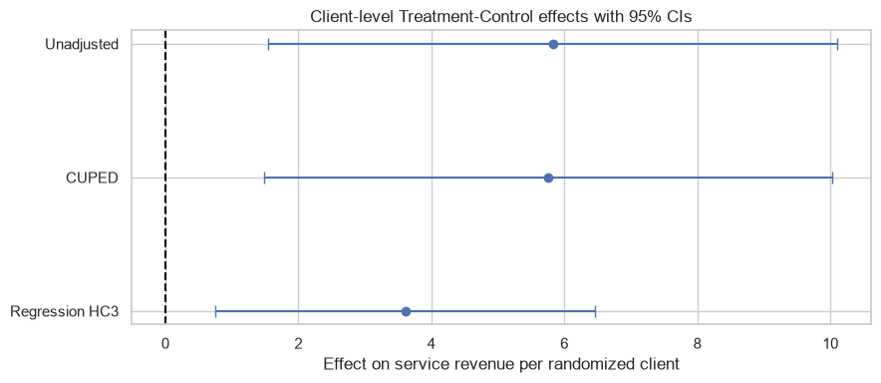
Adjustment comparison from the executed CUPED/regression notebook.

8. Robustness and interpretation
- Outcome is zero-heavy and skewed: 76–77% zero client outcomes; skewness 3.36–3.64.
- Leave-one-client-out unadjusted estimates ranged from 5.700 to 5.983; no clients were deleted.
- A pooled 99th-percentile winsorized outcome sensitivity estimated +5.733 (95% CI 1.780 to 9.686; p=0.0045). This alters the outcome scale and remains sensitivity-only.
- The A/B window overlaps a regional policy post-period beginning July 1; randomization estimates the A/B assignment contrast within the generated policy environment, not an isolated policy effect.
- All estimates are properties of fictional data. They do not prove a real service intervention works.

9. Assumptions and limitations
- Correct recorded client-level assignment, one assignment per client, valid outcome links, and complete ITT inclusion.
- No interference between clients and consistent measurement of service revenue.
- Adjustment covariates are pre-experiment and not caused by treatment; model specification is appropriate enough to support precision adjustment.
- The DiD policy has only four regions (two treated, two control); inference with four clusters is weak and cannot support strong real-world causal evidence.
- Synthetic effects were deliberately injected; all data patterns and numerical outputs are instructional, not external evidence.
The design document is an analysis plan and record of the executed synthetic workflow, not a protocol for a real experiment without further stakeholder, ethics, and operational review.

