Salon Experiment & Causal Analysis
Final internship report | Analysis window: 2025-11 to 2026-10 | Prepared 7 November 2026
SYNTHETIC DATA ONLY — all entities and outcomes are fictional. Injected effects are design assumptions for method testing, not real-world findings.

Executive summary
This project uses a reproducible synthetic salon dataset to practice data checks, randomized experiments, Difference-in-Differences (DiD), CUPED, regression adjustment, and robustness analysis. The A/B experiment includes 24,000 clients, with 12,000 assigned to each group. The client-level intention-to-treat (ITT) estimate for September?October service revenue was +5.83 synthetic currency units per randomized client (8.96% relative to Control; Welch 95% CI 1.55 to 10.11; p=0.0076). This result comes from generated data, not evidence about real salons.
CUPED gave a similar estimate (+5.75; 95% CI 1.48 to 10.03) but reduced outcome variance by only 0.19%. HC3 regression adjustment produced a smaller positive estimate (+3.61; 95% CI 0.76 to 6.47). The primary DiD service-revenue estimate for July–August was +3,558.20 per outlet-month (about 7.75% of Control's post mean), but only four regions (two treated and two control) define the policy assignment; conventional region-clustered inference is unreliable. Pre-period patterns provide a diagnostic, not proof of parallel trends.
Recommendation: do not use this simulation for an operational rollout or real-business causal claim. It is suitable for validating analysis workflows and documenting how assumptions affect estimates.

Business problem and objectives
The fictional salon scenario is used to examine a service intervention and a regional policy when clients can have repeat appointments, many outcomes are zero, and the intervention periods overlap. The project objectives were to build a relational synthetic dataset, check assignment and data integrity, use client-level ITT for the randomized experiment, assess baseline balance and sample-ratio mismatch, estimate DiD on outlet-month outcomes, and compare unadjusted, CUPED, and regression-adjusted estimates.

Synthetic dataset and generation methodology
Element | Specification
Appointments | 300,000; dates within 2025-11-01 to 2026-10-31 inclusive
Entities | 24,000 clients; 22 outlets; 4 synthetic regions; 176 stylists; 10 services; 15 products
Randomness / memory | NumPy seed 42; appointments generated in 25,000-row chunks
Tables | 10 CSV files covering appointments, clients, outlets, stylists, services, products, sales, assignments, policy and dictionary
Effects by construction | 6% Treatment service gross-revenue multiplier in Sep-Oct; 4% treated-outlet multiplier from Jul 1
Safety | Staged output, validation before commit, rollback protection and refusal to overwrite existing CSVs

The generator samples fictional clients and engagement segments, signup dates, visit counts, appointment dates, outlet/stylist/service selections, booking outcomes, prices, discounts, and product sales. Walk-ins have blank client IDs. Service revenue is recorded separately from product revenue. The artificial A/B and DiD multipliers are applied to simulated gross service amounts before discounts; the A/B multiplier does not directly alter appointment volume, retention, no-show/cancellation rates, or product revenue.
The generator's validation design checks schemas and order, dimensions, identifiers, foreign keys, stylist/outlet ownership, valid statuses and date limits, assignment and signup timing, 1:1 assignment counts, policy mapping, sale links, nonnegative revenue and discounts, and product revenue reconciliation within the documented 0.01 rounding tolerance.

Data quality and descriptive EDA
Observed check / measure | Calculated result
Appointment rows / observed dates | 300,000 / 2025-11-01 to 2026-10-31
Completed / Cancelled / No-show | 268,576 (89.525%) / 19,952 (6.651%) / 11,472 (3.824%)
Service revenue / service discounts | 16,422,828.37 / 403,765.28 synthetic currency units
Product sales revenue | 1,885,808.15 synthetic currency units, reported separately
Most frequent service | Classic haircut (60,266 appointments)
Most frequent outlet by appointments | OUT06 (14,457 appointments)
Client retention segments | Regular 9,529; Occasional 6,097; Loyal 4,793; At-risk 3,581
Intentional nullable values | 24,101 appointment client IDs (walk-ins); 268,576 completed cancellation reasons; 7,101 product-sale client IDs (walk-in sales)

Status and revenue summaries were calculated from the existing synthetic CSVs. Missing client IDs for walk-ins and blank cancellation reasons for completed appointments are expected by design; these values should not be treated as data errors without regard to their semantics. EDA time trends describe a single simulated historical period and do not establish causal effects.
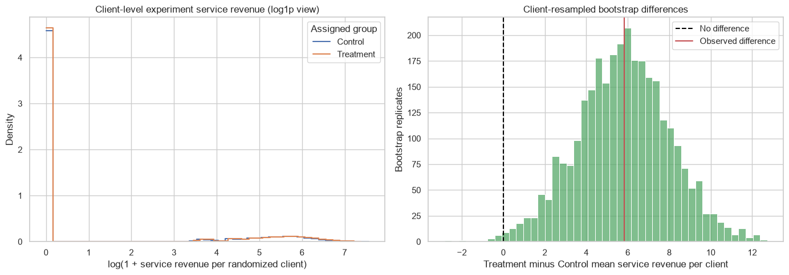
Figure 1. Client-level experiment revenue distribution (visualization from executed A/B notebook; log scale used for display).

A/B experiment design and diagnostics
Hypothesis. Two-sided comparison of mean client-level service revenue in Treatment versus Control during 2026-09-01 to 2026-10-31.
Primary estimand. Treatment-minus-Control difference in total net service revenue per randomized client, analyzed by assigned group (ITT).
Guardrails / secondary outcomes. Appointment completion, cancellation/no-show, period engagement/retention proxy, appointment volume, and identified product revenue per client; secondary metrics are exploratory and not multiplicity-adjusted.
Cohort handling. Exactly one assignment per client; all 24,000 assigned clients are kept. The 18,277 clients with no experiment-window appointment rows remain in the analysis; zero-revenue clients are retained. Repeated appointment rows are aggregated before inference.
Diagnostic | Observed result
Assignment | 12,000 Control / 12,000 Treatment
SRM test | Chi-square statistic 0.00; p=1.00; no 1:1 ratio discrepancy detected
Baseline balance | Largest absolute standardized mean difference among reported numeric/categorical features: 0.027
Baseline definition for power | May–June 2026 client-level revenue; mean 68.97, SD 125.69

The balance notebook includes pre-experiment service revenue, appointment counts, signup age, retention segment, and preferred region. The maximum absolute SMD (0.027) is descriptively small under the common 0.10 rule of thumb, which is not a pass/fail test and does not prove randomization validity.

Sample size and power methodology
Planning used a two-sided alpha of 0.05, target power of 0.80, equal allocation, and a two-sample t-test standardized-effect framework. The stated MDE was 0.10 baseline standard deviations (12.57 currency units per client), chosen as a small standardized planning benchmark—not a business-defined minimum worthwhile effect and not the known injected uplift. The approximation requires about 1,571 clients per arm. With 12,000 per arm, the notebook estimates an approximately detectable effect of 0.036 SD (4.55 currency units per client) at 80% power. This planning calculation is approximate for zero-inflated, skewed revenue and should not be treated as a guarantee.

Primary ITT results
Measure | Estimate
Control mean (n=12,000) | 65.02
Treatment mean (n=12,000) | 70.85
Treatment − Control | +5.83 per randomized client
Relative lift vs Control mean | +8.96%
Welch 95% CI | [1.55, 10.11]
Client bootstrap percentile 95% CI | [1.33, 10.20]
Welch two-sided test | p=0.007604

The interval estimates and p-value quantify uncertainty under the client-level comparison and observed synthetic design. Their statistical significance does not support real-world impact. The generated effect is known by construction to the project design, but it was not inserted into these estimators; observed lift need not equal the nominal injected multiplier because of net discounts, zeros, and simulation variation.

Difference-in-Differences analysis
Policy assignment is at the region level: North and South treated, East and West control, with 22 outlets total (11 per outlet group). The policy date is 2026-07-01. The primary panel uses November 2025–June 2026 as pre-policy and July–August 2026 as post-policy, avoiding the A/B period. Outlet-month outcomes are total service revenue and appointment counts. Two-way fixed effects include outlet and month indicators.
Outcome | DiD estimate | 4-region cluster 95% CI | p-value | Relative to Control post mean
Service revenue / outlet-month | +3,558.20 | [761.48, 6,354.92] | 0.0271* | +7.75%
Appointments / outlet-month | +40.26 | [-36.06, 116.58] | 0.1918* | +4.75%

*Conventional cluster-robust figures use only four region clusters and are unreliable. Ordinary (non-clustered) model-based 95% intervals were [990.66, 6,125.75] for service revenue and [2.74, 77.79] for appointments; these do not address policy-level clustering and should not be treated as decision-grade.
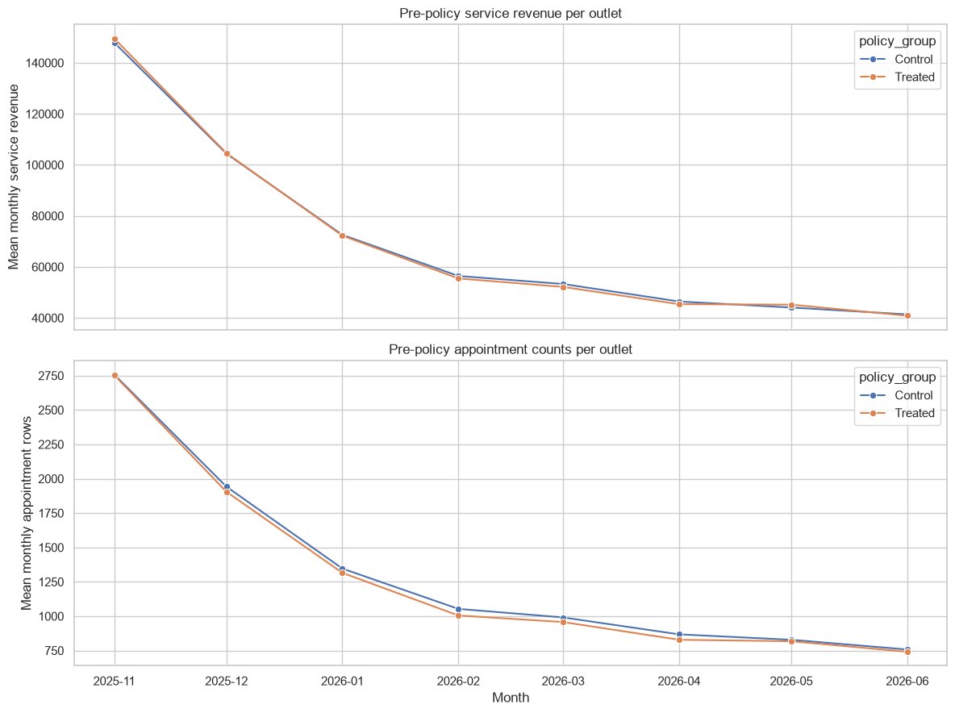
Figure 2. Pre-policy treated/control outcome trends from the executed DiD notebook.
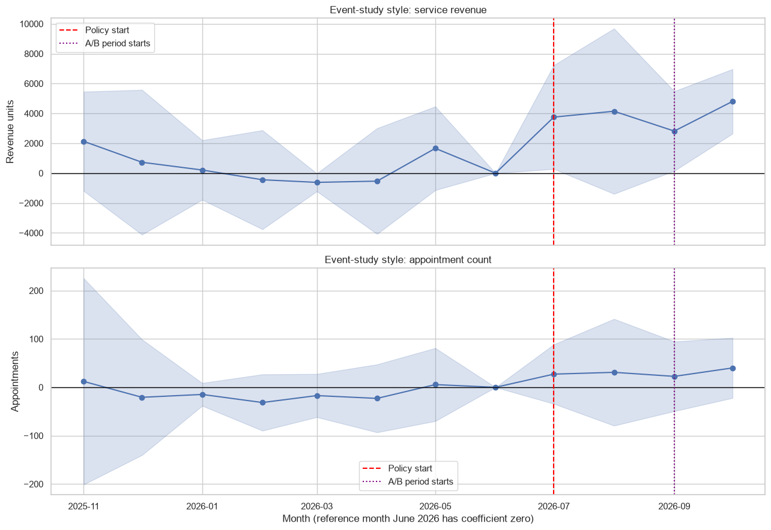
Figure 3. Event-study style estimates relative to June 2026; four-region clustered bands are weak diagnostics.
Descriptive pre-period linear slopes for service revenue were −13,593.63 (treated) versus −13,442.80 (control) per month, a slope difference of −150.83. Appointment-count slopes were −250.411 versus −250.839, difference +0.427. While the linear slopes look similar, monthly revenue gaps fluctuate and parallel trends cannot be established from eight pre months, two treated regions, and two control regions. Visual diagnostics do not prove the unobserved counterfactual.

Overlap sensitivity
September–October 2026 is post-policy but also the A/B intervention period. Extending the post period through October gave revenue DiD estimates of 3,489.13 unadjusted and 3,531.54 with an exploratory outlet-month share of client-linked Treatment appointments; corresponding four-cluster p-values were 0.009 and 0.006. Appointment-count estimates were 41.38 and 40.85, with p-values 0.148 and 0.151. These cluster-based statistics remain unreliable, and the exposure-share adjustment is not a validated correction. July–August remains the primary clean policy window.

CUPED and regression adjustment
Method | Effect/client | 95% CI | p-value | Relative lift
Unadjusted Welch | +5.8278 | [1.5486, 10.1070] | 0.0076 | 8.96%
CUPED | +5.7534 | [1.4782, 10.0285] | 0.0084 | 8.84%
Regression HC3 | +3.6117 | [0.7554, 6.4680] | 0.0132 | 5.55%
HC3, pre-policy-only covariates | +3.4342 | [0.7112, 6.1573] | 0.0134 | 5.28%

CUPED used pre-experiment client service revenue X, with theta=Cov(Y,X)/Var(X)=0.0153. It reduced outcome variance by only 0.19%; the unadjusted versus CUPED confidence-interval width improved by approximately 0.09%. Thus CUPED did not materially improve precision in this dataset. HC3 regression used treatment assignment and only pre-experiment covariates (baseline revenue, appointment count, signup age, retention segment, and preferred region). The smaller regression estimates remain directionally positive, and the pre-policy-only specification is similar to the main adjusted result.
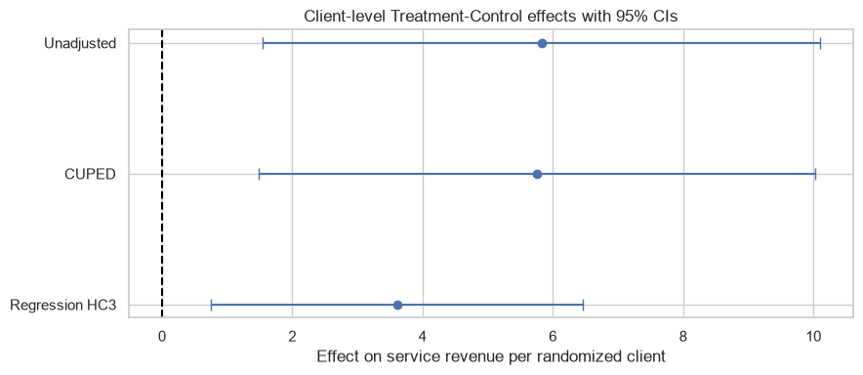
Figure 4. Unadjusted, CUPED, and HC3 effect estimates with 95% intervals from the executed adjustment notebook.
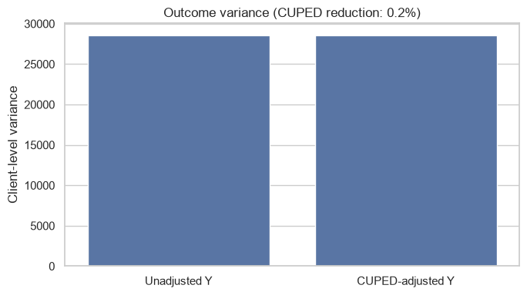
Figure 5. Unadjusted and CUPED outcome variance (0.19% reduction).

Robustness, assumptions, and limitations
- Outcome skew: experiment-period revenue skewness was 3.644 in Control and 3.360 in Treatment; 77.1% and 76.1% of client outcomes were zero. The top 1% contributed 15.9% and 14.7% of group revenue respectively.
- Influence diagnostic: leaving out one client at a time kept the unadjusted difference between 5.700 and 5.983; the largest change from the full estimate was 0.155. No client was removed from the primary analysis.
- Pooled 99th-percentile winsorization retained every client but changed the outcome: estimate 5.7332, 95% CI [1.7804, 9.6860], p=0.0045. This is a sensitivity estimand, not a replacement for the original outcome.
- Randomization-based A/B inference assumes assignment is recorded correctly, outcomes are consistently defined, clients do not interfere, and the client cohort is analyzed by assigned group. Adjustment additionally assumes covariates are measured before treatment and the chosen functional form is useful.
- DiD requires credible parallel counterfactual trends, no differential concurrent changes, stable composition/measurement, no spillovers, and no anticipation. The design has only four region clusters, making conventional cluster-robust inference unreliable.
- A/B and policy periods overlap in September–October; the A/B window also has post-policy exposure. Adjustment cannot turn synthetic data into real evidence.
- The results depend on a single generated dataset and documented artificial parameters. Statistical significance in the simulation is not business significance, external validity, or proof of a real effect.

Final recommendations and conclusion
The project brings the data checks, client-level A/B analysis, DiD, and adjustment comparisons together in a reproducible workflow. The A/B estimates are positive across the unadjusted, CUPED, and regression approaches, while CUPED adds little precision. The primary DiD estimate is positive for service revenue, but its assumptions are uncertain and inference from four regions is weak.
Recommendation: NO-GO for real-world operational rollout or business decisions based on this synthetic analysis. Continue only as a methods exercise; any real decision would require real and authorized data, a pre-specified outcome and decision threshold, a prospectively randomized experiment, and a policy evaluation with substantially more independent regions/clusters.
Source of reported analytical values: executed project notebooks 02, 03, and 04. EDA counts and totals were checked against the existing CSVs; no raw data were changed during documentation.

