Electronics mini project on

Visitor Counter & Auto Light-Switcher

By:

M Devendra Kumar Dora, 127137

Kusuma Shravan Kumar, 127135

Kshitij Kadane, 127134

CSE-II/IV

Section-A

Guided by

smt p.prithvi & smt v.rama

Electronics and communication engineering department

National institute of technology Warangal

November ,2013

Visitor Counter  
&  
Auto Light-Switcher

A circuit that is a bi-directional obstacle counter and can act as a switch depending on the count.

It is implemented using simple IR LEDs and Photodiodes along with the Micro-controller device Arduino to measure the analog current from the photo diode and increment/decrement the count.

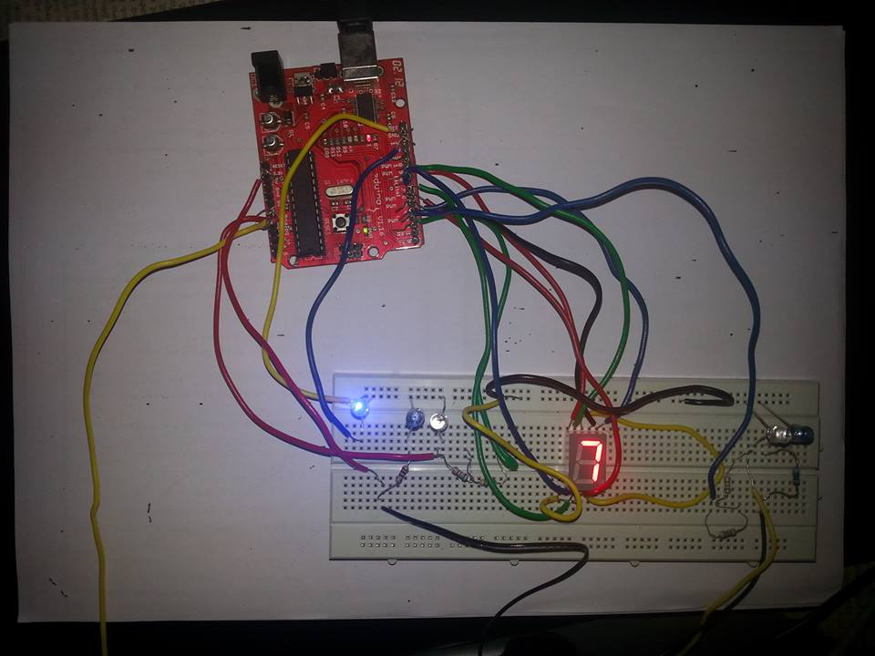

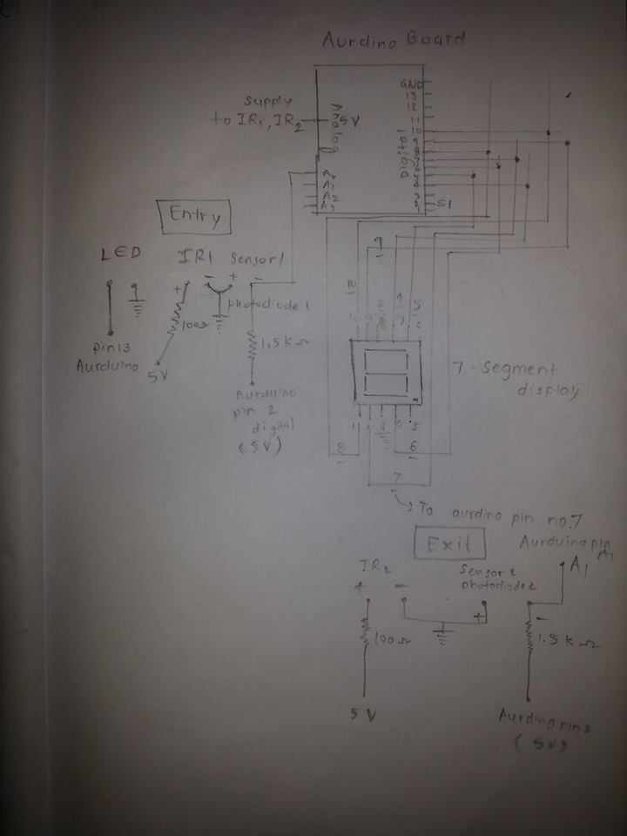

Overview:

This project titled “AUTO LIGHT SWITCHING” based on Bidirectional Visitor counter is designed and presented in order to count the visitors of an auditorium, hall, room, offices, malls, sports venue, etc.

The system counts both the entering and exiting visitor of the auditorium or hall or other place, where it is placed. Depending upon the interrupt from the sensors, the system identifies the entry and exit of the visitor.

On the successful implementation of the system, it displays the number of visitor present in the room. This system can be economically implemented in all the places where the visitors have to be counted and controlled.

For implementing the circuit we have used Arduino board,

2 IR sensors , 2 photo diodes ,1 seven segment display ,

1 led, resistors.

When an person is detected , the IR rays reflected by the person are received by photodiode and count gets increased in seven segment display. When the number of persons in the room is zero, then count will be zero and lights or any electrical appliances connected are switched off and when some persons are in the room ,lights gets ON.

Power shortage in India

* India is the fourth largest energy consumer after United States, China and Russia.
* Annual per capita power consumption in 2009: 96 kWh in rural and 288 kWh in urban areas in India VS. 2600 kWh and 6200 kWh in the European Union.
* 21% of world’s population without electricity is Indian.(300 million out of 1.4 billion)

This system can be used as an automated switch to increase energy efficiency. The system can be used at the entrance of a room to control the lights and other appliances.

For eg. When the number of people in the room is zero, the circuit can automatically switch off the power thus preventing energy wastage.Moreover, we wanted to apply our coding skills in electronics and circuits. So we took up this project.

Conclusion:

* We just took up this project as we were interested in electronics and wanted to learn about it. Through this project, we learnt a lot about the functioning and use of different electronic components and their applications in real life. We were able to correlate what we studied in our course to real life.
* Also this is very simple and effective idea which can be used in many places like hostel and hotel rooms to save energy.
* Thanks to our faculty for guiding us in this project.

## *References*

* Arduino online forums
* Wikipedia
* Google images
* Youtube