/\*\*\*\* Filenotice Product Process Document \*\*\*\*/

Frontend URL :- <https://filenotice.com/filenotice>

Customer :-

1. There is a registration page on fronted when you click on “Registration” menu . Here customer fill their detail and register as customer. And registration confirmation mail send to given email id.

Below is the customer registration page image -

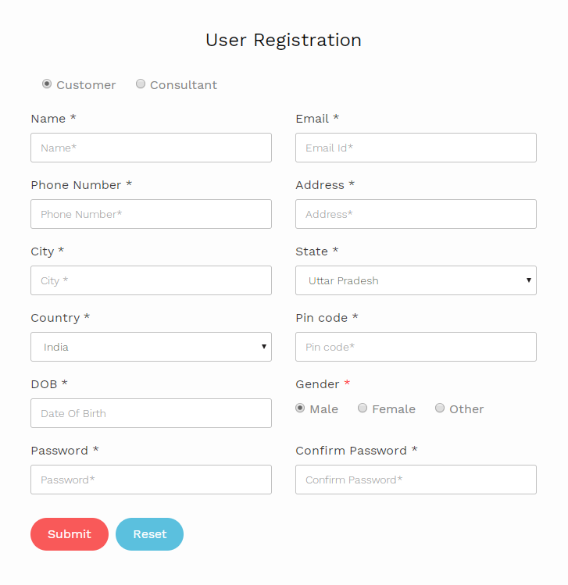

1. After registration there is a user login page that will be open after click on login menu .

Below is user login page image –

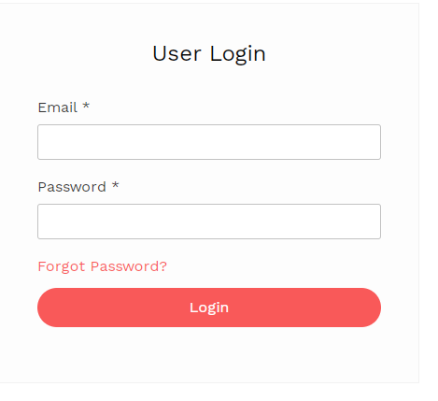

1. After login customer open a customer dashboard . On dashboard page show ticket count that was customer created .

Below is customer dashboard page image –

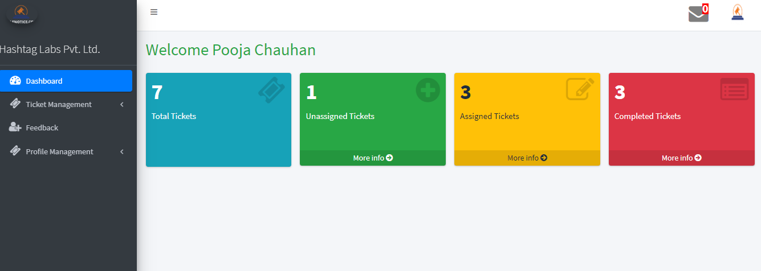

1. There is a ticket management tab where customer can create their ticket by click on “Unassigned Ticket” menu .

Below is unassigned ticket page image –

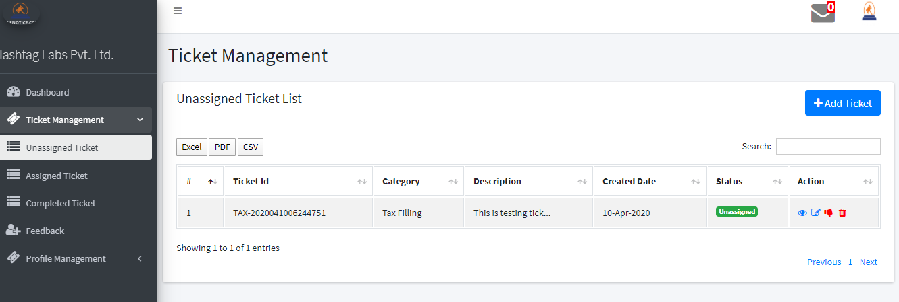

In above image this is the list of all created ticket that is not assigned to any consultant.

1. Click on Add Ticket button you will see a create ticket form as below image –

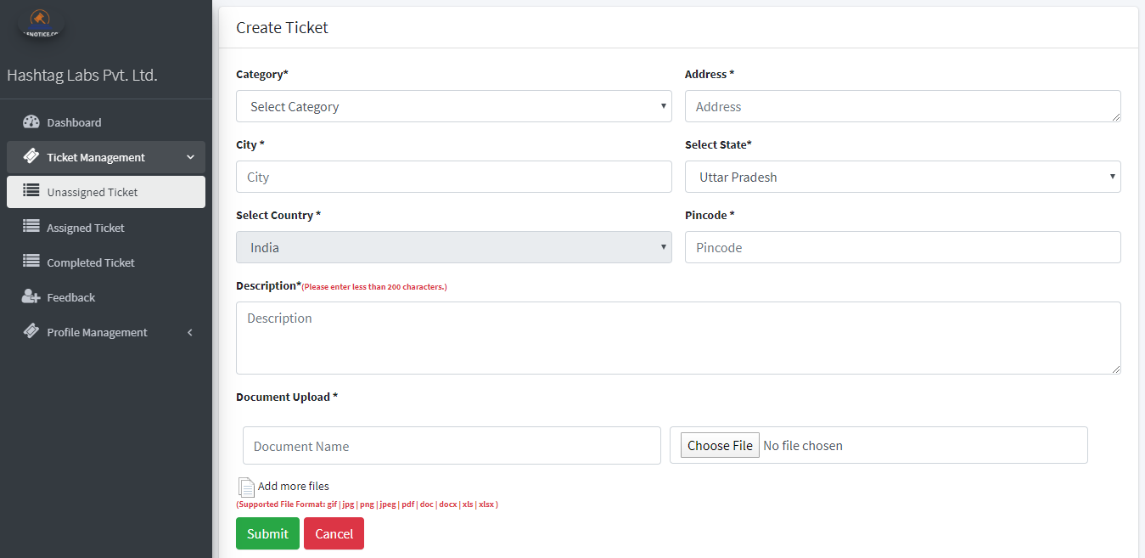

Here customer can fill all mandatory filed and create their ticket.

1. After ticket creation the ticket goes under admin review and then admin assign the ticket to related consultant. After assigning the ticket , the ticket will show on “Assigned Ticket” tab , please check below image –

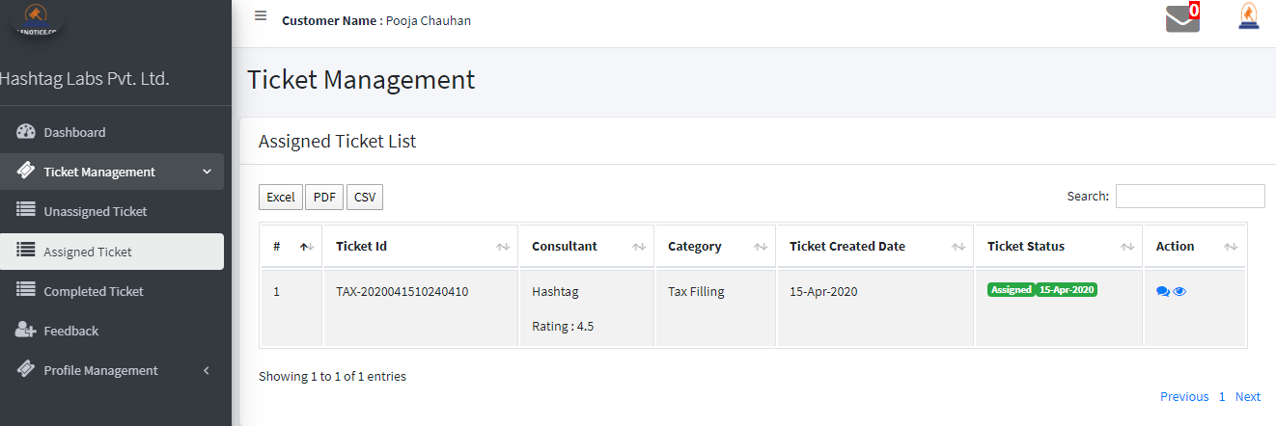

Here customer can chat with assigned consultant by clicking on chat icon.

1. When communication end between customer and consultant then admin mark particular ticket as completed then the ticket will be show in “Completed Ticket” tab as shown in below image –

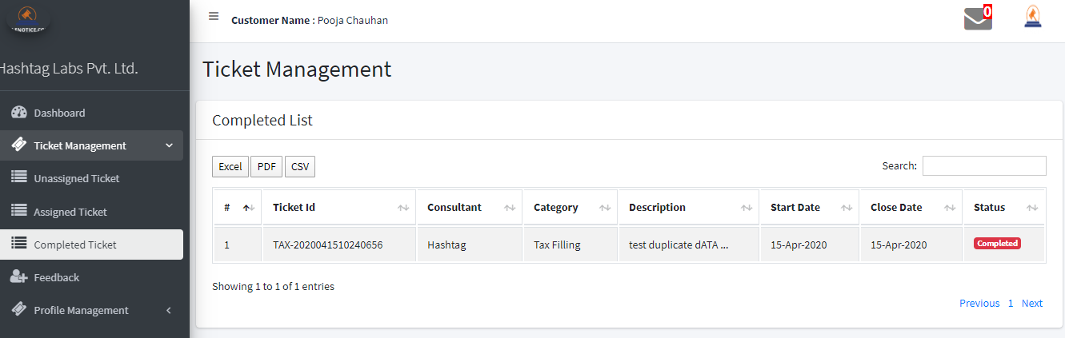

1. After complete ticket customer can give feedback as rating and review to consultant. For giving feedback click on “Feedback” tab then below image will be shown –

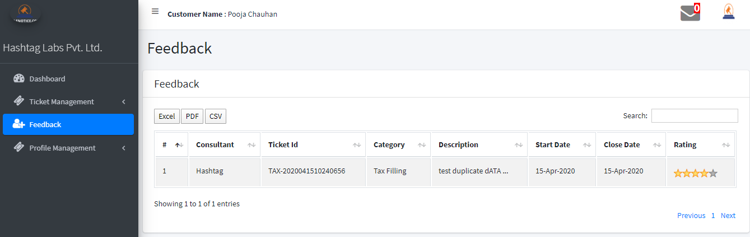

1. Customer can change their profile detail by clicking on “Profile Management” tab.

Consultant :-

1. There is also a registration for consultant on frontend. See below image –

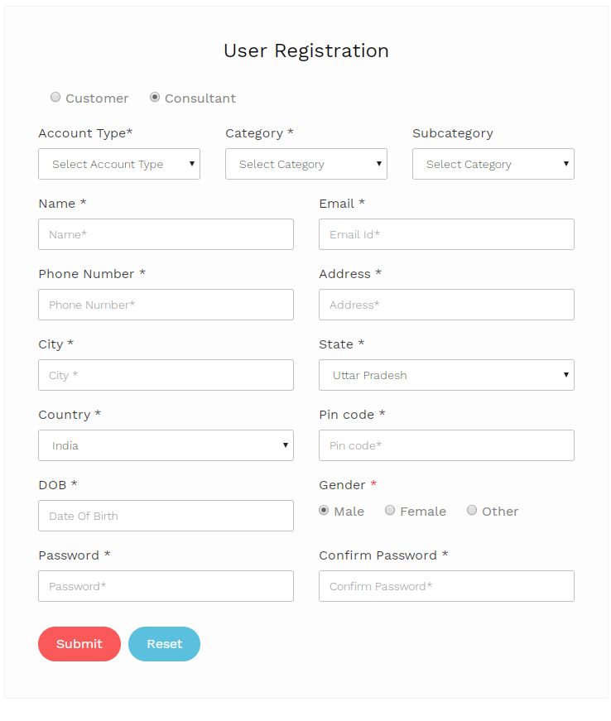

After registration consultant can login on click login menu.

1. After login successfully go to consultant dashboard page where assigned and completed ticket count show. Find below image –

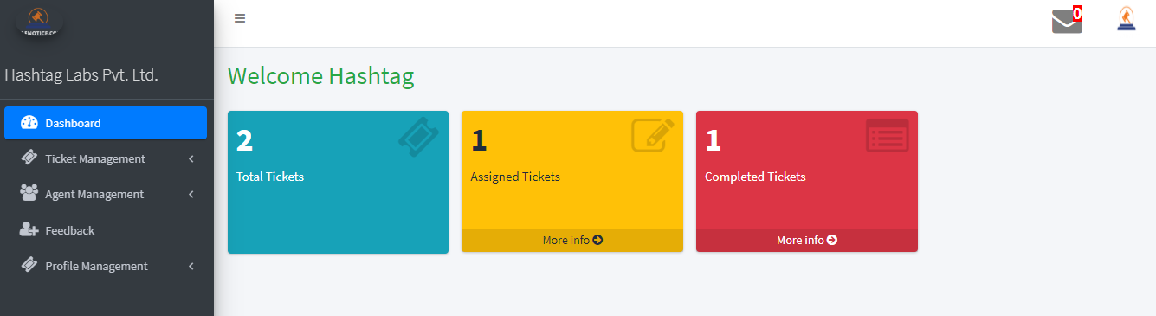

1. Consultant has only assigned ticket and completed ticket information. To showing assigned ticket click on Ticket Management -> Assigned Ticket tab. Below image will be open –

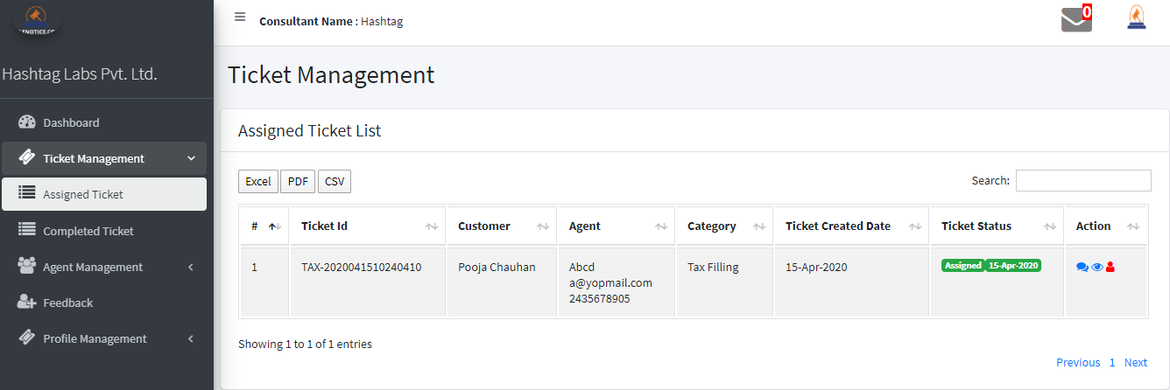

Here consultant can chat with customer by clicking on chat icon. Consultant can assign the ticket to their agent by clicking on user icon. After assign a ticket to agent a mail will be send to agent email id .

1. For showing completed ticket just click on Completed ticket tab and as below image will be open –

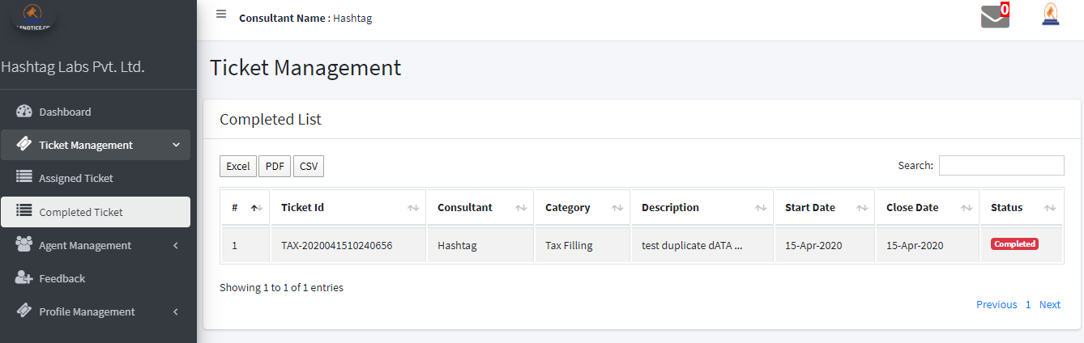

1. Only consultant can add agent , there is no any registration of agent from frontend. To add agent please click on Agent Management -> Agents tab then open a list of agents that consultant added, then click on Add new button for adding agent . find below image –

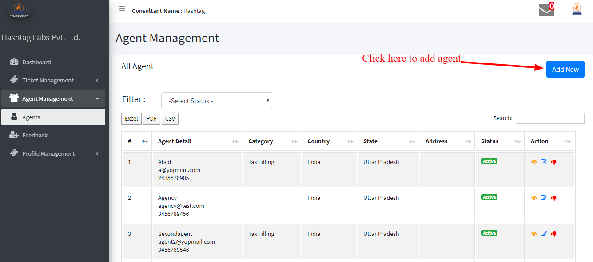

1. After click on Add New button a form will open, here consultant fill agent detail and save. This process done in two step. Find below image –

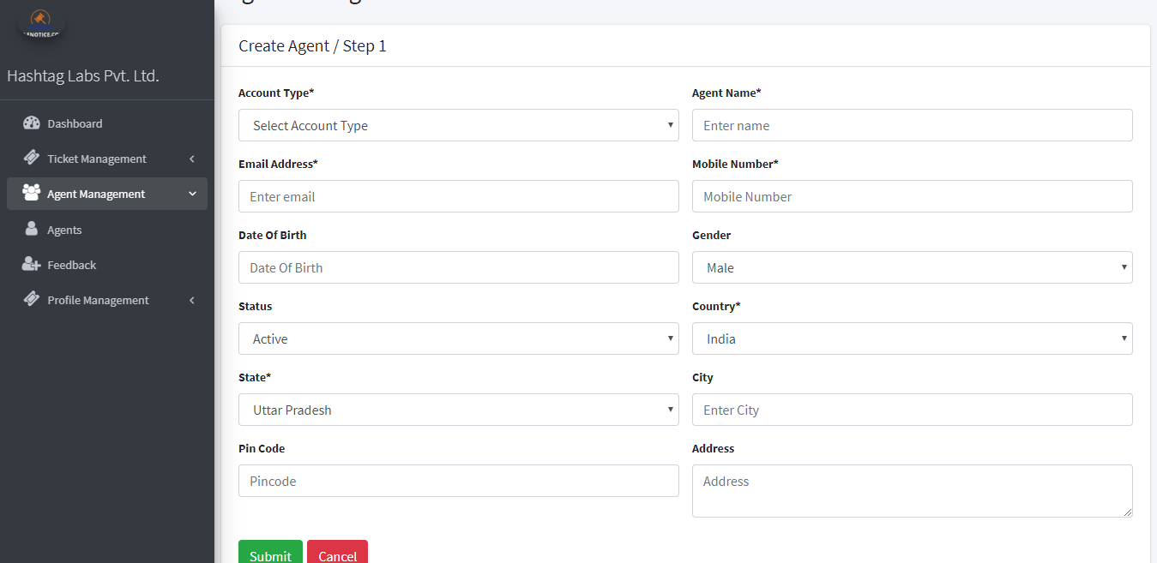

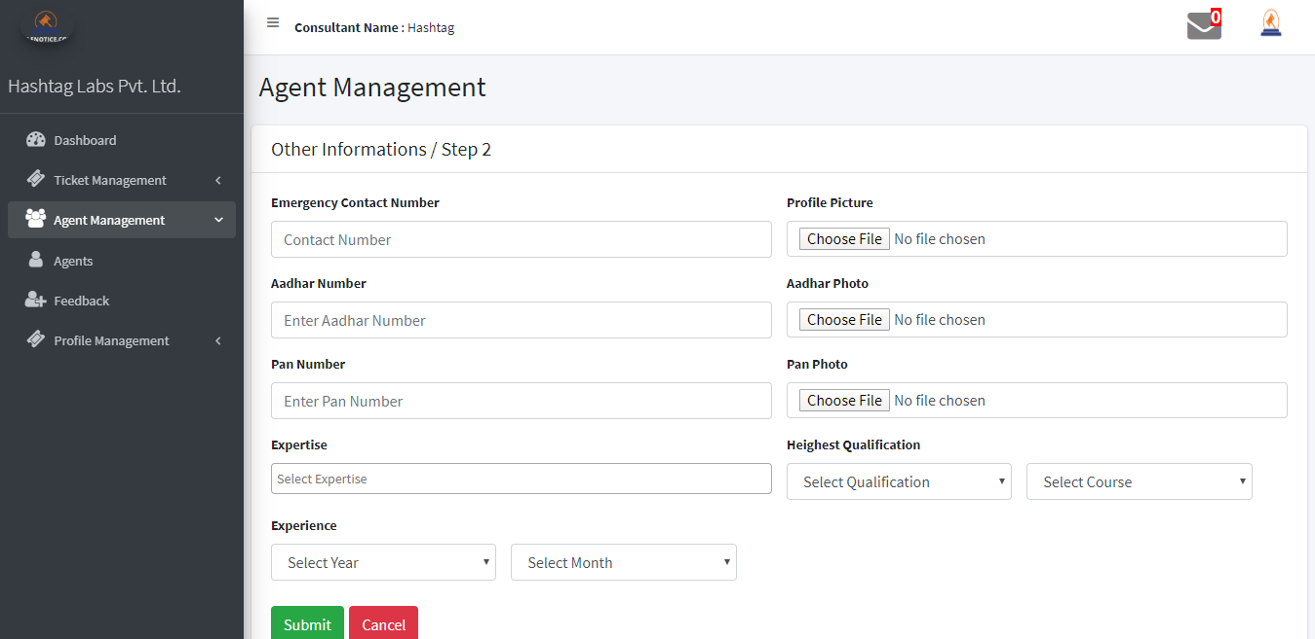

1. For showing feedback that was given by customer then click on Feedback tab and see all list of feedback according ticket. Find below image –

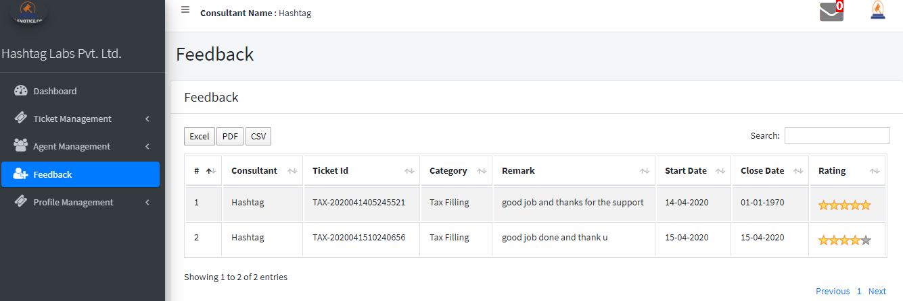

1. Consultant can change their profile details by clicking on Profile Management tab.

Agent :- Agent work as consultant but they have not full access as consultant .

1. Agent can login from frontend by clicking on login menu and then open their dashboard where all assigned and completed ticket count will show. Find below image –

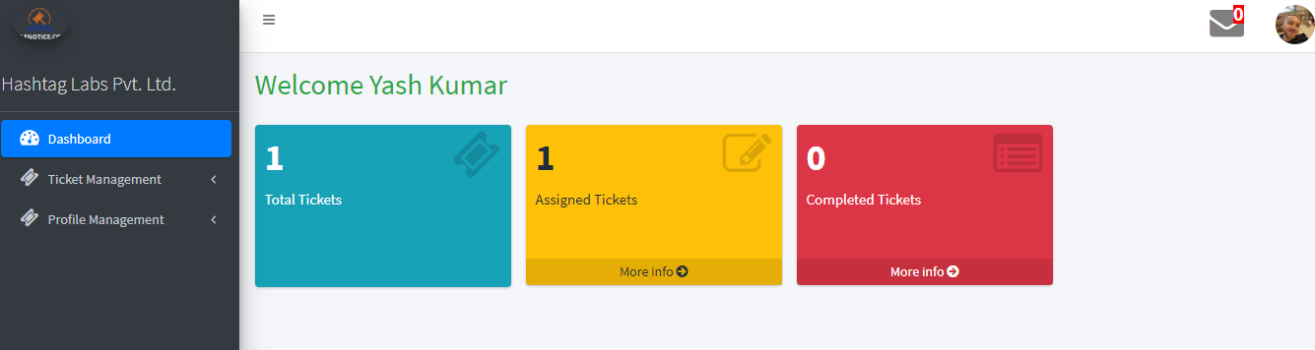

1. Agent can see list of assigned and completed ticket by clicking on Assigned and Completed Ticket tab. There is a feature that agent can communicate with customer directly by clicking on chat icon at Assigned Ticket list . Find below image –

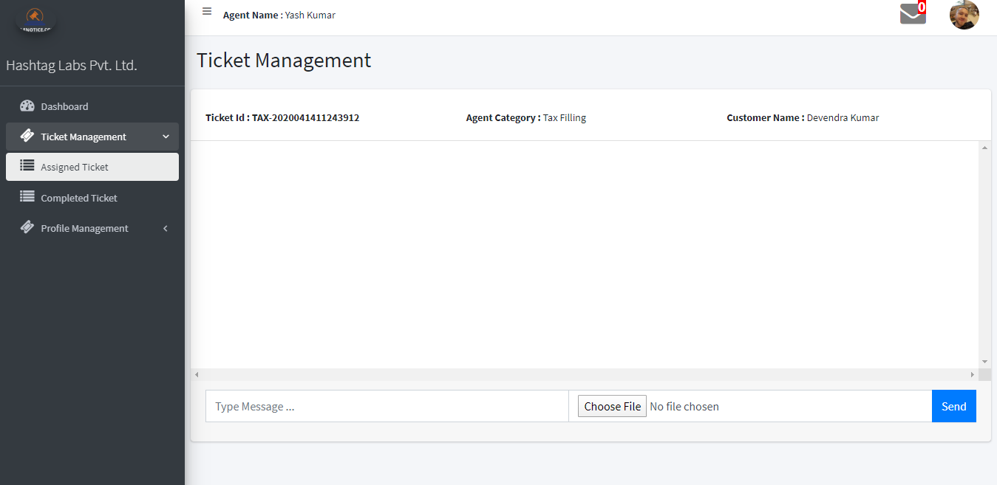

1. Agent can change their profile by clicking on Profile Management tab.

Admin

Admin URL - <https://filenotice.com/filenotice/admin/login>

1. This is backend part of this product. Admin can login by clicking on above url. Find below image –

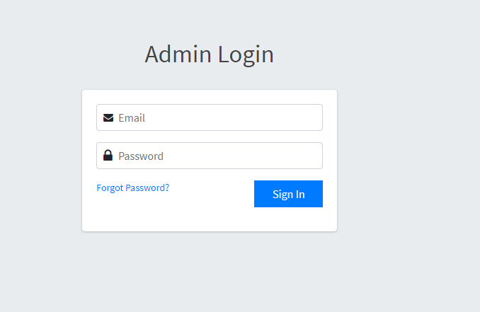

1. After login open a admin dashboard where display count of active customer, active consultant, unassigned ticket and completed ticket. And also show most recent add customer and consultant list. Find below image –

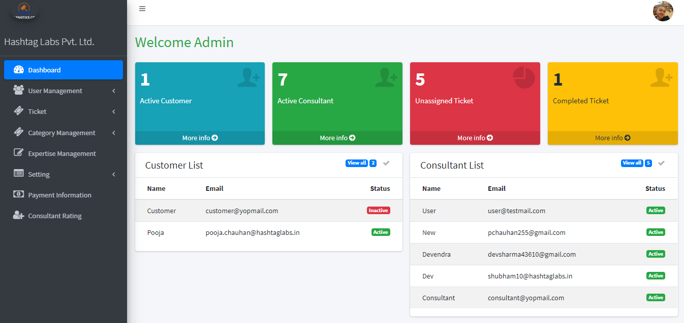

1. Admin can add and update customer and consultant from here. Click on User management tab to see list of customer and consultant.

Customer list –

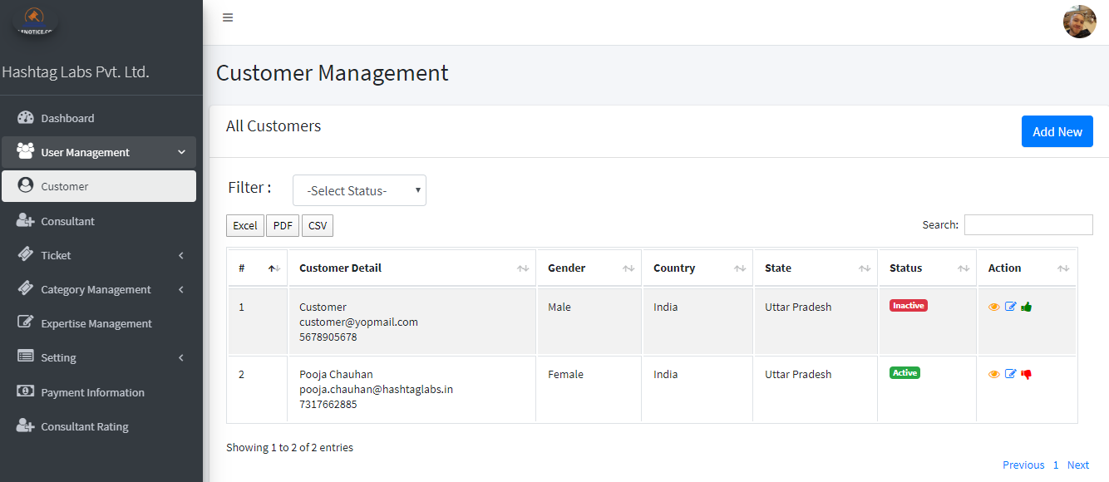

Here admin can update details of customer by clicking on edit icon. Also admin can change the status of customer as active/inactive. And admin also add new customer by clicking on add new button at right corner.

Consultant list -

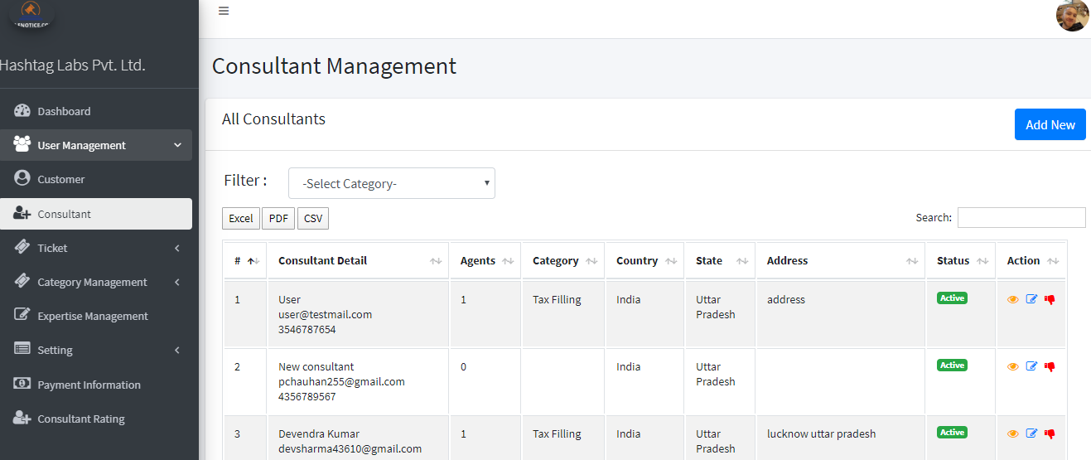

Here admin can update details of consultant by clicking on edit icon. Also admin can change the status of consultant as active/inactive. And admin also add new consultant by clicking on add new button at right corner. Adding consultant is 2 step process. In first step admin fill consultant personal detail and then step 2 add their business detail.

1. Admin can create ticket for customer. Click on ticket management tab and then unassigned tickets a newly created ticket are listed. Find the below image –

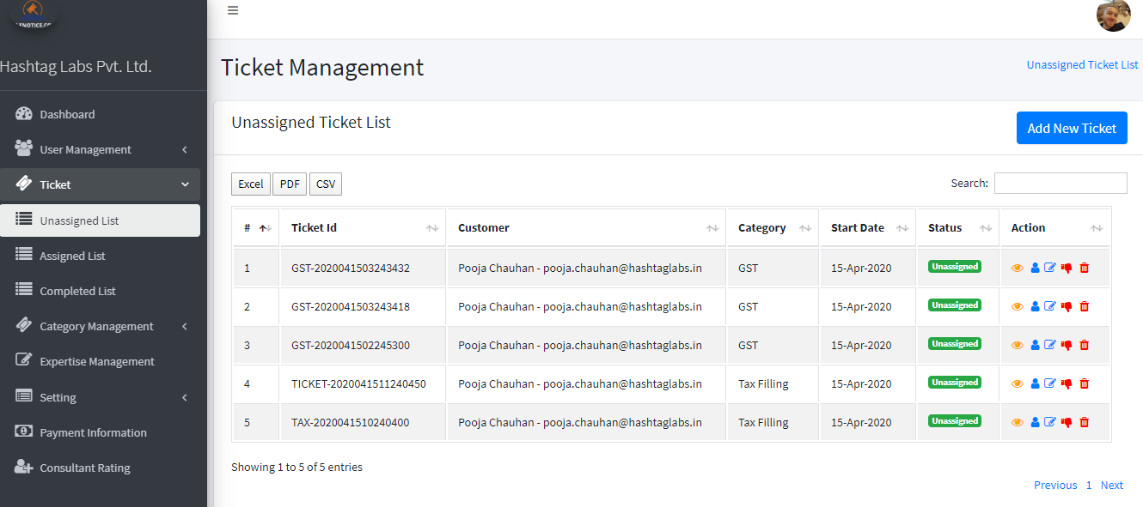

To create click on “Add New Ticket” button then a ticket creation form will open, fill all the detail and submit.

Admin can assign a ticket to ticket related consultant by clicking on user icon. Find below image of assign form –

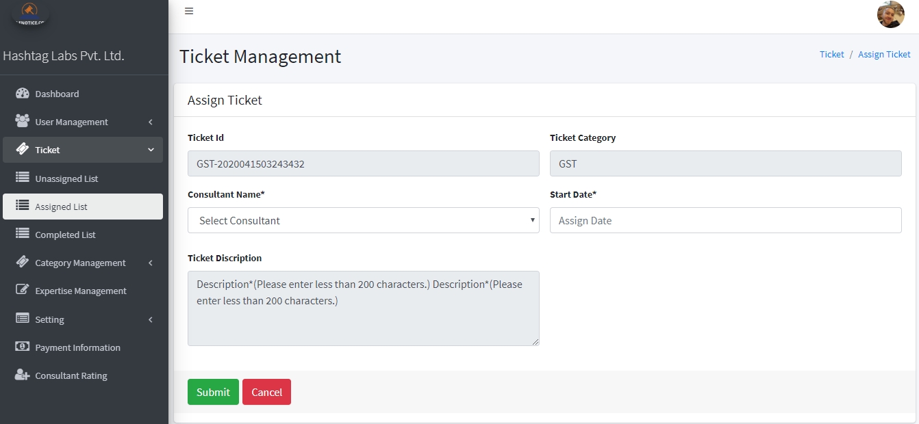

1. To see assigned ticket list please click on “Assigned List” a assigned list will be open. Find below image –

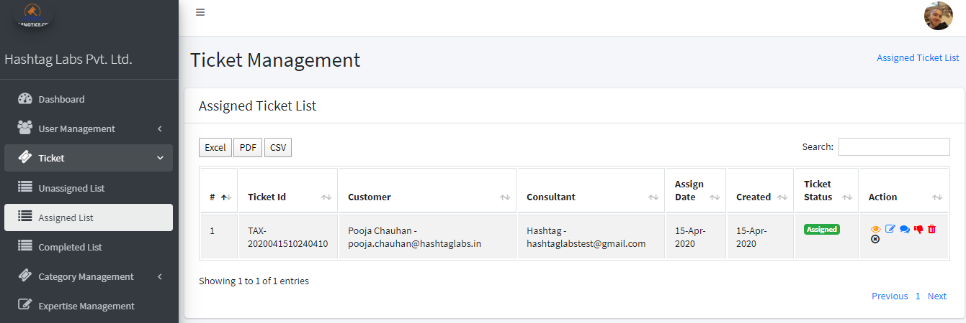

Here admin can change consultant by click on edit icon. Admin can only see the conversation between customer and consultant by click on chat icon. Admin change the status of ticket and also delete the ticket. If conversation is over then consultant / customer send a request mail to mark this ticket as completed. Then admin click on cross icon for marking ticket as completed.

1. There is another tab category management. This tab is for managing category of ticket. Admin can add subcategory also. Find below image –

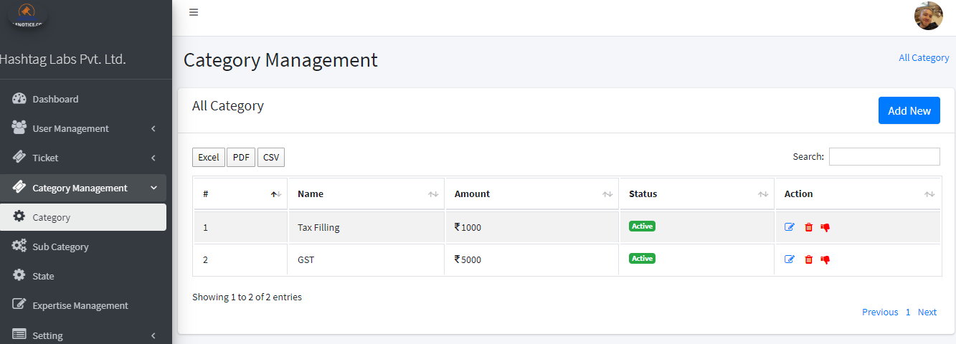

1. Expertise Management -> this is another tab for adding expertise of consultant. Find below image –

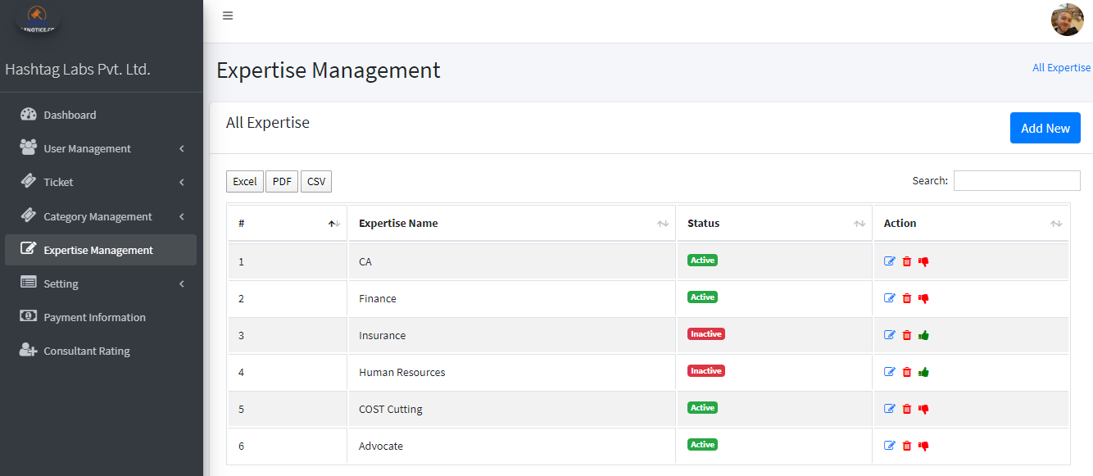

1. There is a setting tab, here all system configuration details are available.
2. Payment information tab -> future implementation
3. Admin can see the consultant rating by clicking on “Consultant Rating” tab, here is the list of consultant with their details and average rating and review that is given by customer. Find below image –

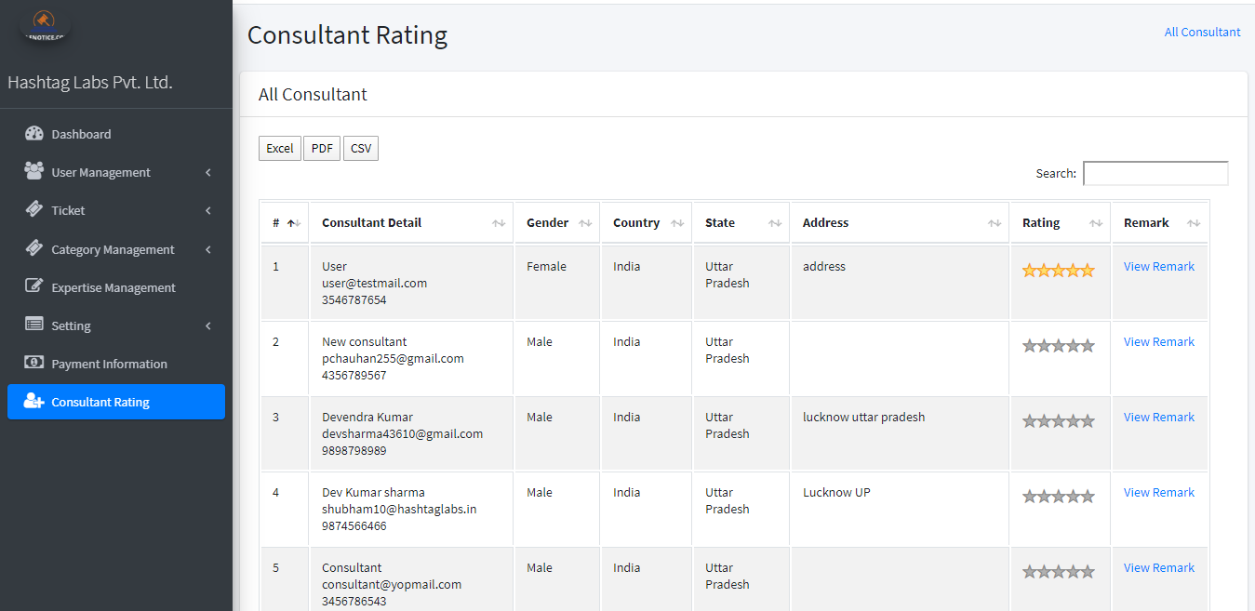

For showing remark please click on view remark link. It will pop up a modal and show remarks.

Thanks You …..