**INDEX**

|  |  |  |  |
| --- | --- | --- | --- |
| **Sr.No** | **Date** | **Practical List** | **Sign.** |
| **1** |  | **Install Selenium IDE; Write a test suite containing minimum 4 test cases for different formats.** |  |
| **2** |  | **Conduct a test suite for any two web sites.** |  |
| **3** |  | **Install Selenium server (Selenium RC) and demonstrate it using a script in Java/PHP.** |  |
| **4** |  | **Arithmetic Operation (using junit)** |  |
| **5** |  | **Write and test a program to specific web page.** |  |
| **6** |  | **Write and test a program to update 10 student records into table into Excel file** |  |
| **7** |  | **Write and test a program to select the number of students whose total is more than**  **100** |  |
| **8** |  | **Write and test a program to provide total number of objects present / available on the page.** |  |
| **9** |  | **Write and test a program to get the number of items in a list / combo box.**  **Combo.html:** |  |
| **10** |  | **Write and test a program to count number of items present on a desktop.** |  |
|  |  |  |  |
|  |  |  |  |
|  |  |  |  |
|  |  |  |  |
|  |  |  |  |
|  |  |  |  |

**___________________**

**Practical no 1**

**Aim: Install Selenium IDE; Write a test suite containing minimum 4 test cases for different formats.**

**1)What is Selenium?**

• Acceptance testing tool for web-apps

• Tests run directly in browser

• Selenium can be deployed on Windows, Linux, and Macintosh.

• Implemented entirely using browser technologies -

 JavaScript

 DHTML

 Frames

• The Selenium-IDE (Integrated Development Environment) is the tool you use to develop your Selenium test cases.

• It is Firefox plug-in

• Firefox extension which allows record/play testing paradigm

• Automates commands, but asserts must be entered by hand

• Creates the simplest possible Locator

• Based on Selene’s

**2)Selenium Components**

– Selenium IDE

**Created by** Shinya Kasatani of Japan

– Selenium RC

**Created by** Paul Hammant

– Selenium Grid

**Developed by**Patrick Lightbody

**We need –**

* Mozilla Firefox
* Active Internet Connection
* If you do not have Mozilla Firefox yet, you can download it **from**[**http://www.mozilla.org/en-US/firefox/new**](http://www.mozilla.org/en-US/firefox/new)**.**

**Steps to install Selenium IDE-**

1. Launch **Mozilla Firefox** Browser.
2. Type URL <https://www.seleniumhq.org/download/>

**OR**

<https://addons.mozilla.org/en-US/firefox/addon/selenium-ide/>

1. Selenium IDE Add-ons page will get open then Click on Add to Firefox button
2. Firefox will show one popup saying do you want to allow Mozilla Firefox to install Selenium IDE Add-ons or not. **Click** on **Install** button.
3. Firefox will automatically install Selenium IDE software. After the installation is completed, a pop up window appears asking to re-start the Firefox. Click on the “Restart Now” button to reflect the Selenium IDE installation. Click on Restart Now button.
4. On clicking on the Restart Now button, Firefox will restart automatically. In case you missed the pop-up, simply close the Firefox and launch again.
5. Once the Firefox is booted and started again, we can see selenium IDE under the tools menu list. **Selenium IDEicon** will be displayed in the Firefox toolbar.
6. Click on **Selenium IDE icon to open Selenium IDE.**

* Selenium IDE Works with all major versions, but we recommend to use 47.0.1 & above as they have better stability.
* Selenium IDE is no longer compatible with Firefox 55 and above.

**perform test cases on 4 different websites**

1. [http://store.demoqa.com](http://store.demoqa.com/)
2. <https://www.seleniumhq.org>
3. htttp://www.google.com
4. htttp://www.yahoo.com

**Steps:**

* Launch Firefox and Selenium IDE.
* Type the value for our Base URL: <http://demo.guru99.com/test/newtours/>.
* Toggle the Record button on (if it is not yet toggled on by default).
* In Firefox, navigate to <http://demo.guru99.com/test/newtours/>. Firefox should take you to the page similar to the one shown below. Navigate over the site which in turn get recorded on the Selenium.
* Go to the Selenium window again and stop the recording, by toggling the Record button again. Then run the current test case to get output.

**OUTPUT:**

**i] Test1: www.google.com**

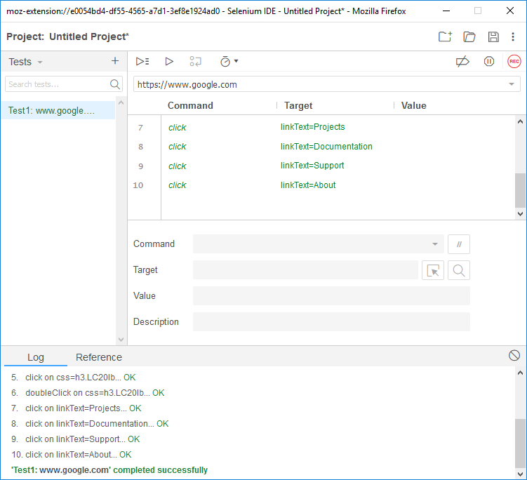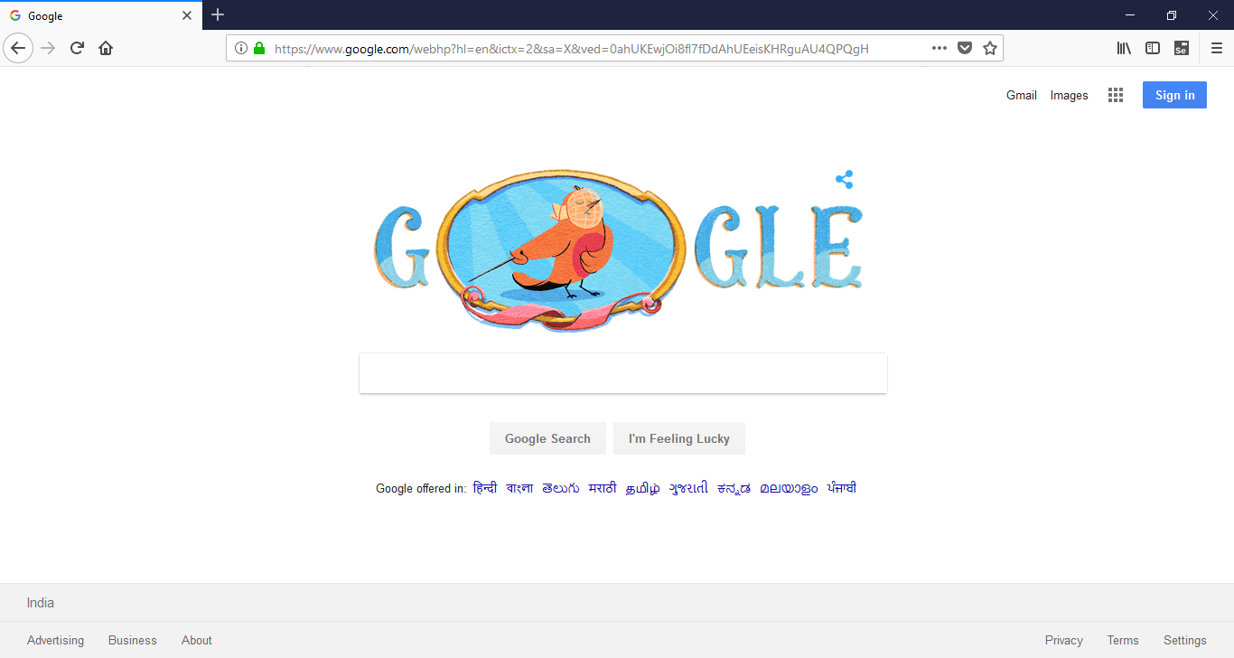

**Ii] Test2: www.yahoo.com**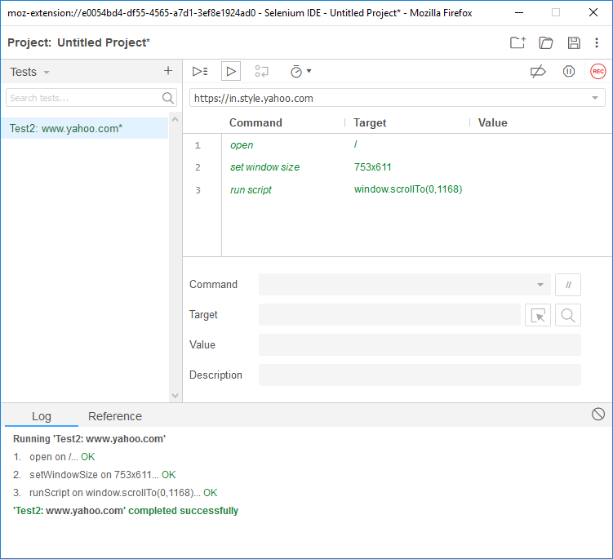

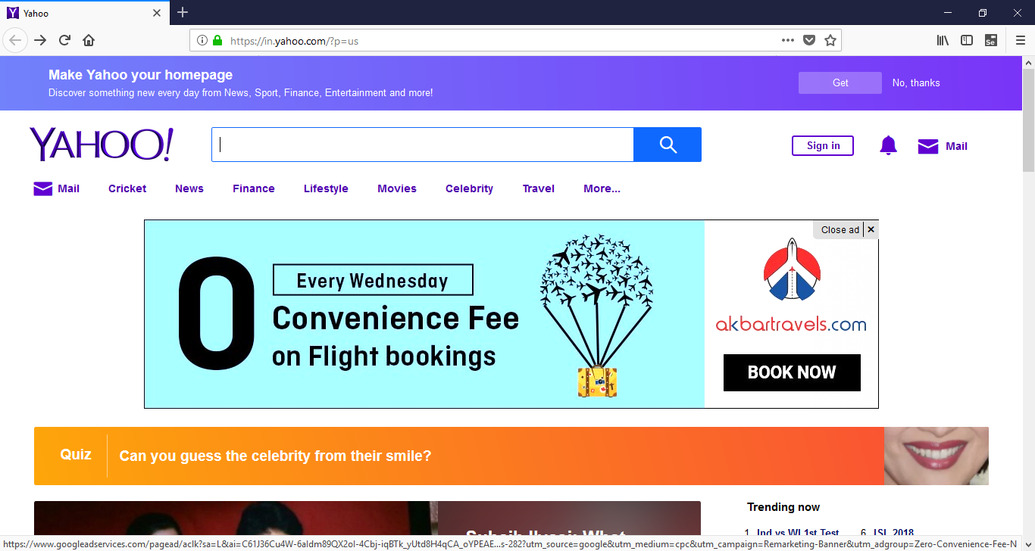

**iii] Test3: www.seleniumhq.com**

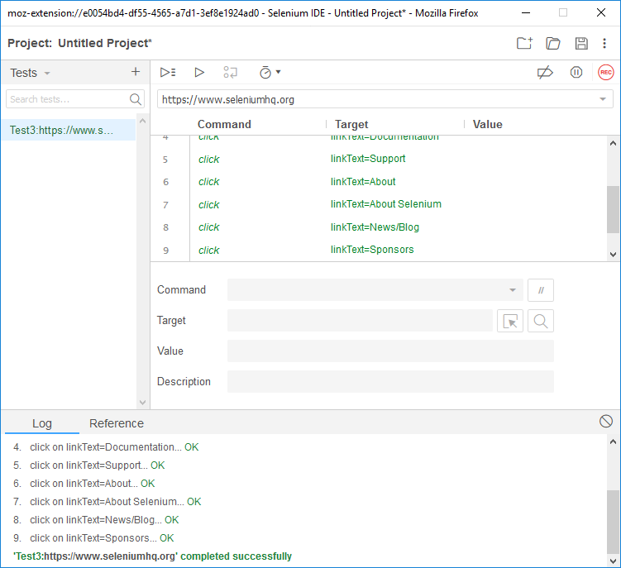

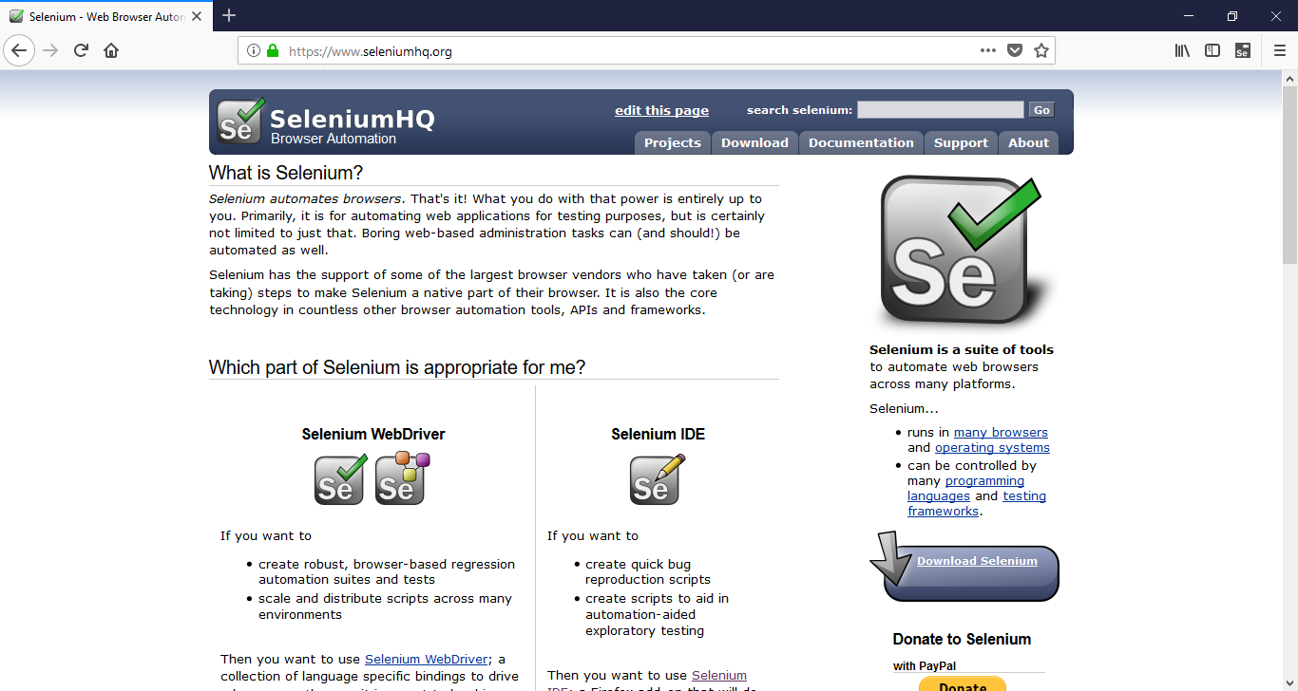

**Iv] Test4: www.demo.guru99.in**

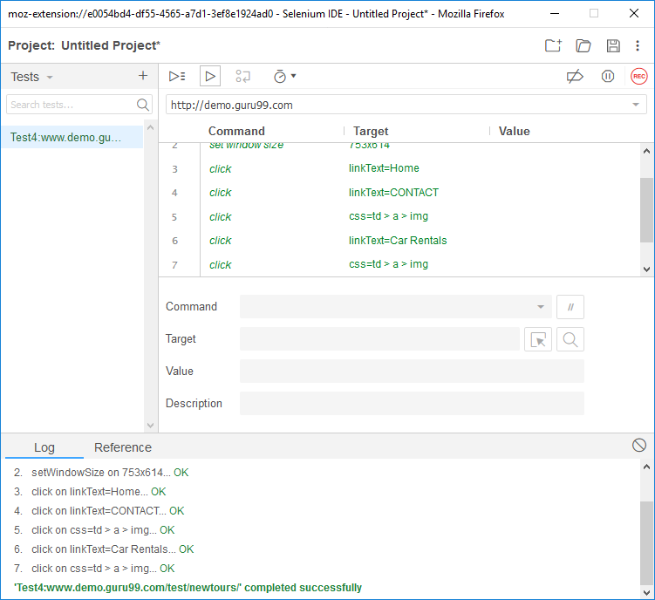

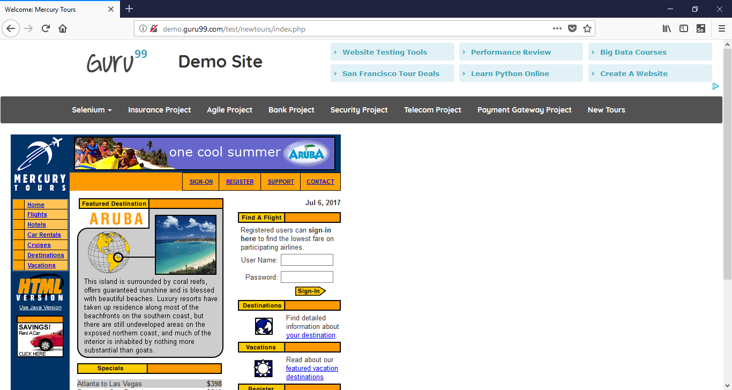

**Practical no -2**

**Aim: Conduct a Test suite for any two websites.**

**Required Software**

1. Mozilla Firefox 61 (If Earlier version of Firefox is installed in the system, then that should be uninstalled and version 61 or above has to be installed)

2. Selenium IDE

**Prerequisite Knowledge**

1. Working of Selenium IDE

2. Knowledge of Selenium Commands

**Basic Steps to follow for every test case**

1. Open firefox browser

2. Open Selenium IDE

3. Type http://www.google.com/ in playback URL

4. Start Recording

5. Type http://www.google.com/ in browser address bar

6. Type selenium IDE as the search text (Don’t use autocomplete option. Type yourself)

7. Press Enter

8. First search result will be seleniumhq website. Click on it

**To check the working of assert title command**

1. Perform the basic steps

2. Right_click anywhere on the screen.

3. Select Selenium IDE option and choose assert title command

4. Click on the hyperlink – Documentation

5. Browser will be redirected to Documentation page

6. Return to Selenium IDE and Stop Recording

7. Run the test case

8. Save the test case as “valid_assert_title

9. Create a new test case and name it as “invalid_assert_title”

10. Repeat the basic steps. Repeat steps 1 to 6 given above

11. Select assert title command from the steps

12. Change the target from “Selenium IDE” to “Selenese”

13. Stop Recording and Run the test case

**To check the working of verify title command**

1. Repeat the steps given for assert title command. But, instead of choosing assert title command from Selenium IDE option, choose verify title command. Give appropriate names to test cases (valid_verify_title and invalid_verify_title)

**To check the working of assert text command**

1. Create a new test case and name it as “valid_assert_text”

2. Perform the basic steps

3. In the seleniumHq page, select and highlight the text selenium IDE from the second paragraph

4. Right click and select selenium ide option and choose assert text command

5. Click on the hyperlink – Documentation

6. Browser will be redirected to Documentation page

7. Return to Selenium IDE, Stop Recording

8. Run the test case

9. Create a new test case and name it as “invalid_assert_text”

10. Repeat the basic steps. Repeat steps 3 to 7 given above

11. Select assert text command from the steps

12. Change the value from “Selenium IDE” to “Selenese”

13. Stop Recording and Run the test case

**To check the working of verify text command**

Repeat the steps given for assert text command. But, instead of choosing assert text command from Selenium IDE option, choose verify text command. Give appropriate names to test cases.

**To check the working of verify element present**

1. Perform the basic steps

2. Click on the hyperlink documentation

3. Return to Selenium IDE screen

4. Stop Recording

5. Click on the empty space at the end in the command-target-value area. Add a new command at the end

6. In command option, choose verify element present

7. In target option, type //div/p

8. Save the test case as valid_element and run the test case

9. Run the test case

10. Add a new test case and rename as invalid_element

11. Repeat steps from 1 to 6 given above

12. In target option, type //div/link

13. Run the test case

**OUTPUT:**

**i]Assert title:**

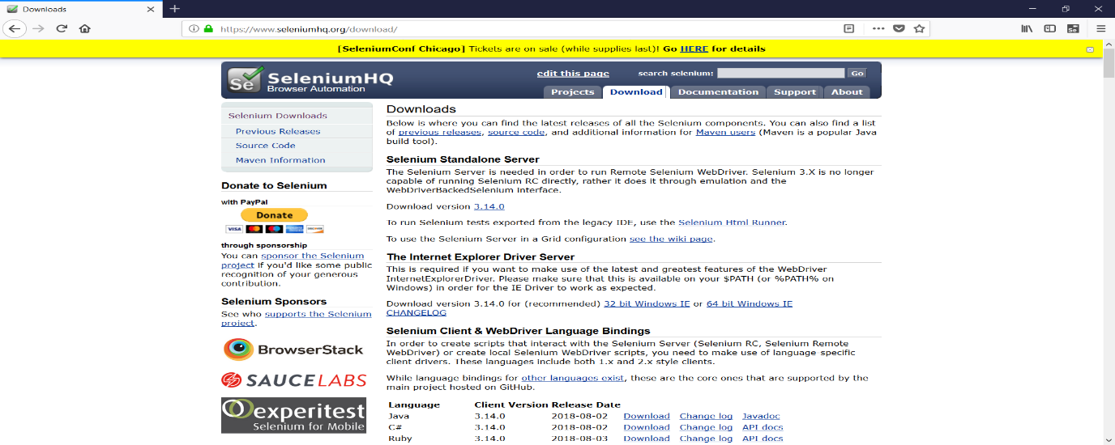

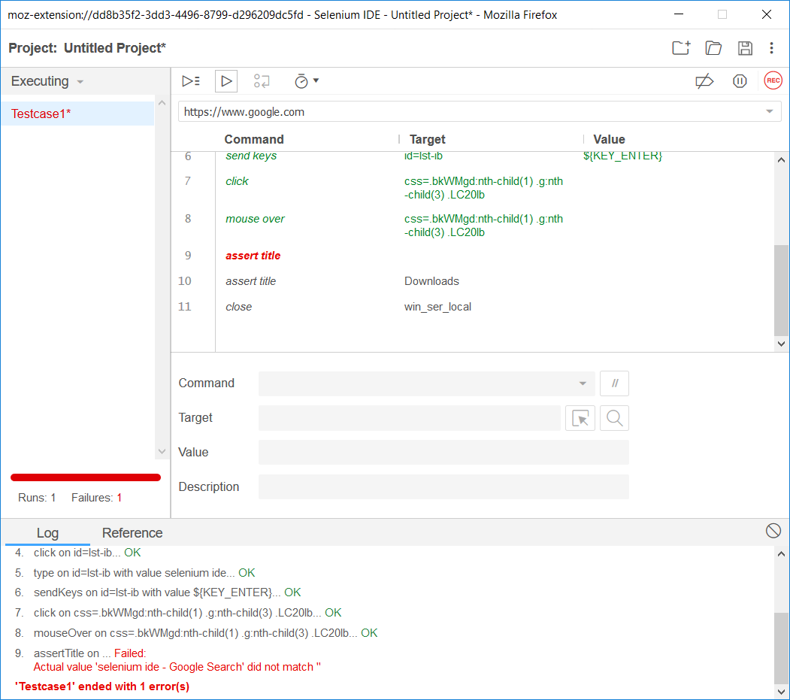

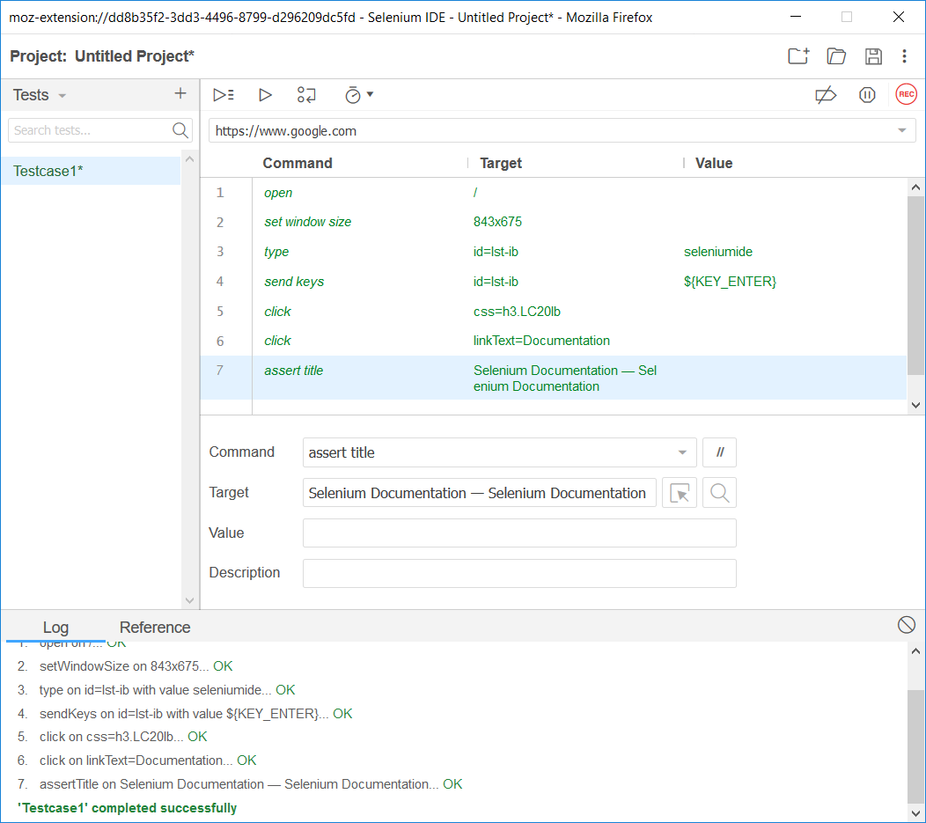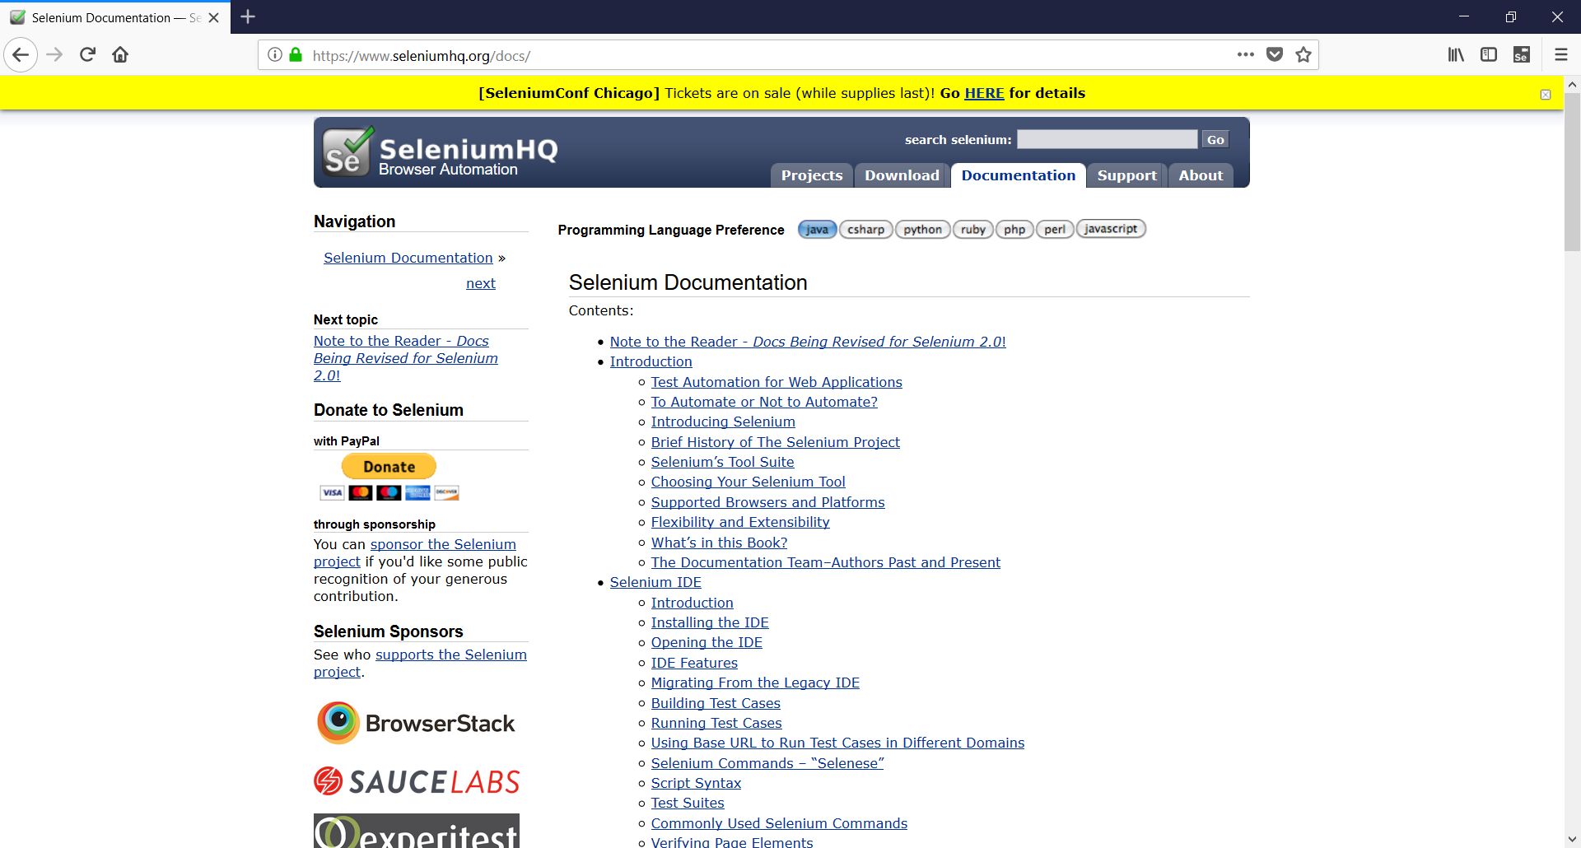

**ii] Assert Text:**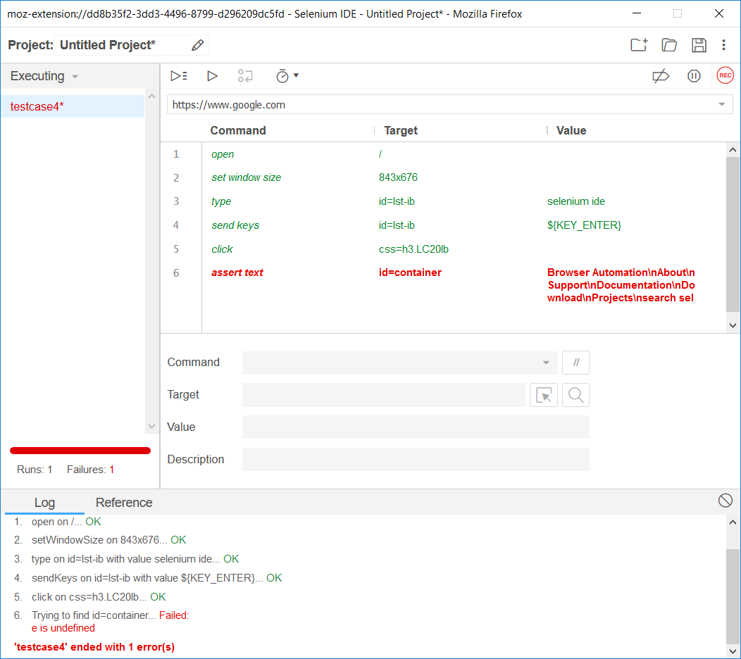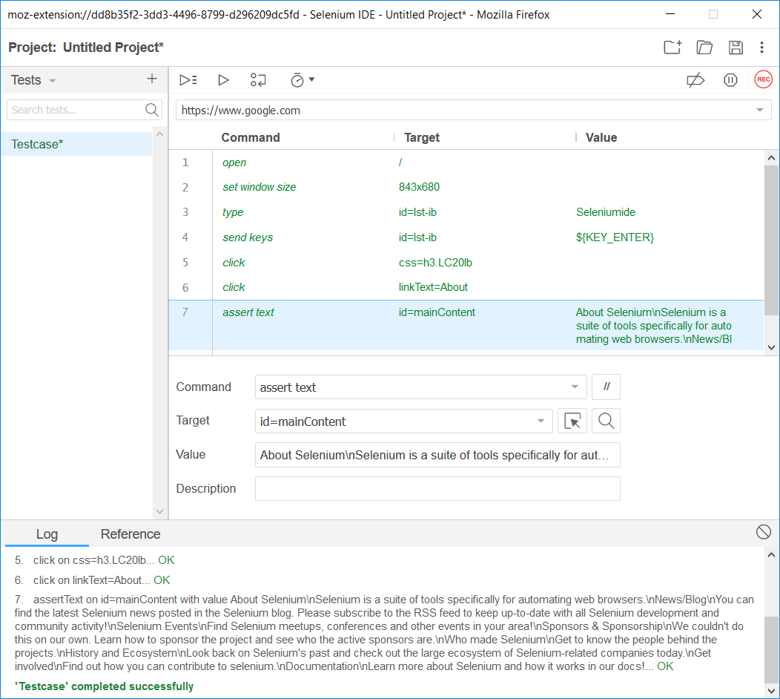

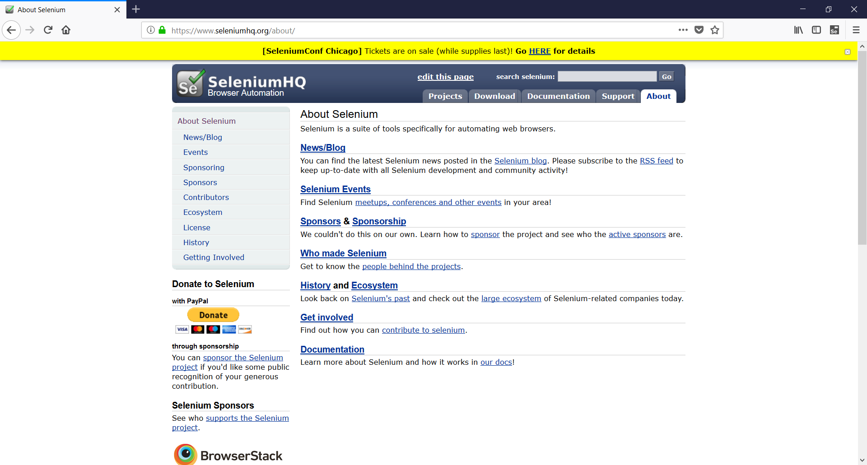

**Practical no 3**

**Aim: Install Selenium server and demonstrate it using a script in Java/PHP.**

**Description**

**Selenium-RC** is the solution for tests that need more than simple browser actions and linear execution.

Selenium-RC uses the full power of programming languages to create more complex tests like reading and writing files, querying a database, emailing test results.

You’ll want to use Selenium-RC whenever your test requires logic not supported by Selenium-IDE.

What logic could this be? For example, Selenium-IDE does not directly support:

• Condition statements

• Iteration

• Logging and reporting of test results

• Error handling, particularly unexpected errors

• Database testing

• Test case grouping

• Re-execution of failed tests

• Test case dependency

• Screenshot capture of test failures

Although these tasks are not supported by Selenium directly, all of them can be achieved by using programming techniques with a language-specific Selenium-RC client library.

**Installation of Selenium RC and Eclipse**

**Download Eclipse**

1. Go to URL – http://www.eclipse.org/downloads/

2. Select **Eclipse IDE for Java Developers** (Click on Windows 32 bit platform)

3. Click on OK button and save to a local drive (i.e. C: or D:,etc)

4. Unzip the downloaded zip file and rename that to Eclipse

5. Create one more folder “Eclipse-Workspace” (i.e. C:Eclipse-Workspace)in the same drive where Eclipse is unzipped and renamed.

6. Create Eclipse desktop shortcut (go to C:Eclipse folder –> right click

Eclipse.exe and then click on “desktop create shortcut”).

We have finished setting up the eclipse.

**Now, we need to download Selenium RC server / client driver and configure that to Eclipse**

1. Download Selenium server: http://seleniumhq.org/download/

2. Download Selenium Client driver for Java (from Selenium Client Drivers section)

3. Create “Selenium” folder in C: drive and copy the Selenium-server.jar as well as unzip the Selenium Client driver (C:Selenium)

Downloading and unzipping the files into a folder is done.

We need to configure the appropriate Selenium Client driver Jar file to the Eclipse.

**Now, follow the following steps:**

1. Go to Eclipse –> Click File –> New –> Project (from various options need to select just “project”)

2. In Select Wizard –> Click Java –> “Java Project”

3. Give the project name (e.g. DemoTests)

4. Click Finish – Click Yes

5. Now we are done with creation of project and need to configure the Selenium Client driver to this Project

6. Right Click “DemoTests” project

7. Click “Java Build Path”

8. Click Libraries tab

9. Click “Add External JARs” button

10. Select “Selenium Client Drivers” unzipped in C:Selenium folder (Selenium

Server JAR file should not be added)

11. Click OK

12.Referenced libraries –> contains both the Selenium Client driver jar files.

13.Create a new class file as “SeleniumDemo” in the “DemoTest” by right click on src folder.

14. Copy the below code in the class file:-

import org.openqa.selenium.WebDriver;

import org.openqa.selenium.firefox.FirefoxDriver;

import org.openqa.selenium.remote.DesiredCapabilities;

public class hello

{

static String driverPath = "D:\\selenium pracs\\geckodriver-v0.21.0-win32\\GeckoDriver.exe";

public static WebDriver driver;

public static void main(String args[])

{

int a=10,b=20;

System.out.println("Hi....");

System.out.println(a+b);

System.out.println("Selenium demo.....");

System.setProperty("webdriver.gecko.driver",driverPath);

DesiredCapabilities capabilities = DesiredCapabilities.firefox();

capabilities.setCapability("marionette",true);

driver= new FirefoxDriver(capabilities);

driver.get("https://www.facebook.com/");

driver.manage().window().maximize();

driver.quit();

}

}

**Now execute the code by right click on the window , then click on run as administrator.**

**OUTPUT:**

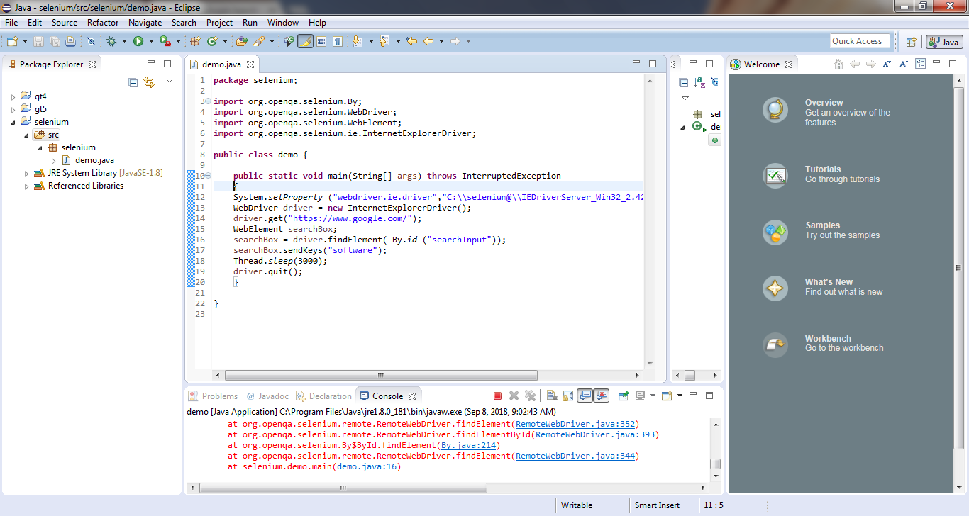

**Practical no 4**

**Aim: Arithmetic operation using Junit.**

**Follow the following steps:**

1. Go to Eclipse –> Click File –> New –> Project (from various options need to select just “project”)
2. In Select Wizard –> Click Java –> “Java Project”
3. Give the project name (e.g.Tests)
4. Click Finish – Click Yes
5. Go to Explorer -> Right click on Project name -> Build Path -> Configure Build path -> Libraries -> Add library -> Select Junit -> Click on Junit4 -> Finish.
6. Create a new class file as “Junit” in the “Tests” by right click on src folder.
7. **Write the below code in the class file :-**

package test

public class Junit

{

public String Concatenate(String one, String two)

{

return one + two;

}

public int Multiply( int no1, int no2)

{

return no1*no2;

}

}

1. **Create a Test Runner class to execute above test for Concatenate operation:-**

package test

import static org.junit.Assert.*;

public class JunitTest

{

public void testConcatenate()

{

Junit test = new Junit();

String result = test.Concatenate(“one”, “two”);

assertEquals (“onetwo”, result);

}

}

1. **Create a Test Runner class to execute above test for Multiply operation:-**

package test

import static org.junit.Assert.*;

public class multiplytest

{

public void testmultiply()

{

Junit test = new Junit();

int result = test.multiply(3,4);

assertEquals (12, result);

}

}

1. Now execute the code.

**OUTPUT:**

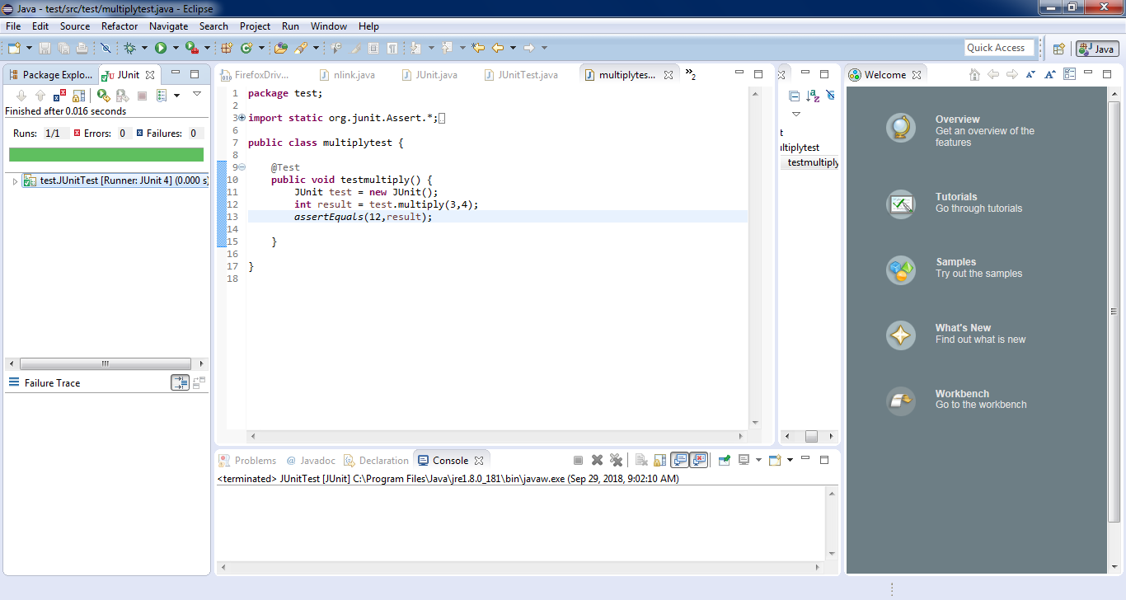

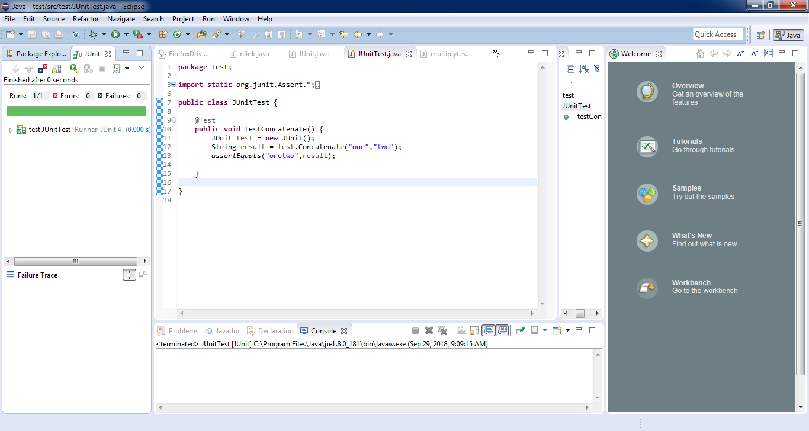

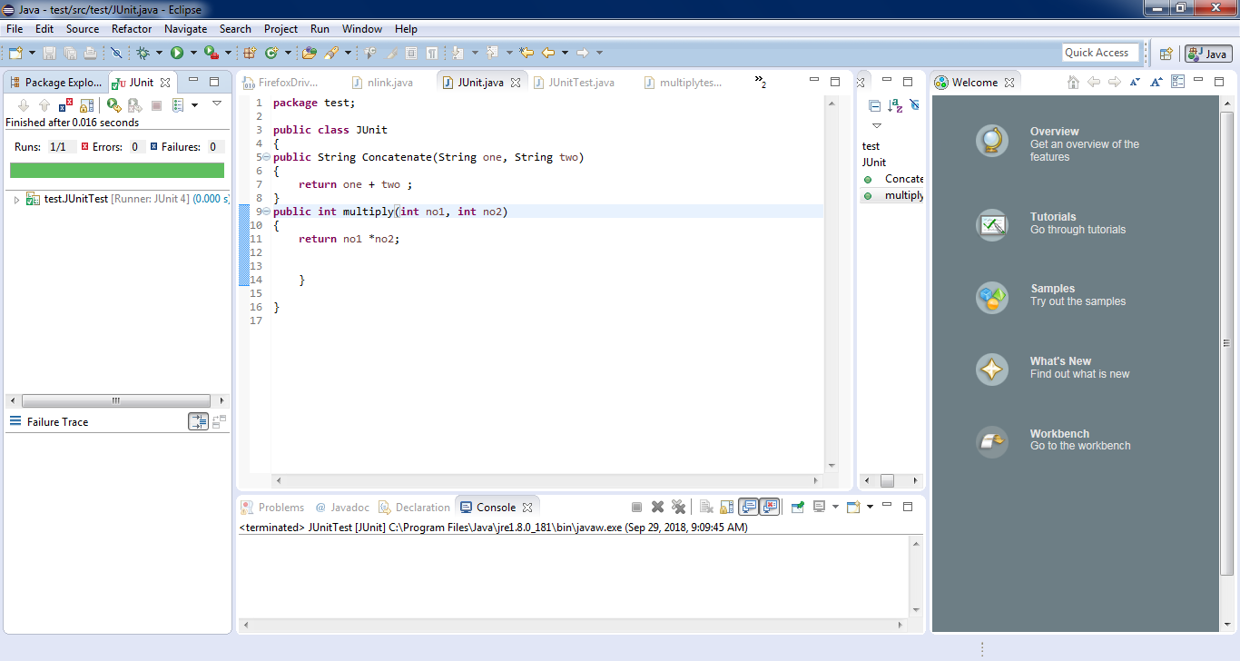

**Practical no 5**

# Aim: Write and test a program to specific web page. (Using JUnit)

**Follow the following steps:**

1. Go to Eclipse –> Click File –> New –> Project (from various options need to select just “project”)
2. In Select Wizard –> Click Java –> “Java Project”
3. Give the project name (e.g.Junittests)
4. Click Finish – Click Yes
5. Go to Explorer -> Right click on Project name -> Build Path -> Configure Build path -> Libraries -> Add library -> Select Junit -> Click on Junit4 -> Finish.
6. **Create a new class file as “Junit2” in the “Tests” by right click on src folder.**

import org.junit.Test;

import static org.junit.Assert.assertEquals;

public class TestJunit {

@Test

public void testSetup() {

String str= "I am done with Junit setup";

assertEquals("I am done with Junit setup",str);

}

}

1. **Create a Test Runner class to execute above test.**

import org.junit.runner.JUnitCore;

import org.junit.runner.Result;

import org.junit.runner.notification.Failure;

public class TestRunner {

public static void main(String[] args) {

Result result = JUnitCore.runClasses(TestJunit.class);

for (Failure failure : result.getFailures()) {

System.out.println(failure.toString());

}

System.out.println("Result=="+result.wasSuccessful());

}

}

1. Execute the code.

**OUTPUT:**

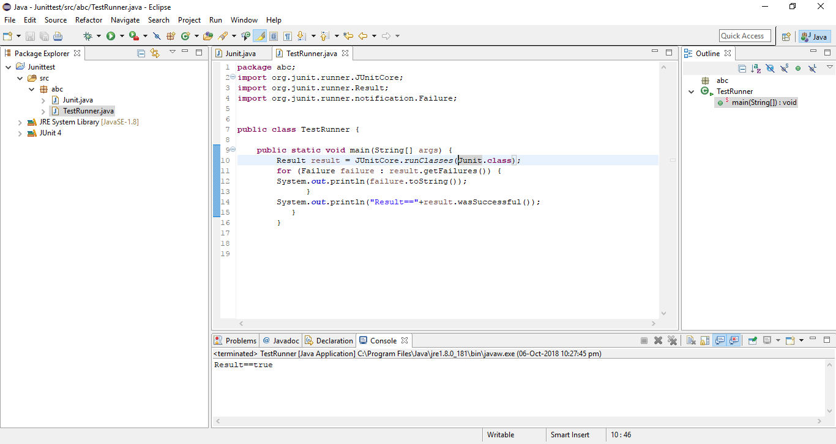

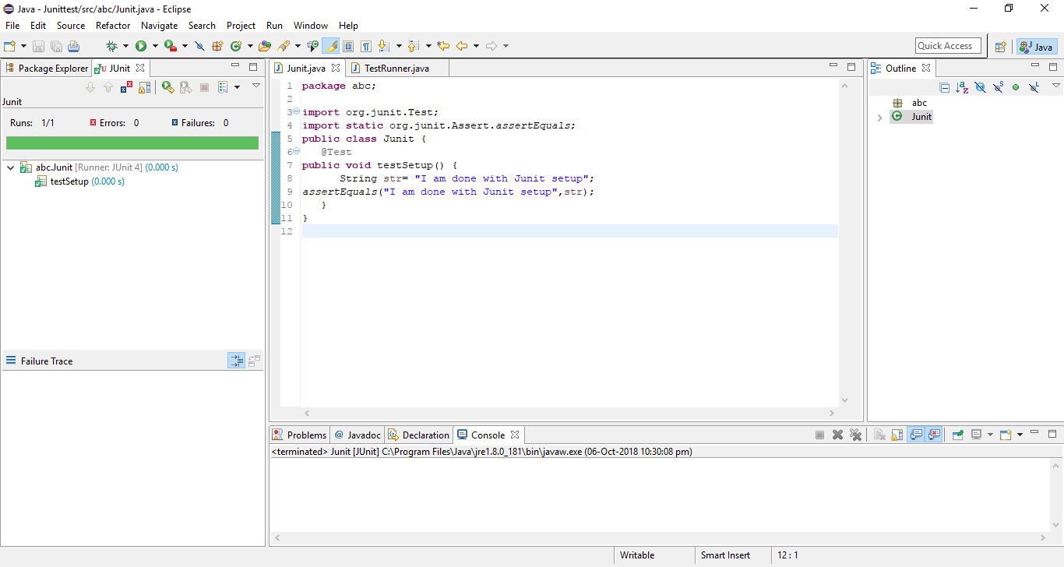

**Practical no 6**

**Aim: Write and test a program to update 10 student records into table into Excel file**

**Follow the following steps:**

1. Go to Eclipse –> Click File –> New –> Project (from various options need to select just “project”)
2. In Select Wizard –> Click Java –> “Java Project”
3. Give the project name (e.g. gt5)
4. Click Finish – Click Yes
5. Right Click “gt5” project
6. Click “Java Build Path”
7. Click Libraries tab
8. Click “Add External JARs” button
9. Add two external jar files: jxl.2.6.jar file & selenium-server-standalone-3.1.0
10. Click OK
11. Create a new class file as “Xsldata” in the “gt5” by right click on src folder.
12. Write the code-

package gt;

import java.io.File;

import java.io.IOException;

import jxl.Workbook;

import jxl.write.Label;

import jxl.write.Number;

import jxl.write.WritableSheet;

import jxl.write.WritableWorkbook;

import jxl.write.WriteException;

import jxl.write.biff.RowsExceededException;

public class Xsldata {

private String inputFile;

public void setOutputFile(String inputFile) {

this.inputFile = inputFile;

}

public void write() throws IOException, WriteException {

File file = new File(inputFile);

WritableWorkbook workbook = Workbook.createWorkbook(file);

workbook.createSheet("Report", 0);

WritableSheet excelSheet = workbook.getSheet(0);

createLabel(excelSheet);

createContent(excelSheet);

workbook.write();

workbook.close();

}

private void createLabel(WritableSheet sheet)

throws WriteException {

addCaption(sheet, 0, 0, "Student Name");

addCaption(sheet, 1, 0, "Subject 1");

addCaption(sheet, 2, 0, "subject 2");

addCaption(sheet, 3, 0, "subject 3");

addCaption(sheet, 4, 0, "Total");

}

private void createContent(WritableSheet sheet) throws WriteException,

RowsExceededException {

for (int i = 1; i < 10; i++) {

addLabel(sheet, 0, i, "Student " + i);

addNumber(sheet, 1, i, ((i*i)+17));

addNumber(sheet, 2, i, ((i*i)+14));

addNumber(sheet, 3, i, ((i*i)+13));

int total;

total=3*(i*i)+17+14+13;

addNumber(sheet,4,i,total);

}

}

private void addCaption(WritableSheet sheet, int column, int row, String s)

throws RowsExceededException, WriteException {

Label label;

label = new Label(column, row, s);

sheet.addCell(label);

}

private void addNumber(WritableSheet sheet, int column, int row,

Integer integer) throws WriteException, RowsExceededException {

Number number;

number = new Number(column, row, integer);

sheet.addCell(number);

}

private void addLabel(WritableSheet sheet, int column, int row, String s)

throws WriteException, RowsExceededException {

Label label;

label = new Label(column, row, s);

sheet.addCell(label);

}

public static void main(String[] args) throws WriteException, IOException {

Xsldata test = new Xsldata();

test.setOutputFile("F://Jayshree//sample.xls");

test.write();

System.out.println("Please check the result file under F://Jayshree//sample.xls");

}

}

1. **Create a file in a folder in any drive for showing the excel sheet(output).**

**OUTPUT:**

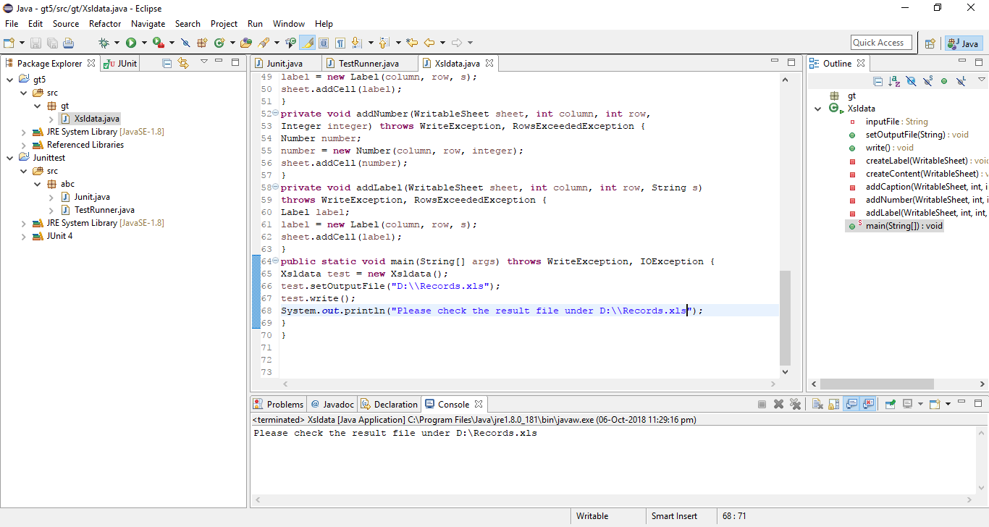

**Practical no 7**

**Aim: Write and test a program to select the number of students whose total is more than 100.**

**Follow the following steps:**

1. Go to Eclipse –> Click File –> New –> Project (from various options need to select just “project”)
2. In Select Wizard –> Click Java –> “Java Project”
3. Give the project name (e.g. gt5)
4. Click Finish – Click Yes
5. Right Click “gt5” project
6. Click “Java Build Path”
7. Click Libraries tab
8. Click “Add External JARs” button
9. Add two external jar files: jxl.2.6.jar file & selenium-server-standalone-3.1.0
10. Click OK
11. Create a new class file as “Xsldata” in the “gt5” by right click on src folder.

**Write the code-**

package gt;

import java.io.File;

import java.io.IOException;

import jxl.Cell;

import jxl.CellType;

import jxl.Sheet;

import jxl.Workbook;

import jxl.read.biff.BiffException;

public class Xslread {

public void read() throws IOException {

File inputWorkbook = new File("f:/Jayshree/Sample.xls");

Workbook w;

boolean flag=false;

int count=0;

try {

w = Workbook.getWorkbook(inputWorkbook);

Sheet sheet = w.getSheet(0);

for (int j = 0; j < sheet.getRows(); j++) {

Cell cell = sheet.getCell(4, j);

if (cell.getType() == CellType.NUMBER) {

if(Integer.parseInt(cell.getContents())>100){

count++;

}

}

}

System.out.println("Total number of students who scored more than 100 is: " +count);

} catch (BiffException e) {

e.printStackTrace();

}

}

public static void main(String[] args) throws IOException {

Xslread test = new Xslread();

test.read();

}

}

1. **Create a file in a folder in any drive for showing the excel sheet(output).**

**OUTPUT:**

# 

**Practical no 8**

**Aim: Write and test a program to provide total number of objects present / available on the page.**

**Documentation :**

Using the web resource – https://seleniumhq.github.io/selenium/docs/api/java/org/openqa/selenium/WebElement.html

The following methods are used :

1)Click()

2)findElement(By by)

3)findElements(By by)

4)getAttribute(java.lang.String name)

5)getCssValue(java.lang.String propertyname)

6)getTagName()

7)getText()

8)sendKeys(java.lang.CharSequence... keysToSend)

**OC.java :**

package gt;

import org.openqa.selenium.By;

import org.openqa.selenium.Platform;

import org.openqa.selenium.WebDriver;

import org.openqa.selenium.WebElement;

import org.openqa.selenium.firefox.FirefoxDriver;

import org.openqa.selenium.remote.DesiredCapabilities;

public class OC {

static String driverPath = "C:\\xampp\\htdocs\\sw\\node-test\\GeckoDriver.exe";

public static WebDriver driver;

public static void main(String args[])

{

System.setProperty("webdriver.gecko.driver",driverPath);

DesiredCapabilities capabilities = new DesiredCapabilities();

capabilities = DesiredCapabilities.firefox();

capabilities.setBrowserName("firefox");

capabilities.setVersion("38.0.5");

capabilities.setPlatform(Platform.WINDOWS);

capabilities.setCapability("marionette", false);

driver= new FirefoxDriver(capabilities);

driver.get("http://toolsqa.wpengine.com/");

java.util.List<WebElement> links = driver.findElements(By.tagName("a"));

System.out.println("Total links are"+links.size());

for (int i = 0; i<links.size(); i=i+1)

{

System.out.println("Link "+ i + " Link name "+ links.get(i).getText());

}

}

}

**OUTPUT:**

Total links are246

Link 0 Link name

Link 1 Link name

Link 2 Link name

Link 3 Link name

Link 4 Link name

Link 5 Link name

Link 6 Link name

Link 7 Link name

Link 8 Link name HOME

Link 9 Link name TUTORIAL

.

.

.

Link 243 Link name

Link 244 Link name

Link 245 Link name

BUILD SUCCESSFUL (total time: 1 minute 10 seconds)

**Practical no 9**

**Aim: Write and test a program to get the number of items in a list / combo box.**

**Combo.html:**

<html>

<body>

<select>

<option>Maharashtra</option>

<option>Gujarat</option>

<option>Rajasthan</option>

<option>Madhya Pradesh</option>

</select>

</body>

</html>

**ListCount.java :**

package gt;

import org.openqa.selenium.By;

import org.openqa.selenium.Platform;

import org.openqa.selenium.WebDriver;

import org.openqa.selenium.WebElement;

import org.openqa.selenium.firefox.FirefoxDriver;

import org.openqa.selenium.remote.DesiredCapabilities;

import com.thoughtworks.selenium.*;

/**

*

* @author Jayasree.Ravi

*/

public class ListCount extends SeleneseTestCase{

static String driverPath = "C:\\xampp\\htdocs\\sw\\node-test\\GeckoDriver.exe";

public static WebDriver driver;

public static void main(String args[])

{

System.setProperty("webdriver.gecko.driver",driverPath);

DesiredCapabilities capabilities = new DesiredCapabilities();

capabilities = DesiredCapabilities.firefox();

capabilities.setBrowserName("firefox");

capabilities.setVersion("38.0.5");

capabilities.setPlatform(Platform.WINDOWS);

capabilities.setCapability("marionette", false);

driver= new FirefoxDriver(capabilities);

driver.get("http://localhost:1111/sw//combo.html");

java.util.List<WebElement> optionCount = driver.findElements(By.xpath("//select/option"));

System.out.println("Number of Options in the Combo Box is "+ optionCount.size());

for (int i = 0; i<optionCount.size(); i=i+1)

{

System.out.println(optionCount.get(i).getText());

}

}

}

**OUTPUT:**

Number of Options in the Combo Box is 4

Maharashtra

Gujarat

Rajasthan

Madhya Pradesh

BUILD SUCCESSFUL (total time: 44 seconds)

**Practical no 10**

**Aim: Write and test a program to count the number of items present on a desktop.**

1)Write this java test code in eclipse. Since we are not using any Selenium object here no need of selenium RC Server to run at the command prompt for this program.

2)Write a visual basic script with the following code and save as count.vbs under the desktop.

Set fso = createobject("Scripting.FileSystemObject")

DesktopPath = CreateObject("WScript.Shell").SpecialFolders("Desktop") 'Files count

msgbox "The number of files on the desktop is : " &fso.GetFolder(DesktopPath).Files.Count 'Folders count

msgbox "The number of folders on the desktop is : " &fso.GetFolder(DesktopPath).SubFolders.Count

∙ In eclipse write the following code.

import java.io.*;

public class desktop_item_count

{

public static void main(String[] args)

{

Try

{

Runtime.getRuntime().exec("wscript C:/Users/Savitha/Desktop/count.vbs");

}

catch (IOException e)

{

System.exit(0);

}

}

}

Note: Don’t forget to change the desktop file path for your system

**OUTPUT:**

