Tel: +91 8769212779 Email:chouhanankita10@gmail.com

PAN No: BEEPC3123F

**Invoice**

**Date: 01-November-2023**

**Invoice Number: AFY23-24-11**

**To**

**GeniaTEQ Pvt Ltd, Pune**

**Please fine the details below**

|  |  |  |  |
| --- | --- | --- | --- |
| Sr. No | Services Offered | Quantity | Amount (INR) |
| 1 | Consulting | 1 | 50000 |
|  | **Total** |  | 50000 |

Payment Details:

Ankita Chouhan,

Bank A/C Number: 38435861920

IFSC Code: SBIN0006490

Branch : UIT Jodhpur

Thanks and Warm Regards

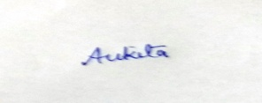

Signature

Ankita

Consultant