CAPSTONE 4
SMART HOME IoT PROJECT DOCUMENTATION ASSISTANT
Project: Room Temperature & Humidity Monitor

Abstract
This project designs a beginner-friendly smart-home IoT monitor using an ESP32 development board and a DHT22 temperature/humidity sensor. The controller samples the sensor, prints CSV readings over USB serial, and activates visual and audible indicators when either configurable threshold is reached. The baseline intentionally operates offline so it can be built and reviewed without cloud credentials.

1. Problem statement and objectives
Room temperature and humidity can vary throughout the day. The goal is to demonstrate a low-cost sensing system with clear status feedback and a reproducible documentation workflow.
- Measure temperature and relative humidity at a practical interval.
- Print timestamp, readings, and status in a stable CSV format.
- Trigger a red LED and buzzer at configurable threshold limits.
- Create a verified component list, wiring plan, firmware, test plan, user guide, and presentation.

2. Requirements
- Measure room temperature in °C and relative humidity in %RH.
- Sample approximately every 2.5 seconds (within the DHT22's recommended sampling limits).
- Show readings and status over USB serial in CSV format.
- Turn green LED on when both readings are below thresholds.
- Turn red LED and buzzer on when temperature >= 30 °C OR relative humidity >= 70%.
- Indicate sensor read failures with a red LED and a SENSOR_ERROR serial row.
- Use ESP32 Wi-Fi capability as a future extension; this baseline deliberately works offline.
- Keep the system low-voltage and breadboard-friendly.
- Thresholds must be configurable in firmware and are illustrative, not medical or building-safety limits.

3. System architecture
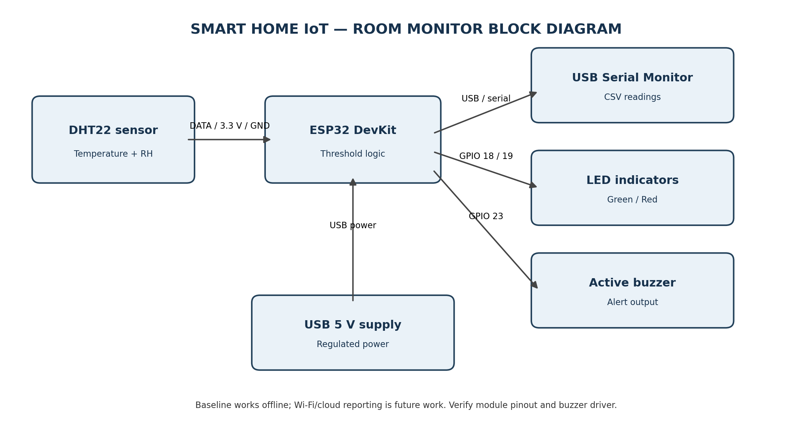
Signal path: DHT22 DATA → ESP32 GPIO 4. The ESP32 evaluates the configured thresholds and updates green/red LEDs and the buzzer output. Serial output is provided over USB. The ESP32 Wi-Fi radio is not used in this baseline.

4. Bill of materials
Component | Qty | Estimate | Notes
ESP32 DevKit V1 (30-pin) | 1 | ₹401.20 | Wi-Fi microcontroller; verify exact board pinout
DHT22 / AM2302 sensor module | 1 | ₹212.40 | Temperature + relative humidity; use module or add pull-up per datasheet
Active buzzer, 3.3 V compatible | 1 | ₹25.00 | Local audible alert; drive through transistor if current exceeds GPIO rating
Red LED | 1 | ₹2.00 | High-condition indicator
Green LED | 1 | ₹2.00 | Normal-condition indicator
330 Ω resistors | 2 | ₹4.00 | One series resistor per LED
NPN transistor + base resistor (optional buzzer driver) | 1 set | ₹10.00 | Use if buzzer current is above GPIO limit
Breadboard + jumper wires | 1 set | ₹120.00 | Prototyping
USB cable / 5 V USB supply | 1 | ₹150.00 | Power supply; use a reputable regulated supply
Estimated subtotal: ₹926.60 before shipping and price variation. ESP32 DevKit V1 (₹401.20) and DHT22 (₹212.40) were observed on the supplier listing linked below; remaining prices are planning estimates, not verified quotes. Check current stock and shipping before purchase.

5. Wiring description
- DHT22 VCC → ESP32 3V3; DHT22 GND → ESP32 GND; DHT22 DATA → GPIO 4.
- Green LED anode → GPIO 18 through 330 Ω; cathode → GND.
- Red LED anode → GPIO 19 through 330 Ω; cathode → GND.
- Buzzer driver input → GPIO 23. If the buzzer current exceeds the GPIO's safe output capability, use an NPN/MOSFET driver and suitable supply; share ground.
- Power ESP32 using USB from a regulated supply. Confirm the exact board and sensor module pinout before applying power. Bare DHT22 sensors may require an external pull-up resistor; many modules include one.

6. Firmware design
The Arduino sketch uses the Adafruit DHT library. It samples every 2.5 seconds, checks for NaN sensor values, and prints CSV rows at 115200 baud. If temperature is at least 30 °C or relative humidity is at least 70%, the status is ALERT and red LED/buzzer outputs are activated. Sensor read failures print SENSOR_ERROR, illuminate the red LED, and silence the buzzer.
Dependencies: ESP32 board support in Arduino IDE; Adafruit DHT sensor library; Adafruit Unified Sensor library.

7. Verification plan and evidence
The test matrix in simulation/test_plan.csv specifies normal readings, individual thresholds, both thresholds, sensor failure, boundary values, sampling cadence, and startup. These tests are marked planned—not executed. No hardware or simulator execution was performed while preparing this package. Add real serial logs or simulator screenshots after executing tests.

8. AI-assisted workflow and automation
AI assistance was used to draft requirements, architecture, firmware, BOM structure, report, test matrix, prompt library, poster, and presentation. The included Python automation reads BOM.csv and creates a formatted BOM workbook. This reduces repetitive formatting, but does not replace engineering verification.

9. Safety, privacy, and limitations
- Use only low-voltage USB power; inspect wiring before energizing.
- Do not drive a high-current buzzer directly from a GPIO; verify its current rating and use a transistor driver when needed.
- Do not treat the device as a certified fire, health, or building safety system.
- The sensor has not been calibrated; thresholds are illustrative and not universal comfort/safety standards.
- The baseline does not connect to Wi-Fi/cloud and collects no personal data. If cloud features are added, keep credentials private, use TLS, and disclose what data is stored.
- AI-generated code, wiring, and prices can be wrong. Compile, simulate, inspect datasheets, and test on the bench before relying on the system.

10. Future improvements
Add a Wi-Fi dashboard with authentication, local data logging, threshold configuration through a web UI, sensor calibration, enclosure design, and a more accurate sensor if the use case requires it.

References
1. Espressif Systems, ESP32 Datasheet: https://documentation.espressif.com/esp32_datasheet_en.html
2. Sonani Electronics parts listing (observed prices for ESP32 DevKit V1 and DHT22): https://sonanielectronics.com/?tab=parts
3. DHT22/AM2302 manufacturer datasheet and the exact development-board pinout should be consulted before assembly.

