**Introduction**

Product sales analysis is an indispensable tool for modern businesses striving for success in an increasingly competitive market. By delving into the intricacies of sales data, companies can gain profound insights into customer preferences, market trends, and the performance of their products. This essay explores the significance of product sales analysis, its key components, and its vital role in shaping business strategies.

**Objective**

The objective of product sales analysis is to maximize revenue by identifying top-performing products, optimizing pricing, and improving inventory management. It enhances marketing efforts through customer-focused strategies and gains a competitive edge by understanding market dynamics. It also informs product development, mitigates risks, and enables data-driven decision-making, contributing to sustainable business growth.

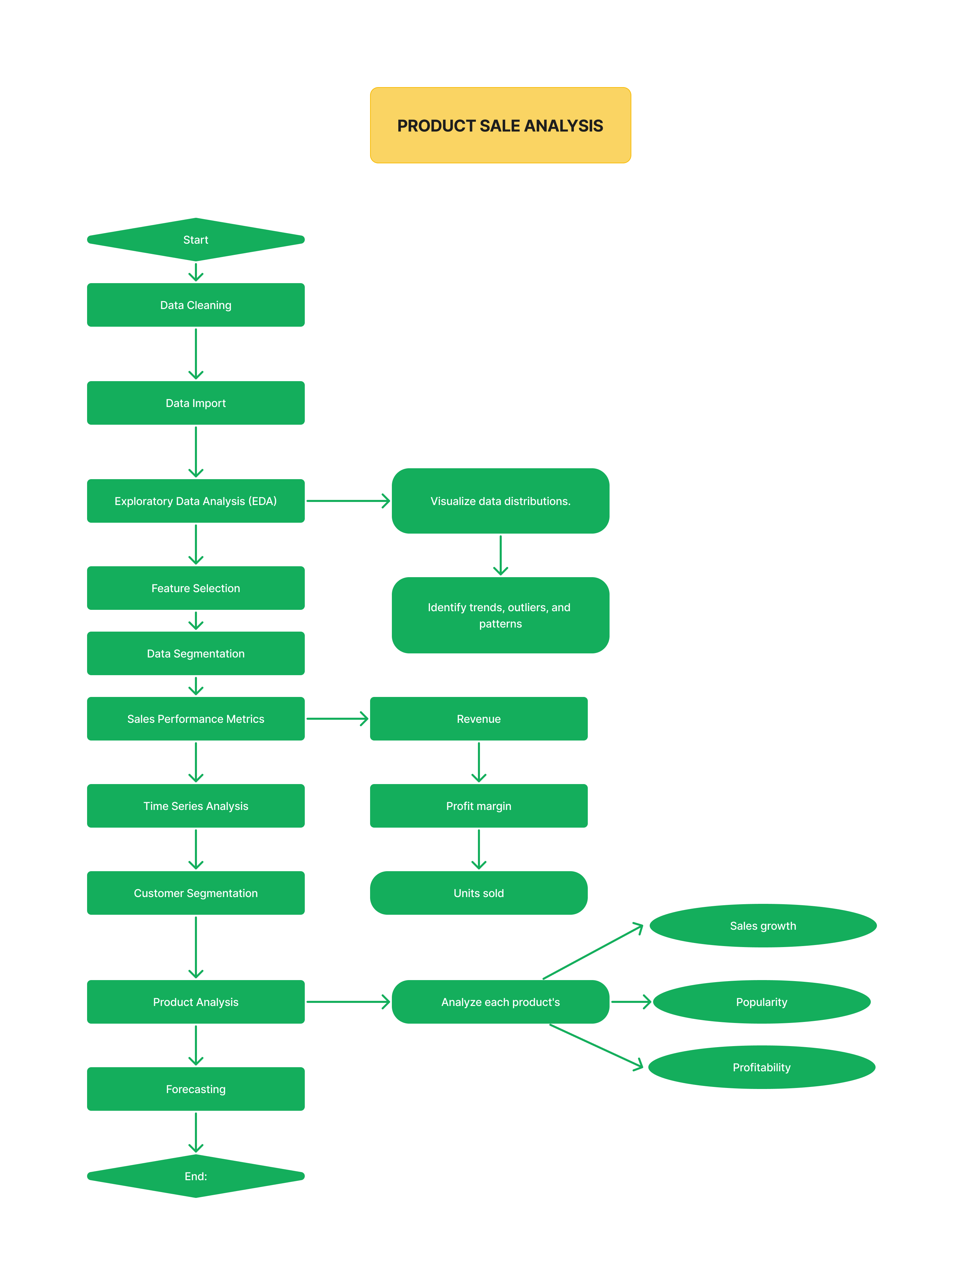**Flowchart**

Product sales analysis is a critical process for businesses to evaluate the performance of their products in the market. It involves collecting, processing, and interpreting data related to the sales of a company's products. This analysis provides valuable insights that can help businesses make informed decisions about their product strategies, pricing, marketing efforts, and more. Here's an overview of the key components and steps involved in product sales analysis:

1. Data Collection: The first step in sales analysis is to gather relevant data. This data can come from various sources, including point-of-sale systems, online sales platforms, CRM (Customer Relationship Management) software, and more. It should include information about product sales, such as unit sales, revenue, date of sale, location, and customer demographics.
2. Data Cleaning and Preparation: Raw sales data often requires cleaning and preparation. This involves removing duplicates, correcting errors, and formatting data for analysis. The data should be organized in a structured format for ease of analysis.
3. Data Segmentation: To gain meaningful insights, data can be segmented in various ways. Common segmentation criteria include time periods (daily, monthly, quarterly, annually), product categories, geographical regions, customer segments, and more.
4. Key Performance Indicators (KPIs): Identify and calculate KPIs that are relevant to your analysis. Common sales KPIs include total revenue, total units sold, average selling price, profit margins, market share, customer acquisition cost, customer lifetime value, and more.
5. Trend Analysis: Analyze sales trends over time to identify patterns and seasonality. This can help in understanding when and why sales peak or dip and allow for better inventory management and marketing planning.
6. Product Performance Analysis: Evaluate the performance of individual products or product categories. Identify which products are best-sellers, which are underperforming, and assess their contribution to overall revenue and profit.
7. Customer Analysis: Understand customer behavior by analyzing data related to customer demographics, purchasing frequency, average transaction value, and customer retention rates. This can help in tailoring marketing efforts to specific customer segments.
8. Competitive Analysis: Examine how your products compare to competitors in terms of market share, pricing, and features. This information can guide pricing strategies and product development efforts.
9. Sales Channels Analysis: Evaluate the performance of different sales channels (e.g., online, retail, wholesale) to determine which channels are the most profitable and efficient.
10. Forecasting: Use historical sales data and trends to create sales forecasts. Accurate forecasts are essential for inventory management, production planning, and budgeting.
11. Data Visualization: Create charts, graphs, and dashboards to visually represent the sales data and insights. Visualization makes it easier to communicate findings and trends to stakeholders.
12. Actionable Insights: Based on the analysis, develop actionable recommendations and strategies to improve sales performance. These recommendations might include adjusting pricing, launching marketing campaigns, introducing new products, or optimizing distribution channels.
13. Monitoring and Iteration: Sales analysis is an ongoing process. Continuously monitor sales performance, track the impact of implemented strategies, and iterate on your approach as needed to adapt to changing market conditions.

Product sales analysis is a dynamic process that plays a crucial role in helping businesses make data-driven decisions to optimize their product offerings and maximize revenue and profitability. It requires a combination of data analysis skills, domain knowledge, and business acumen.