**Table of Contents**

1. Overview 2

1. Scope 2

2.1. Inclusions 2

2.2. Test Environments 3

2.3. Exclusions 3

3. Test Strategy 4

4. Roles/Responsibilities 5

5. Test Schedule 6

6. Test Deliverables 6

7. Entry and Exit Criteria 6

8. Suspension and Resumption Criteria 7

9. Tools 7

10. Risks and Mitigations 8

11. Approvals 8

# **1 Overview**

As part of the project, Given the specificity of the site it is very important to have the same quality and the site.

This document describe approaches and methodologies that will apply to the unit, integration and system testing of the “https://demo.opencart.com/”.

This document serves as high level test planning document with details on the scope of the project, test strategy, test schedule and resource requirements, test deliverables and schedule.

# **2 Scope**

The scope of the project includes testing the following features of

‘https://demo.opencart.com/’ web application.

## Inclusions

* Register
* Login & Logout
* Forgot Password
* Search
* Add to Cart
* Wish List
* Shopping Cart
* Home Page
* Checkout Page
* My Account Page
* Order History Page
* Downloads Page
* Contact Us Page
* Menu Options
* Category Pages

From our understanding, we believe above functional areas need to be Tested.

## 

## Test Environments

* Windows 10 – Chrome, Firefox and Edge
* Mac OS – Safari Browser
* Android Mobile OS – Chrome
* iPhone Mobile OS - Safari

## Exclusions

* All the features except that are mentioned under ‘Inclusions’
* Any third-party features or Payment gateways
* Test Automation

# **3 Test Strategy**

## 3.1 QA role in test process

* Understanding Requirements
* Preparing Test Cases
* Preparing Test Matrix
* Reviewing test cases and matrix
* Creating Test Data



* Executing Test Cases
* Retesting and Regression Testing
* Deployment/Delivery

## 3.2 Bug life cycle:

All the issues found while testing will be logged into Word document.

Bug life cycle for this project is as follows:

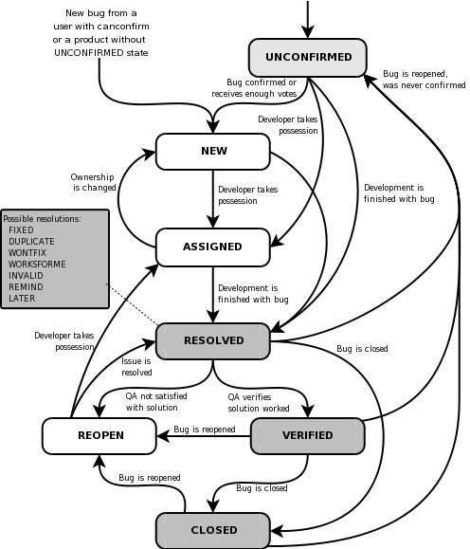

## 3.3 Testing types

- Black box Testing

- GUI Testing

- Integration Testing

- Functional Testing

- System Testing

- Performance Testing

- User Acceptance Testing

- Alpha Testing

## 3.4 Bug Severity and Priority Definition

Bug Severity and Priority fields are both very important for categorizing bugs and prioritizing if and when the bugs will be fixed. The bug Severity and Priority levels will be defined as outlined in the following tables below. Testing will assign a severity level to all bugs. The Test Lead will be responsible to see that a correct severity level is assigned to each bug.

# **4 Roles/Responsibilities**

|  |  |  |
| --- | --- | --- |
| Name | Role | Responsibilities |
| Person A | Test Manager | * Escalations |
| Person B | Test Lead | * Create the Test Plan and get the client signoffs * Interact with the application, create and execute the test cases * Report defects * Coordinate the test execution. Verify validity of the defects being reported. * Submit daily issue updates and summary defect reports to the client. * Attend any meeting with client. |
| Person C | Senior Test Engineer | * Interact with the application * Create and Execute the Test cases. * Report defects |
| Person D | Test Engineer | * Interact with the application * Execute the Test cases. * Report defects |

# 

# **5 Test Schedule**

Following is the test schedule planned for the project –

|  |  |
| --- | --- |
| Task | Time Duration |
| * Creating Test Plan | Start Date to End Date |
| * Test Case Creation | Start Date to End Date |
| * Test Case Execution | Start Date to End Date |
| * Summary Reports Submission | Date |

# **6 Test Deliverables**

The following are to be delivered to the client:

|  |  |  |
| --- | --- | --- |
| Deliverables | Description | Target Completion Date |
| Test Plan | Details on the scope of the Project, test strategy, test schedule, resource requirements, test deliverables and  schedule | Date |
| Functional  Test Cases | Test Cases created for the scope defined | Date |
| Defect Reports | Detailed description of the defects identified along with screenshots and steps to reproduce on a daily basis. | NA |
| Summary Reports | Summary Reports – Bugs by Bug#,  Bugs by Functional Area and Bugs by Priority | Date |

# **7 Entry and Exit Criteria**

## Entry Criteria

* All test hardware platforms must have been successfully installed, configured, and functioning properly.
* All the necessary documentation, design, and requirements information should be available that will allow testers to operate the system and judge the correct behavior.
* All the standard software tools including the testing tools must have been successfully installed and functioning properly.
* Proper test data is available.
* The test environment such as, lab, hardware, software, and system administration support should be ready.
* QA resources have completely understood the requirements
* QA resources have sound knowledge of functionality
* Reviewed test scenarios, test cases and RTM

## Exit Criteria

* A certain level of requirements coverage has been achieved.
* No high priority or severe bugs are left outstanding.
* All high-risk areas have been fully tested, with only minor residual risks left outstanding.
* Cost – when the budget has been spent.
* The schedule has been achieved

# **8 Suspension and Resumption Criteria**

Based on the Client decision, we will suspend and resume the Project. We will ramp up and ramp down the resources as per Client needs.

**9 Tools**

The following are the list of Tools we will be using in this Project:

* Bug Tracking Tool
* Mind map Tool
* Snipping Screenshot Tool
* Word and Excel documents

# **10 Risks and Mitigation**

The following are the list of risks possible and the ways to mitigate them: Risk: Non-Availability of a Resource

Mitigation: Backup Resource Planning Risk: Build URL is not working

Mitigation: Resources will work on other tasks Risk: Less time for Testing

Mitigation: Ramp up the resources based on the Client needs dynamically

# **11 Approvals**

Team will send different types of documents for Client Approval like below:

* Test Plan
* Test Scenarios
* Test Cases
* Reports

Testing will only continue to the next steps once these approvals are done.