Lesson 03 Demo 01

Integrating n8n for Automated Customer Support Ticket Routing

Objective: To build an n8n-based ticket routing workflow that captures support emails, prioritizes them with simple rules, and logs to Google Sheets to reduce missed or delayed responses by centralizing intake and highlighting urgent cases

Tools required: n8n, Gmail, Google Sheets

Prerequisites: An n8n account, a Gmail account with access to the inbox you will monitor, and a Google Sheet you can edit

Steps to be followed:
- Set up the n8n environment
- Create the Gmail trigger
- Parse and prioritize the email in a Code node
- Log tickets to Google Sheets

Step 1: Set up the n8n environment

- Go to n8n.io and click Get started for free to open n8n Cloud

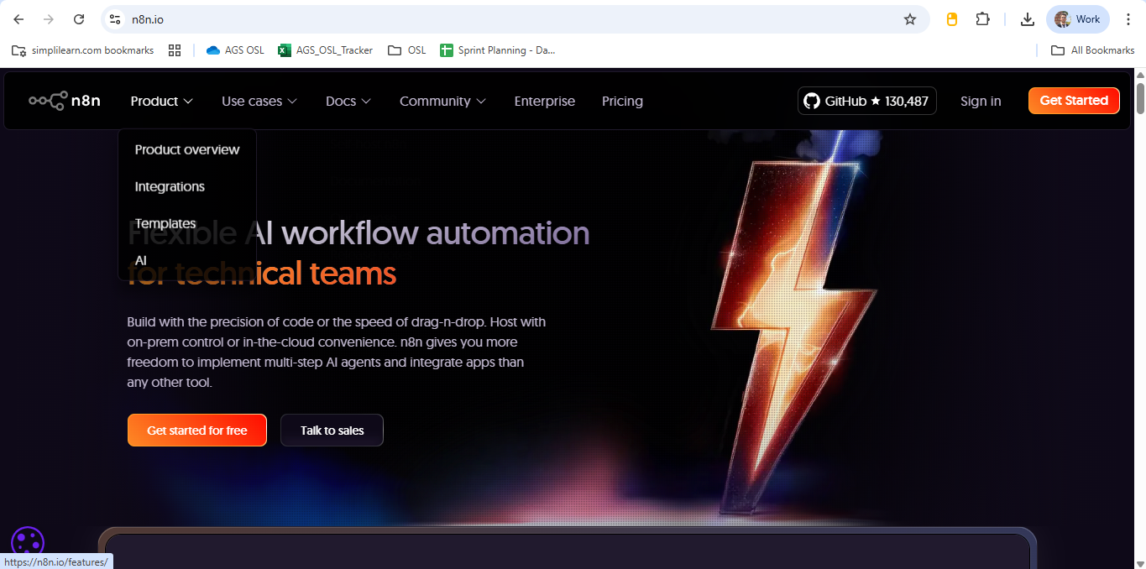

- Enter your credentials and click Start free 14-day trial

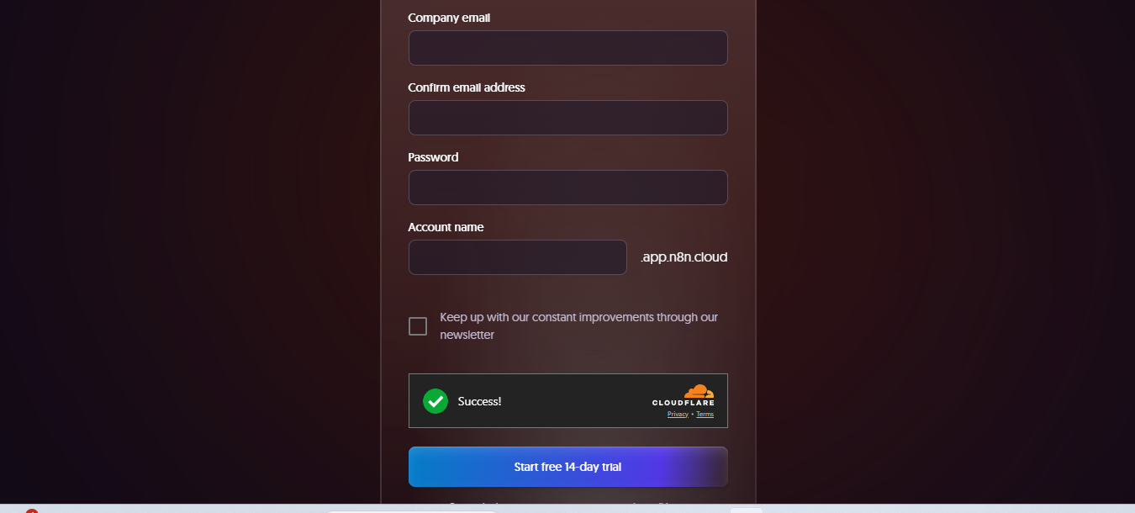

- Answer the onboarding questions to proceed

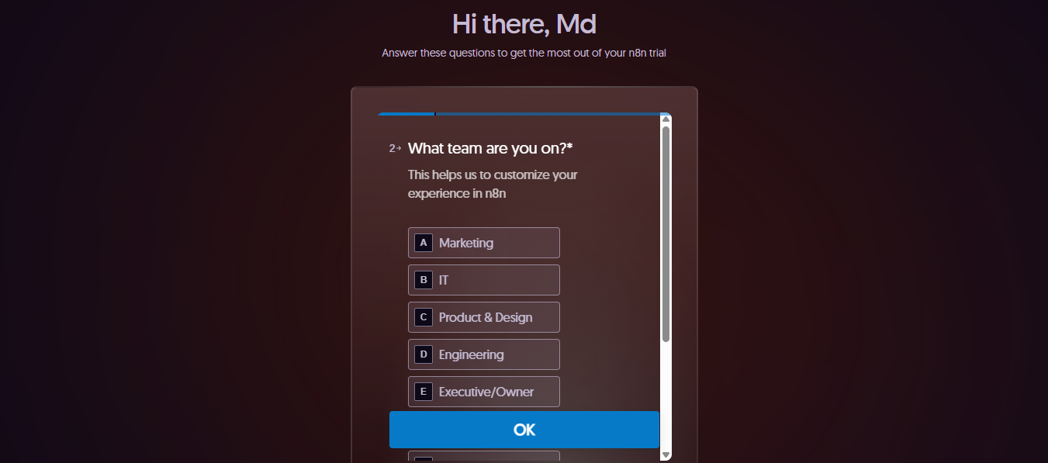

- After answering the questions, click Start automating

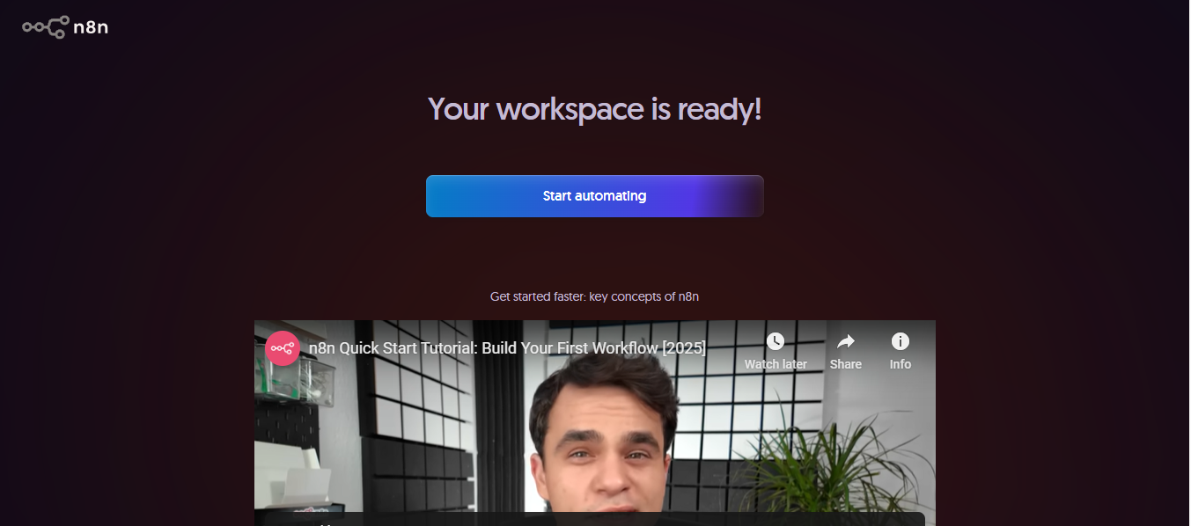

- You will be directed to the n8n dashboard; click Create Workflow.

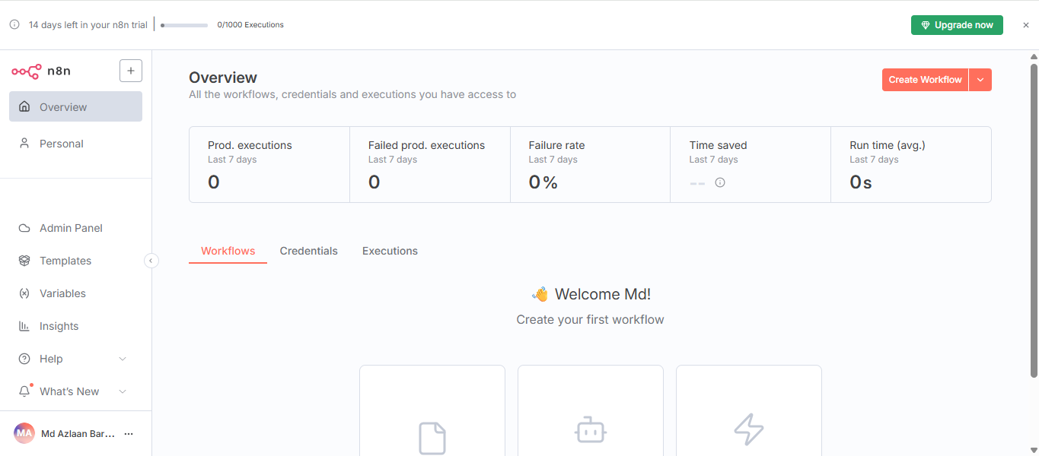

Step 2: Create the Email Trigger

  - On the n8n canvas, click +

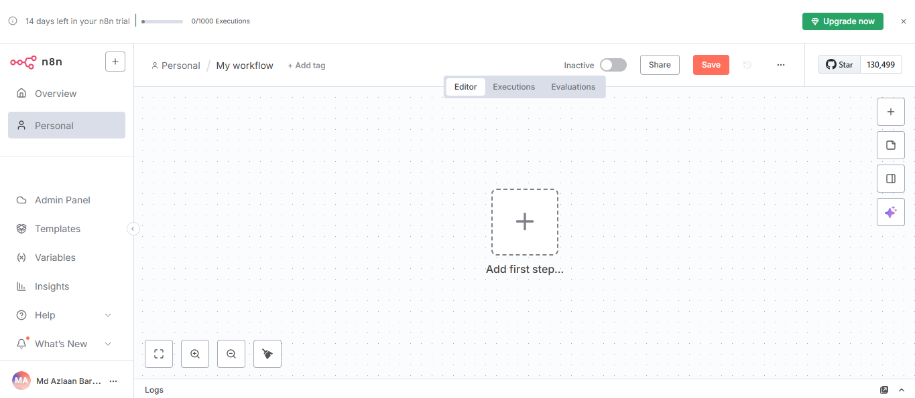

  - A panel from the right will open; search Gmail and select the Gmail trigger.

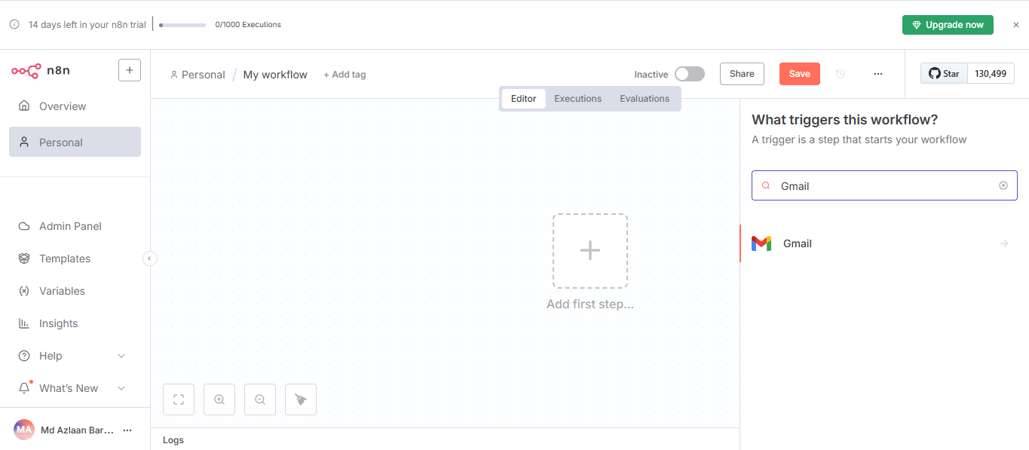

  - In the Trigger settings, choose On message received and turn Simplify Output = ON

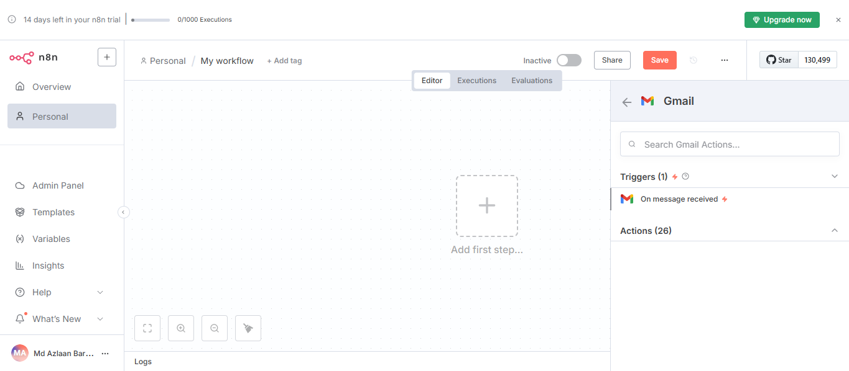

  - Click Credentials → + Create new credentials

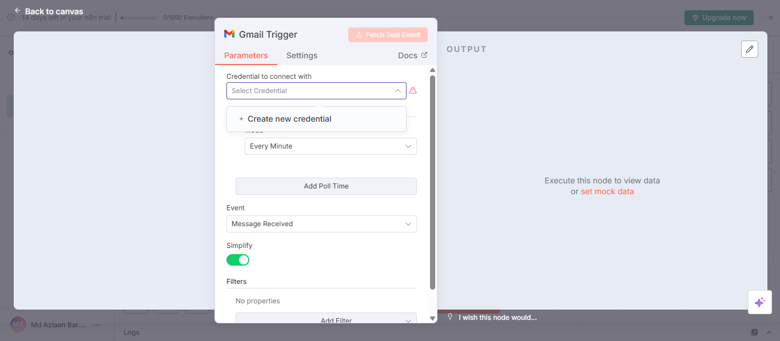

  - Choose Sign in with Google and grant the requested permissions

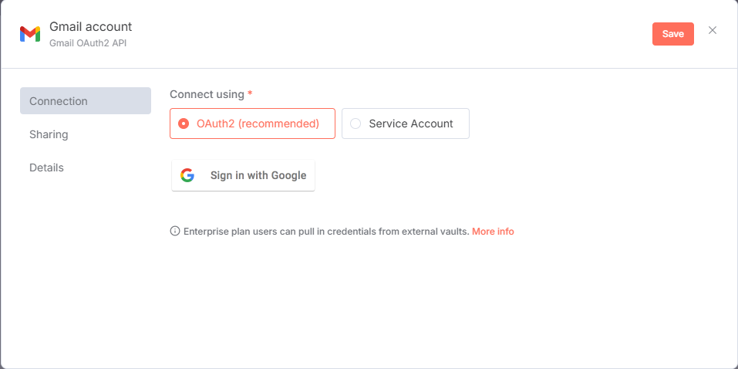

  - When you see Account connected, close this window to return to the workflow

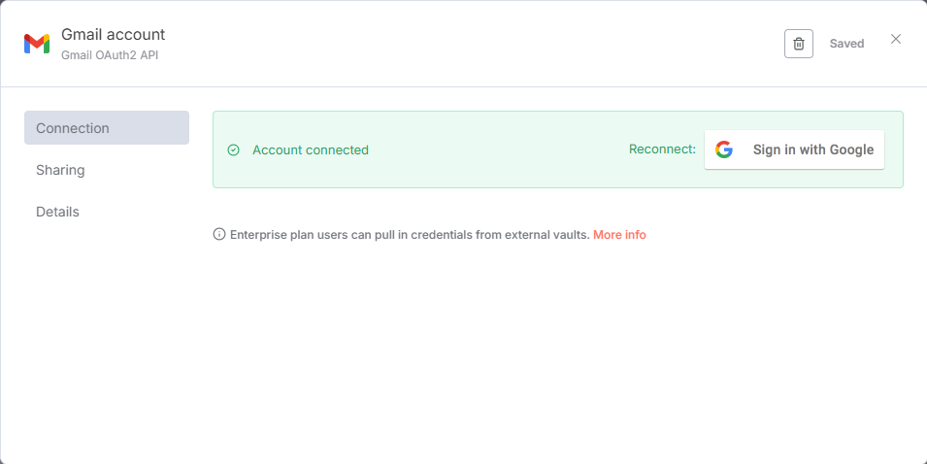

Note: If you see Forbidden / insufficient scopes, reconnect the credential and allow read/modify access.

Step 3: Parse and prioritize the Email

  - Open the nodes panel by clicking the + icon

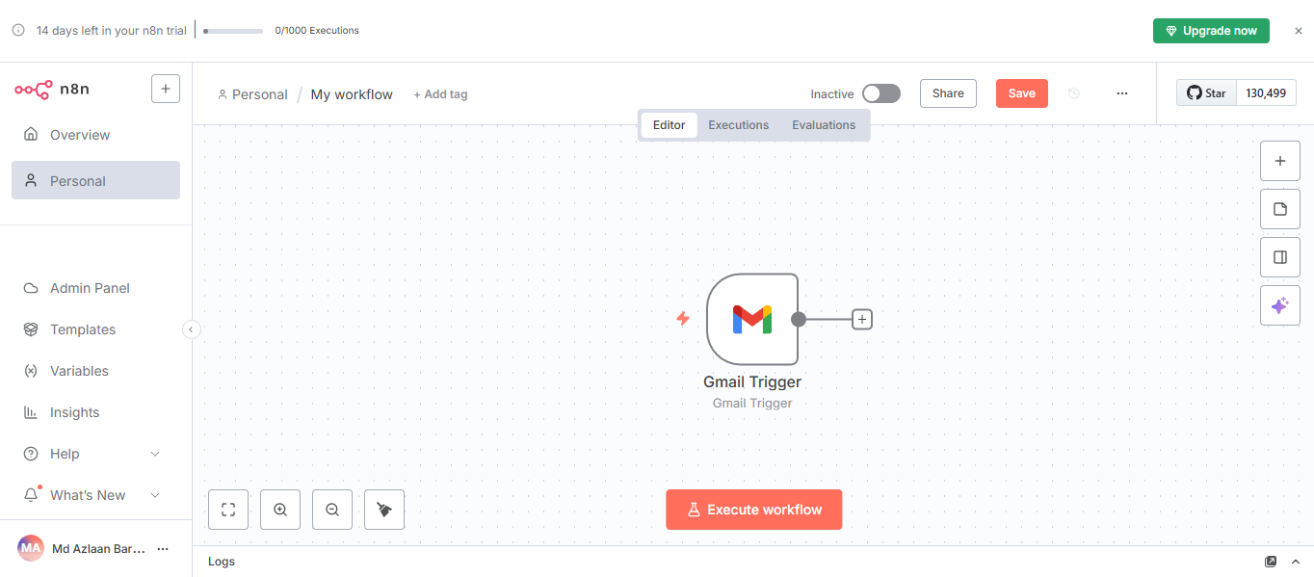

  - Search for Code, and select the {} Code option

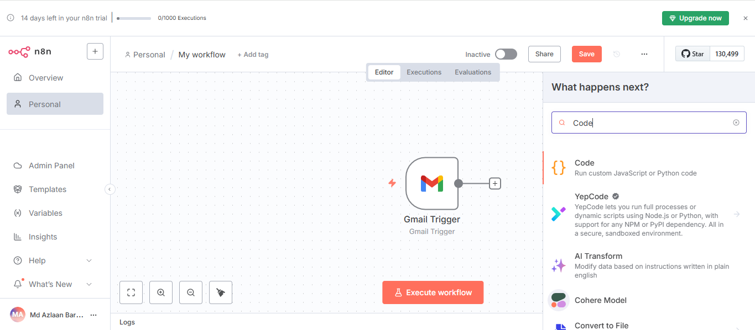

  - In the Code node editor, paste the following script:

const r = $json || {}; // previous node's json

// Try multiple common Gmail fields (works with Simplify Output ON)
const sender = r.from || r.sender || r.headers?.from || "";
const subject = r.subject || r.headers?.subject || "";
const body = r.text || r.textPlain || r.textHtml || r.snippet || "";

// Simple priority rules
const text = `${subject} ${body}`;
let priority = "Low";
if (/(urgent|critical|immediately|down)/i.test(text)) priority = "High";
else if (/(issue|problem|error|delay)/i.test(text)) priority = "Medium";

// ALWAYS wrap in { json: ... }
return [{
json: { timestamp: new Date().toISOString(), sender, subject, body, priority }
}];

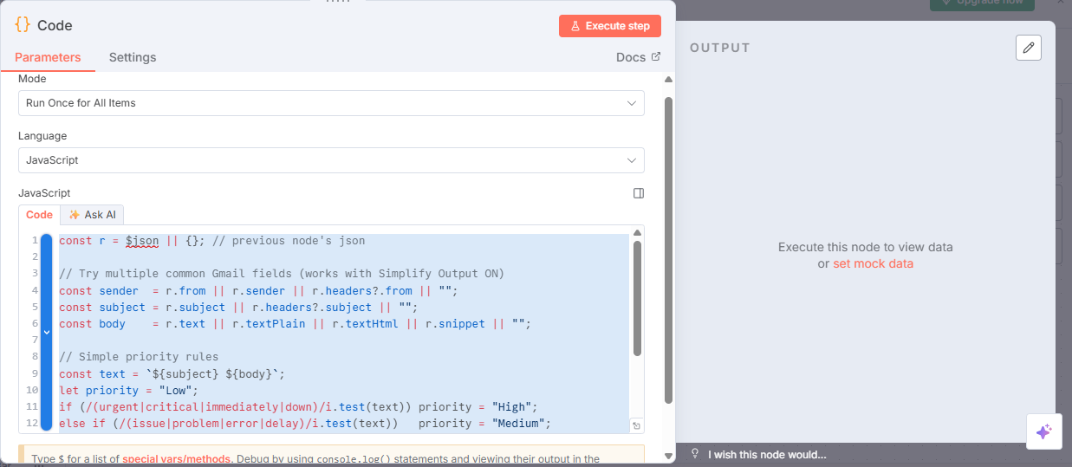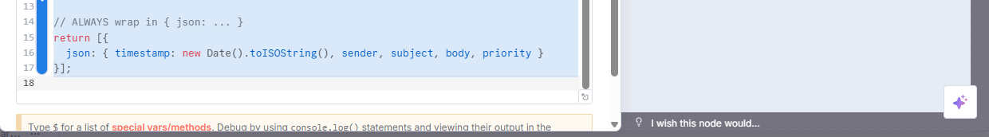

  - Click the Execute step to run the code node

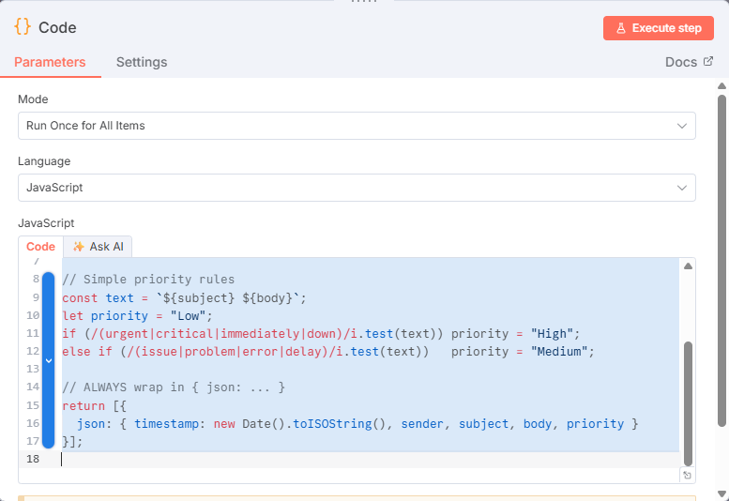

  - Return to the canvas and connect Gmail Trigger → Code

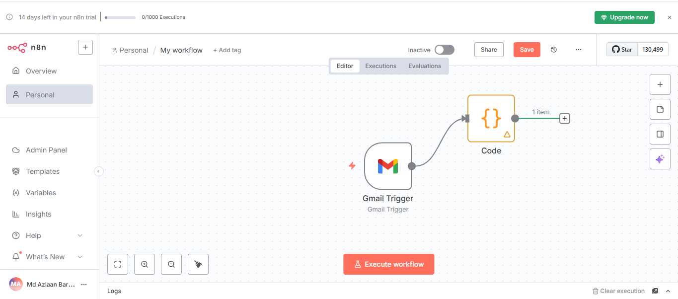

Note: If the Code output says, “Item is empty,” re-run Execute workflow so the Gmail Trigger produces a fresh item.

Step 4: Log tickets to Google Sheets

  - In Google Drive, create a spreadsheet named Ticket Log

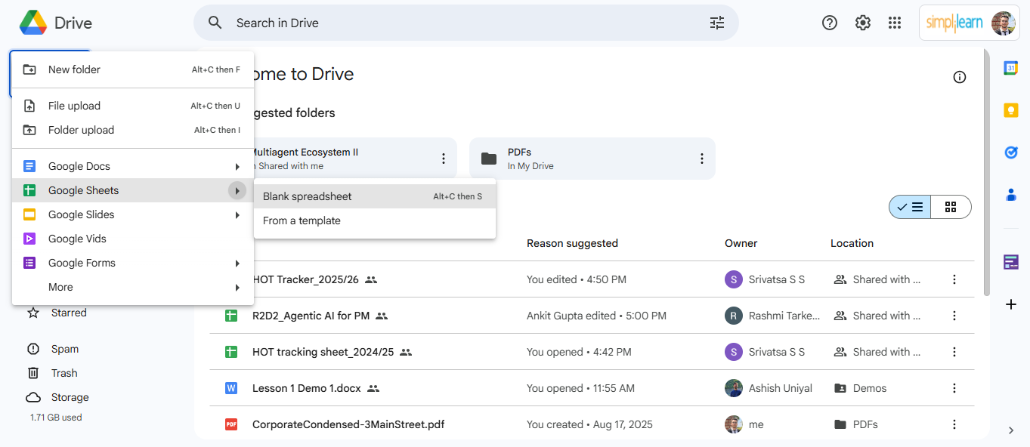

  - In Row 1, add the following headers: timestamp, sender, subject, priority, status

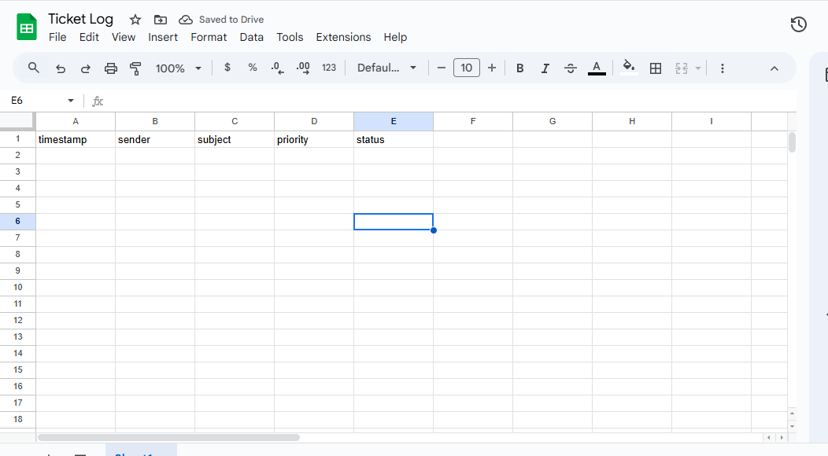

  - Go back on the canvas, click +, search Google Sheets and select it

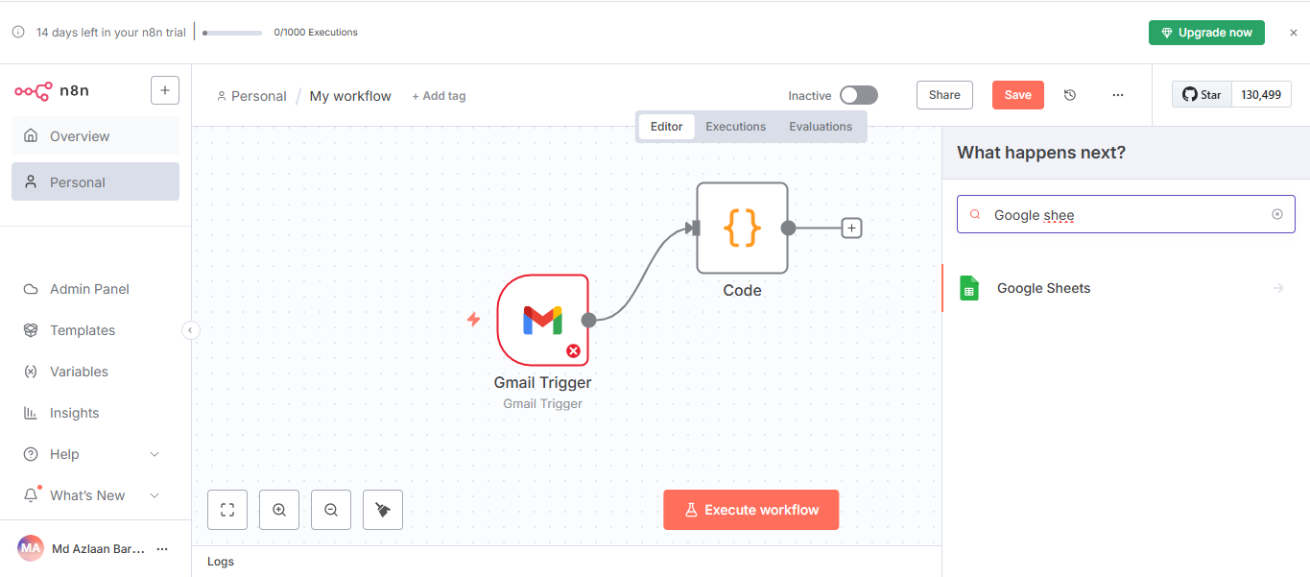

  - Choose Append row in sheet from the list of options

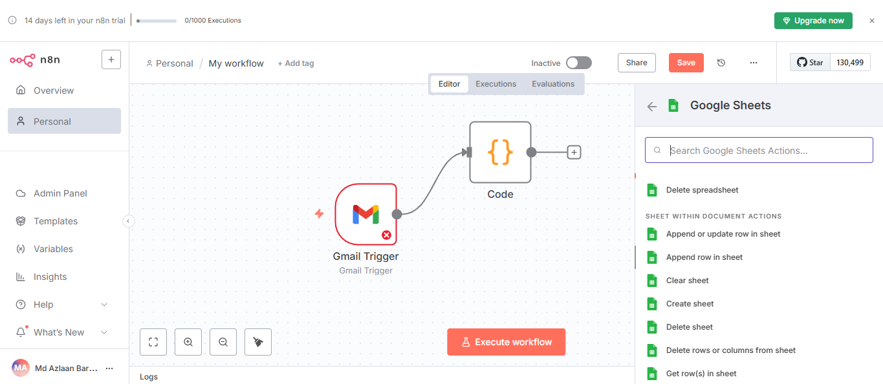

  - Click + Create new credentials

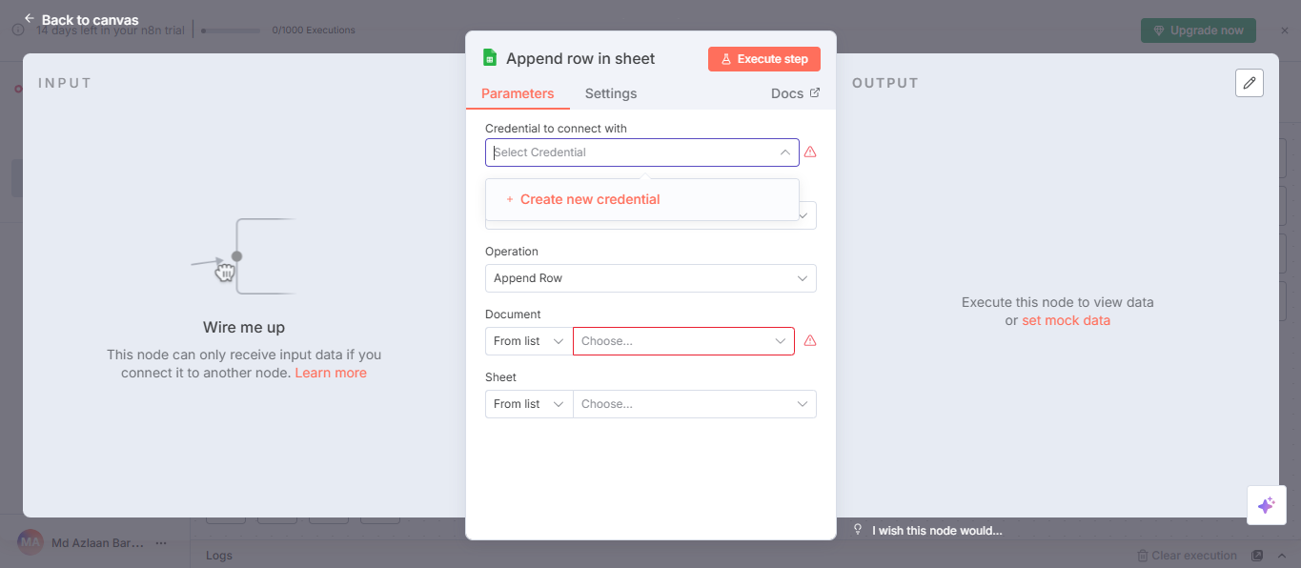

  - Click Sign in with Google and grant the requested permissions

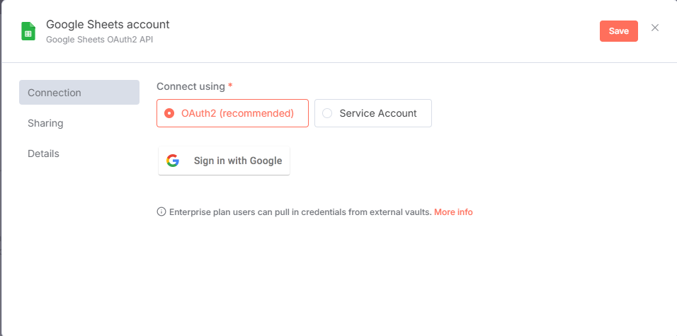

  - When connected, close this window to return to the node

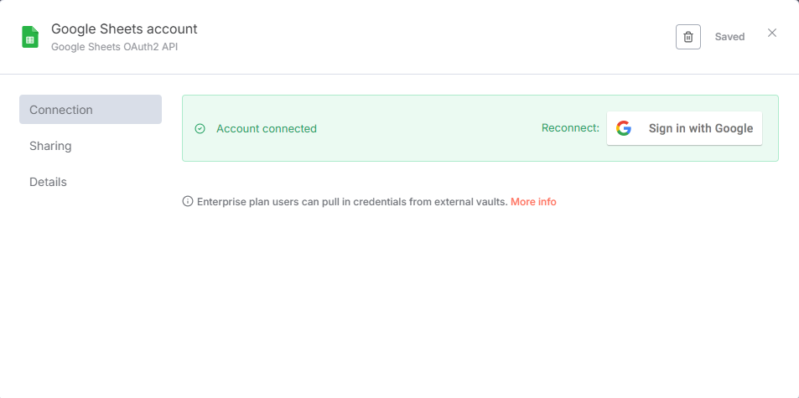

  - Double-click on Google Sheets, then select the name of the sheet under the Document option and the sheet number under the Sheet option

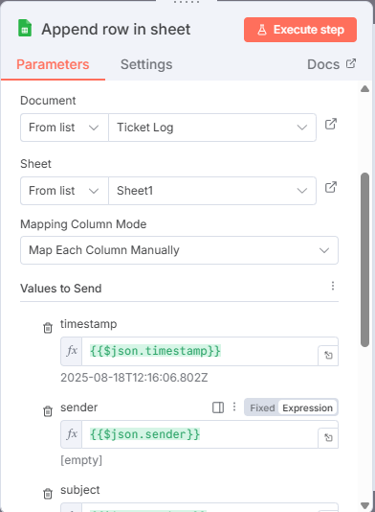

  - Scroll down to the Values to Send section and enter the following values under each placeholder and hit Execute step:

Timestamp → {{$json.timestamp}}
Sender → {{$json.sender}}
Subject → {{$json.subject}}
Priority → {{$json.priority}}
Status → Logged

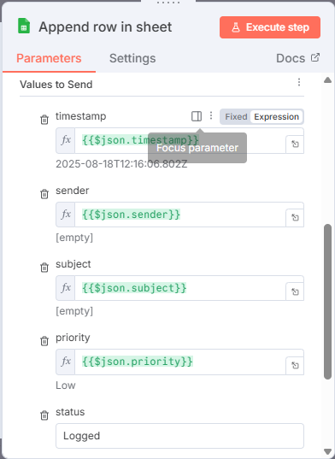

- Return to the canvas, connect Code → Google Sheets (Append row in sheet), and click Execute workflow

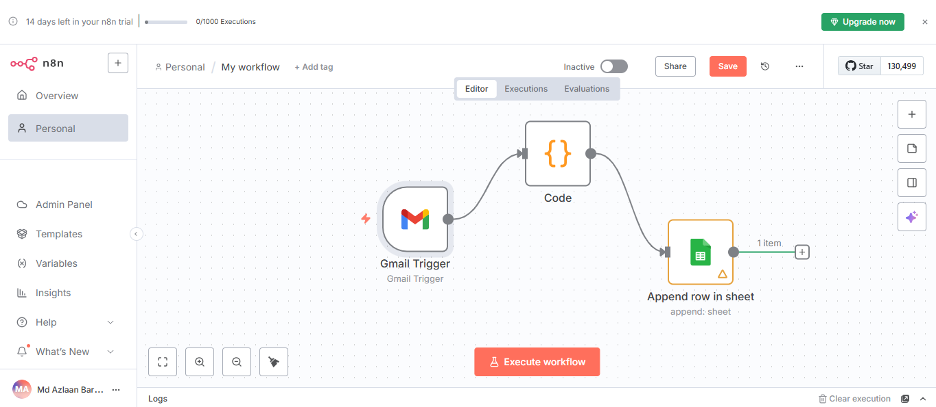

Note: After you click Execute workflow, send test emails and verify if a new row appears in Ticket Log; if not, re-run to refresh Gmail input and check Google Sheets mappings and credentials.

By following these steps, you have successfully set up n8n ticket routing that collects support emails, sets priority, and appends to a Google Sheet, improving response times by auto-logging and surfacing high-priority tickets.

