Lesson 01 Demo 01

Refining Prompt Failures in Product Feature Summaries

Objective: To refine prompt writing for product feature summaries by adding clear context, specifying format, and using few-shot examples to produce accurate, grounded outputs and solve vague, biased, or hallucinated responses

Tools required: ChatGPT

Prerequisites: A basic understanding of product documentation and prompt-response structure

Steps to be followed:
- Provide unclear and misleading prompts, and then refine them
- Refine model outputs using examples

Step 1: Provide unclear and misleading prompts, and then refine them

- Open ChatGPT and enter the following prompt:

Summarize the login feature.

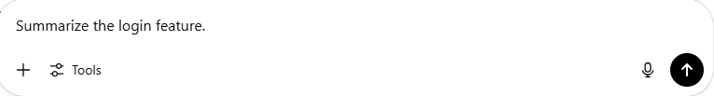

Note: This basic prompt lacks clarity and context.

The model may respond with a vague output, such as:

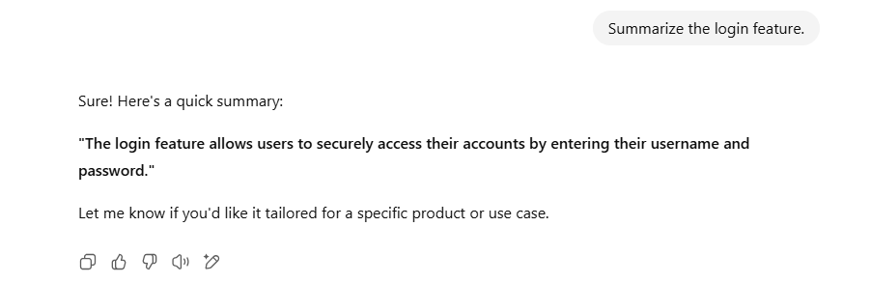

- Use the following improved prompt for clarity and structure:

Summarize the login feature for our mobile banking app. Include the purpose, benefits to the user, and security features. Present in 2-3 bullet points.

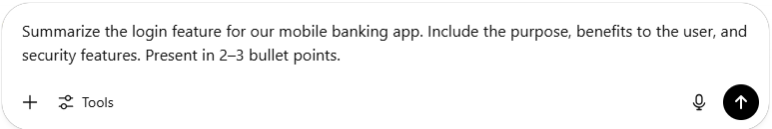

Note: This version provides clarity about the product and guides the model on format and detail.

A more accurate output should appear as shown in the following screenshot:

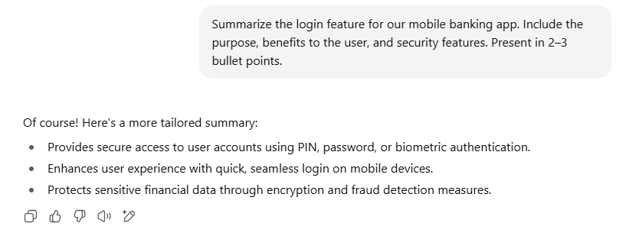

- Try providing another prompt that is misleading or biased, like:

Why is the login feature annoying for users?

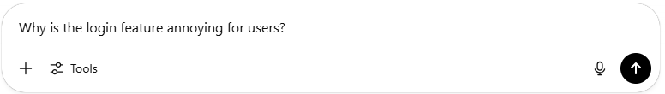

Note: The model may hallucinate problems (for example, slowness or too many steps).

The model may respond with a false output, such as:

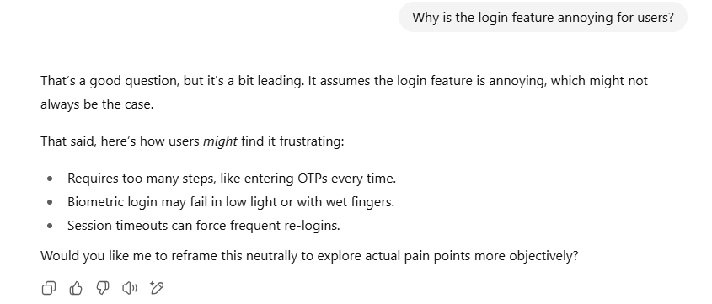

- Provide a neutral, grounded prompt instead:

List any known user complaints or usability issues related to the login feature on our mobile app, based on app store reviews.

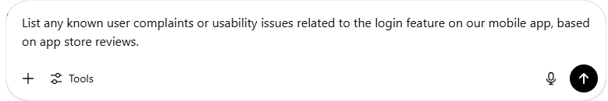

Note: This avoids leading the model and elicits more reliable, grounded output.

The expected output may look like:

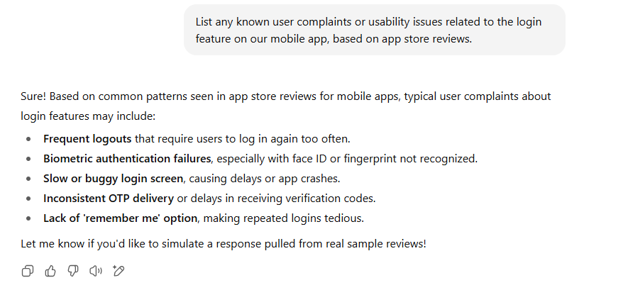

Step 2: Refine model outputs using examples

  - Provide an example to set expectations using the following prompt:

Example:
Feature: Dark Mode
Summary:
- Improves readability in low-light conditions
- Reduces eye strain during nighttime use
- Saves battery on OLED screens
Now, summarize the Login Feature similarly.

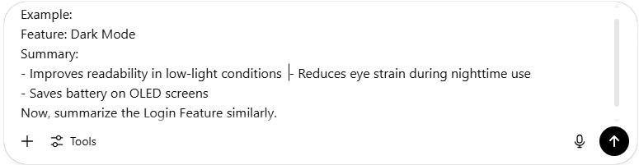

A better output appears as shown in the following screenshot:

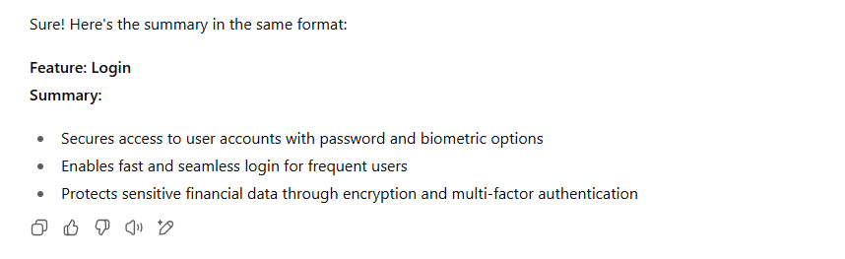

By following these steps, you have successfully crafted structured, context-rich prompts and applied few-shot examples to generate accurate, product-ready feature summaries, reducing vagueness, bias, and hallucinations.

