Lesson 01 Demo 02

Applying CoT and ReAct Prompting for Drafting User Stories and Analyzing Problems

Objective: To demonstrate how Chain-of-Thought (CoT) and ReAct prompting techniques can help product managers reason through user stories and product problems and simulate decision-making using structured thinking and tool-based action planning

Tools required: ChatGPT (or any LLM interface)

Prerequisites: Basic understanding of user stories, product discovery, and reasoning frameworks (CoT and ReAct)

Steps to be followed:
- Break down a user story using CoT prompting
- Analyze a product problem using CoT prompting
- Simulate market research using ReAct prompting

Step 1: Break down a user story using CoT prompting

- Open ChatGPT and enter the following prompt:

You are a product manager. Given the user story below, break down the reasoning step by step to identify:
• The user needs
• The business goal
• Assumptions or constraints
• Dependencies
• Acceptance criteria
User Story: “As a registered user, I want to receive a confirmation email after booking a ticket so that I have a record of my purchase.”

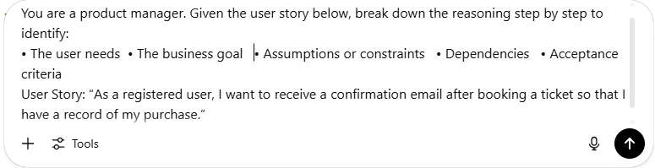

Expected output may look as shown in the following screenshot:

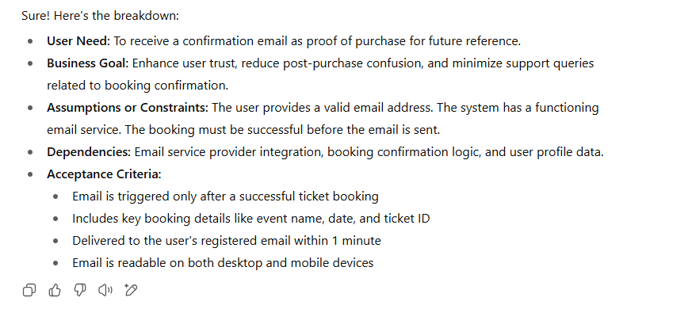

Step 2: Analyze a product problem using CoT prompting

  - Now, enter the following prompt:

You are a solution architect. Given a problem statement, reason through the situation to identify:
• The core problem
• The stakeholders
• The root cause
• Constraints and trade-offs
• Possible solutions
Problem Statement: “Our e-commerce app sees a 60% cart abandonment rate at the checkout stage.”

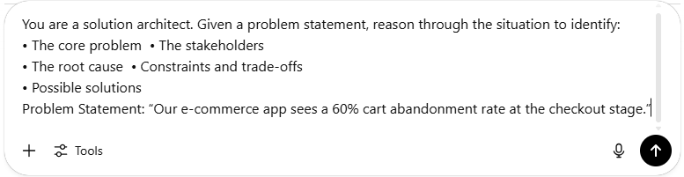

The expected output may look as shown in the following screenshot:

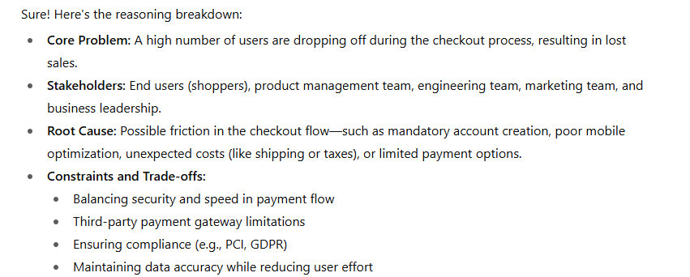


Step 3: Simulate market research using ReAct prompting

  - Enter the following prompt, using ReAct style:

You are a product manager researching AI-based writing assistants. Think step by step. Use search when needed to get competitor information. Then summarize findings into 3 user story ideas.

Available Tools: [Search], [Thought], [Write]

Begin:
Thought: I need to know what features AI writing assistants typically offer.
Action: Search ["Top features of AI writing assistants"]
Observation: Most AI writing tools include grammar checks, tone suggestions, rewriting, and content templates.
Thought: These features could be helpful for students, marketers, and bloggers.
Action: Write [“Create 3 user stories based on this information.”]

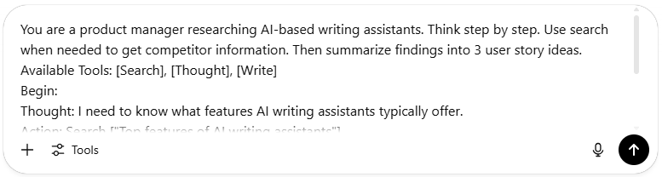

The expected output may look as shown in the following screenshot:

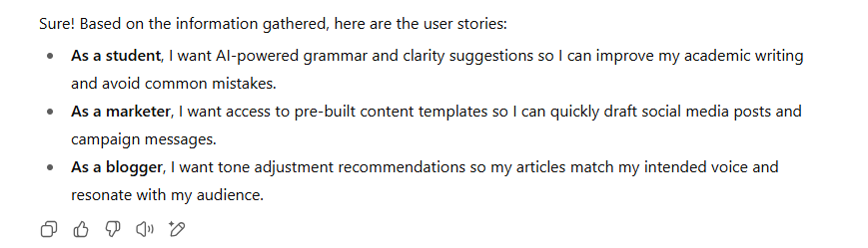

By following these steps, you will be able to apply Chain-of-Thought and ReAct prompting to break down user stories, analyze product problems, and perform market research, whether clarifying acceptance criteria or generating targeted user stories for students, marketers, and bloggers.

