Lesson 02 Demo 01

Building an RAG-Powered FAQ Agent with Custom Knowledge

Objective: To build an RAG-powered FAQ agent using LangChain, FAISS, and an LLM that retrieves relevant document chunks and generates grounded, source-backed answers to solve ungrounded or inconsistent responses and speed up accurate support

Tools required: Python, LangChain, FAISS, Azure OpenAI API, and Visual Studio Code

Prerequisites: Familiarity with LangChain and RAG concepts

Steps to be followed:
- Set up your local environment in Visual Studio Code
- Load and chunk your custom FAQ document
- Configure embeddings and create the vector store
- Initialize the LLM and set up the RAG chain
- Query the RAG agent and view results

Step 1: Set up your local environment in Visual Studio Code

- Open the terminal on your system and run the following commands:

mkdir rag_faq_agent && cd rag_faq_agent

python3 -m venv venv

source venv/bin/activate

code .

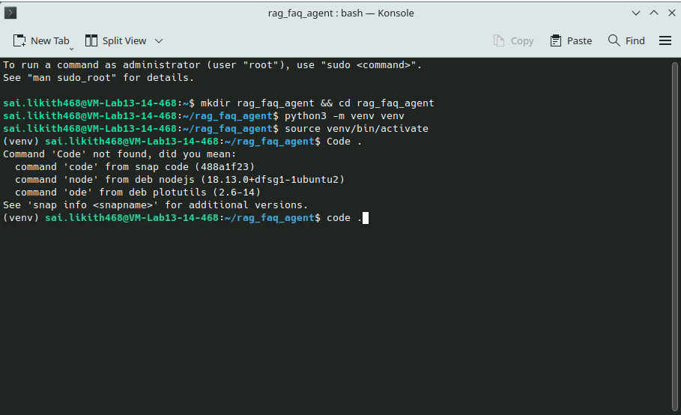

Note: This creates a virtual environment inside the rag_faq_agent directory and opens the folder in Visual Studio Code.

- Click New File… to create a new file, and name it main.ipynb

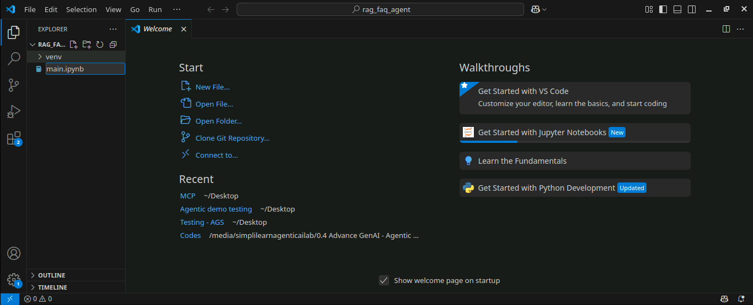

- In the first cell in the file, run the following command to install required packages:

!pip install langchain langchain-openai langchain-community faiss-cpu tiktoken

- When prompted, select Python Environments... and then choose the venv interpreter venv (Python 3.12.3)

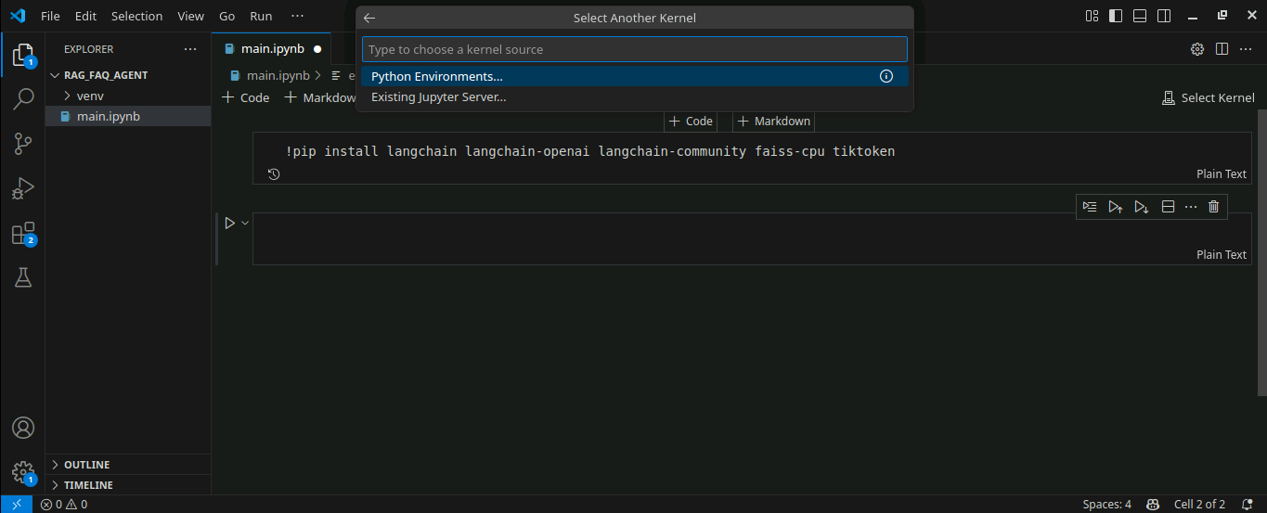

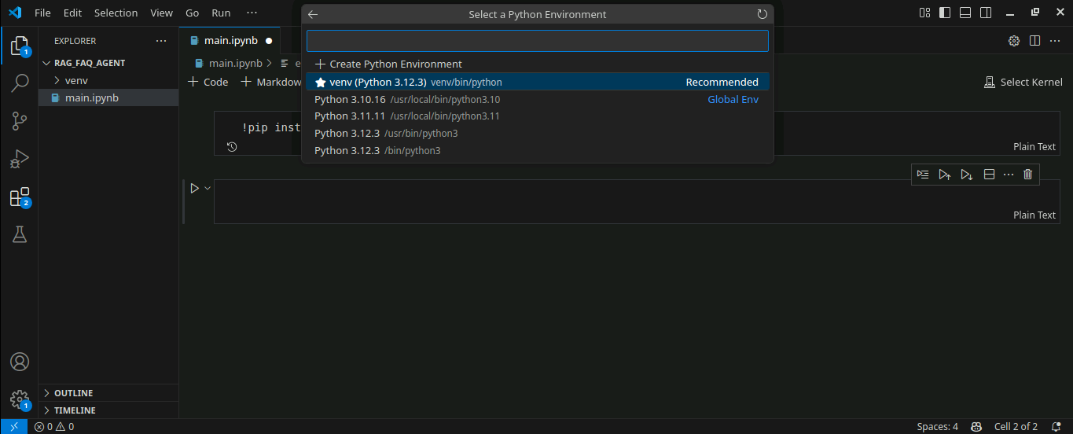

- If prompted to install ipykernel, click Install

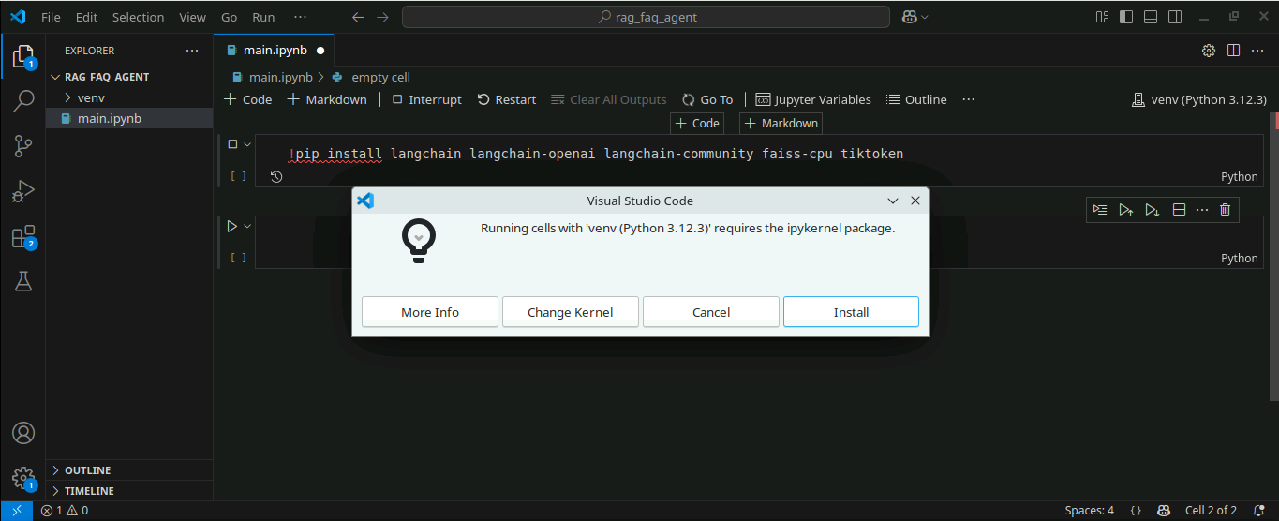

- Rerun the installation cell to complete the package setup

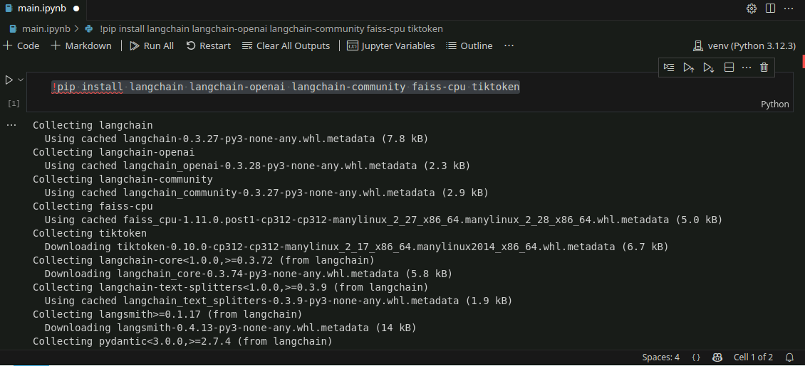

- Import the required libraries using the following code:

import os
from langchain_openai import AzureChatOpenAI, AzureOpenAIEmbeddings
from langchain_community.document_loaders import TextLoader
from langchain.text_splitter import CharacterTextSplitter
from langchain.vectorstores import FAISS
from langchain.chains import RetrievalQA

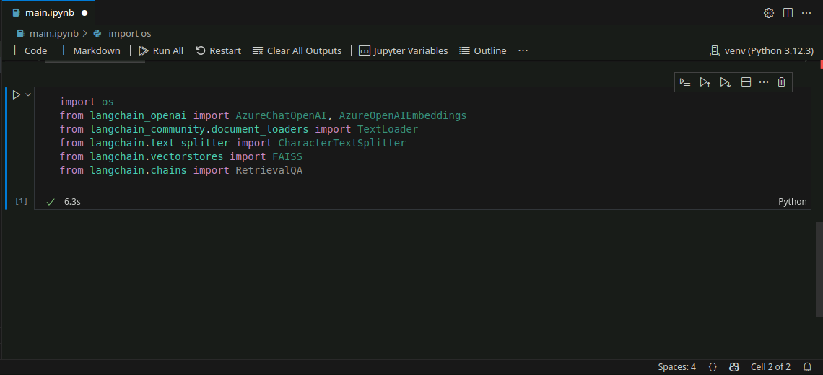

Note: These imports load classes for document loading, text chunking, vector storage, LLM access, and QA pipelines using LangChain and Azure OpenAI.

Step 2: Load and chunk your custom FAQ document

  - Create a new file named faq.txt in the same directory and copy and paste the content from the resource file provided. Press Ctrl + S to save the file.

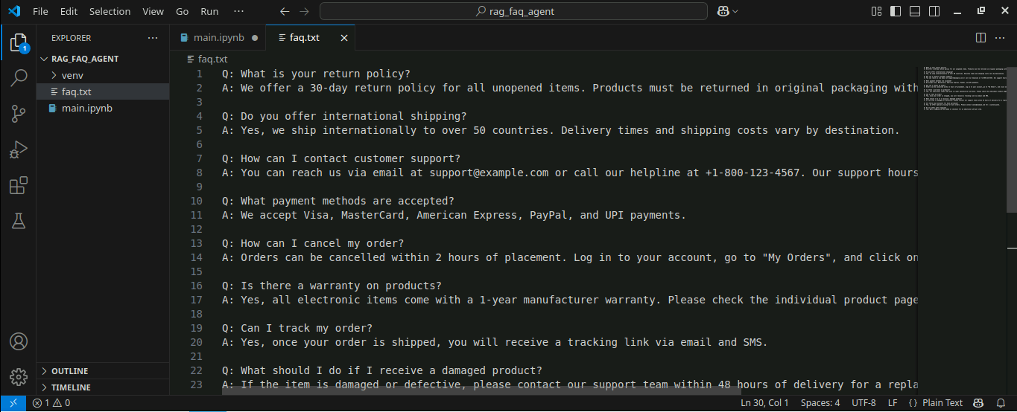

Note: You can download the resource file (faq.txt) from the Reference Materials section.

  - Load and split the document using the following code in the main.ipynb file:

loader = TextLoader("faq.txt") # Ensure this file exists
documents = loader.load()

text_splitter = CharacterTextSplitter(chunk_size=500, chunk_overlap=50)
docs = text_splitter.split_documents(documents)

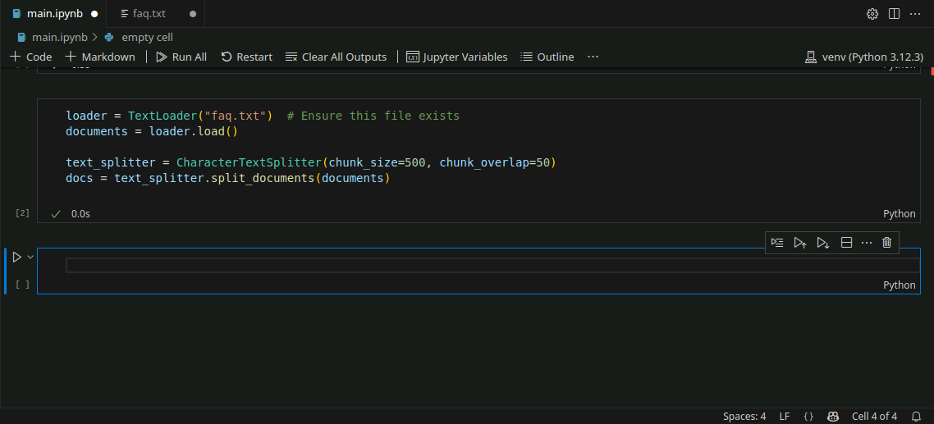

Note: The document is split into smaller chunks to enable semantic search during retrieval.
Step 3: Configure embeddings and create the vector store

  - Set your Azure OpenAI API key using the following command:

os.environ["AZURE_OPENAI_API_KEY"] = "2ABecnfxzhRg4M5D6pBKiqxXVhmGB2WvQ0aYKkbTCPsj0JLKsZPfJQQJ99BDAC77bzfXJ3w3AAABACOGi3sC"

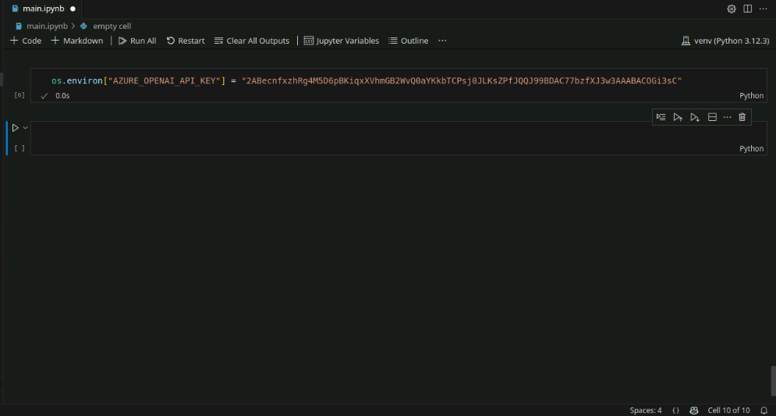

  - Generate embeddings and store them in FAISS using the following code:

embeddings = AzureOpenAIEmbeddings(
azure_endpoint="https://openai-api-management-gw.azure-api.net",
api_version="2023-05-15",
deployment="text-embedding-ada-002",
api_key=os.environ["AZURE_OPENAI_API_KEY"]
)

vectorstore = FAISS.from_documents(docs, embeddings)

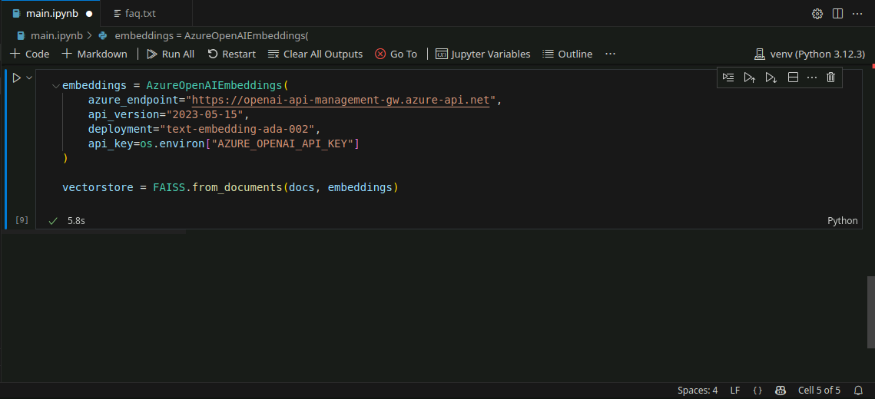

Note: The embedding model text-embedding-ada-002 transforms chunks into vectors, which are then stored in FAISS for similarity-based retrieval. FAISS (Facebook AI Similarity Search) is an open-source library for fast vector search.

Step 4: Initialize the LLM and set up the RAG chain

  - Create a GPT-4o LLM instance using the following code:

llm = AzureChatOpenAI(
azure_endpoint="https://openai-api-management-gw.azure-api.net",
api_version="2025-01-01-preview",
deployment_name="gpt-4o-mini",
temperature=0
)

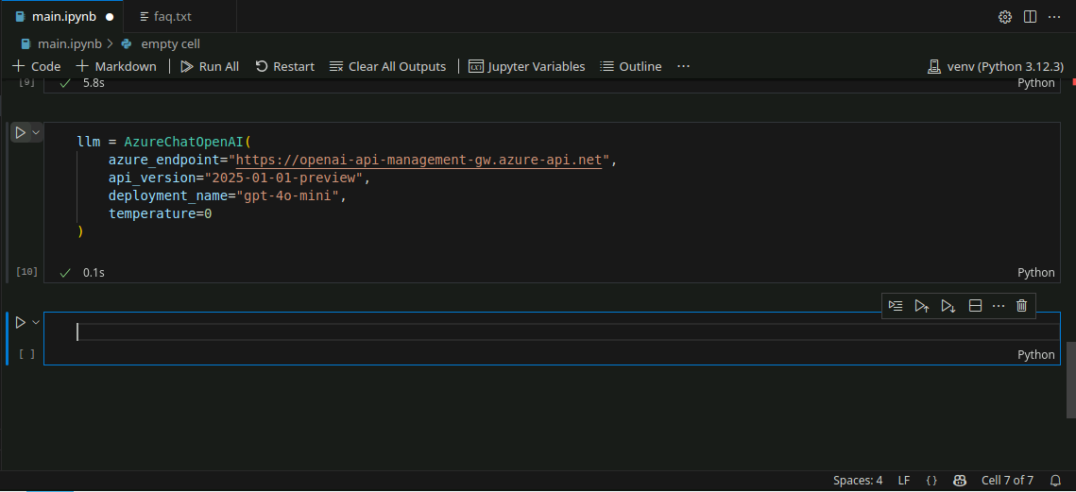

Note: The temperature is set to 0 for consistent and deterministic responses.

  - Initialize the RAG pipeline using the following code:

qa_chain = RetrievalQA.from_chain_type(
llm=llm,
retriever=vectorstore.as_retriever(),
return_source_documents=True
)

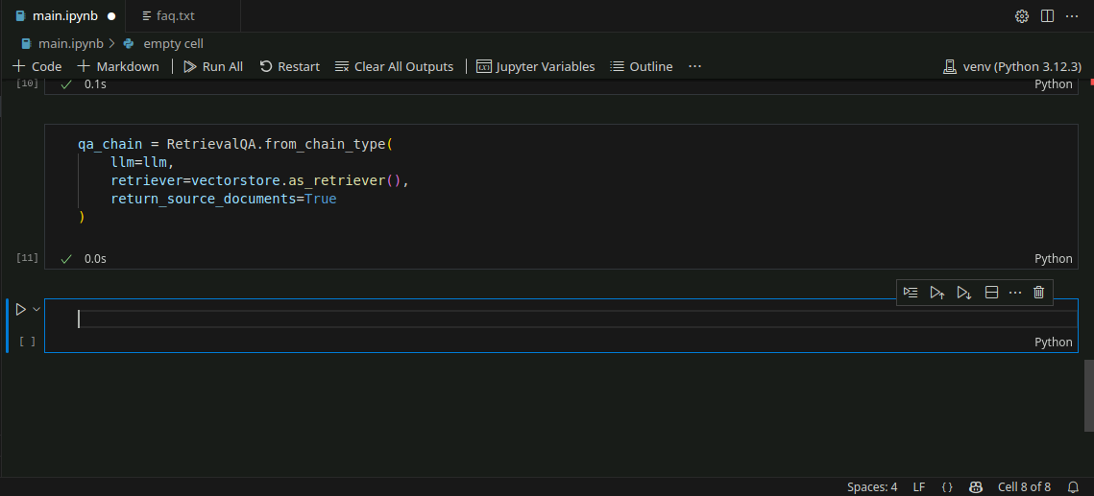

Note: This sets up a LangChain pipeline that combines retrieval with GPT-based reasoning and provides source context along with the answer.

Step 5: Query the RAG agent and view results

- Ask a sample question within the query parameter:

query = "What is our return policy?"
result = qa_chain.invoke({"query": query})

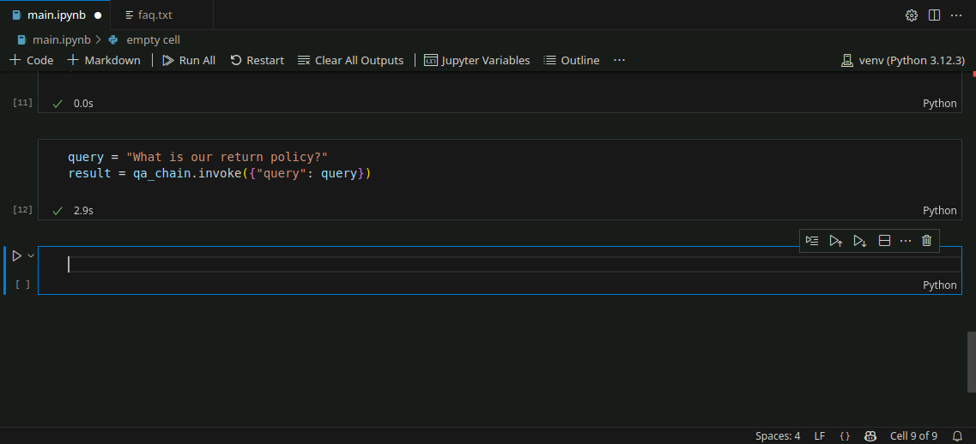

- Display the final answer and its source context using the following code:

print("Answer:", result["result"])
print("\n--- Sources ---")
for i, doc in enumerate(result["source_documents"], 1):
print(f"\nSource {i}:")
print(doc.page_content)

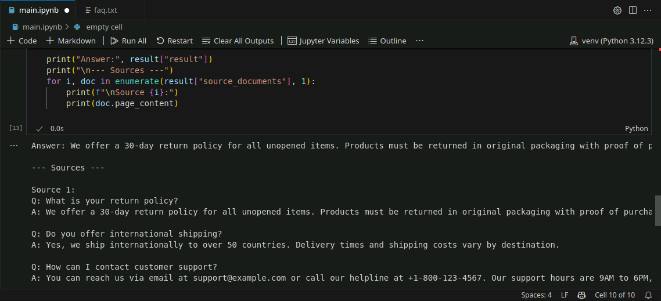

Note: The output includes both the generated answer and the specific document snippets used to produce it.

By following these steps, you have successfully set up a complete RAG workflow that indexes your FAQ content, retrieves the best matches, and returns cited answers, reducing hallucinations, improving answer accuracy, and centralizing domain knowledge.

