Lesson 02 Demo 02
Building a Financial Q&A Agent Using LangChain

Objective: To build a LangChain and Azure OpenAI–based financial Q&A agent that interprets business questions, generates and runs Python code, and explains results in plain English to speed up analysis and reduce manual errors

Tools required: Python, LangChain, Azure OpenAI API, and Visual Studio Code

Prerequisites: Familiarity with LangChain agents and tools

Steps to be followed:
- Set up your local environment in Visual Studio Code
- Configure the Azure OpenAI model
- Define the execution tool and prompt template
- Define the processing logic and business questions
- Run the agent loop and view the outputs

Step 1: Set up your local environment in Visual Studio Code

- Open the terminal in your system and run the following commands:

mkdir financial_agent && cd financial_agent
python3 -m venv venv
source venv/bin/activate
code .

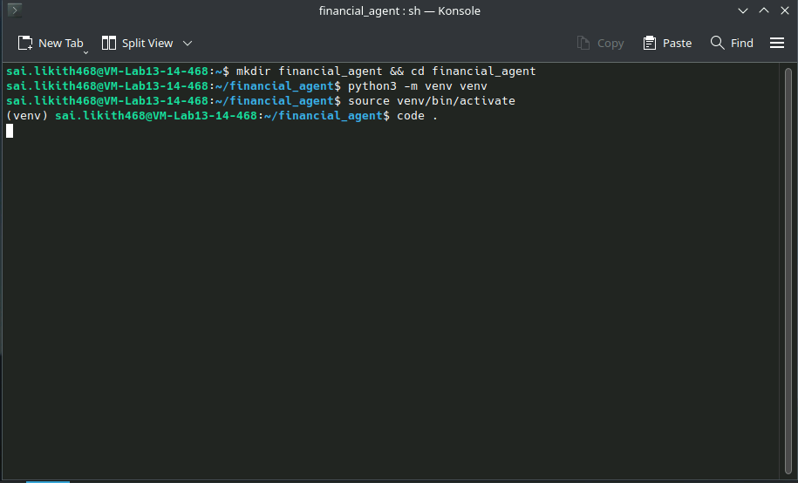
Note: This creates a virtual environment inside the financial_agent folder and opens the project in VS Code.

- Click New File… to create a new file, and name it main.ipynb

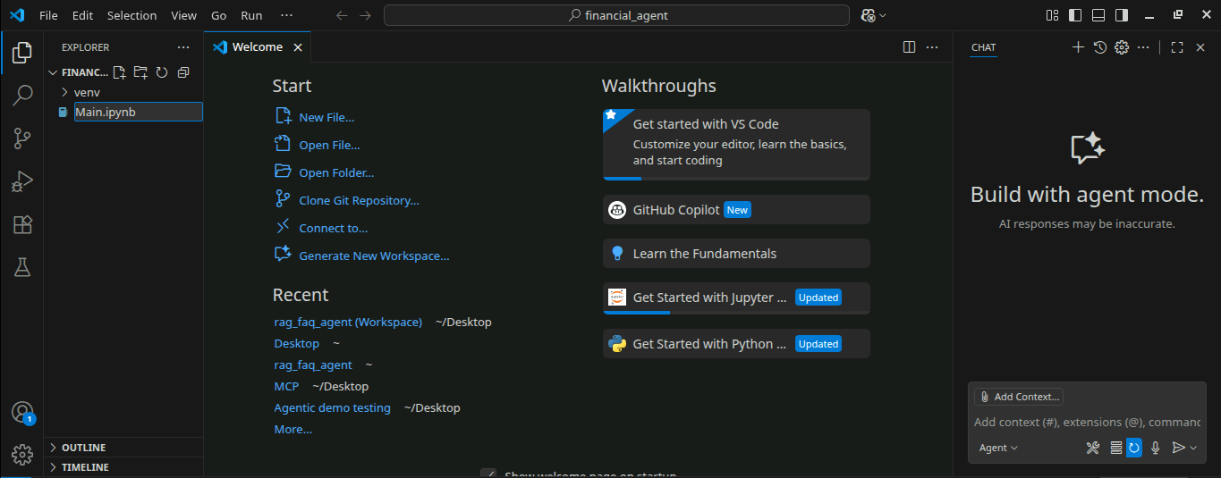

- In the first cell in the file, run the following command to install required packages:

!pip install langchain langchain-openai langchain-community

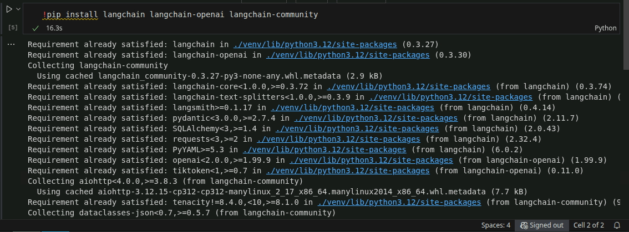

Note: If prompted, select the Python interpreter from the newly created virtual environment. If a pop-up asks to install ipykernel, click Install and re-run the first cell.

- Import the required libraries using the following code:

import os
from langchain_openai import AzureChatOpenAI
from langchain_community.tools.python.tool import PythonREPL
from langchain.prompts import PromptTemplate

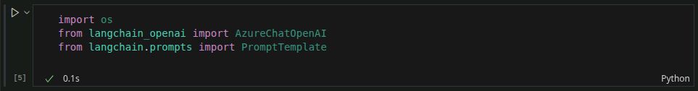

Step 2: Configure the Azure OpenAI model

  - Set your credentials and initialize the model using the following code:

os.environ["AZURE_OPENAI_API_KEY"] = "2ABecnfxzhRg4M5D6pBKiqxXVhmGB2WvQ0aYKkbTCPsj0JLKsZPfJQQJ99BDAC77bzfXJ3w3AAABACOGi3sC"

llm = AzureChatOpenAI(
azure_endpoint="https://openai-api-management-gw.azure-api.net/",
api_version="2025-01-01-preview",
deployment_name="gpt-4o-mini",
temperature=0
)

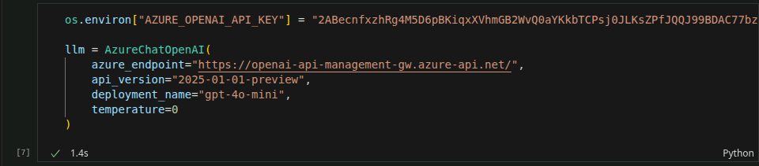

Note: This configures the GPT-4o model for deterministic outputs using the Azure OpenAI API credentials.

Step 3: Define the execution tool and prompt template

- Define a custom Python execution tool using the following code:

def safe_python_repl(code: str) -> str:
try:
local_vars = {}
exec(code, {}, local_vars)
return str(local_vars)
except Exception as e:
return f"Error: {str(e)}"

class PythonREPL:
def run(self, code):
return safe_python_repl(code)

repl = PythonREPL()

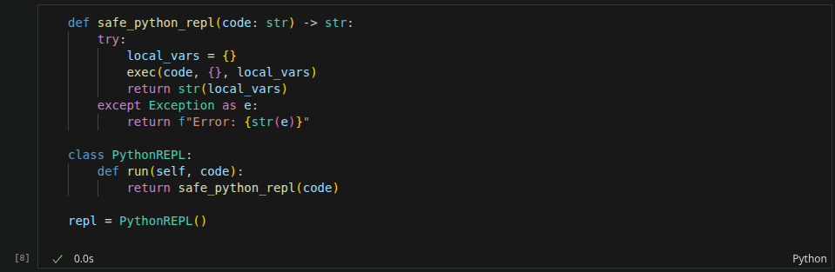

Note: The REPL (Read-Eval-Print Loop) lets you run Python code interactively as you work on a project or learn the language. It comes with every Python installation, so you can use it anytime.

- Use the following code with a structured prompt to get Python code for the calculation and a brief explanation in plain English:

prompt = PromptTemplate.from_template(
"""You are a smart assistant for product managers.
Given a business-related question, return:
1. Valid Python code using print(...) to calculate the answer.
2. A brief explanation of the result in plain English.

Question: {input}
Response:"""
)

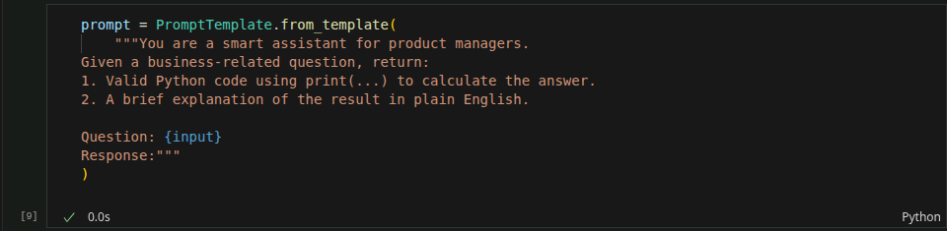

Note: This prompt instructs the model to return both code and a plain-English explanation in a consistent format.

Step 4: Define the processing logic and business questions

  - Define a function to process the question, extract the code, and execute it using the following code:

def process_pm_query(q):
response = llm.invoke(prompt.format(input=q)).content.strip()

if "```python" in response:
code_block = response.split("```python")[1].split("```")[0].strip()
else:
code_block = next((line for line in response.splitlines() if "print" in line), "")

try:
result = repl.run(code_block)
return {
"question": q,
"code": code_block,
"result": result.strip(),
"explanation": response.replace(code_block, "").replace("```python", "").replace("```", "").strip()
}
except Exception as e:
return {
"question": q,
"code": code_block,
"error": str(e),
"raw_response": response
}

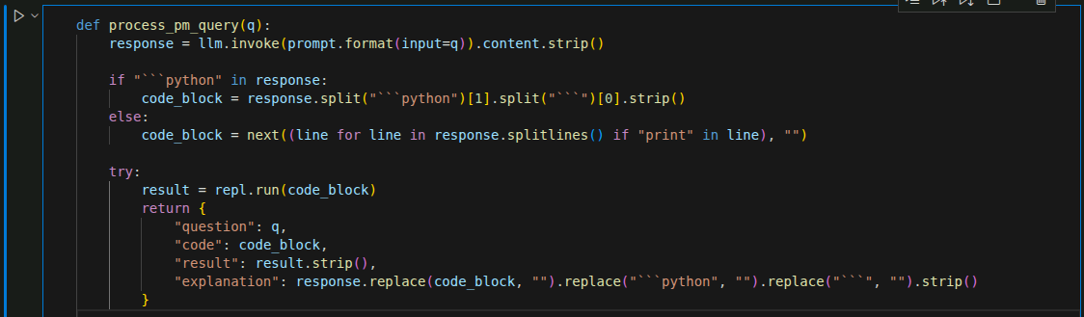
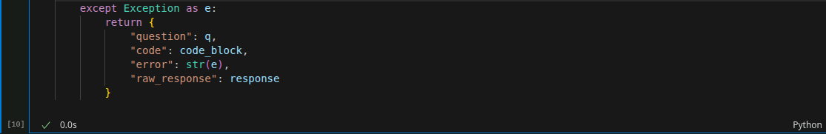

Note: This function sends the question to the model, extracts code from the response, executes it using Python REPL, and returns both the code and the explanation.

  - Define sample business questions using the following code:

questions = [
"If we grow 8% monthly, what is our user count after 6 months starting from 10,000?",
"We lose 25% of our 40,000 users. How many do we retain?",
"If each user pays $10/month and we have 5000 users, what is the monthly revenue?",
"If revenue is $50,000 and cost is $37,000, what’s our profit?"
]

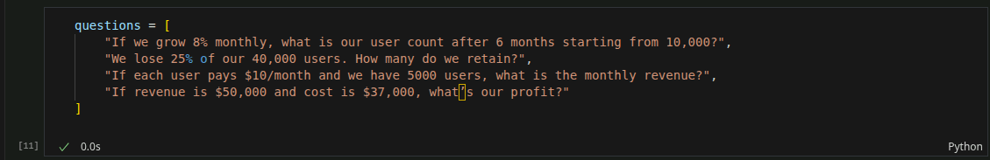

Note: These test cases reflect common business scenarios that product managers face.

Step 5: Run the agent loop and view the outputs

- Execute the agent loop and view the outputs using the following code:

for q in questions:
print(f"\nQuestion: {q}")
output = process_pm_query(q)
print("Code:", output.get("code", "No code"))
print("Result:", output.get("result", output.get("error", "Failed to execute")))
print("Explanation:", output.get("explanation", "No explanation"))

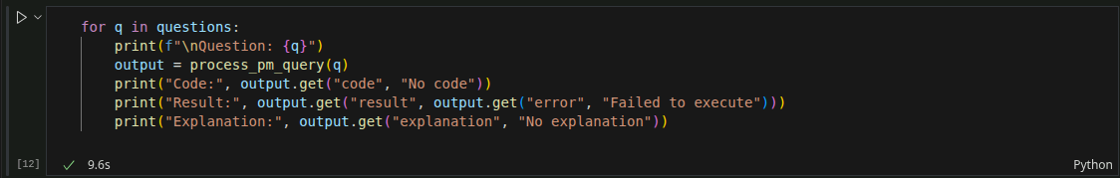

Note: This loop processes each question, runs the code, and displays both the output and the explanation for quick business insights.

The output appears as shown in the following screenshot:

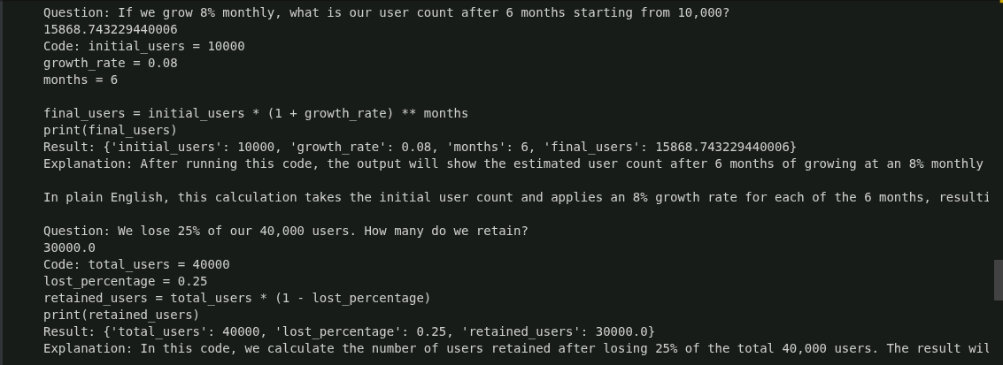

By following these steps, you will create a LangChain financial Q&A agent that turns business questions into executable calculations and clear explanations, enabling faster decisions while reducing spreadsheet work and mistakes.

