Guided Practice
Lesson 1: AI Tools and Prompt Engineering for PMs

Overview
In this guided practice, you’ll explore how AI-powered tools can accelerate different stages of product development, from crafting compelling value propositions to prototyping user interfaces and simulating backend infrastructure. You’ll work hands-on with Lovable, Uizard, and Firebase Studio to ideate, validate, and simulate product features without needing deep design or engineering skills. By completing this exercise, you’ll learn how to rapidly prototype product ideas using modern AI tools that support faster iteration and validation in a product management workflow.
Instructions
- Use Lovable, Uizard, and Firebase Studio to complete each step in this guided practice
- Work individually or in pairs to discuss prompts, outputs, and design trade-offs
- Spend approximately 30 minutes completing the full workflow
- Document screenshots, generated outputs, and links to any prototypes in a shared doc for review

Tasks
Scenario: You are a product manager exploring how AI-powered tools can support different stages of product development. Your goal is to utilize a combination of AI tools, including Lovable, Uizard, and Firebase Studio, to ideate, validate, and simulate a product idea. You’ll begin by crafting a strong value proposition, then translate it into a functional user interface prototype, and finally simulate backend functionality to demonstrate how data would flow in a real application. Follow the guided steps to complete each part of this end-to-end product workflow using AI, even without deep technical or design expertise.

Steps to be followed:
- Draft a value proposition using Lovable
- Create a UI prototype from text using Uizard
- Simulate the backend with Firebase Studio

Tools required: Lovable, Uizard, and Firebase Studio

Discussion Questions (Optional):

If time permits, discuss the following questions:
1. How might AI-powered prototyping tools like Uizard and Firebase Studio shift the role of a product manager during early-stage product discovery?
2. What skills remain essential, even as AI automates design and development steps?

Answer Key

Step 1: Draft a value proposition using Lovable
- Open a browser and go to https://lovable.dev/

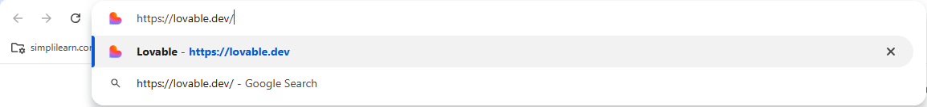

- Click Get started or Log In

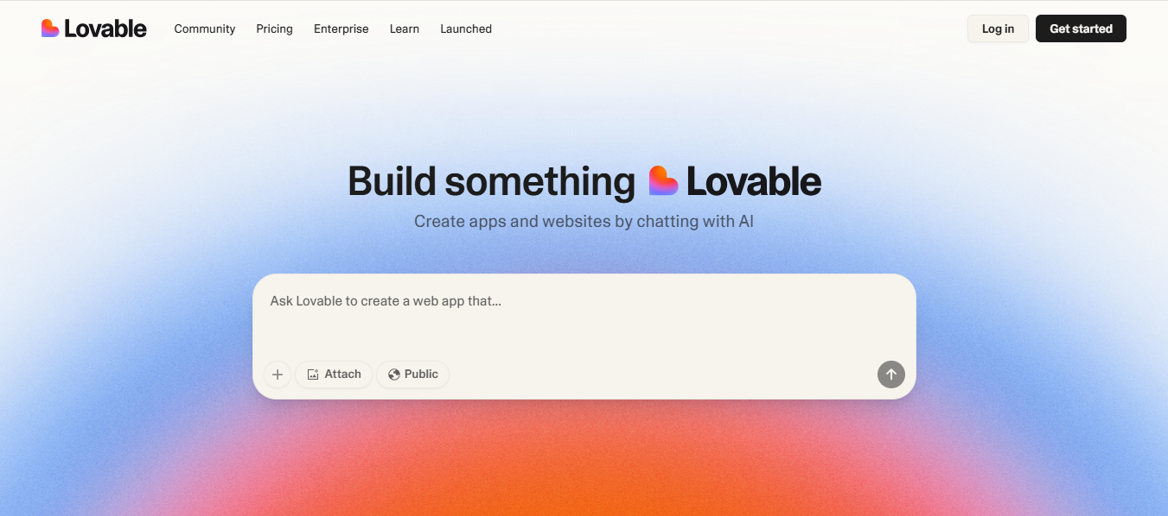

- Sign in using your email address
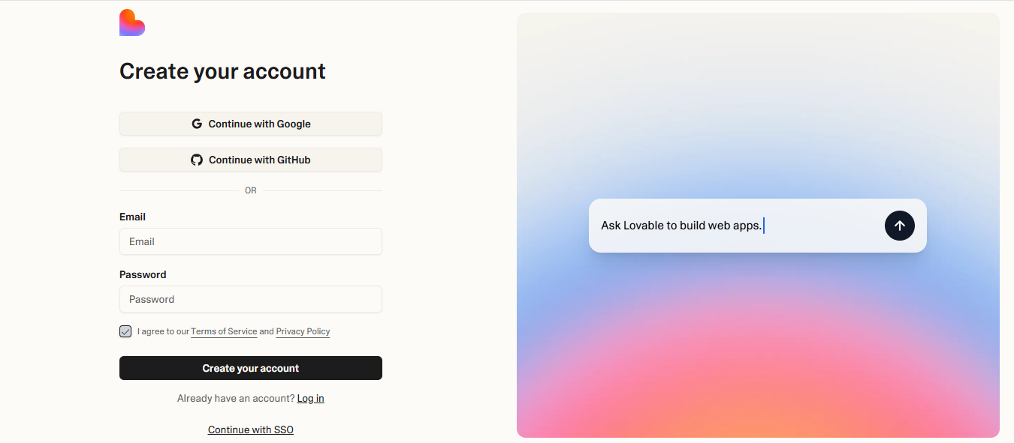

- Enter the following product idea in the input field: A mobile app that tracks carbon footprint based on shopping habits. Press Enter on your keyboard.

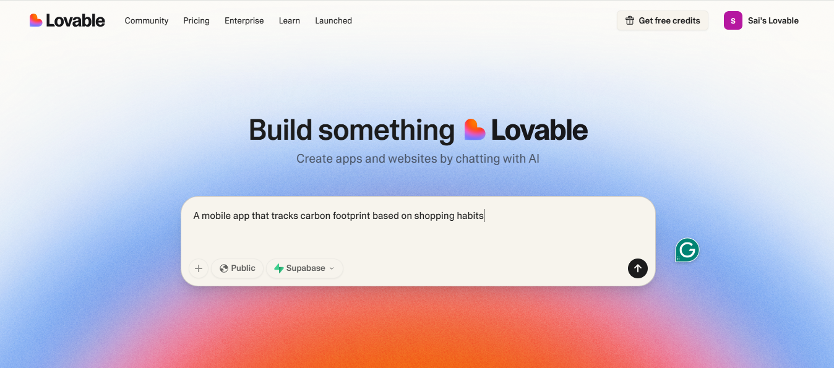

- Lovable will generate the following output:

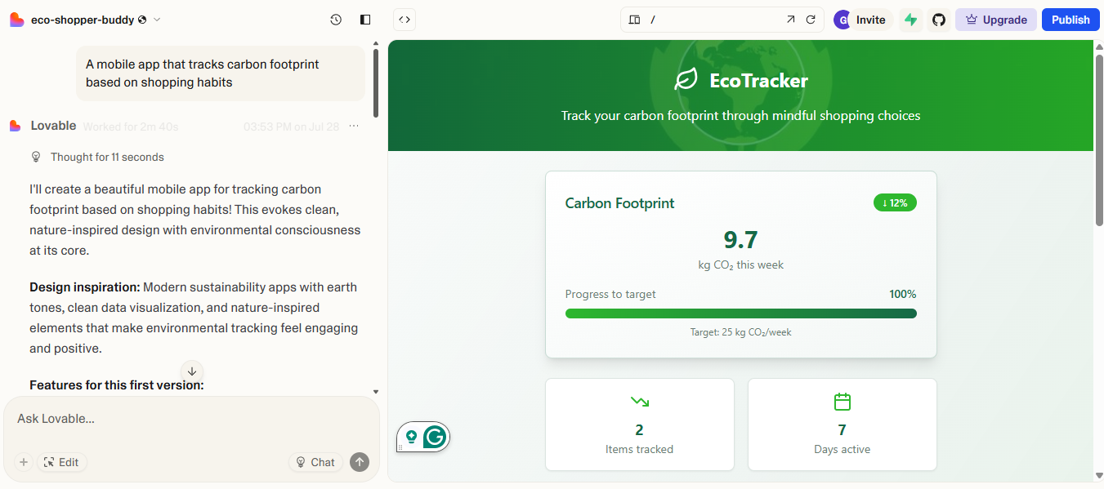

Note: Lovable provides an output that highlights the value proposition, including the benefits and target users of your product.

Step 2: Create a UI prototype from text using Uizard
- Open a browser and go to https://uizard.io/

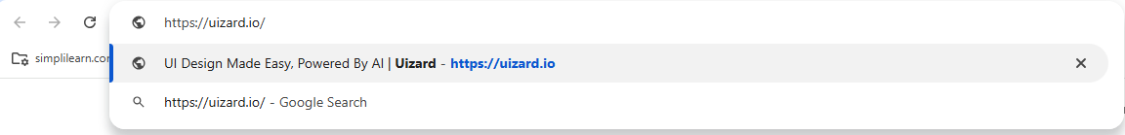

- Click on Sign up for free

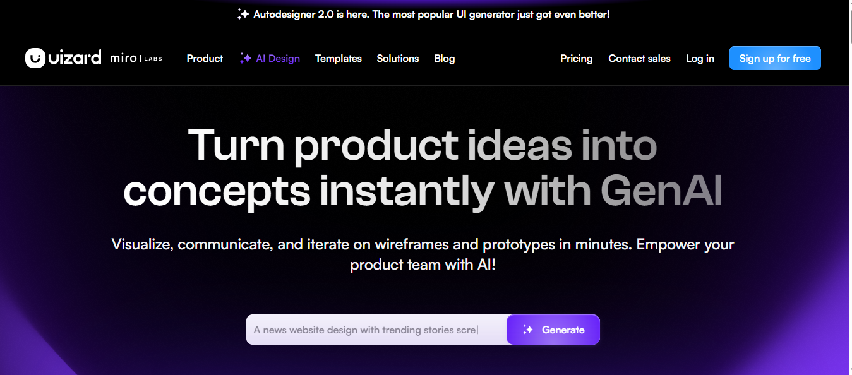

- Sign in using your email address



- Answer or skip onboarding questions, then select a subscription tier (free or paid)

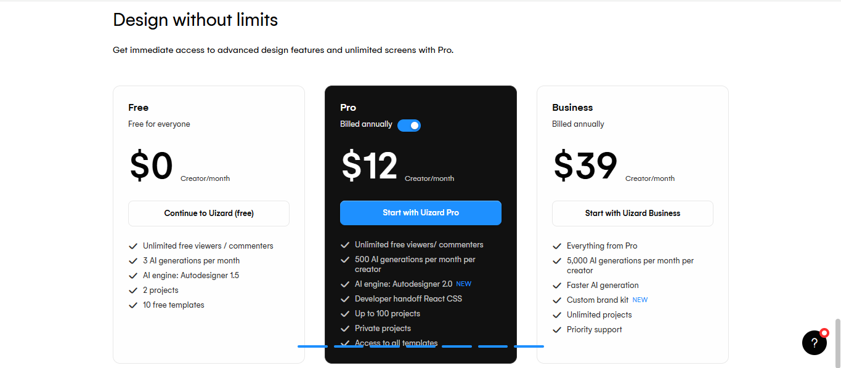

- On the dashboard, click New blank project, then select Desktop

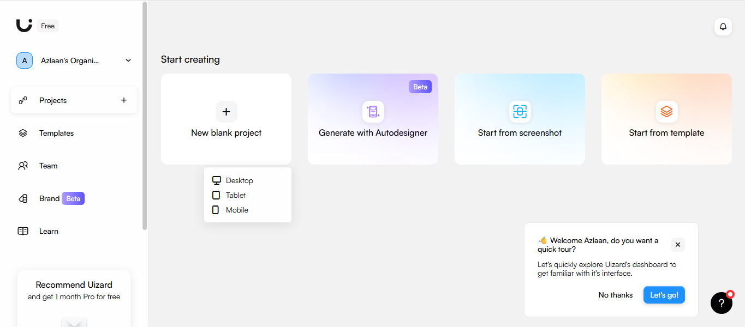

- In the left sidebar, click Magic, then click Generate new project

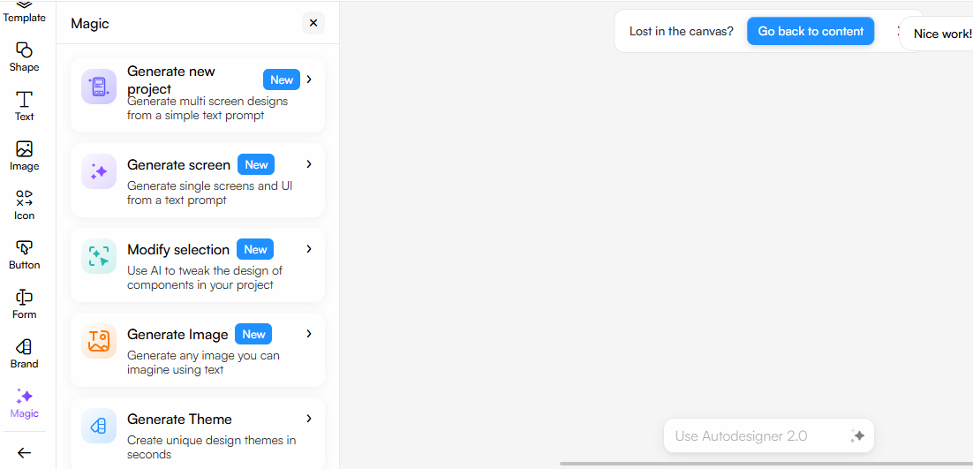

- In the AI assistant input field, type the following prompt and hit Continue:
Design a mobile onboarding flow for a personal finance app that includes screens for welcome, income entry, budget setup, and progress tracking.

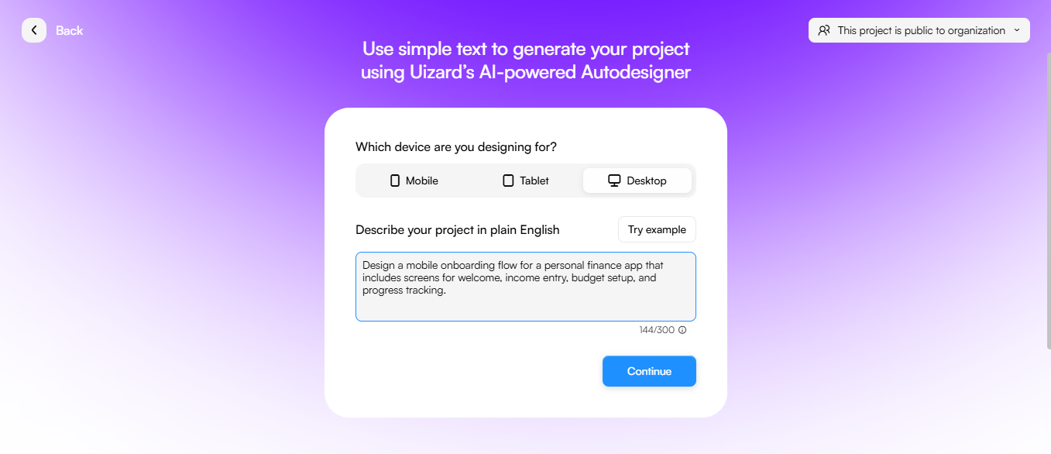

- Click the Prompt button

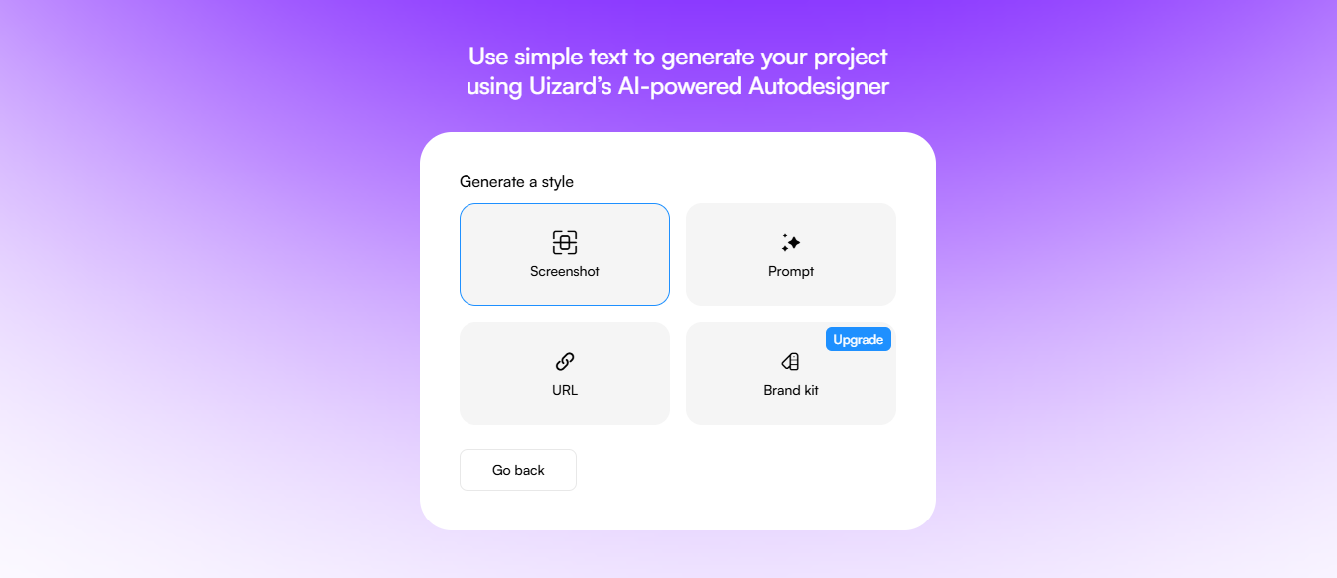

- Describe the desired style (for example, Modern aesthetic style), then click Generate my project

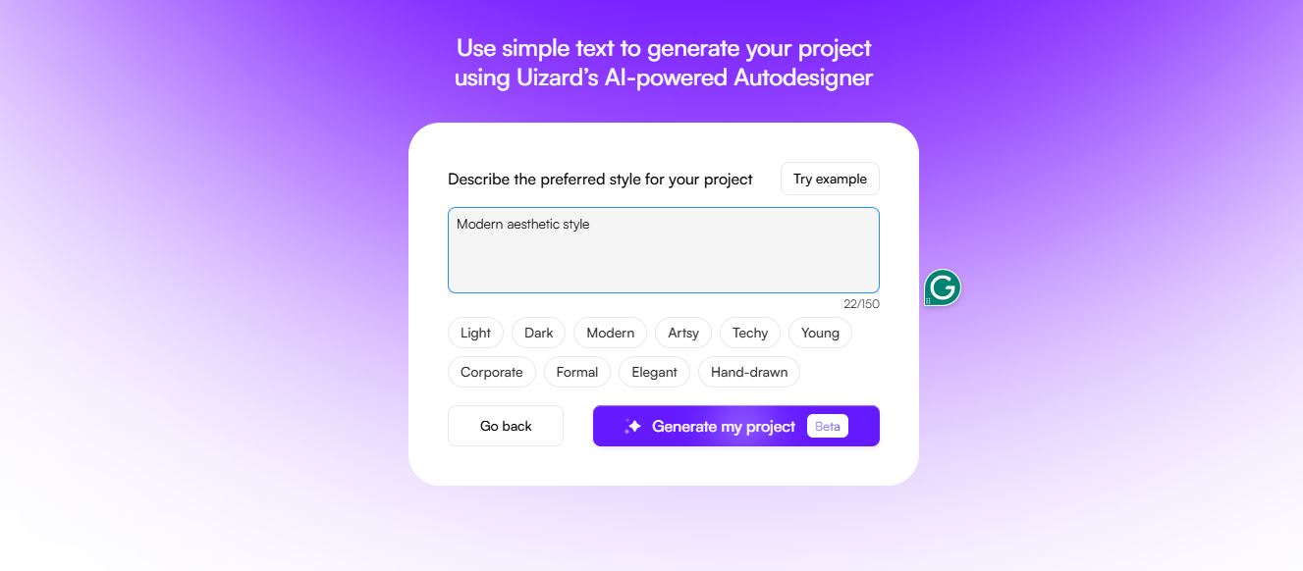

2.10 Uizard generates a visual wireframe based on your input, as given in the following screenshot:
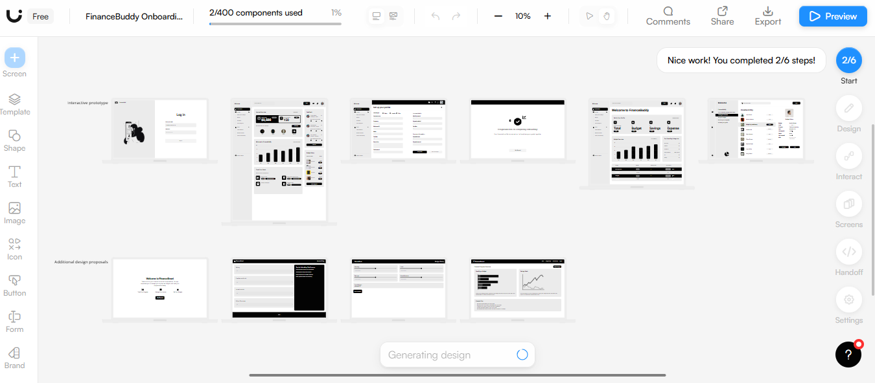
Note: Uizard enables PMs to create prototypes quickly without relying on designers in the early idea phase.

Step 3: Simulating the backend with Firebase Studio

- Visit https://firebase.studio/

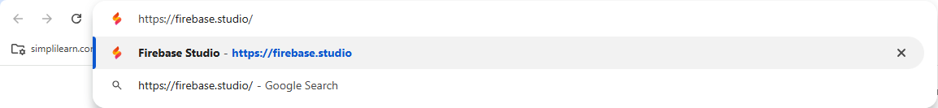
- On the homepage, click Get Started

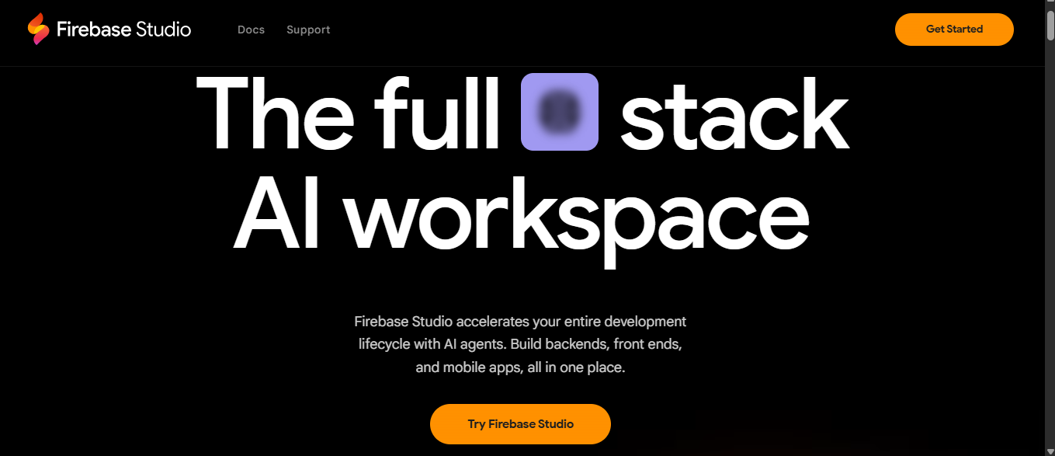

- Accept the terms and conditions, then click Confirm

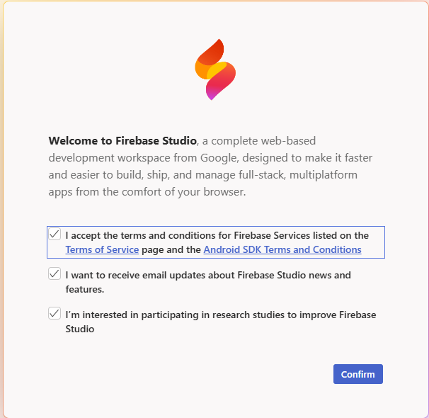

- In the prompt field, enter the following prompt and hit Prototype with AI:
A backend for a mobile app that tracks carbon footprint based on user shopping habits. The database should store user profiles, purchase history, and calculate the estimated CO₂ impact in real time.

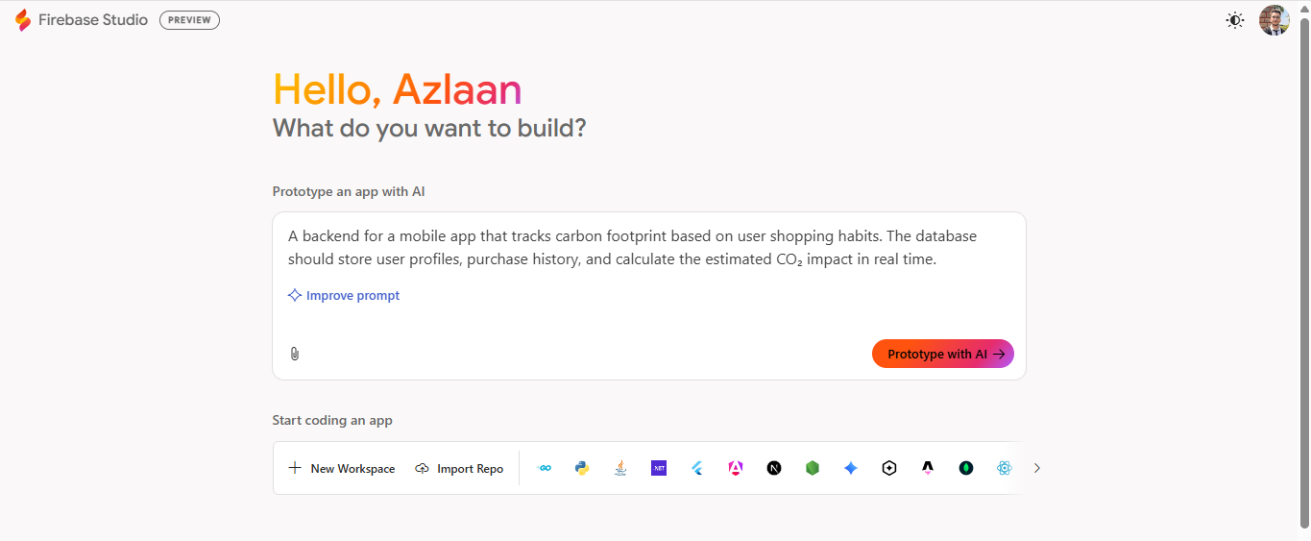

- Firebase Studio generates a backend blueprint including data structure, logic, and real-time behavior as given in the following screenshot:

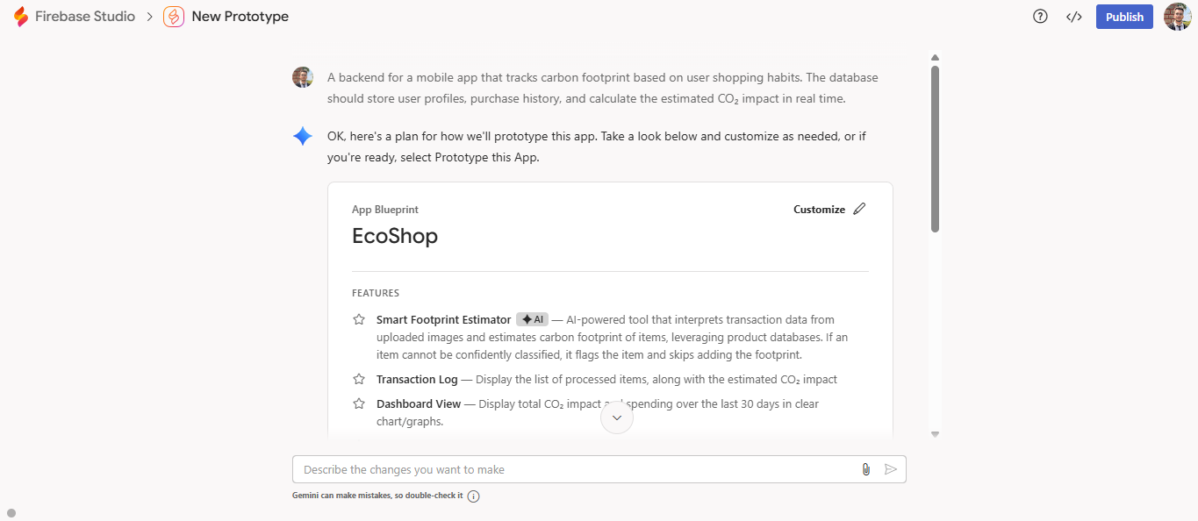

- Make any required edits, then scroll down and click Prototype this App

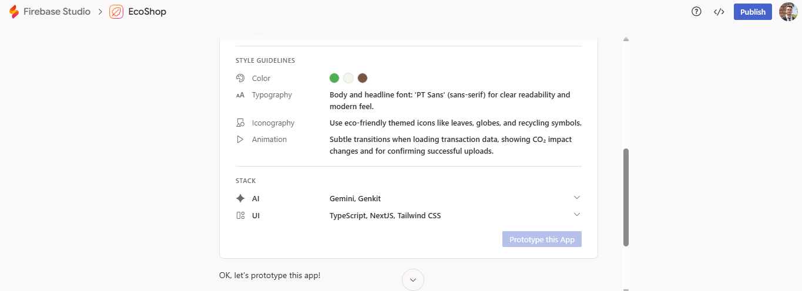

- Firebase creates a working backend simulation based on your instructions as given in the following screenshot:

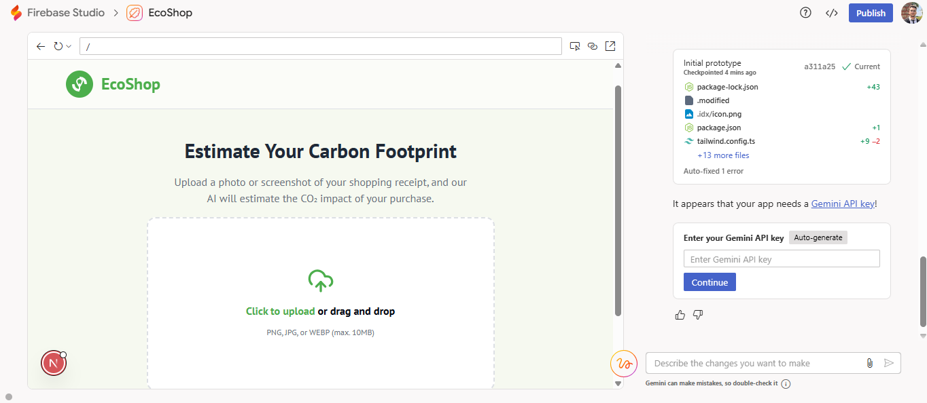

Note: Firebase enables PMs to quickly prototype backend behavior for MVPs.

By following these steps, you gain hands-on experience with real-world AI tools that support ideation, prototyping, and backend simulation, enabling faster, lower-cost innovation in product management.

