Guided Practice
Lesson 2: Designing and Deploying Intelligent Agents

Overview
In this guided practice, you will build a multi-agent system using LangChain and Azure OpenAI to simulate feature prioritization. You will use three domain-specific agents, User Advocate, Tech Lead, and Business Analyst, to score and explain feature values from different perspectives. The LangChain agent will query each tool, aggregate insights, and return a prioritized list. By completing this guided practice, you will learn how to orchestrate tool-based agents for better decision-making.

Instructions
- Use Visual Studio Code and Python to complete each step
- Work individually or in pairs to experiment as needed
- Spend approximately 20-30 minutes completing all steps
- Document your code, outputs, and final results for review

Tasks
Scenario: You are a product manager evaluating three upcoming product features: Dark Mode, AI-based Smart Search, and Offline Support. To make a data-backed decision, you must use LangChain agents that simulate input from internal stakeholders. Each agent scores the features based on their specific lens, usability, feasibility, or business value. You will then run a master agent that uses these tools to return a prioritized list based on cumulative scoring.

Steps to be followed:
- Set up your local environment in Visual Studio Code
- Define scoring functions and convert them into tools
- Connect to Azure OpenAI and initialize the agent
- Prompt the agent and analyze the result

Tools required: Python, Visual Studio Code, LangChain, and Azure OpenAI

Discussion questions (optional):
If time permits, discuss the following questions:
- If each team in a company had its own AI agent, would decision-making become more efficient or more chaotic? Why?
- Would you trust an AI-generated feature roadmap? What evidence would you need to feel confident in its recommendations?
Answer Key

Step 1: Set up your local environment in Visual Studio Code

- Open the terminal on your system and run the following command:

mkdir feature_agent && cd feature_agent
python3 -m venv venv
source venv/bin/activate
code .

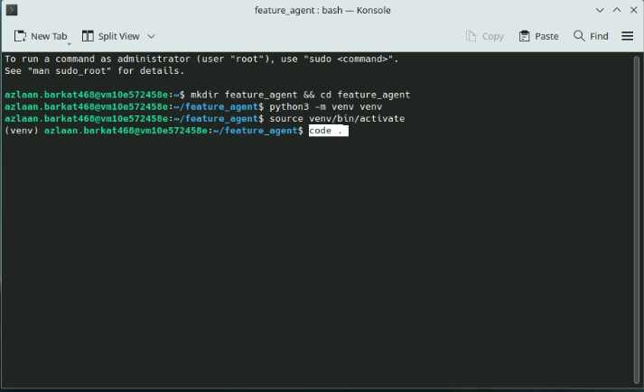

Note: This creates a virtual environment inside the feature_agent folder and opens the project in VS Code.

- Click New File… to create a new file, and name it main.ipynb

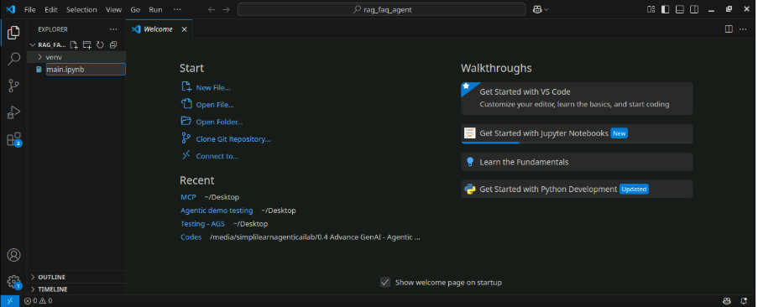

- In the first cell, run the following command to install required packages:
!pip install langchain langchain-openai

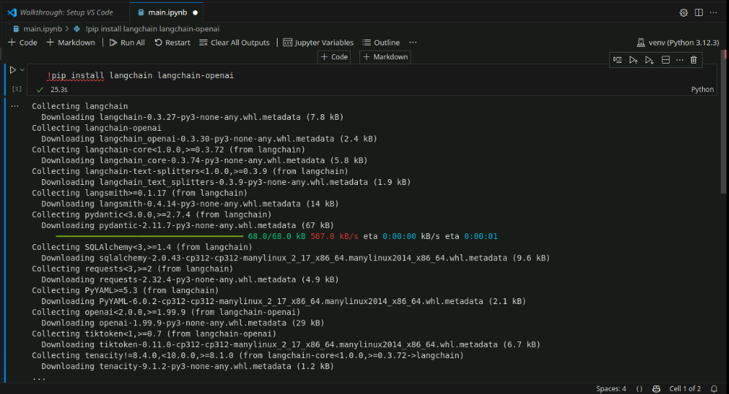

Step 2: Define scoring functions and convert them into tools

- Execute the following code to import dependencies:

from langchain.agents import Tool, initialize_agent
from langchain_openai import AzureChatOpenAI

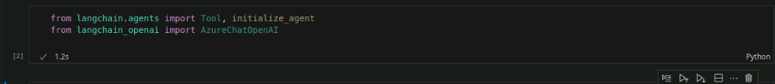

- Use functions to define role-specific scoring logic using the following code:

def user_advocate_tool(feature):
scores = {
"Dark Mode": (5, "Some users want it for comfort"),
"AI-based Smart Search": (9, "Highly requested feature"),
"Offline Support": (7, "Useful for travel and remote work")
}
score, comment = scores.get(feature, (0, "No data"))
return f"{feature} → User Score: {score}. Note: {comment}"

def tech_lead_tool(feature):
scores = {
"Dark Mode": (8, "Easy to implement"),
"AI-based Smart Search": (5, "Requires custom model integration"),
"Offline Support": (6, "Moderate complexity")
}
score, comment = scores.get(feature, (0, "No data"))
return f"{feature} → Tech Score: {score}. Note: {comment}"

def business_analyst_tool(feature):
scores = {
"Dark Mode": (4, "Minimal impact on revenue"),
"AI-based Smart Search": (9, "Improves retention and engagement"),
"Offline Support": (6, "Moderate business value")
}
score, comment = scores.get(feature, (0, "No data"))
return f"{feature} → Business Score: {score}. Note: {comment}"

tools = [
Tool(name="UserAdvocate", func=user_advocate_tool, description="User desirability scoring"),
Tool(name="TechLead", func=tech_lead_tool, description="Technical feasibility scoring"),
Tool(name="BusinessAnalyst", func=business_analyst_tool, description="Business value scoring")
]

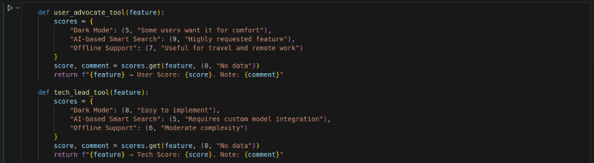

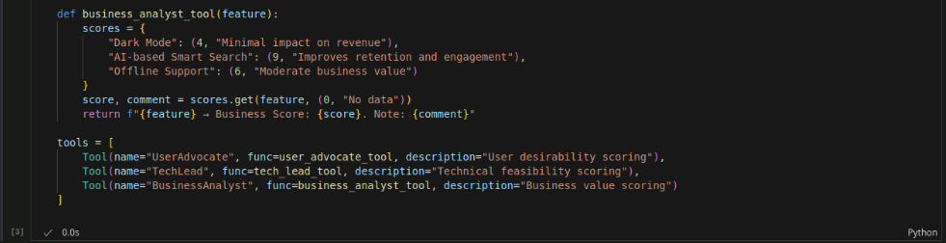

Note: Each function simulates stakeholder input and is wrapped into a LangChain-compatible tool using the Tool class.

- Initialize the agent using the following code:

agent = initialize_agent(tools, llm, agent="zero-shot-react-description", verbose=True)

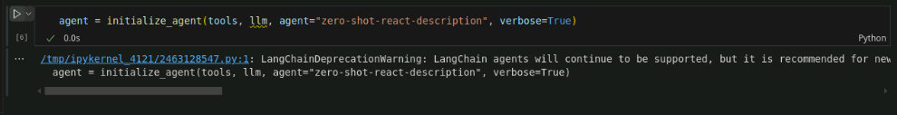

Step 3: Connect to Azure OpenAI and initialize the agent

- Configure the model and initialize the agent using the following code:

llm = AzureChatOpenAI(
api_key="2ABecnfxzhRg4M5D6pBKiqxXVhmGB2WvQ0aYKkbTCPsj0JLKsZPfJQQJ99BDAC77bzfXJ3w3AAABACOGi3sC",
azure_endpoint="https://openai-api-management-gw.azure-api.net",
deployment_name="gpt-4o-mini",
api_version="2025-01-01-preview",
temperature=0
)

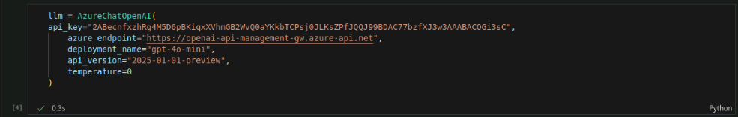

Note: Use 0 for the temperature to ensure deterministic outputs

Step 4: Prompt the agent and analyze the result

- Provide the agent with the following prompt and run the agent to view the results:

prompt = """
Evaluate each of the following features one by one:
Dark Mode, AI-based Smart Search, and Offline Support.

Use the available tools to get:
- User Score (from UserAdvocate)
- Technical Feasibility Score (from TechLead)
- Business Value Score (from BusinessAnalyst)

Then combine the scores and return a prioritized list from highest to lowest.
"""

response = agent.run(prompt)
print(response)

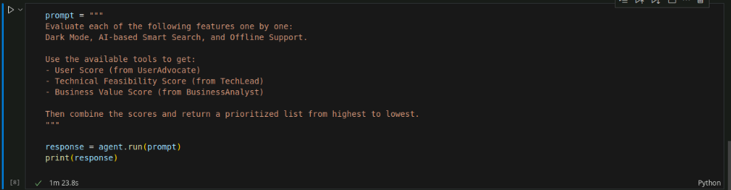

Note: This code block instructs the agent to query all tools for each feature and aggregate the results into a ranked list.

Expected output may look as shown in the following screenshot:

