Download twAlgo.zip into any directory on your system
unzip this dir
cd twAlgo
open command prompt to this location
execute below command
--install dependency for program
--only for test case i have used pytest, but formatted out and many other aspects of the game, some more dependencies can be used

option1
python setup.py

option2
pip install -U -r requirements.txt

option3
sudo apt-get install python-pytest

python battleship_game.py print=0
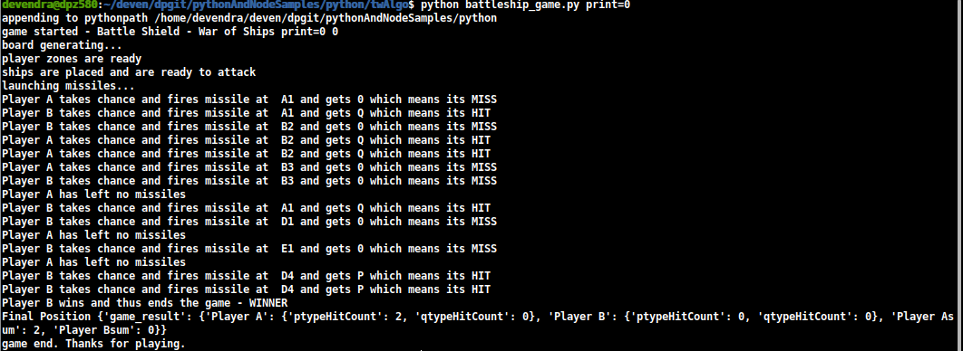
python battleship_game.py print=1
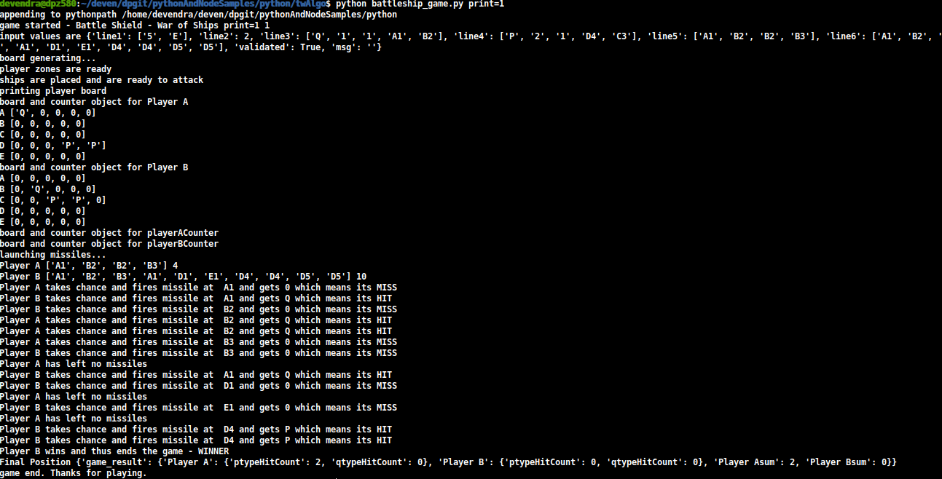

to change the parameters
open gameInput.txt and change the parameters of your choice
assumption: only 6 lines will be entered. Although program doesnt crash if you do, but program will factor in only top 6 lines

python -m pytest testCases.py
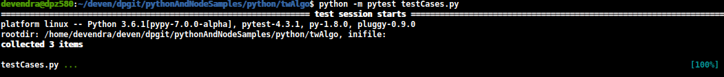
python -m pytest -v -s --capture=no testCases.py
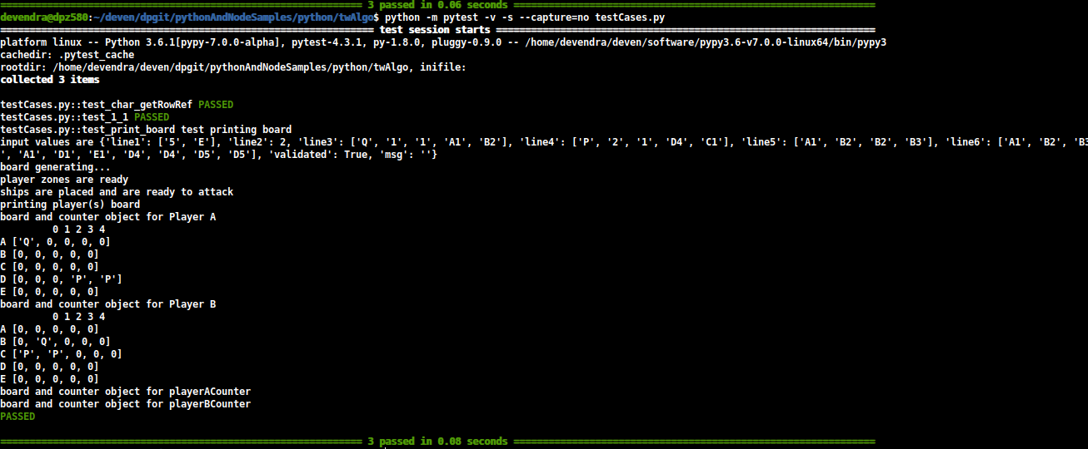
code coverage in intellij using converage.py
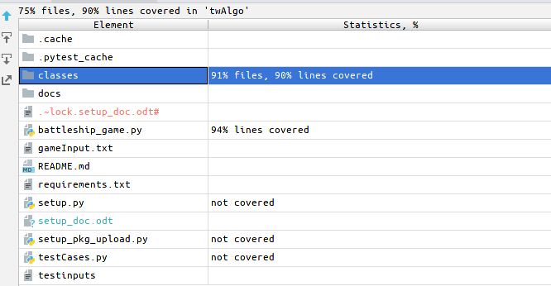
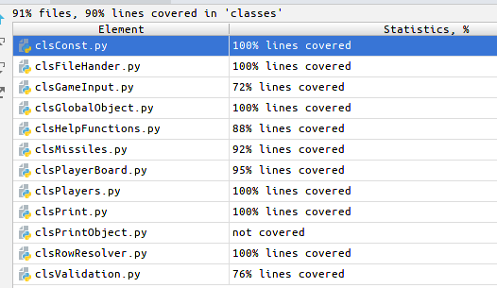

error handling or validation on input lines has been done and custom error defination will be shown like so
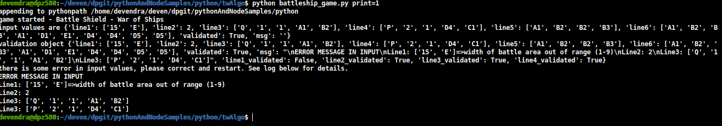
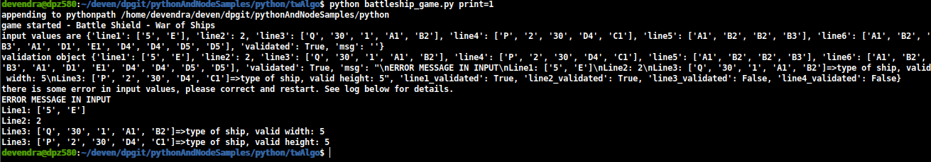
Assumption: line5 and line6 of missiles targets are entered without error

