Q1 :- Conditional where the dice is 6

Even

1+6 = 7

2+6 = 8

3+6 = 9

4+6 = 10

5+6 = 11

6+6 = 12

Even instance are 3 hence 3/6 =0.5

Q2 :- 2 Dice = 36 Instances

If a Dice start with 1 V/s other die with instance of >7 are 5

If a Dice start with 2 V/s other die with instance of >7 are 4

If a Dice start with 3 V/s other die with instance of >7 are 3

If a Dice start with 4 V/s other die with instance of >7 are 2

If a Dice start with 5 V/s other die with instance of >7 are 1

If a Dice start with 6 V/s other die with instance of >7 are 0

Hence the answer is 15/36 = 0.41

Q3 :- Step by step workout  
step 1 Find the total possible events of sample space S with at least one Heads  
S = {HHH, HHT, HTH, HTT, THH, THT, TTH, TTT}  
  
S = 7  
  
step 2 Find the expected or successful events A  
A = {HHH, HHT, HTH, THH}  
  
A = 4  
  
step 3 Find the probability  
P(A) =Successful Events Total Events of Sample Space  
=4/7  
  
= 0.57

Q4: Let RR be the event that it's rainy, TT be the event that there is heavy traffic, and LL be the event that I am late for work. As it is seen from the problem statement, we are given conditional probabilities in a chain format. Thus, it is useful to draw a tree diagram. Figure 1.27 shows a tree diagram for this problem. In this figure, each leaf in the tree corresponds to a single outcome in the sample space. We can calculate the probabilities of each outcome in the sample space by multiplying the probabilities on the edges of the tree that lead to the corresponding outcome.

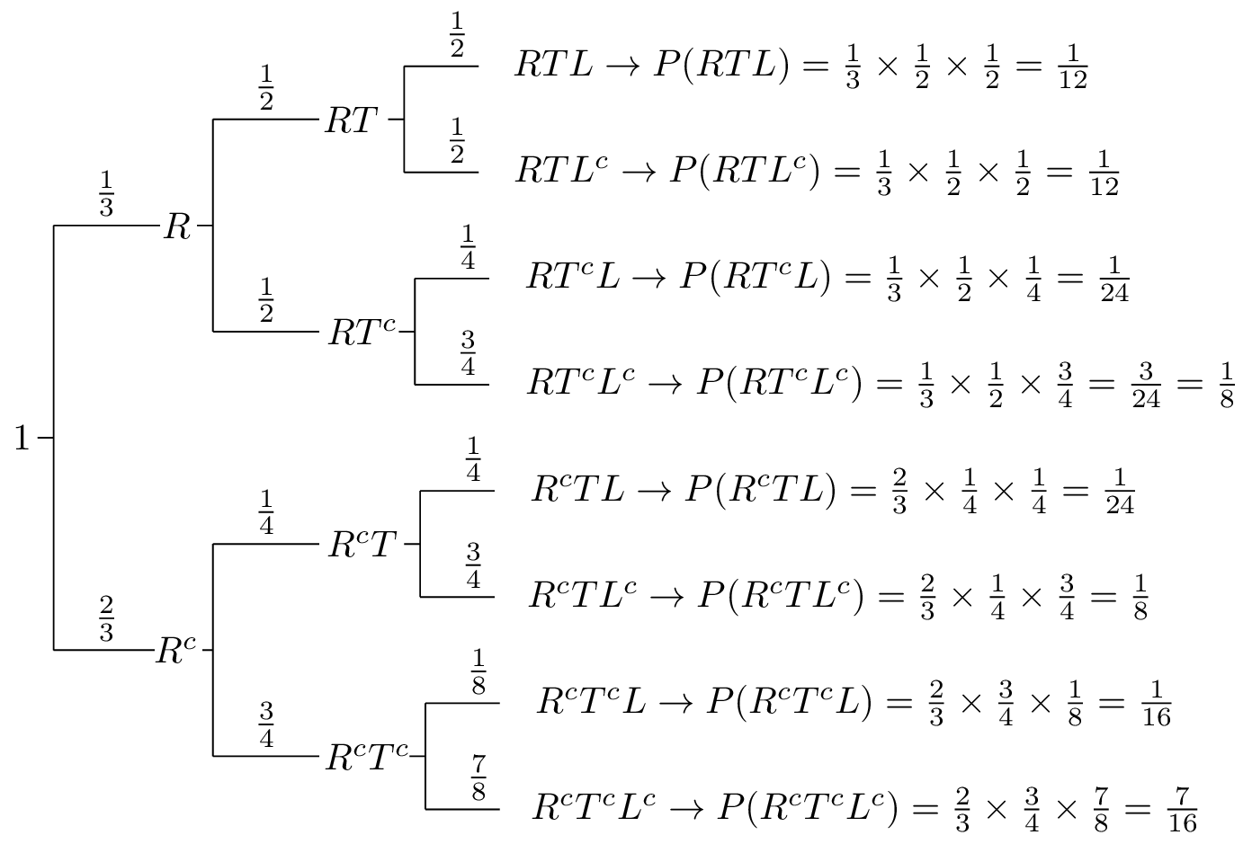Fig.1.27 - Tree diagram for Problem 5.

1. The probability that it's not raining and there is heavy traffic and I am not late can be found using the tree diagram which is in fact applying the chain rule:

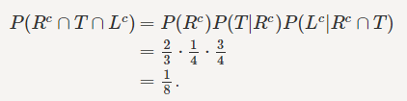

1. The probability that I am late can be found from the tree. All we need to do is sum the probabilities of the outcomes that correspond to me being late. In fact, we are using the law of total probability here.

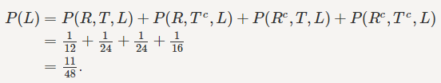

Wecan find P(R|L)P(R|L) using P(R|L)=P(R∩L)P(L)P(R|L)=P(R∩L)P(L). We have already found P(L)=1148P(L)=1148, and we can find P(R∩L)P(R∩L) similarly by adding the probabilities of the outcomes that belong to R∩LR∩L. In particular,

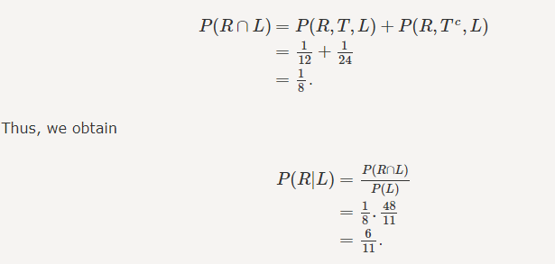

Q5: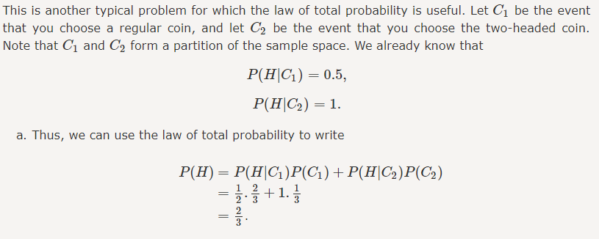

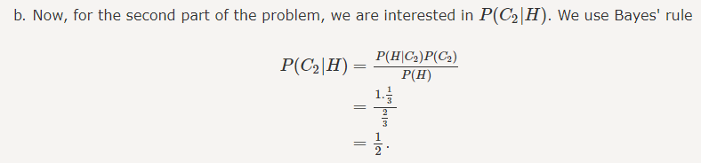

Q6:

A 70% purchase a cup of coffee

   b 40% purchase a piece of cake

   C 20% purchase both a cup of coffee and a piece of cake.

Given that a randomly chosen customer has purchased a piece of cake, what is the probability that he/she has also purchased a cup of coffee?

P(A) = 0.7

P(B) = 0.4

P(A ∩ B) = 0.2

P(A|B) = P(A ∩ B)/ P(B) = 0.2 /0.4 = 1/ 2 = 0.5

Q 7 :- (a) Mean = 50, SD = 1.6

X ~ N( μ, σ2/ n)

in this case we have

X~N (50\*162/100)

the mean will be μm=50

standard error/deviation σm = √162/100=16/10 = 1.6

(b) Mean = 50, SD = 2

X ~ N( μ, σ2/ n)

in this case we have

X~N (50, 202/100)

the mean will be μm=50

standard error/deviation σm = √202/100=20/10 = 2

Q9:-

a) 0.2023

b) 0.0186

c) 0.0004

d) 0.0955