Solution 15

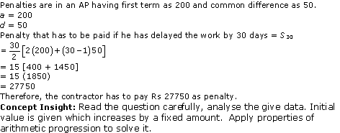

Solution 16

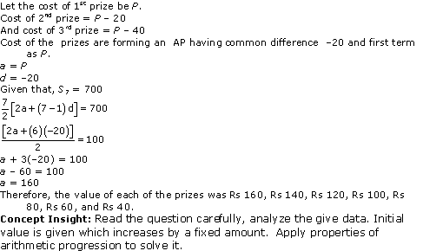

Solution 17

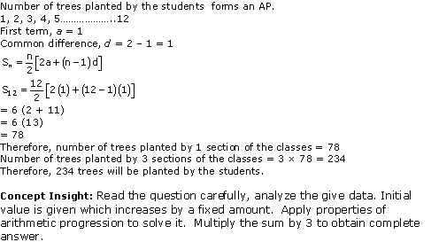

Solution 18

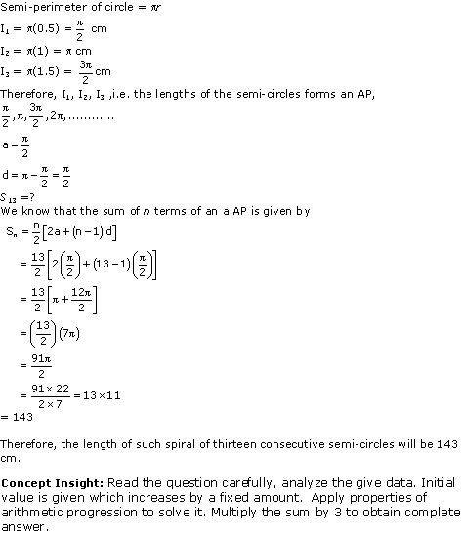

Solution 19

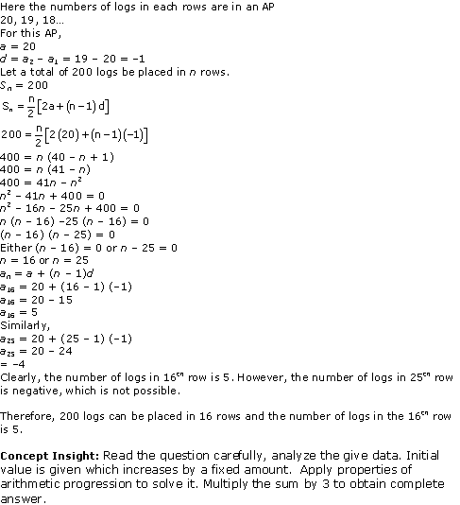

Solution 20

In a potato race, a bucket is placed at the starting point, which is 5m from the first potato and other potatoes are placed 3m apart in a straight line. There are ten potatoes in the line.

So, we get the series as

5, 8, 11, 14, ........

Here, a= 5 and  d = 8 - 5 = 11 - 8= 3

the difference between the two consecutive terms are same.

So, this is an arithmetic Progression.

According to the condition, we get the series as

5 + 5 , 8 + 8, 11 + 11, .....

10, 16, 22, ..............

Here a = 10 and d = 16 - 10 = 6

the difference between the two consecutive terms are same.

So, this is an arithmetic Progression.

The total distance the competitor has to run is given by,

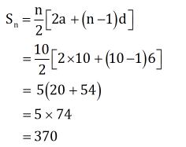

Therefore the total distance the competitor has to run is 370 m.

Chapter 5 - Arithmetic Progressions Exercise Ex. 5.4

Solution 1

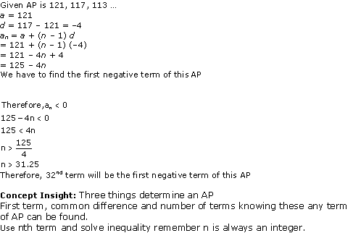

Solution 2

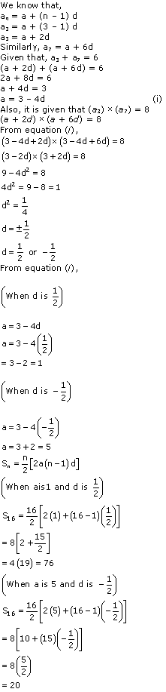

Solution 3

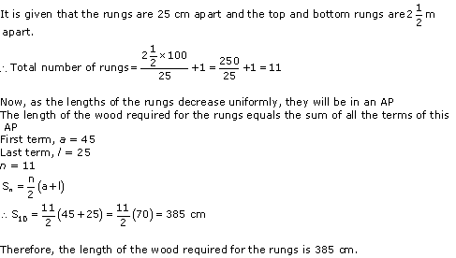

Solution 4

The number of houses was 1, 2, 3, ..... 49.

It can be observed that the number of houses are in an AP having a as 1 and d also as 1.

Let us assume that the number of xth house was like this.

We know that,

Ncert Solutions Cbse Class 10 Mathematics Chapter - Arithmetic Progressions

Sum of number of houses preceding xth house = Sx-1

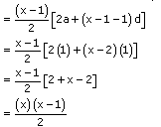

Sum of number of houses preceding xth house = S49- Sx

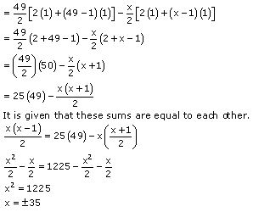

However, the house numbers are positive integers.

The value of x will be 35 only.

Therefore, house number 35 is such that the sum of the numbers of houses preceding

the house numbered 35 is equal to the sum of the numbers of the houses following it.