**Objective**  
To verify the basic proportionality theorem by using parallel lines board, triangle cut outs.

**Basic Proportionality Theorem**  
If a line is drawn parallel to one side of a triangle, to intersect the other two sides at distinct points, the other two sides are divided in the same ratio.

**Materials Required**  
White chart paper, coloured papers, geometry box, sketch pens, fevicol, a pair of scissors, ruled paper sheet (or Parallel line board).

**Procedure**

1. Cut an acute-angled triangle say ABC from a coloured paper.
2. Paste the ΔABC on ruled sheet such that the base of the triangle coincides with ruled line.  
   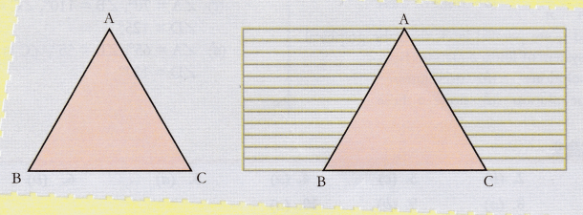
3. Mark two points P and Q on AB and AC such that PQ || BC.  
   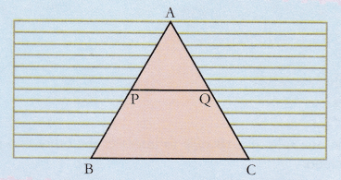
4. Using a ruler measure the length of AP, PB, AQ and QC.
5. Repeat the same for right-angled triangle and obtuse-angled triangle.
6. Now complete the following observation table.

**Observation**  
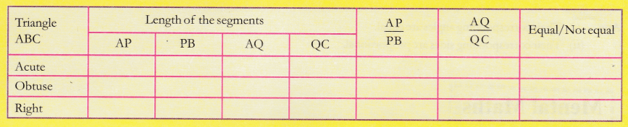  
**Result**  
In each set of triangles, we verified that \frac { AP }{ PB } =\frac { AQ }{ QC }

**Learning Outcome**  
Thus we observe that in all the three triangles the Basic Proportionality theorem is verified