*Adult Census Income Prediction*

***Wireframe Documentation***

# Homepage

We have divided *Adult Census Income Prediction* Homepage into Two Sections: -

1. First thing anyone will see is a pop-up window on Homepage which will ask for User Inputs like whether he/she will enter the all inputs.

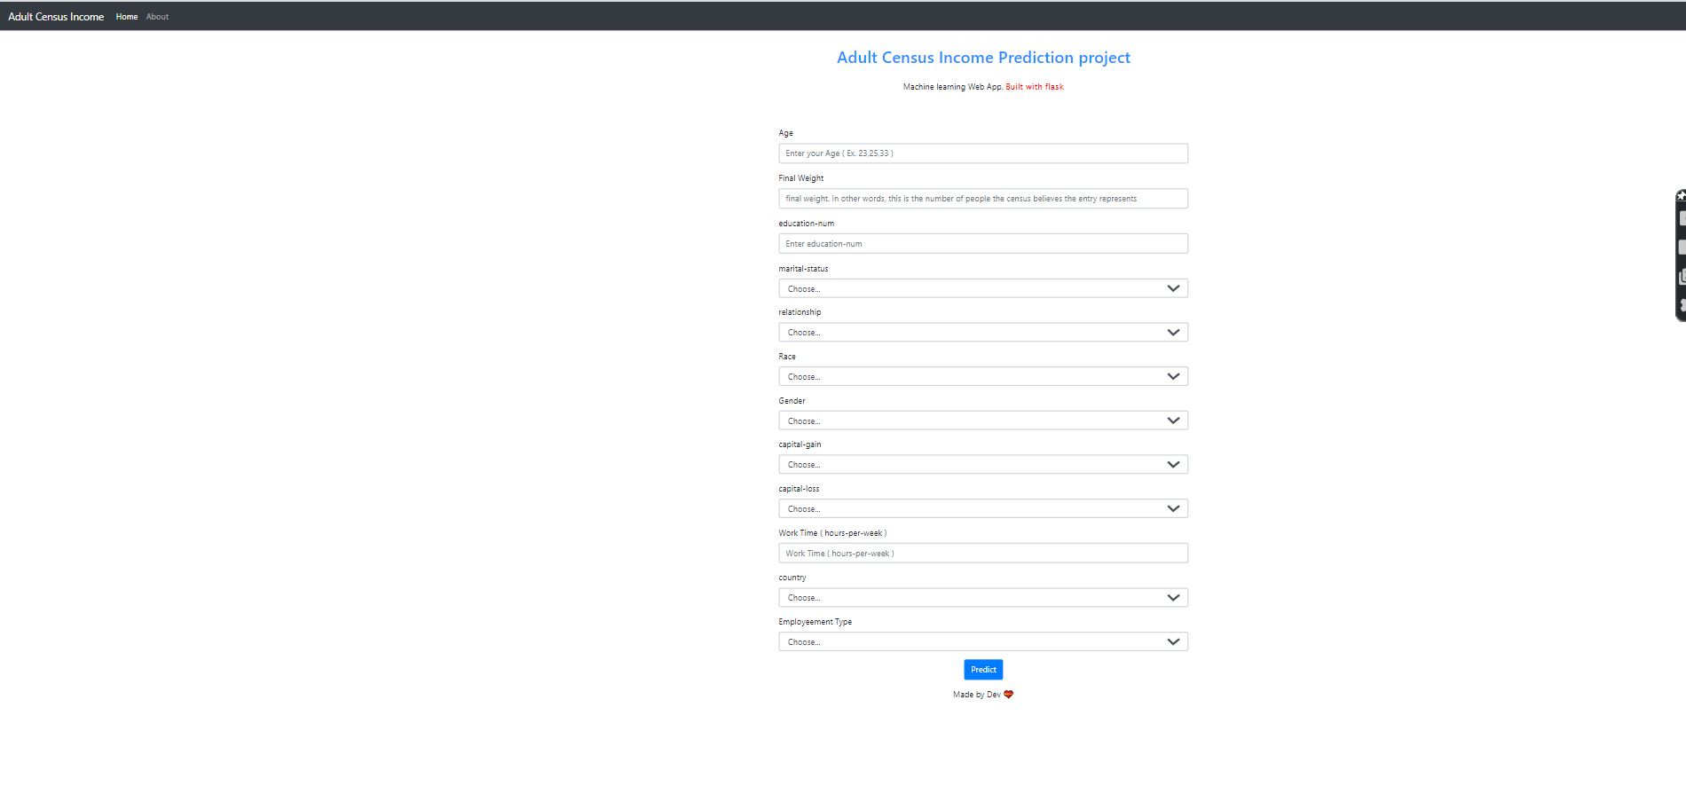

1. If user get any difficulty to understand the input, then we have another page called about, there user will get all the information about input.

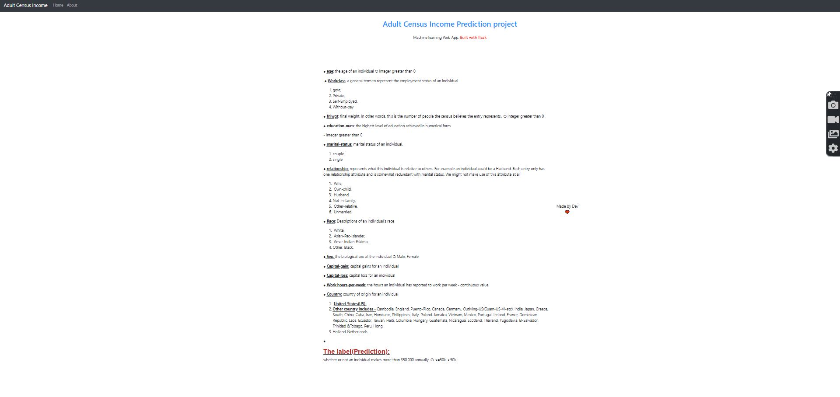

1. Based on User’s input, Adult Census income Prediction System will predict the output on another page. A sample view of showing results is below:

