**-CREATE DATABASE**

CREATE DATABASE IF NOT EXISTS tempdb

SHOW DATABASES

**-CREATE A TABLE**

CREATE TABLE tempdb.tableOne

(

Id UInt64,

Name String,

Surname String,

Department String,

EnrolDate Date

)ENGINE = MergeTree()

PARTITION BY Department

PRIMARY KEY Id

ORDER BY Id

SHOW TABLES

DESCRIBE tempdb.tableOne

**-INSERT A ROW USING COMMAND LINE**

INSERT INTO tempdb.tableOne(Id,Name,Surname,Department,EnrolDate) values(1,'Viktor','Stavrinopoulos','Computer',now())

INSERT INTO tempdb.tableOne(Id,Name,Surname,Department,EnrolDate) values(2,'Deven','Ramani','Computer',now())

INSERT INTO tempdb.tableOne(Id,Name,Surname,Department,EnrolDate) values(3,'ABC','XYZ','Arts',now())

SELECT * FROM tempdb.tableOne

**-SELECT STATEMENT USING HTTP**

curl 'http://localhost:8123/?query=SELECT * FROM tempdb.tableOne'

wget -nv -O- 'http://localhost:8123/?query=SELECT * FROM tempdb.tableOne'

POSTMAN GET -> 'http://localhost:8123/?query=SELECT * FROM tempdb.tableOne'

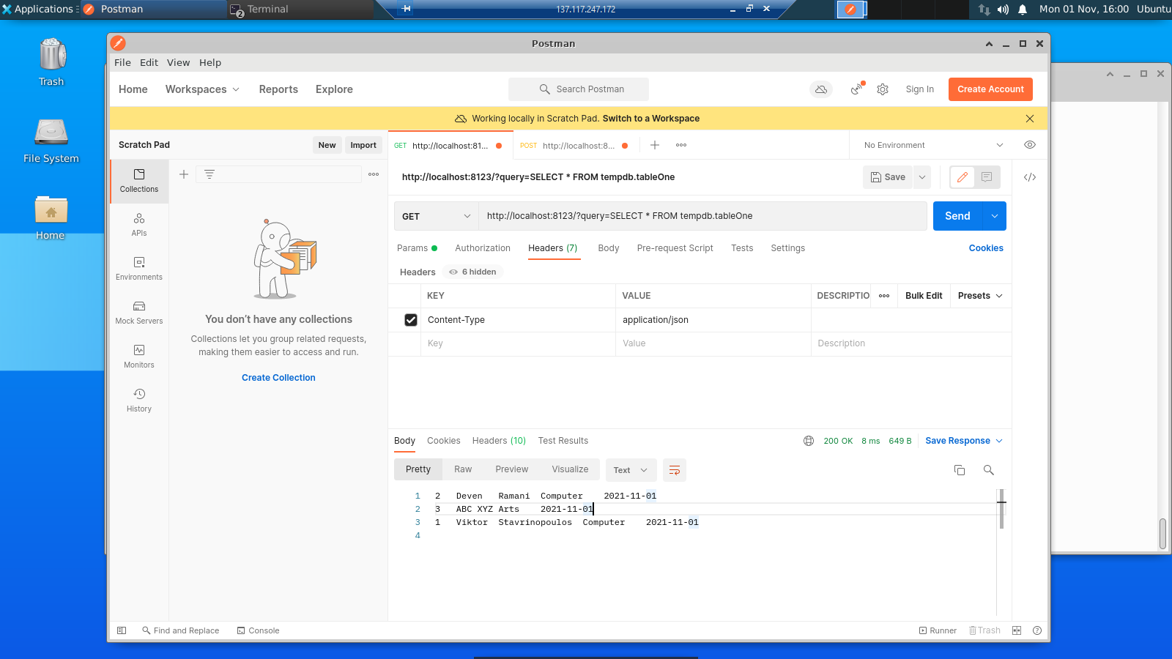

**-INSERT A ROW USING HTTP**

wget -nv -O- 'http://localhost:8123/?query=INSERT INTO tempdb.tableOne(Id,Name,Surname,Department,EnrolDate) values(3,"ABC","XYZ","Arts",now())'

curl 'http://localhost:8123/?query=INSERT INTO tempdb.tableOne(Id,Name,Surname,Department,EnrolDate) values(3,'ABC','XYZ','Arts',now())'

POSTMAN POST -> 'http://localhost:8123/?query=INSERT INTO tempdb.tableOne(Id,Name,Surname,Department,EnrolDate) values(3,'ABC','XYZ','Arts',now())'

**-SELECT STATEMENT USING HTTP IN PYTHON**

r =requests.get('http://localhost:8123/?query=SELECT * FROM tempdb.tableOne')