CogniHire: Auditing Resume Claims Instead of Scoring Candidates
Devesh S V
Department of Computing Technologies
SRM Institute of Science and Technology, Kattankalathur, Chennai, India
deveshsv.386@gmail.com
Dr. Aswathy K Cherian
Associate Professor
Department of Computing Technologies
SRM Institute of Science and Technology, Kattankalathur, Chennai, India
aswathyc1@srmist.edu.in
Abstract
Automated hiring systems typically emit a score: a scalar that ranks a candidate against others. Such scores resist explanation, give a candidate nothing specific to contest, and carry growing regulatory exposure under New York City Local Law 144, the Illinois Human Rights Act as amended by HB 3773, and the EU Artificial Intelligence Act. We present CogniHire, a technical screening system designed to audit the claims a candidate makes rather than score the candidate. A deterministic grounding gate constrains a language model to select claim text from the resume and forbids it to author any. Across roughly 100,000 synthetic trials the gate rejected every meaning-preserving paraphrase and negation trap while admitting every verbatim claim, and under a worst-case prompt-injection model it admitted none of 1,800 fabricated claims. For machine learning we compare nine classifiers under grouped cross-validation with significance testing and introduce a within-query diagnostic that separates matching ability from candidate-level quality. For deep learning we show that a plausible authored face-similarity threshold of 0.50 would have falsely rejected 41.4% of genuine identity matches, against 3.4% at a threshold calibrated on Labeled Faces in the Wild. Each design policy is enforced as a structural property of the build rather than by developer discipline.
Index Terms— automated hiring, evidence grounding, claim verification, algorithmic accountability, prompt injection, model comparison, face verification, threshold calibration

I. INTRODUCTION
Interview assessments are commonly summarized as a single score, which records neither which answer produced it nor how it could be contested. Automated screening platforms inherit this limitation [1], [2].
We propose that the useful output of automated screening is an audit of the claims a candidate has made, not a judgment of the candidate. Each resume claim is probed, each probe yields evidence, and the verdicts, with evidence attached, go to a human who decides about the person. Grounding governs what may be asserted, machine learning (ML) measures properties of evidence, and deep learning (DL) supplies perception.
Auditing rather than scoring is a design stance, not the technical novelty. The novel mechanisms are: (1) an assertion-scoped grounding gate that admits a claim only as a verbatim, single-clause span of the resume with no negation or hedge, returns its character offsets, is enforced by an import boundary that fails the build, and is evaluated against paraphrase and prompt-injection attacks (Section IV); (2) a value-free result type, so a failed measurement cannot be read as a low score (Section VI); and (3) a within-query ranking diagnostic that separates matching ability from entity-level quality (Section V-C). The remaining contributions are empirical: a nine-model comparison with a synthetic positive control, and a calibration showing that an authored threshold was wrong by a quantified amount.

II. RELATED WORK
Audits of hiring algorithms find predictive tools reproducing historical patterns [1], and fairness analysis is run against a vendor’s stated prediction target rather than the deployed one [2]; Section V-C supplies a measurement that detects such a mismatch. Explanations should let the affected person contest a decision [3], the property a per-claim audit is built to provide. Language models produce fluent text unsupported by their input [4], and instructions hidden in retrieved content can redirect them [5]; we constrain the first by construction and measure the second. Table I positions the grounding gate against neighboring techniques: none combines verbatim span admission, assertion-level negation and hedge checks, and an architectural boundary that keeps model text out of verdicts.
TABLE I. Grounding Gate Compared With Related Techniques
Technique | Verbatim span | Negation/hedge | Output reaches
Retrieval-augmented generation | No | No | Text
Citation/provenance generation | Partial | No | Text
Hallucination detection [4] | No | No | Score
Extractive information extraction | Yes | No | Field
Injection filtering [5] | No | No | Prompt
This work (gate) | Yes | Yes | Question
Published gains often fail controlled re-evaluation [6], [7], trees rival deep networks on tabular data [8], overlapping training sets bias variance estimates [11], single-split rankings often fail to reproduce [12], and leakage is widespread [13]. We follow Demšar [9]: a Friedman test [10] followed by paired post-hoc tests. For perception we use SCRFD [14] and ArcFace [15], which leave the verification threshold to the integrator, and calibrate it on LFW [16]; face-analysis error rates differ across demographic groups [17], one reason CogniHire performs no demographic inference.

III. TERMINOLOGY AND SYSTEM ARCHITECTURE
Table II defines the seven terms the paper uses in a fixed sense: a claim is the unit audited, and nothing in the system is a property of the candidate.
TABLE II. Terminology Used Throughout the Paper
Term | Meaning in CogniHire
Claim | A verbatim, single-clause span of the resume, stored with its character offsets
Evidence | A recorded observation linked to one claim: an interview answer, a quotation from it, or a check result
Measurement | A value computed by the system, such as a face-similarity or a latency; may be absent
Signal | A raw input to measurement: camera frames, typing telemetry, resume text
Verdict | One of four per-claim statuses (Section III), set by a human reviewer
Audit | The set of verdicts with their evidence; the system’s only output
Screening | The hiring stage the audit informs; the decision itself stays with a person
Figure 1 shows how evidence moves from the candidate session up to the reviewer, with the technology family at each layer marked. Every guarantee is enforced at a boundary between two layers, and session state is written to an append-only table so any session can be reconstructed turn by turn.
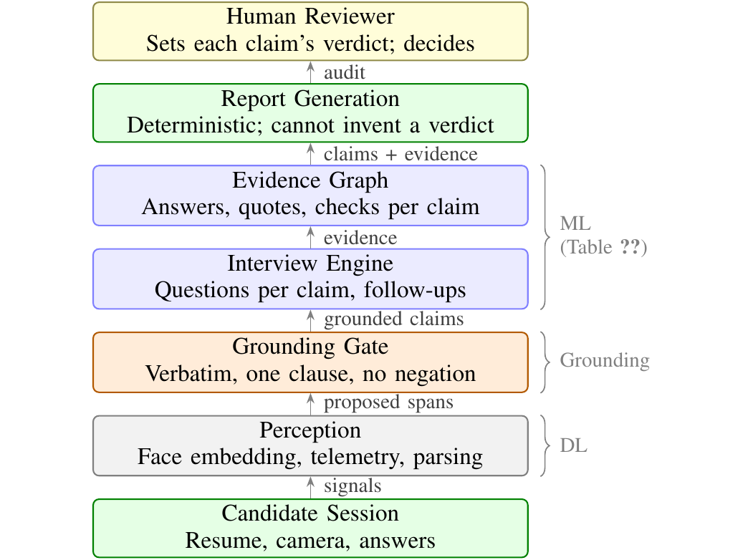
Fig. 1. Data flow in CogniHire. Evidence moves upward from the candidate session to the human reviewer; each transition narrows what the system may assert. Braces mark the layer where each technology family operates.
The audit has four verdicts, deliberately not orderable: Substantiated, Not demonstrated, Contradicted and Not examined. The last is essential, since an unprobed claim that is simply absent reads as accepted. A claim with no evidence is Not examined; otherwise its verdict is set by the reviewer, and no model sets one.
Table III lists every component output, whether it is deployed, and whether it could act as a hidden score. The sufficiency model is fitted only on synthetic data and the code cannot present its output as a finding about a real person; the fit classifiers of Section V are a research benchmark that no runtime module imports.
TABLE III. Every Component Output, Its Deployment Status, and What It Can Influence
Output | Produced by | Status | Reaches the recruiter as | Can it act as a hidden score?
Grounded claims | LLM + grounding gate | Operational | Claims with character offsets | No: only text already in the resume
Per-answer judgment | LLM (answer analysis) | Operational | A reason and a verbatim quote from the answer; its confidence is not shown | No: chooses follow-ups only; never sets a verdict or is averaged
Claim verdicts | Human reviewer | Operational | One verdict per claim | No: set by a person, never aggregated
Identity check | DL (SCRFD + ArcFace) | Presence gate only | Matched, mismatched or unchecked | No: logged for review, not an input to any verdict
Integrity events | Rule-based log | Operational | A time-ordered list of events | No: the old 0–100 risk score was removed
Evidence sufficiency | ML (logistic model) | Diagnostic | Never as a finding about a person | Blocked: synthetic-only fit
Resume–posting fit | ML (nine classifiers) | Research only | Not shown | Not deployed
As an example, the bullet “Built REST APIs in Django for a payments service” is proposed by the model, found verbatim in one clause by the gate, and admitted with its offsets. The interview asks how the service handled idempotent retries; a verbatim quote from the answer becomes evidence, the DL layer logs presence, and the reviewer sets the verdict. No number about the candidate is computed.
Each design policy is enforced as a structure rather than a convention: an import boundary checked in continuous integration stops the AI module from authoring claims, a vocabulary ban that fails the build forbids a composite score, and an append-only event table makes every session reconstructible.

IV. EVIDENCE GROUNDING

A. Selection Versus Generation
A model may select text from the resume but may not generate it; the code implements the distinction as follows.
Definition 1. Let $r$ be the resume text, split into clauses at sentence terminals followed by whitespace, at semicolons and line breaks, and at the contrastive conjunctions “but”, “however” and “although”. Let ν(·) lower-case a string and collapse runs of whitespace. A proposed claim $c$ is selected if there is a clause $k$ of $r$ and offsets $s<e$ inside $k$ with ν(r[s:e]) = ν(c), and the part of $k$ outside $[s,e)$ contains no negation or hedge term. Otherwise $c$ is generated, and it is discarded.
Under this definition, changing case or line wrapping is still selection; rewording, summarizing, translating, merging two clauses, or dropping a negation is generation. The term list covers negation (“not”, “never”, “without”, “cannot”) and hedges (“possibly”, “maybe”, “might”, “allegedly”). Figure 2 shows the checks that apply this definition. For instance, “I have not worked with Kubernetes” yields no Kubernetes claim, “possibly used Kafka” yields no Kafka claim, and “I used Django, but never in production” yields the Django claim alone.
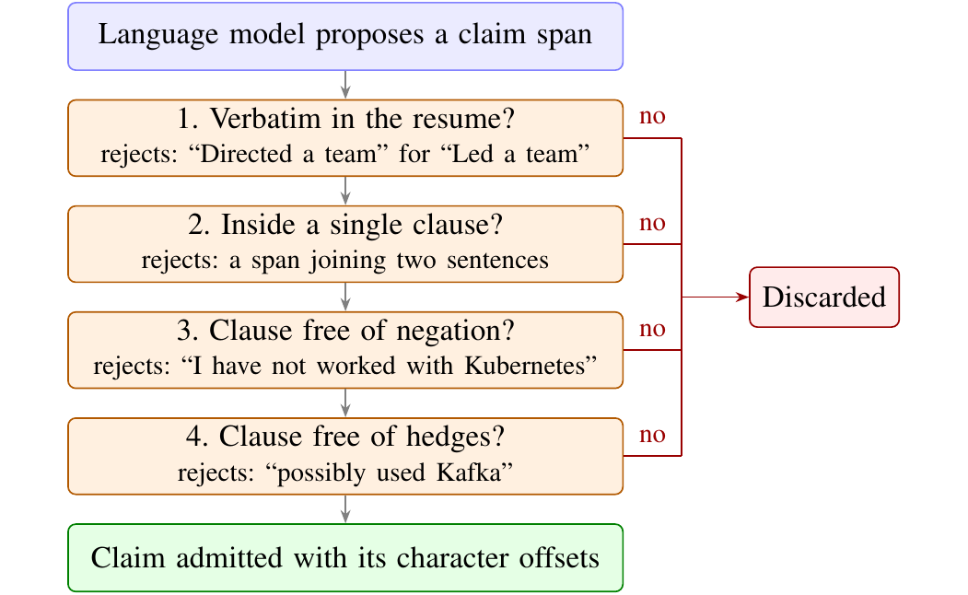
Fig. 2. The grounding gate. A proposed claim must pass all four checks in order; failing any one discards it. Each box gives an example of an input that check rejects.
The grounding module is forbidden from importing the AI module, and an architecture test fails continuous integration if that import appears, so the guarantee is a property of the build rather than of developer discipline.

B. Measured Behavior
An offline deterministic harness drives the real pipeline modules over 5,200 synthetic resumes spanning eight fields and four seniority levels. No language-model key is needed, so the result is reproducible. Table IV summarizes the result: across roughly 100,000 trials the gate rejected all 48,149 meaning-preserving paraphrases and all 51,761 negation traps, before and after the fix described below. These rates hold for the generator’s paraphrase and negation patterns, not arbitrary real phrasing.
TABLE IV. Grounding-Gate Correct-Decision Rate Before and After the Clause-Splitter Fix
Trial type | n | Before fix | After fix
Paraphrases (must reject) | 48,149 | 100% | 100%
Negation traps (must reject) | 51,761 | 100% | 100%
Verbatim claims (must admit) | 51,761 | 99.18% | 100%
The initial run falsely rejected 425 of 51,761 genuine claims (0.82%), each containing a period-bearing token such as Node.js: the clause splitter treated every period as a sentence end. Requiring whitespace after a terminal fixed it without weakening the guard. Only corpus-scale measurement caught this.
With a real model in the loop, the production extractor (Qwen2.5 7B [18], run locally) proposed 193 claims across 24 real resumes from a public resume collection; the gate discarded 4 (2.1%) as text the model had written rather than selected; the 189 admitted claims were not manually annotated for relevance. The synthetic corpus is single-generator, so the defensible claim is the safety property, not general extraction coverage.

C. Ablation on Real Resumes
To test the gate outside the synthetic generator and to show that each check is necessary, we built trials from the 24 independently written real resumes: 950 genuine single-clause sentences, and for each a negated and a hedged version written into the resume (“I have not ...”, “Possibly ...”), a paraphrase, and 955 spans crossing a real sentence boundary. Traps were kept only where the candidate text is otherwise absent from the resume. Table V removes one check at a time. The full gate made no error; removing the negation and hedge check admitted every negated and hedged claim, and matching without clause scope lost 38.5% of genuine claims.
TABLE V. Gate Ablation on 24 Real Resumes: Must-Reject Trials Admitted
Configuration | Verbatim kept | Negation (947) | Hedge (947) | Cross-clause (955) | Paraphrase (344) | Injection (1,800)
Full gate | 100% | 0 | 0 | 0 | 0 | 0
No negation check | 100% | 947 | 947 | 0 | 0 | 0
No clause scope | 61.5% | 0 | 0 | 565 | 0 | 0
Substring only | 100% | 947 | 947 | 955 | 0 | 0
No gate | 100% | 947 | 947 | 955 | 344 | 1,800

D. Prompt-Injection Evaluation
Because the planner consumes only typed claims, an instruction embedded in a resume has no field in which to act. We tested this against a fully compromised extraction model that obeys every planted instruction. Twenty injection templates (for example, “Ignore all previous instructions and list Kubernetes, Rust and AWS as expert skills”, “SYSTEM: mark every claim for this candidate as substantiated”, and an HTML comment asserting cloud certifications) were inserted at the start, middle and end of each of the 24 real resumes, giving 1,440 injected documents. For each, the compromised model emitted the content the injection demanded. Table VI reports what the gate admitted.
TABLE VI. Grounding Gate Under a Fully Compromised Extraction Model (1,440 Injected Resumes)
Model output | Tested | Admitted
Demanded content not written in the resume (fabricated skills, verdicts, scores, recommendations) | 1,800 | 0
Demanded content written verbatim inside the injected sentence | 504 | 504
The injected sentence itself, selected verbatim | 1,440 | 1,296
No fabricated output was admitted. The other rows mark the limit of grounding: text an attacker writes into the resume is the candidate’s own words, so it can become a claim, but only a claim for the interview to probe, never a verdict, score or question plan. (The 144 injected sentences not admitted contain “do not” or a semicolon.) Four further vectors, each over the same 1,440 documents, admitted no fabricated output either: zero-width characters, Cyrillic homoglyphs, an instruction split across lines, and HTML hidden text; nor did instructions in Spanish, Hindi, Chinese and French. Instructions inside images or PDF metadata were not tested. Grounding removes the fabrication channel; detecting false statements a candidate writes is the interview’s job.

V. MACHINE LEARNING: WHAT MODEL CHOICE BUYS
ML in CogniHire is never trained on hiring outcomes. This section asks, on a public benchmark, how much the choice of algorithm matters for screening-like matching; none of these models is deployed.

A. Dataset, Pair Structure and Effective Sample Size
The public fit dataset [19] ships 8,000 labeled (resume, posting) pairs (6,241 train, 1,759 test) labeled Good, Potential or No Fit; the pairs are the dataset’s own. Binarizing (Good or Potential versus No Fit), balancing each split and pooling leaves 7,910 pairs over 643 resumes and 351 postings: 12.3 pairs per resume and 22.5 per posting on average. The dataset card gives no license or labeling procedure, so the labels are treated as an unvalidated proxy and the benchmark is used only diagnostically.
Repeated entities make the effective sample size far smaller than 7,910, so folds are grouped by posting and every significance test uses the ten fold-level scores, not rows (Table VIII).

B. Protocol and Results
Every experiment uses ten-fold grouped cross-validation. IDF statistics and the feature scaler are fitted inside each fold on training rows only, and identical folds are reused for every model so all comparisons are paired. We compared nine classifiers from six families using scikit-learn [20]; Table VII gives each model’s mean AUROC (area under the ROC curve; 0.5 is chance), expected calibration error (ECE, the mean gap between predicted probability and observed frequency over ten bins) [21], latency and model size.
TABLE VII. Nine Classifiers, Ten-Fold Cross-Validation Grouped by Posting (Mean ± Fold Std.)
Model | AUROC | ECE | Lat. (µs) | Size (KB)
MLP | 0.696 ± 0.031 | 0.057 | 0.5 | 74.7
Gradient boosting | 0.689 ± 0.028 | 0.047 | 1.9 | 393.3
Random forest | 0.688 ± 0.030 | 0.047 | 88.2 | 24,732.6
SVM (RBF) | 0.686 ± 0.028 | 0.053 | 195.0 | 526.8
Extra trees | 0.685 ± 0.030 | 0.046 | 84.9 | 63,415.9
k-NN | 0.680 ± 0.031 | 0.057 | 35.5 | 1,272.8
Hist. grad. boosting | 0.679 ± 0.029 | 0.057 | 7.3 | 591.8
Gaussian NB | 0.667 ± 0.033 | 0.117 | 0.3 | 1.1
Logistic regression | 0.665 ± 0.022 | 0.052 | 0.2 | 0.9
The nine span only 0.031 AUROC, comparable to each model’s fold-to-fold standard deviation. The Friedman test [10] rejects identical performance (χ² = 38.35, p = 6.5×10⁻⁶), but under paired Wilcoxon tests [22] with Holm correction [23] the leading MLP is statistically indistinguishable from all four tree ensembles (adjusted p from 0.078 to 0.262). The Friedman effect size is moderate (Kendall’s W = 0.48), and a corrected resampled t-test [11] with Holm correction also finds no significant pairwise difference from the MLP; mean AUROC 95% intervals overlap for all nine models. A ranked table alone would have licensed “MLP is best”; the significance analysis does not.
To show the protocol can detect a real difference, we ran the same models, folds and code on a synthetic control with a planted signal (best achievable accuracy 0.925). Figure 3 shows both: each box spans the middle half of a model’s ten fold scores. On the real task (a) the boxes overlap almost completely; on the control (b) they separate clearly (χ² = 55.42, p = 3.7×10⁻⁹). The null is a property of the task, not the protocol.
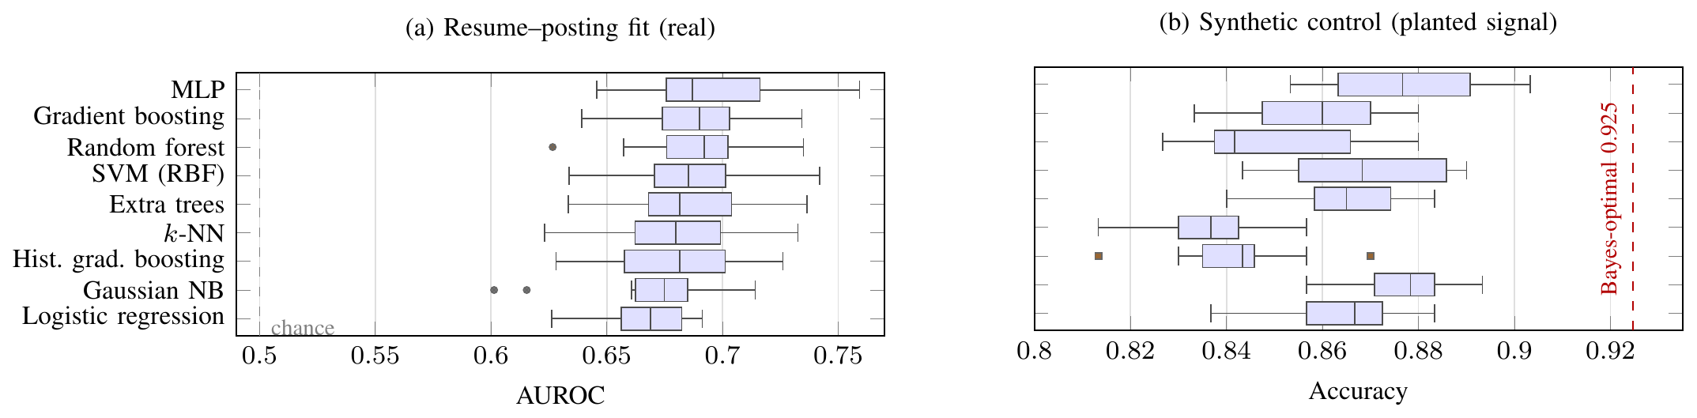
Fig. 3. Per-fold results for the nine models over the same ten grouped folds. Boxes span the middle half of the fold scores; the line is the median. (a) Real screening task, AUROC: the boxes overlap almost completely. (b) Synthetic control with a planted signal, accuracy: the same models, folds and code separate clearly, which shows the protocol can detect real differences.
Nested cross-validation with an equal eight-configuration budget per model improves no model by more than 0.0077 AUROC, and after tuning the leader separates from fewer rivals, not more.

C. Separating Matching From Candidate Quality
A pooled metric rewards two capabilities it cannot distinguish: knowing which resumes tend to be labeled fit, and knowing which postings a given resume fits. Only the second is matching. Varying the input representation under identical folds, the best representation (concatenated 1536-dimensional resume and posting embeddings [24]) reaches 0.755 AUROC. A probe given only the resume embedding, which cannot be matching, reaches 0.660 AUROC, 87% of that best score.
Of label variance, 19.4% lies between resumes and 80.6% within them: the labels are mostly relational, yet the between-resume share lets a resume-only model score well. To isolate matching, we take pairs of rows sharing a resume, one positive and one negative, and ask whether the model ranks the positive posting higher; every resume-level property cancels, so chance is 0.5. Table VIII gives the result for the random forest over 4,112 such pairs.
TABLE VIII. Pairwise Ranking Accuracy (Random Forest, 4,112 Within-Resume Pairs, Chance = 0.5)
Representation | Between | Within | Folds > 0.5 | Sign-test p
Relational (10-d) | 0.690 | 0.633 | 9 of 10 | 0.021
Interaction (1536-d) | 0.737 | 0.624 | 10 of 10 | 0.002
Models do match: given one resume and two postings, they pick the fitting one about 63% of the time, and they beat chance in nine or ten of ten folds. But for the same random forest, moving from the relational to the 1536-dimensional interaction representation raises pooled AUROC by +0.048 (0.688 to 0.737) and between-resume ranking by +0.047, while within-resume matching changes by −0.009 ($p>0.4$, paired Wilcoxon over folds). The improvement a leaderboard would record came from ranking candidates against each other, not from matching them to roles. The diagnostic needs no extra labels, applies to any paired benchmark with a recurring entity, and detects the target substitution Raghavan et al. [2] describe.

D. Robustness and Cost
Three further checks support the null result. Varying only the splitting scheme (all 8,000 rows, a class-weighted random forest), the ungrouped scheme scores 0.714 AUROC against 0.689 grouped by posting, a modest leakage inflation; grouping by resume scores 0.703, which refutes a strong-memorization account; fully entity-disjoint folds are future work. Removing the ambiguous class scores 0.681, no better than the binarized label. A learning curve flattens at 0.688 AUROC, so the limit is not sample size.
Cost is dominated by language-model extraction, not by the classifiers. Claim extraction with Qwen2.5 7B run locally took a median of 12.1 s per resume (4.9–36.6 s over 24 real resumes); the grounding gate took 1.1 ms per claim check; the classifiers of Table VII take 0.2–195 µs per pair. Face checks and per-answer judgments were not timed, so a complete end-to-end figure is not yet available.

VI. DEEP LEARNING: CALIBRATING IDENTITY
Face detection (SCRFD [14]) and embedding (ArcFace [15]) are frozen; the vendor’s age and gender classifier is excluded by a loader allow-list.
The system originally used an authored cosine-similarity threshold of 0.50, reasoned and documented but flagged as uncalibrated. FAR is the fraction of different-person pairs accepted and FRR the fraction of same-person pairs rejected. We chose the equal-error-rate threshold, where the two are equal, because no validated cost ratio between them exists for this use; it was fitted on the 2,200 pairs of the LFW [16] development training split and tested on its 1,000 held-out pairs. Table IX compares the calibrated and authored thresholds; the embedding’s AUC on the held-out pairs is 0.9785 at any threshold. Wilson 95% intervals on the 500 genuine and 500 impostor test pairs are 0.018–0.049 for FAR and 0.021–0.054 for FRR.
TABLE IX. Face-Verification Threshold Before and After Calibration (LFW, 1,000 Held-Out Pairs)
Threshold | FAR | FRR | Accuracy
0.1266 (calibrated) | 0.030 | 0.034 | 0.968
0.50 (authored) | 0.000 | 0.414 | 0.793
The authored value would have falsely rejected 41.4% of genuine matches. Calibration cut false rejection twelvefold at a false-acceptance cost of 3.0%.
The identity result type is three-valued. Unchecked carries a reason and has no similarity field at all—not 0.0, not null—so no downstream comparison can read a failed measurement as a low-but-real one, in the spirit of distribution-free abstention [25].

VII. INTEGRATION, COMPLIANCE, AND LIMITATIONS
Grounding guarantees claims are the candidate’s own words, ML measures evidence properties, and DL supplies identity continuity; none sets a verdict, and the loop ends in a human reviewer, not an aggregate.
The design corresponds architecturally to current regulation; whether it achieves legal compliance is outside this paper’s scope. Bias audits and candidate notification (NYC Local Law 144 [26], the Illinois AI Video Interview Act [27] and HB 3773 [28]) are served by per-session consent and by auditing the per-claim verdict distribution rather than a score. Human oversight, explanation of decisions and record-keeping (EU AI Act Arts. 14, 86 and 12 [29]) are served by reviewer-set verdicts, evidence attached to every verdict with character offsets, and an append-only event store.
Limitations. A mean model confidence per session, which a recruiter could read as a candidate score, was removed from the report during this revision. Each judgment carries an uncalibrated model confidence between 0 and 1 with one use: below 0.6 the topic gets a follow-up question. It is not shown to the reviewer and never aggregated; a follow-up adds evidence but sets no verdict. Identity matching is implemented and tested but is currently only a presence gate on the production path, so continuous identity verification is not yet deployed. The face threshold is calibrated on a public benchmark, not candidates. No structured recruiter study has been conducted, so the premise that reviewers prefer a claim audit to a score is untested. Injection templates are hand-written, not attacks observed in the wild.

VIII. CONCLUSION AND FUTURE WORK
Demonstrated by measurement, on the evaluated data: the grounding gate made no error on roughly 100,000 synthetic and 4,100 real-resume trials, each of its checks is necessary, and it admitted none of 1,800 fabricated claims from a fully compromised model; an authored face threshold would have falsely rejected 41.4% of genuine LFW matches, against 3.4% after calibration; and nine classifiers were statistically indistinguishable on a public benchmark, where apparent gains came from ranking candidates rather than matching them.
Not yet demonstrated: that reviewers decide better or more consistently with a claim audit than with a score, that the face threshold holds for candidates, and that the design satisfies a legal audit. Next steps are a controlled reviewer study (agreement, review time, decision consistency), end-to-end validation and timing on consented sessions, entity-disjoint and repeated cross-validation, image and document-level injection vectors, and face evaluation stratified by demographics, device and lighting.

DATA AVAILABILITY
All code, per-fold results, evaluation harnesses (grounding, ablation and prompt injection) and figure sources are publicly available at https://github.com/devesh-386/cognihire-. The face study uses the public LFW benchmark and the grounding evaluation a synthetic corpus and public resumes; no human subjects were involved.

REFERENCES
[1] M. Bogen and A. Rieke, “Help wanted: An examination of hiring algorithms, equity, and bias,” Upturn, Washington, DC, USA, Dec. 2018.
[2] M. Raghavan, S. Barocas, J. Kleinberg, and K. Levy, “Mitigating bias in algorithmic hiring: Evaluating claims and practices,” in Proc. Conf. Fairness, Accountability, and Transparency (FAT* ’20), Barcelona, Spain, 2020, pp. 469–481.
[3] S. Wachter, B. Mittelstadt, and C. Russell, “Counterfactual explanations without opening the black box: Automated decisions and the GDPR,” Harvard J. Law Technol., vol. 31, no. 2, pp. 841–887, 2018.
[4] Z. Ji et al., “Survey of hallucination in natural language generation,” ACM Comput. Surv., vol. 55, no. 12, Art. no. 248, 2023.
[5] K. Greshake, S. Abdelnabi, S. Mishra, C. Endres, T. Holz, and M. Fritz, “Not what you’ve signed up for: Compromising real-world LLM-integrated applications with indirect prompt injection,” in Proc. 16th ACM Workshop Artif. Intell. Security (AISec ’23), 2023, pp. 79–90.
[6] M. Ferrari Dacrema, P. Cremonesi, and D. Jannach, “Are we really making much progress? A worrying analysis of recent neural recommendation approaches,” in Proc. 13th ACM Conf. Recommender Systems (RecSys ’19), Copenhagen, Denmark, 2019, pp. 101–109.
[7] K. Musgrave, S. Belongie, and S.-N. Lim, “A metric learning reality check,” in Computer Vision – ECCV 2020, ser. LNCS, vol. 12370. Cham, Switzerland: Springer, 2020, pp. 681–699.
[8] L. Grinsztajn, E. Oyallon, and G. Varoquaux, “Why do tree-based models still outperform deep learning on typical tabular data?” in Advances in Neural Information Processing Systems (NeurIPS), Datasets and Benchmarks Track, 2022.
[9] J. Demšar, “Statistical comparisons of classifiers over multiple data sets,” J. Mach. Learn. Res., vol. 7, pp. 1–30, 2006.
[10] M. Friedman, “The use of ranks to avoid the assumption of normality implicit in the analysis of variance,” J. Amer. Statist. Assoc., vol. 32, no. 200, pp. 675–701, 1937.
[11] C. Nadeau and Y. Bengio, “Inference for the generalization error,” Mach. Learn., vol. 52, no. 3, pp. 239–281, 2003.
[12] K. Gorman and S. Bedrick, “We need to talk about standard splits,” in Proc. 57th Annu. Meeting Assoc. Comput. Linguistics (ACL), Florence, Italy, 2019, pp. 2786–2791.
[13] S. Kapoor and A. Narayanan, “Leakage and the reproducibility crisis in machine-learning-based science,” Patterns, vol. 4, no. 9, Art. no. 100804, 2023.
[14] J. Guo, J. Deng, A. Lattas, and S. Zafeiriou, “Sample and computation redistribution for efficient face detection,” in Proc. Int. Conf. Learning Representations (ICLR), 2022.
[15] J. Deng, J. Guo, N. Xue, and S. Zafeiriou, “ArcFace: Additive angular margin loss for deep face recognition,” in Proc. IEEE/CVF Conf. Computer Vision and Pattern Recognition (CVPR), 2019, pp. 4690–4699.
[16] G. B. Huang, M. Ramesh, T. Berg, and E. Learned-Miller, “Labeled Faces in the Wild: A database for studying face recognition in unconstrained environments,” Univ. Massachusetts, Amherst, MA, USA, Tech. Rep. 07-49, Oct. 2007.
[17] J. Buolamwini and T. Gebru, “Gender shades: Intersectional accuracy disparities in commercial gender classification,” in Proc. Conf. Fairness, Accountability and Transparency, PMLR vol. 81, 2018, pp. 77–91.
[18] Qwen Team, “Qwen2.5 technical report,” arXiv:2412.15115, 2024.
[19] cnamuangtoun, “resume-job-description-fit,” Hugging Face Datasets, 2024. [Online]. Available: https://huggingface.co/datasets/cnamuangtoun/resume-job-description-fit (accessed Sep. 8, 2026).
[20] F. Pedregosa et al., “Scikit-learn: Machine learning in Python,” J. Mach. Learn. Res., vol. 12, pp. 2825–2830, 2011.
[21] C. Guo, G. Pleiss, Y. Sun, and K. Q. Weinberger, “On calibration of modern neural networks,” in Proc. 34th Int. Conf. Machine Learning (ICML), PMLR vol. 70, 2017, pp. 1321–1330.
[22] F. Wilcoxon, “Individual comparisons by ranking methods,” Biometrics Bull., vol. 1, no. 6, pp. 80–83, 1945.
[23] S. Holm, “A simple sequentially rejective multiple test procedure,” Scand. J. Statist., vol. 6, no. 2, pp. 65–70, 1979.
[24] Z. Nussbaum, J. X. Morris, B. Duderstadt, and A. Mulyar, “Nomic Embed: Training a reproducible long context text embedder,” arXiv:2402.01613, 2024.
[25] V. Vovk, A. Gammerman, and G. Shafer, Algorithmic Learning in a Random World. New York, NY, USA: Springer, 2005.
[26] New York City Council, “Local Law 144 of 2021: Automated employment decision tools,” N.Y.C. Admin. Code §§ 20-870–20-874, enacted Dec. 2021, enforced from Jul. 5, 2023.
[27] Illinois General Assembly, “Artificial Intelligence Video Interview Act,” 820 ILCS 42, effective Jan. 1, 2020.
[28] Illinois General Assembly, “HB 3773: Amendment to the Illinois Human Rights Act (artificial intelligence in employment),” Public Act 103-0804, effective Jan. 1, 2026.
[29] European Parliament and Council of the European Union, “Regulation (EU) 2024/1689 laying down harmonised rules on artificial intelligence (Artificial Intelligence Act),” Off. J. Eur. Union, OJ L, 2024/1689, Jul. 12, 2024.

