**Simple Programs**

1. Write a Java program to check the entered year is a Leap Year or not.
2. Write a Java program to solve quadratic equations.
3. Take three numbers from the user and print the greatest number
4. Write a Java program that takes a number 1 to 7 for a week day and displays the name of the weekday.
5. Write a Java program that takes the user to provide a single character from the alphabet. Print Vowel or Consonant, depending on the user input. If the user input is not a letter (between a and z or A and Z), or is a string of length > 1, print an error message
6. Write a program in Java to display n terms of natural numbers and their sum
7. Write a program in Java to display the cube of the number from 1 upto given an integer
8. Write a Java method to count all vowels in a string
9. Write a Java method to compute the future investment value at a given interest rate for a specified number of years

Input the investment amount: 1000  
Input the rate of interest: 10  
Input number of years: 5

FV = PV (1+I)n  [ FV= Future Value, PV = Present Value, I = Interest Rate]

1. Write a program in Java to display the multiplication table of a given integer.

i.e. if input number is 5:

5 X 0 = 0

5 X 1 = 5

5 X 2 = 10

5 X 3 = 15

5 X 4 = 20

5 X 5 = 25

1. Write a program in Java to display the n terms of odd natural number and their sum.
2. Write a program that accepts three numbers from the user and prints "increasing" if the numbers are in increasing order, "decreasing" if the numbers are in decreasing order, and "Neither increasing or decreasing order" otherwise
3. Write a program in Java to display the triangular pattern as shown below:

|  |  |  |  |
| --- | --- | --- | --- |
| A. | 1  12  123  1234  12345 | B. | 1  22  333  4444  55555 |
| C. | 1  2 3  4 5 6  7 8 9 10  11 12 13 14 15 | D. | 1  2 2  3 3 3  4 4 4 4  5 5 5 5 5 |
| E | 1  01  101  0101  10101 | F. | *  ***  *****  *******  *********  *******  *****  ***  * |
| G. | Pascal Triangle  1  1 1  1 2 1  1 3 3 1  1 4 6 4 1 | H. | ******  *****  ****  ***  **  * |
| I. | @  @@  @@@  @@@@  @@@@@ | J. | A  ABA  ABCBA  ABCDCBA  ABCBA  ABA  A |
| K. | 1  212  32123  4321234  32123  212  1 |  |  |

1. Write a Java method to count all words in a string
2. Write a Java method to find all prime numbers less than 100.
3. Write a program to find area of a Pentagon.

**Intermediate (Medium Level Expertise) Problem Statements**

1. WAP to accept an array of numbers and sort the same using Bubble Sort Algorithm.
2. WAP to accept a number from the user and test if it is a Fibonacci number or not.
3. WAP to accept a string from the user and find the number of vowels and the vowels that got repeated the most.
4. Write a Java program that reads in two floating-point numbers and tests whether they are the same up to three decimal places.
5. Reverse the given string (without using library function)
6. Sorting the list of cities in Ascending/ Descending order
7. Pentagonal Numbers (Check whether entered number is pentagonal or not)
8. Write a Java method to check whether a string is a valid password

A password must have at least ten characters.  
 A password consists of only letters and digits.  
 A password must contain at least two digits

1. Display the time taken by a particular algorithm to execute.
2. Write a Java program to find the common elements between two arrays of integers
3. Write a Java program to find the second largest element in an array.

**GUI Problem Statements:**

1. Design a Login Form in Java using AWT. Apply Validations and if any validation is violated report error/warning messages with Dialog boxes.

Note:

A password must have at least eight characters.  
A password consists of at least one digit, one special character and one caps letter

1. Develop a GUI to shift the 2D ball in all directions:

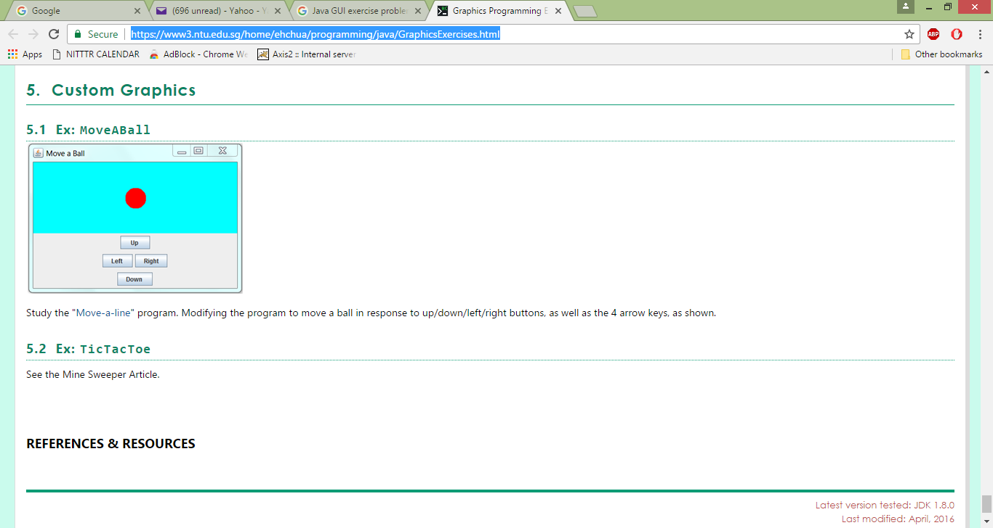

<https://www3.ntu.edu.sg/home/ehchua/programming/java/GraphicsExercises.html>

1. Write the problem statement 2 by creating 2 threads. One thread will run the application and other thread will play music in the background.
2. Producer Consumer Problem using GUI
3. BookBank GUI program. It should have menu bar having Books, Authors, Help and About Us as menus. Books and Authors menu contains relevant menu items for CRUD (Create(add), Read(display), Update, Delete) operations.
4. Create 2 threads. One thread will move the circle in the container i.e. Frame/JFrame infinitely and other thread will play music.

http://www.w3resource.com/java-exercises/conditional-statement/index.php