# Task 1

## Create a vpc not by wizard this time but manually, having 2 public subnets and 2 private subnets and 2 protected subnets.

* Choose Services
* Click on create VPC  
  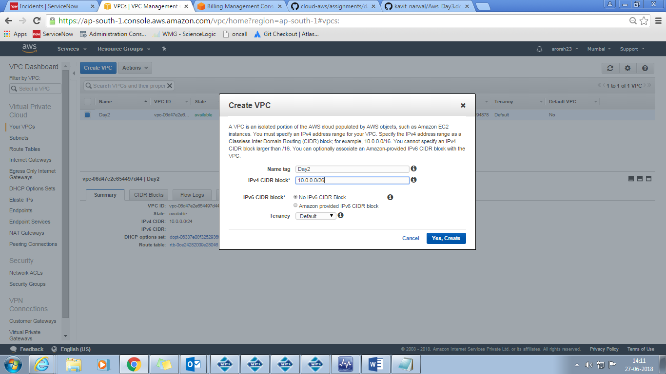
* VPC created
* Click on Subnet, then choose create Subnet

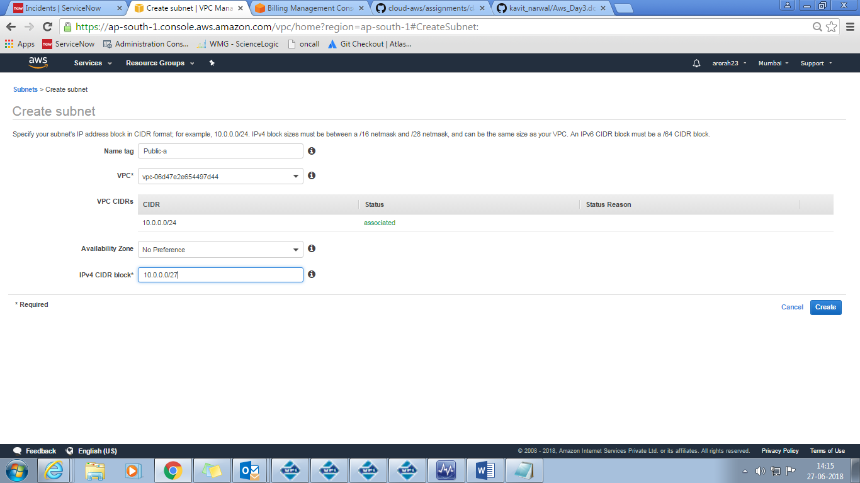

* Similarly create 5 remaining subnets.

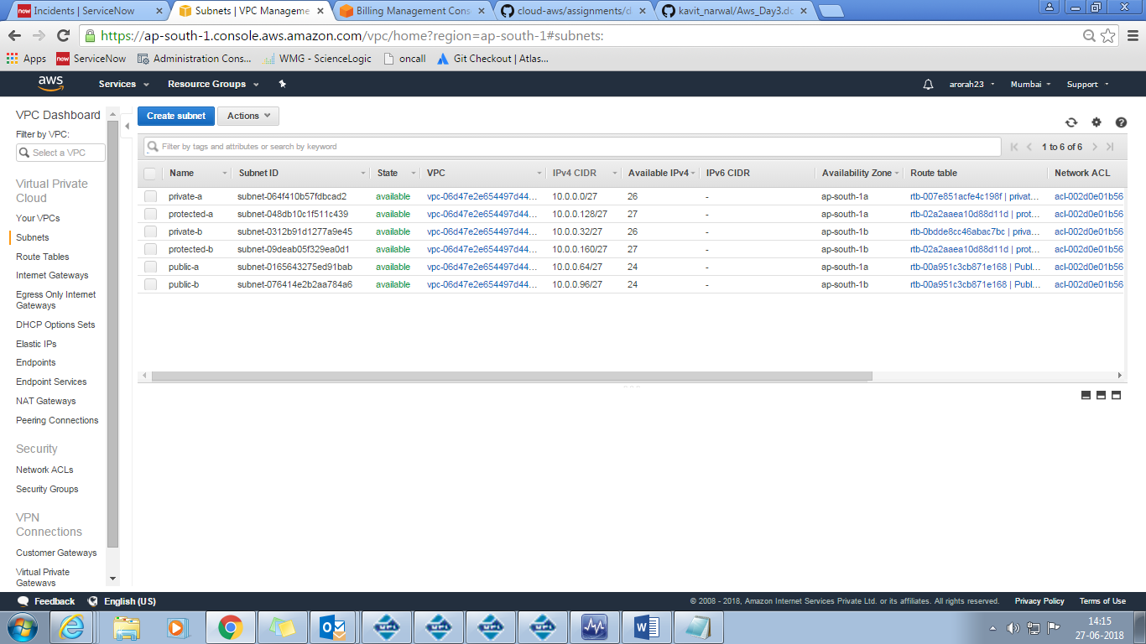

#Creating IGW and NGW

* Choose Internet gateway

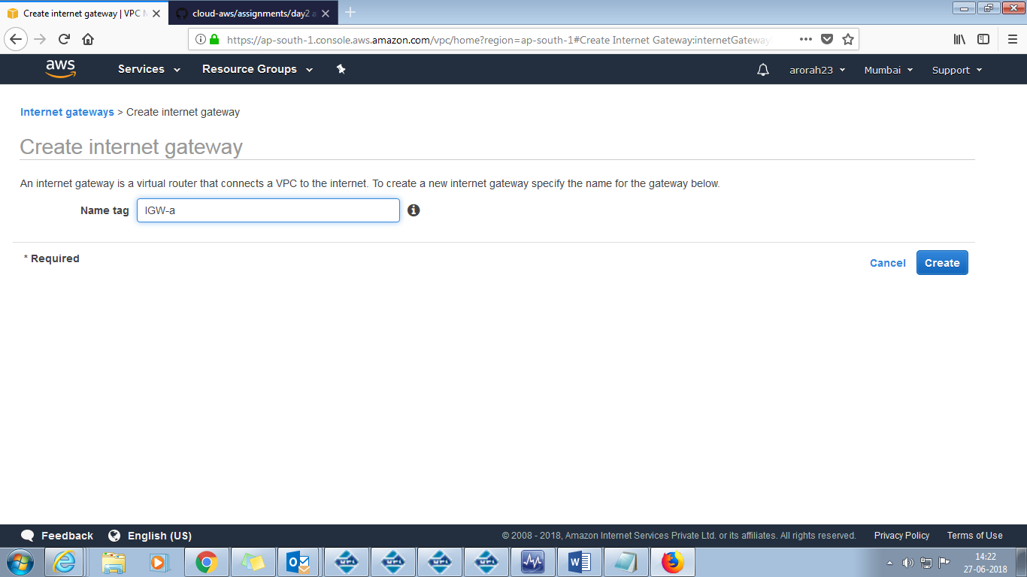

Created

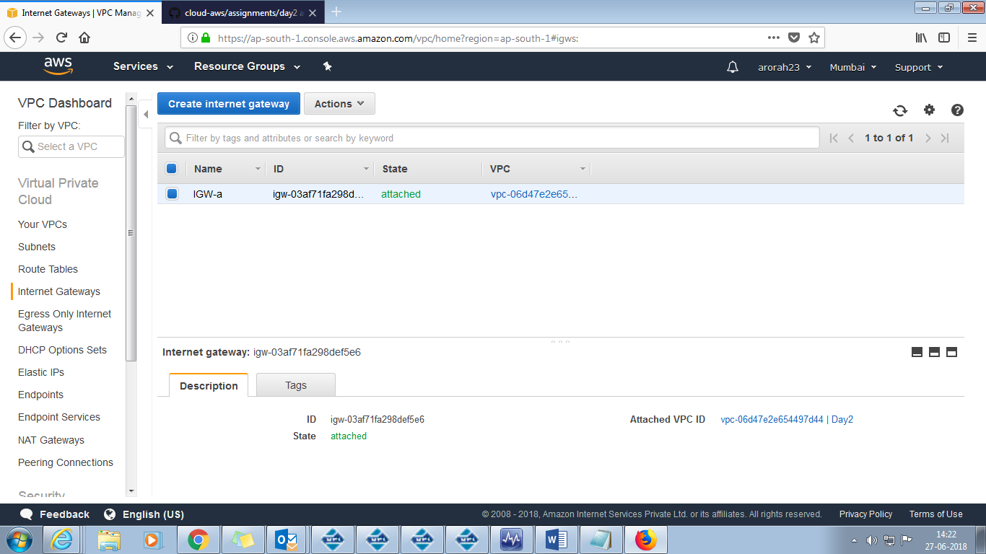

#Creating Nat gateways

* Click on NAT gateways
* Create NAT gateway
* Choose Subnet (make sure Nat is assigned to Public subnet)
* Assign Elastic IP

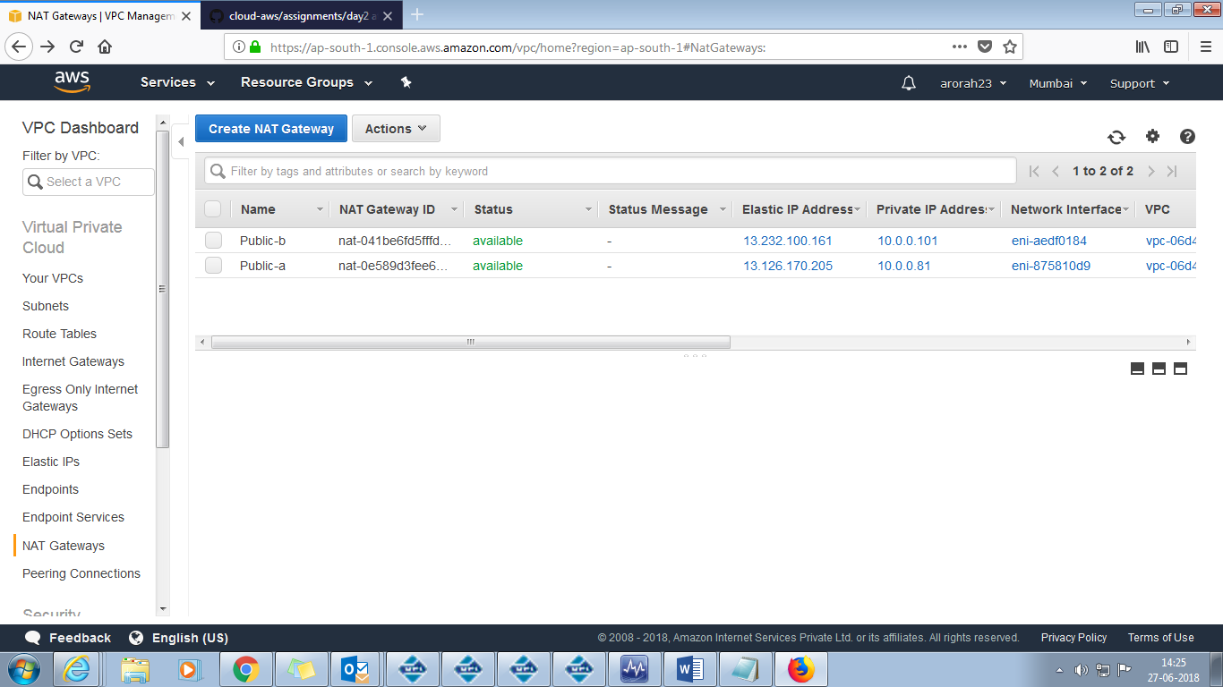

#Creating Route Table

* Click on Route tables
* Click on Create Route table

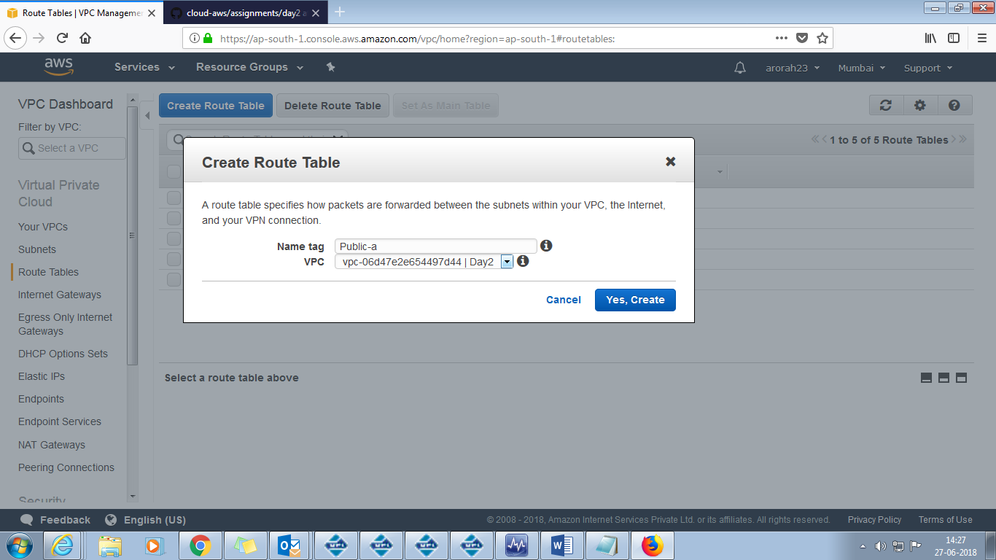

Create all required Route tables

* In Private Route Tables create a route to NAT and add Private subnet
* In Public Route Tables create a route to IGW and add Public Subnets

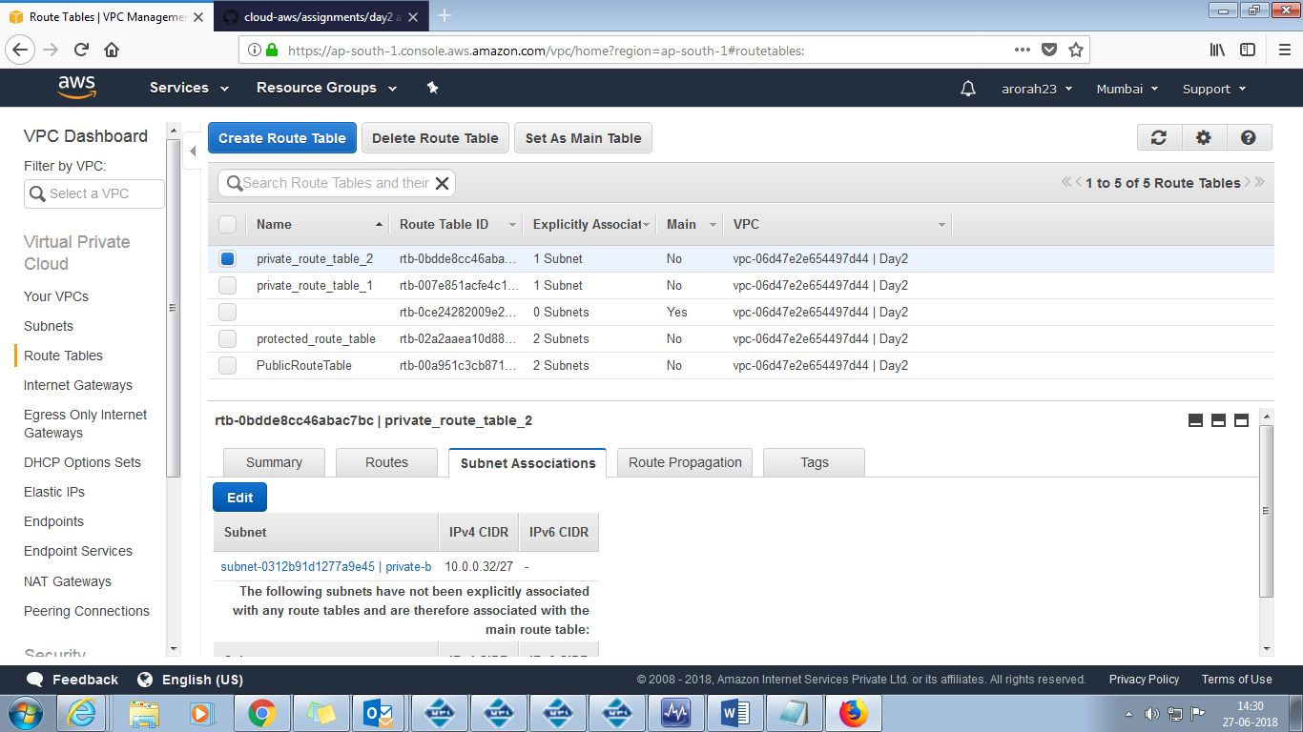

setup should be highly available

Task 2

Make LAMP setup with 2 instances in each private subnets.

Server-1 should serve a webpage that would say "Hi! i am server 1"

Server-2 should serve a webpage that would say "Hi! i am server 2"

For a LAMP instance create a public instance through which we can access Private Instance and Setup LAMP

For LAMP server follow below steps

* sudo apt-get install python-software-properties
* sudo add-apt-repository ppa:ondrej/php

#Update the repositories

* sudo apt-get update
* #Apache, Php, MySQL and required packages installation
* sudo apt-get -y install apache2 php7.0 libapache2-mod-php7.0 php7.0-mcrypt php7.0-curl php7.0-mysql php7.0-gd php7.0-cli php7.0-dev mysql-client
* php7.0enmod mcrypt
* #The following commands set the MySQL root password to MYPASSWORD123 when you install the mysql-server package.
* sudo debconf-set-selections <<< 'mysql-server mysql-server/root_password password MYPASSWORD123'
* sudo debconf-set-selections <<< 'mysql-server mysql-server/root_password_again password MYPASSWORD123'
* sudo apt-get -y install mysql-server

#Restart all the installed services to verify that everything is installed properly

* echo -e "\n"
* service apache2 restart && service mysql restart > /dev/null
* echo -e "\n"

Task 3

Launch a public load balancer that would forward the requests to these 2 LAMP instances

