Create a test repo in your github account, write some demo commits.........Done

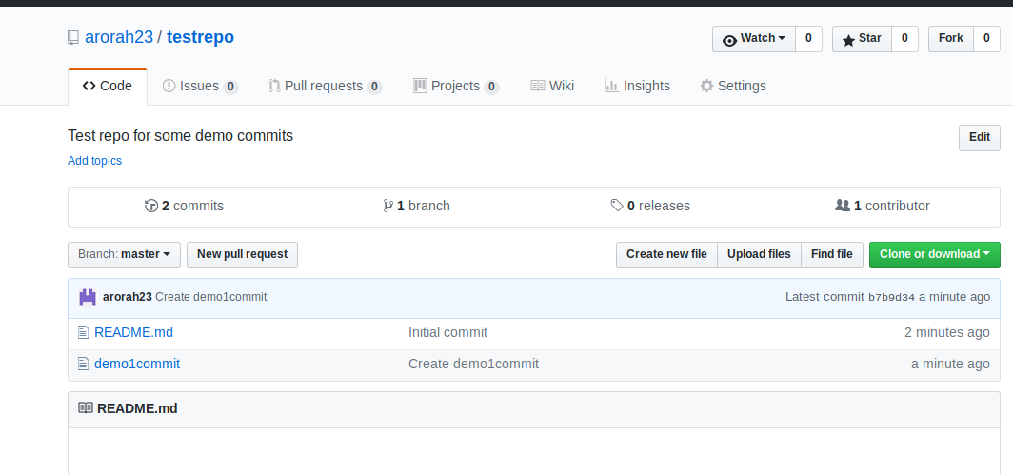

Add Testrepo as submodule

https://git-scm.com/book/en/v2/Git-Tools-Submodules

Submodules
Git has a solution to add another repo as a subdirectory in any repo.

COMMAND

$git submodule add “Path”

By default, submodules will add the subproject into a directory named the same as the repository, in this case “DbConnector”. You can add a different path at the end of the command if you want it to go elsewhere.
If you run git status at this point, you’ll notice a few things.
$ git status
On branch master
Your branch is up-to-date with 'origin/master'.

Changes to be committed:
(use "git reset HEAD <file>..." to unstage)

new file: .gitmodules
new file: DbConnector
First you should notice the new .gitmodules file. This is a configuration file that stores the mapping between the project’s URL and the local subdirectory you’ve pulled it into:
[submodule "DbConnector"]
path = DbConnector
url = https://github.com/chaconinc/DbConnector

$ Git Commit

once you commit git will create mode 1600 for testrepo
that is a special mode in Git that basically means you’re recording a commit as a directory entry rather than a subdirectory or a file.
$ Git Push origin master
=======================================================================

Cloning a Project with Submodules

When you clone a project with subdirectory, by default you get the directories that contain submodules, but none of the files within them yet:

We must run two commands

1. git submodule init
2. git submodule update

