Gitolite

Use case

Gitolite is useful in any server that is going to host multiple git repositories, each with many developers, where "anyone can do anything to any repo" is not a good idea.

Follow http://gitolite.com/gitolite/overview/ for more details

how does it work?
At a very high level, gitolite relies on sshd (or httpd if you're using the smart http mode) to authenticate the user and supply the username. Based on this, and the command given, it decides whether to allow or deny the request.
Consider a push command in ssh mode. Normally (i.e., without gitolite) this would invoke git-receive-pack on the server, and the flow would be somewhat like this (left side is client, right side is server):
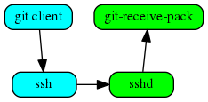

When you install gitolite and setup the user, gitolite sets up ssh to force the gitolite-shell command to run first, instead of the command requested:
The gitolite-shell program uses the username supplied by ssh, and the repo name in the command, to decide if the user has write access to the repo or not.
If he does have some write access, git-receive-pack is called, but that's not the end of the story. The branch/tag/file(s) he is pushing also need to be checked, and gitolite sets up the update hook on the repo to do that.
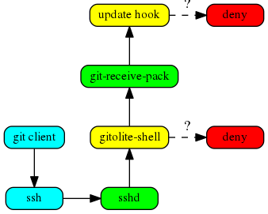

SSH key generated

Your identification has been saved in /root/.ssh/id_rsa.
Your public key has been saved in /root/.ssh/id_rsa.pub.
The key fingerprint is:
SHA256:z3AWs1kt3FVR9KDSXVlF09b8stBCJEVsZMRsEIbX+I0 root@bahubali
The key's randomart image is:
+---[RSA 2048]----+
| .=#B .*^|
| ..o=O= =B|
| .+=*++.o|
| BE.+ .|
| S = o o |
| * . |
| o |
| |
| |
+----[SHA256]-----+

Install

openssh-server on host and remote machine else you will get error connection refused

Step 1(no need if recently updated)

sudo yum -y update

Step 2.

Add user Git and set password

adduser git

passwd git

Install dependencies
sudo yum -y install autoconf git

Get Gitolite
su – git

Now switch to remote machine

cd ~

mkdir ~/bin

git clone git://github.com/sitaramc/gitolite

Install Gitolite

gitolite/install -ln ~/bin

ls ~/bin
gitolite must be there

SWITCH to local machine

SSH Key Generation
ssh-keygen

Transferring our Public Key
cp .ssh/id_rsa.pub himanshu.pub

scp himanshu.pub git@localhost:/home/git

scp -P 2222 jeramy.pub git@localhost:/home/git

On remote machine

Refresh Bash and Finish Setup

source .bash_profile
gitolite setup -pk himanshu.pub

TESTING

git clone git@localhost:gitolite-admin

Vagrantfile
Removing VirtualBox VMs/
Removing a.sh
Skipping repository assignment3/
Removing export/
Skipping repository firstrepo/
Removing fp.txt
Removing himanshu.pub
Removing nestedfor.sh
Removing nestedtest.sh
Removing nestedtest2.sh
Skipping repository prashant/
Removing repair.sh
Skipping repository subpart/
Removing vagrant/
Skipping repository vagrant2/centos7/repo/dtask
Skipping repository vagrant2/centos7/gitolite-admin
Removing vagrant2/centos7/Vagrantfile
Removing vagrant2/centos7/himanshu.pub
Removing vagrant2/centos7/centos-7-x86_64.box
Removing vagrant2/centos7/apache-tomcat-8.5.31
Removing vagrant2/centos7/apache-tomcat-8.5.31.tar.gz
Removing vagrant2/centos7/.vagrant
Removing vagrant2/apache-tomcat-8.5.31
Removing vagrant2/apache-tomcat-8.5.31.tar.gz

