User Manual & Feature Guide
Welcome to the Universal AI Autofill Assistant User Manual. Follow this guide to set up your profiles, scan documents, backup data, and automate form-filling securely across your favorite apps and web browsers.
____________________________________________________
🏁 1. Initial Setup & Security Onboarding
First-Time Wizard
When you launch the app for the first time, you are guided through a multi-step introduction detailing the application's offline capabilities. You will immediately configure your default profile:
- Onboarding Details: Fill in your basic information: Name, Country, State, Gender, and Date of Birth.
- "My Info" Generation: This creates your primary "My Info" profile. It has a special pinned status on your dashboard with a unique gradient border.
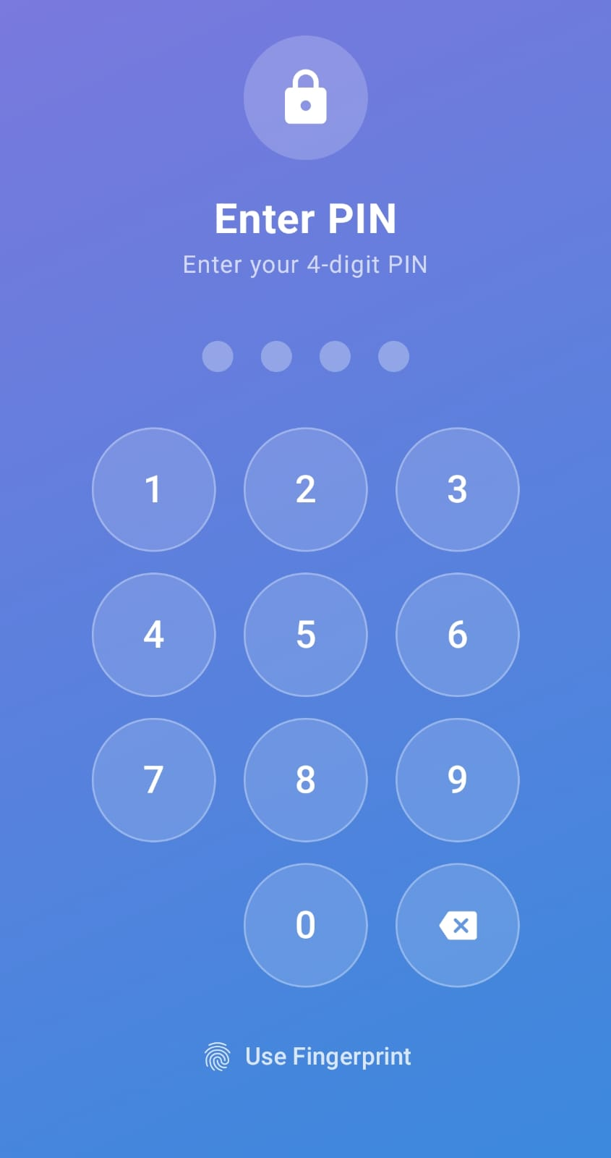
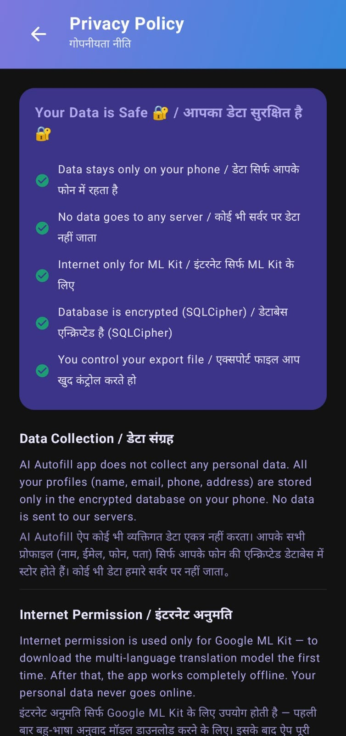
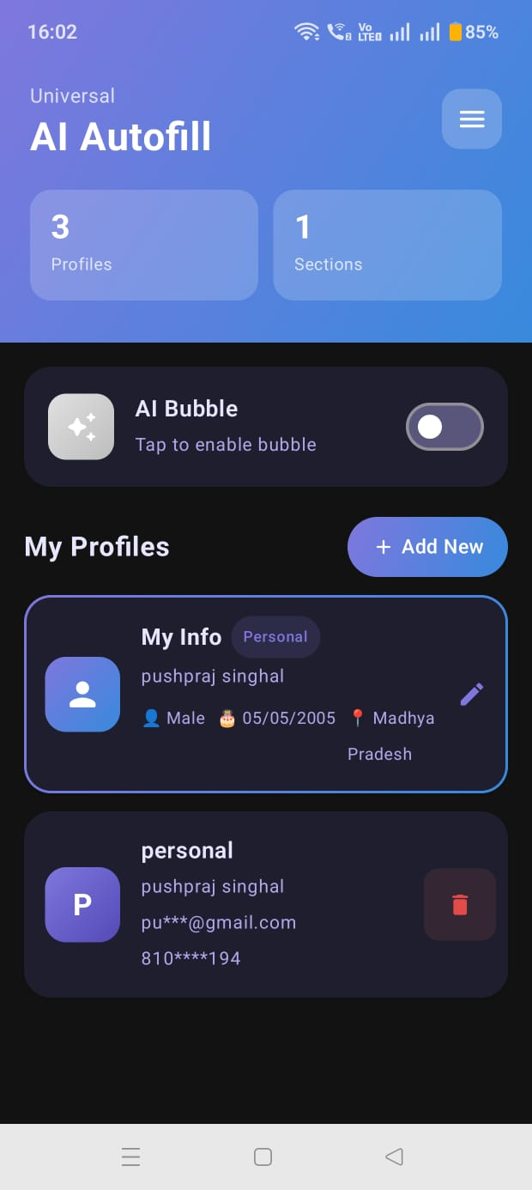
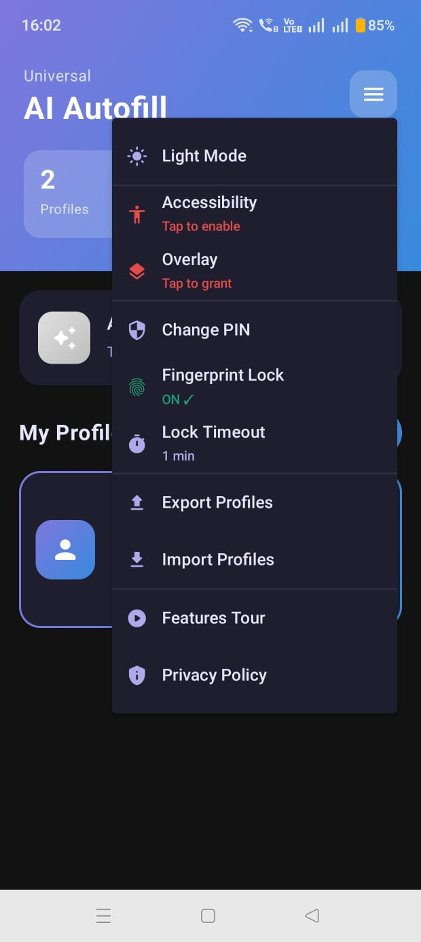
Figure 1: Onboarding Flow and Basic Setup Screen Sequences
Security Configurations
Because your profile stores sensitive data, you must establish a lock screen:
- 4-Digit PIN: Set and confirm a PIN. This is stored in AES-256 encrypted storage.
- Biometric Toggle: Go to the hamburger menu ➔ enable Fingerprint Lock. Once enabled, you can bypass the PIN keypad using your fingerprint.
- Lock Timeout: Set how quickly the app should lock itself when in the background (options: *Instant*, *1 min*, *5 min*, *15 min*, *30 min*).
____________________________________________________
🗂️ 2. Profile Customization
Profiles allow you to organize data for different contexts. You can maintain separate cards for "Academic Applications", "Professional Job Registrations", or "E-Commerce Shipping".
Creating a Profile
- On the main dashboard, tap the "Add New" button.
- Set a profile name and input your name, email, phone, and address.
- Tap Save.
Adding Custom Fields & Custom Sections
For details that do not fit in the standard fields:
- Tap a profile card ➔ select Edit Profile (or click the edit pencil icon).
- Tap Add Custom Field to create a simple key-value row (e.g. linkedinUrl ➔ linkedin.com/in/user).
- Tap Add Section to create a grouped block of fields (e.g. creating an "Academic Record" group containing fields for Roll Number, GPA, and Major).
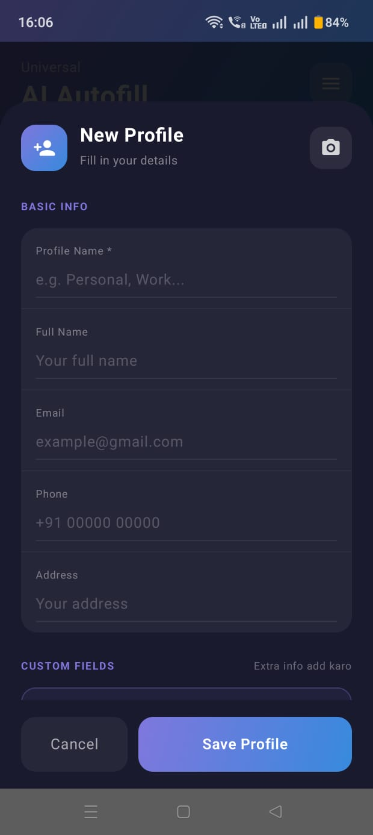
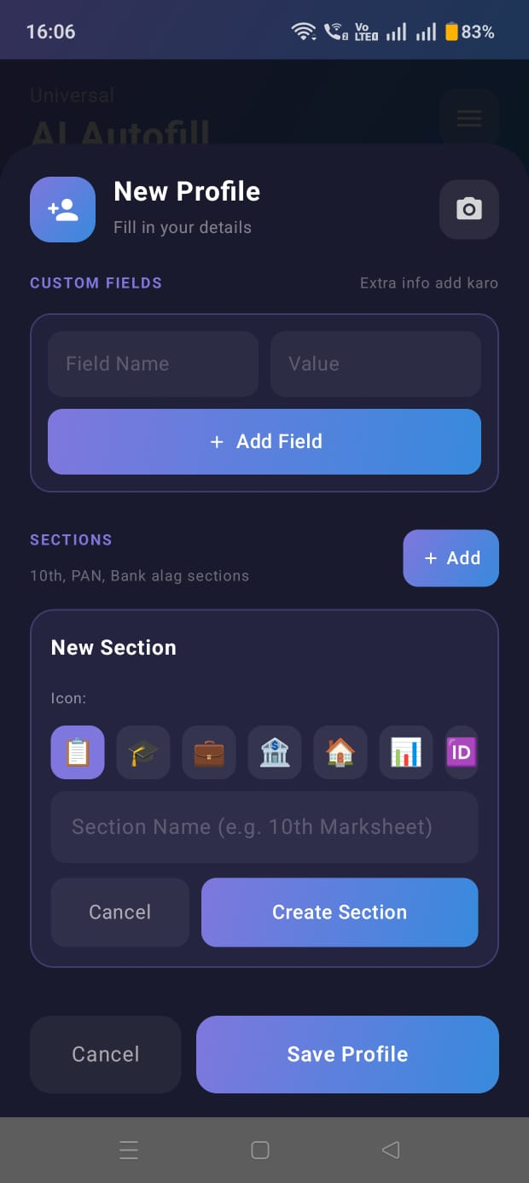
Figure 2: Profile Dashboard Interface and Custom Section Fields Editor
____________________________________________________
📷 3. Camera Document Scanner (OCR)
To skip typing long numbers or transcript lists, use the built-in scanner:
- Open the profile you want to edit and tap Edit Profile.
- Tap the Camera button in the header.
- Center your physical document (e.g., Driver's License, Tax Card, Passport, or Marksheet transcript) inside the camera frame.
- Tap the Capture shutter.
- The offline ML Kit OCR engine will detect the text:
- If standard ID Card: Automatically creates section labels and values for Name, ID numbers, and DOB.
- If Marksheet: Scans rows, subjects, and grades, compiling them into a tabular list.
- A verification card will display the parsed data. Adjust any text box values if the scan had minor OCR errors, and select "Use Data" to import the new section into your profile.
____________________________________________________
💬 4. Smart Overlay & Form Filling
The floating bubble interface allows you to automate form-filling:
Activating the Overlay
- Navigate to the app drawer and turn on AI Bubble.
- Or, swipe down your quick settings panel and click the AI Fill tile.
- A floating bubble view will overlay your screen.
Executing Autofill
- Open any third-party app or web browser showing a form.
- Click on the first form input field to focus it.
- Tap the Floating Bubble.
- The service will traverse the layout tree, translate the labels if the form is in a regional language, match inputs against your profile, and fill the fields.
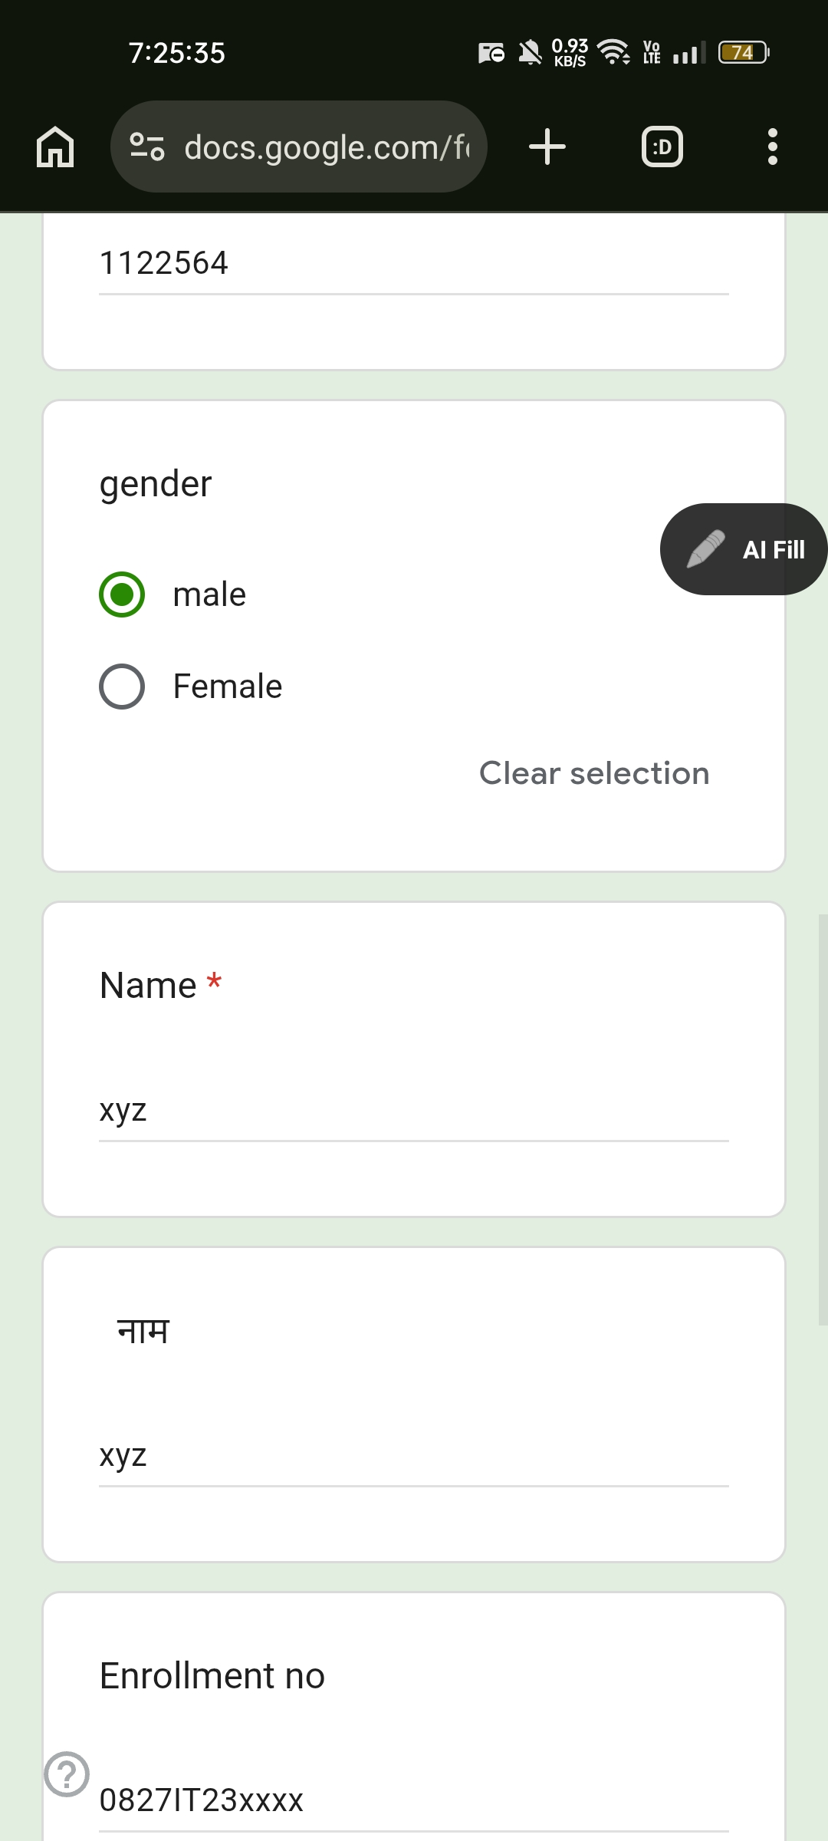
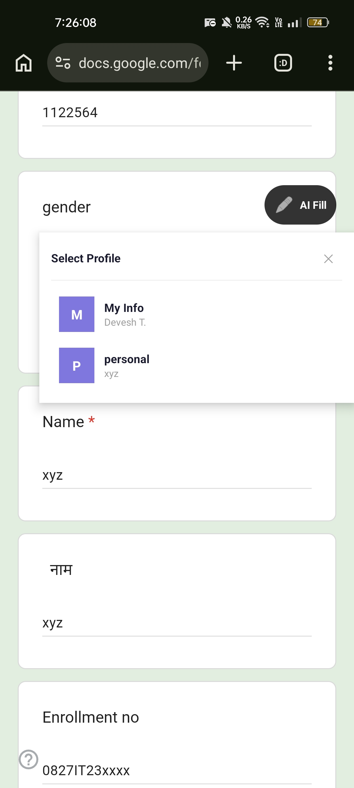
Figure 3: Form Filling Overlay Trigger and Profile Selection Popup Dialog
Switching Profiles on the Fly
- Long-press the floating bubble to open the Profile Selector. A popup will list all your profiles. Tap a profile to switch context and fill the form using that profile's details.
____________________________________________________
🛡️ 5. Built-in Security Controls
Restricted Application Safety (Payment App Guard)
To protect your privacy and prevent malicious overlays or accidental submissions in sensitive fields:
- Automatic Deactivation: The Autofill service automatically monitors active application package names.
- Blocklist Guard: Autofill inputs and popup overlays are automatically blocked on secure applications. This includes:
- Messaging Tools: SMS, MMS, WhatsApp, Telegram, Signal.
- Social Media: Instagram, Snapchat, Facebook, Twitter/X.
- System Tools: Calculator, Gallery, Camera.
- Payment & Banking Apps: Google Pay, PhonePe, Paytm, and secure bank apps. If one of these packages is active, the autofill triggers will bypass execution to keep your credentials safe.
Automatic Clipboard Purge
When copying profile fields manually to your clipboard, a system receiver (CopyReceiver.kt) runs a 30-second countdown in the background. After 30 seconds, your system clipboard is cleared automatically to prevent other applications from reading cached credentials.
____________________________________________________
⚡ 6. Notification Panel Quick Copy (`QuickCopyService`)
If you prefer not to use the floating overlay bubble, you can copy profile details using the Quick Copy service:
- Enable the Quick Copy service in the settings menu.
- A persistent notification will appear in your notification shade showing: "Smart Autofill Active: [Profile Name]".
- The notification features three quick-action buttons: "Name", "Phone", and "Email".
- Tap any of the buttons to copy the corresponding value to your clipboard.
- You can paste the copied value into any input box. The 30-second auto-clear timer will protect the copied text.
____________________________________________________
⌨️ 7. Dynamic Text Expansion Shortcuts
For inline expansions, type a shortcut word in any input field:
- Standard Shortcuts: name- (full name), email- (email address), mob- (phone number), addr- (address).
- Custom Field Shortcuts: Type the lowercase custom label with spaces removed followed by a hyphen (e.g. githuburl- or gpa-).
- Triggering: Tap the floating bubble, and the shortcut text will be replaced with your profile value. You can use multiple shortcuts on a single page to fill several fields simultaneously.
____________________________________________________
💾 8. Local Backup & Restore (Import / Export)
To save your configurations or move them to a new device:
- Export Profiles: Open the settings drawer and tap "Export Profiles". The app compiles your configurations into a JSON file (profiles_export.json) and saves it to your device's Downloads directory.
- Import Profiles: Tap "Import Profiles" in the drawer. A system file picker will open. Select your backed-up JSON file to restore your profiles.

