AI-NATIVE SOFTWARE ENGINEERING AND DEVELOPMENT ENVIRONMENT

PROJECT REPORT FOR THE COURSE AD23731 FOUNDATIONS OF AGENTIC AI
Submitted by

ADHARSH S. (Reg. No. 231501006)
MAHESH KUMAR J.R (Reg. No. 231501092)
DEVESH D. (Reg. No. 231501034)

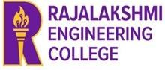

DEPARTMENT OF
ARTIFICIAL INTELLIGENCE AND MACHINE LEARNING RAJALAKSHMI ENGINEERING COLLEGE THANDALAM, CHENNAI, 602105



BONAFIDE CERTIFICATE

Certified that this is a Bonafide Record of the project work done by Adharsh S. (231501006), Devesh D. (231501034) and Mahesh Kumar J R. (231501092) of VII Semester, B.Tech. Artificial Intelligence and Machine Learning Department in partial fulfilment of the requirements of the course AD23731 – Foundations of Agentic AI during the Academic Year 2026 – 2027.

Faculty in charge

Submitted for the Project Review held on: ………………………

INTERNAL EXAMINER EXTERNAL EXAMINER

S. NO. | TITLE | PAGE NO.
1. | Introduction | 1
2. | Problem Statement and Business case | 2
3. | User and Stakeholder Analysis | 4
4. | Proposed Agentic AI Solution | 5
5. | Dataset and Knowledge Sources | 6
6. | Tools and Technologies Used | 6
7. | Agent Architecture | 7
8. | Agent Workflow and Orchestration | 9
9. | Agentic RAG Implementation | 11
10. | System Implementation | 13
11. | Experimental Evaluation and Results | 17
12. | Comparison, Innovation and Scalability | 18
13. | Conclusion and Future Work | 19

INTRODUCTION

BACKGROUND AND MOTIVATION
Software development is a multi-step activity: a request must be understood, broken into work items, implemented, tested, debugged, and reviewed before it can be trusted. A developer who begins a new task is quickly faced with repetitive and knowledge-intensive debugging cycles, particularly for complex faults like concurrency race conditions. This process involves the developer defining the problem, running tests, reading stack traces, looking up past fixes, and verifying results. Recent advances in Large Language Models (LLMs) make it tempting to hand this entire task to an AI coding assistant. In practice, a single LLM call is unreliable for software engineering because it produces code in a single pass; it does not run the code, observe real failures, or remember how a similar defect was fixed previously. AegisDev is motivated by the need for a system that keeps the generative speed of an LLM while binding every proposed fix to real test execution, retrieved project knowledge, and human oversight.

NEED FOR AGENTIC AI
Conventional AI coding assistants generate code in a single prompt-and-response pass; the execution, failure diagnosis, and regression testing are left entirely to the human developer. Basic Retrieval-Augmented Generation (RAG) improves code generation by retrieving external context, but a single-agent RAG pipeline is essentially a fixed retrieve-then-generate step. It cannot observe real-time runtime failures, decide whether a concurrency trace requires database documentation or past fix memory, execute diagnostic scripts in an isolated environment, or iteratively refine a patch based on test feedback. Software engineering is inherently a multi-stage, decision-driven workflow. Agentic AI fits this nature because it allows the full lifecycle to be split among specialized agents, each with a bounded responsibility, and allows the system to loop: when a test fails, it diagnoses the trace and retrieves targeted fix patterns; when a patch introduces regressions, it routes back to development for correction; when the repair budget is exhausted, it escalates to the human reviewer. These behaviours — planning, tool use, reflection, self-correction, and human oversight — are exactly what agentic architectures provide.

PROJECT OBJECTIVES
The primary objective is to develop a multi-agent AI system that can autonomously perform the major stages of the software development life cycle (SDLC) while maintaining full traceability and accountability to a human reviewer. The specific objectives are:
    - To decompose a natural-language client brief into a structured work-breakdown and sprint plan.
    - To execute generated code and real test suites inside an isolated Docker sandbox using Model Context Protocol (MCP) servers.
    - To retrieve and rank the most relevant past fixes and technical documentation using an Agentic RAG strategy.
    - To extract structured diagnostic information from stack traces and logs to propose reviewable patches.
    - To generate an evidence-backed release package and validate every phase through six human-in-the-loop approval gates.
    - To evaluate the system quantitatively against no-retrieval and fixed-RAG baselines across different LLMs.

PROBLEM STATEMENT AND BUSINESS CASE

PROBLEM DEFINITION
Small and medium-sized software teams spend a disproportionate amount of engineering time on the test–diagnose–fix cycle under tight delivery pressures. The process is time-consuming, repetitive, and difficult to scale; it is prone to recurring errors, hard to debug for concurrency faults, and, when existing AI coding tools are used, vulnerable to unverified code suggestions. Existing tools address only the code-generation fragment of the workflow and provide no structured audit trail. The problem addressed by this project is therefore stated as follows:
“How can a supervised team of AI agents take a software task through planning, implementation, real test execution, retrieval-grounded debugging, and review, while remaining bounded, traceable, and accountable to a human reviewer?”

LIMITATIONS OF EXISTING APPROACHES
Current commercial AI coding assistants and development tools address only isolated fragments
of the software development lifecycle, primarily focusing on single-pass code generation. These existing approaches suffer from several fundamental limitations when applied to real-world software engineering and debugging tasks:
- Lack of Real Test Verification: Traditional assistants generate code snippets but fail to execute them against a real test suite or observe actual runtime failure stack traces.
- Absence of Contextual Retrieval: They do not retrieve project-specific past fixes, historical bug signatures, or targeted technical documentation, causing them to repeatedly make the same class of errors.
- Unbounded and Unsupervised Execution: They operate in open-ended loops without structured governance, checkpointing, or bounded iteration limits, making it difficult to control runaway agent behavior.
- No Audit Trail or Governance: They provide no structured human approval gates, version history, or verifiable audit trails for AI-authored changes before code is merged into production.
These shortcomings demonstrate that conventional tools fail to close the test–diagnose–fix loop reliably, leaving developers entirely responsible for manual testing, diagnosis, and verification

BUSINESS AND REAL-WORLD CONTEXT
The reference business scenario is a small retail or distribution company (represented in the demonstration by the sample organisation NexaSoft Technologies) that needs an Inventory Management System to replace manual stock tracking and spreadsheets. The application manages products and categories, stock quantities and movements, suppliers, purchase orders, low-stock alerts, a dashboard, and basic reports.

This domain was chosen because inventory software contains classic, well-understood defect classes – most notably concurrent stock reservation, where two simultaneous orders read the same quantity and both decrement it, producing an incorrect balance. This makes it a realistic and reproducible target for testing an automated debugging team: the failure is detectable by a real test, the cause is diagnosable from a stack trace, and the remedy (pessimistic row-level locking with SELECT ... FOR UPDATE) is a documented engineering pattern that can be stored in and retrieved from memory.

USER AND STAKEHOLDER ANALYSIS

TARGET USERS
AegisDev is intended for members of small and medium software development teams, software consultancies, and internal engineering groups with limited project-coordination capacity. The primary user is a project manager, software developer, QA engineer, or tech lead who begins with a natural-language client brief and needs a fully tested, reviewable, and release-ready software solution quickly.

STAKEHOLDER IDENTIFICATION

Beyond the primary development team, AegisDev interacts with and impacts several key project stakeholders across technical and administrative functions:
- Client / Business Owner: Requires working, production-ready software that meets the specified functional requirements with full delivery visibility.
- Engineering Manager / Administrator: Responsible for system access control, role allocation, resource utilization, and overall developer workload governance.
- AI System Administrator: Configures underlying LLM providers, manages vector database collections, updates evaluation benchmarks, and monitors token costs and runtime errors.
- Maintenance / Support Engineer: Relies on persisted fix histories, architectural decisions, and diagnostic records when similar recurring defects arise in maintenance cycles.
- Course Faculty / Evaluators: Expects demonstrable agentic workflows, sound empirical evaluation across baseline configurations, and comprehensive project documentation

USER REQUIREMENTS
    - Functional requirements:
    - Submit a software task or project brief in natural language and inspect the generated project plan and subtasks.
    - Display real test execution outputs and logs rather than model-asserted or fabricated results.
    - Review each proposed bug fix as a diff with an attached rationale, with options to approve, reject, or request changes.
    - Inspect the specific retrieved past-fix patterns and technical documentation chunks that grounded a proposed patch.
    - Escalate automatically to a human reviewer when the bounded repair budget (three iterations) is reached.
    - Export the complete release package, including source code, test reports, debug traces, execution logs, and documentation.
    - Non-functional requirements:
    - Traceability — Every requirement must map directly to its corresponding design, code modification, test case, and release artifact.
    - Reliability & Statefulness — The workflow must checkpoint intermediate graph states to enable resuming runs after human interrupts or failures.
    - Security & Isolation — All generated code, scripts, and test suites must execute in an isolated Docker sandbox with resource quotas and no host network access.
    - Configurability — The platform must allow seamless configuration and switching across underlying LLM providers and tier

PROPOSED AGENTIC AI SOLUTION

OVERALL SOLUTION
AegisDev treats software development as a multi-stage workflow rather than a single code-generation task. The user submits a natural-language client brief; a Requirements Agent analyzes the brief and generates an SRS with acceptance criteria; a Planning Agent breaks the scope into ordered tasks and estimates effort; a Design Agent proposes system architecture, schemas, and API contracts; a Development Agent implements the source code; a QA Agent executes the real test suite; on test failure, a Debugging Agent analyzes the stack trace, retrieves relevant past-fix patterns or technical documentation, and proposes a fix that routes back to Development; on test success, a Documentation Agent produces user and API guides; and a Release Agent prepares the deployment build and checklist before the final package is released. If tests fail or evidence is required, the workflow loops back through bounded self-correction instead of proceeding with defective code.

KEY FEATURES
    - Full-lifecycle coverage — Eight specialized agents automate the entire SDLC from requirements analysis to release preparation.
    - Isolated tool execution — Model Context Protocol (MCP) servers run tests, linters, and Git operations inside a sandboxed Docker container.
    - Agent-driven retrieval (Agentic RAG) — The Debugging Agent dynamically decides whether to query fix memory, consult technical documentation, or bypass retrieval entirely.
    - Bounded self-correction — A repair loop around development, QA, and debugging is strictly capped at three iterations before escalating.
    - Human-in-the-loop checkpoints — Six approval gates ensure human validation for requirements, project plans, architecture, code reviews, test acceptance, and releases.
    - End-to-end traceability — Every generated artifact and patch is linked from requirements through code, tests, and audit logs.
    - Three-layer memory architecture — Working graph state, long-term semantic Chroma vector storage, and persistent structured relational logs operate concurrently.

DATASET AND KNOWLEDGE SOURCES
AegisDev does not train an underlying language model; instead, its operational dataset comprises indexed technical knowledge for retrieval alongside an empirical benchmark dataset of seeded software defects. The system indexes multiple knowledge sources within Chroma vector collections, segmented into verified past-fix memory, technical documentation (covering Python, PyTest, SQLAlchemy, and database transaction isolation), target repository documentation, coding standards, and client requirements. Documents are chunked with overlap, tagged with metadata, and strictly updated with new fixes only after they pass all tests and receive human sign-off, preventing hallucinated or unverified patches from contaminating future retrieval. For experimental evaluation, the platform uses a benchmark suite of seeded defects injected into an Inventory Management System, spanning concurrency race conditions, boundary arithmetic errors, missing input validations, state-transition faults, and ORM library misuse. Each defect is paired with an executable failing test and labeled knowledge chunks to rigorously assess retrieval precision and repair capability.

TOOLS AND TECHNOLOGIES USED
AegisDev is implemented across a six-layer architecture spanning front-end presentation, API and state orchestration, specialized LLM agents, an Agentic RAG pipeline, a human-in-the-loop review interface, and persistent data storage. The user interface is developed using React, TypeScript, and Tailwind CSS, backed by a Python FastAPI server handling authentication, RBAC, and workflow state. The multi-agent workflow is orchestrated via LangGraph and LangChain, enabling stateful execution, conditional routing, and human-in-the-loop checkpoints across dual configurable LLM tiers. Agents interact with their environment via Model Context Protocol (MCP) servers for isolated code execution and Git operations, running inside Docker sandbox containers with resource quotas, non-root execution, and no host network access. Vector search and selective knowledge retrieval are managed using ChromaDB over segmented collections, while PostgreSQL and SQLite persist project artifacts, test results, and auditable decision logs for the target FastAPI and SQLAlchemy Inventory Management System.

AGENT ARCHITECTURE

AGENT COMPONENTS

AegisDev assigns one specialized agent to each of the eight SDLC stages—Requirements, Planning, Design, Development, QA, Debugging, Documentation, and Release—ensuring that every phase has a clear owner, a defined output artifact, and a strictly bounded toolset. Each agent is defined by a dedicated system prompt establishing its role, an explicit input/output contract within the shared state, a restricted tool list, and precise instructions governing stopping conditions or hand-offs. Under the principle of least privilege, the QA Agent can execute test suites but cannot modify code, the Debugging Agent can retrieve knowledge and formulate reviewable patches but cannot merge them, and only the Development Agent modifies workspace files following human approval. Furthermore, all agent outputs undergo schema validation before the shared graph state updates, ensuring that malformed responses cannot propagate to subsequent stages, while shared utility modules provide centralized control, audit logging, and RAG knowledge access across the entire team

TOOLS
Agents act on the outside world only through tools, which keeps their behaviour auditable and secure. Tools are exposed through two Model Context Protocol (MCP) servers communicating over JSON-RPC on STDIO. The Code Execution server provides functions such as run_tests(), run_python(), run_linter(), and read_test_output(), used by the Development, QA, Debugging, and Release Agents. The Git and Workspace server provides read_file(), write_file(), list_files(), get_diff(), and create_commit(), accessible to the Development, Design, Debugging, Documentation, and Release Agents according to their role. The Debugging Agent additionally uses a retriever tool over the vector store to query fix memory and technical documentation. All execution occurs inside an isolated Docker sandbox container with resource quotas, non-root execution, and no host network access, ensuring generated code is never run directly on the host machine.

MEMORY
AegisDev employs a three-layer memory architecture to maintain context, project knowledge, and complete traceability across runs. Short-term (working) memory is maintained in the LangGraph state with a checkpointer, capturing the active client brief, SRS, sprint plan, source code, real test results, stack traces, repair iteration counters, and retrieved context for a single run. Long-term (semantic) memory is indexed in a Chroma vector store across dedicated collections containing verified past fixes, technical documentation, repository documents, and engineering standards to assist future retrieval. Finally, structured logs (episodic record) are stored in PostgreSQL (using SQLite for the local prototype) to persist requirements, tasks, system designs, code revisions, test logs, human approvals, releases, and immutable audit trails across the system's operational lifetime

REASONING FLOW
Reasoning follows an analyze–plan–execute–observe–reflect pattern. The Requirements and Planning agents analyze needs and establish tasks; the Design and Development agents implement the architecture and source code; the QA Agent executes real tests to observe actual outcomes; and the Debugging Agent diagnoses stack traces, decides whether to retrieve external knowledge, and formulates patches. A test outcome and bounded iteration check (capped at three attempts) determines whether the system proceeds to documentation and release, loops back to development for self-correction, or escalates to a human reviewer.

AGENT INTERACTIONS
Agents interact indirectly through a single shared, typed graph state rather than free-form conversational chat. Each agent reads only the fields required for its task and writes exclusively to its assigned output schema, ensuring that responsibilities remain strictly decoupled and verifiable. The LangGraph orchestrator inspects state updates and evaluates conditional edges to route execution or trigger human-in-the-loop interrupts, avoiding conversational drift and keeping token consumption bounded and predictable.

AGENT WORKFLOW AND ORCHESTRATION

WORKFLOW DESIGN
The workflow, shown in Figure 2, begins with the Requirements Agent and progresses sequentially through Planning, Design, and Development to the QA Agent. A test outcome check then evaluates execution results: passing tests route forward to the human test acceptance gate and documentation, while failing tests trigger conditional routing to the Debugging Agent to formulate a repair. A bounded self-correction loop cycles between debugging and development up to three iterations; if unresolved, the system escalates directly to a human reviewer before any final release build is authorized.

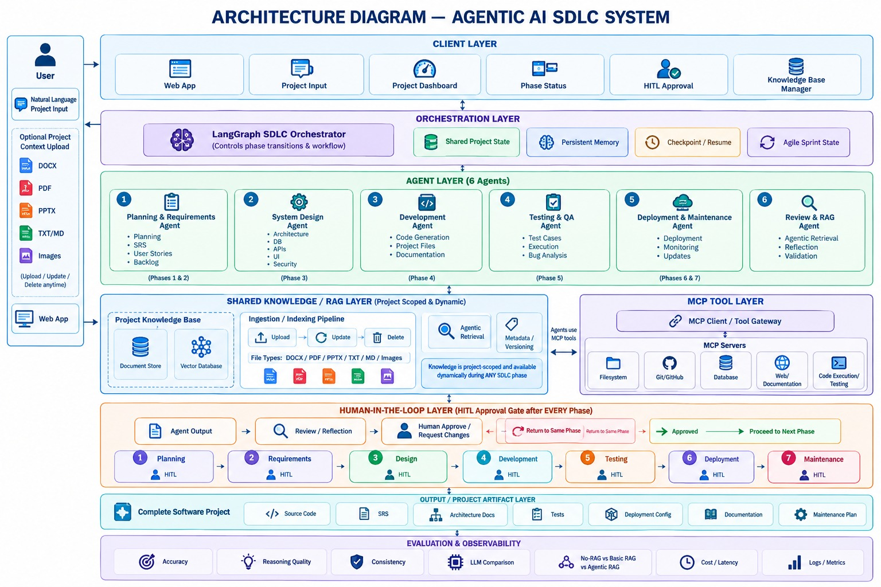

Figure 8.1: Workflow Desgin

TASK DECOMPOSITION
The Planning Agent converts the approved requirements into an ordered list of subtasks, each with an assigned owner, expected artifact, and acceptance condition. For the concurrency repair task on stock reservation, subtasks include locating the reservation routine and transaction logic, implementing or reusing a concurrency test that reproduces the lost update, executing the fix via the Debugging and Development agents, rerunning the full suite for regressions, and updating documentation. Each subtask targets a specific acceptance condition, so that execution is directed and results can later be reviewed and traced to requirements.

AGENT COORDINATION
Coordination is achieved through a single shared, typed state object rather than open-ended agent chat. Every agent reads only the fields it requires and writes strictly to its assigned output schema, which is what allows LangGraph to checkpoint progress, support rollback, and evaluate conditional routing. The conceptual state contains the following fields: brief, srs, plan, design, code_files, test_report, error_trace, iteration, retrieved_context, fix_proposal, docs, release, gate, human_decision, and decisions.

ORCHESTRATION IMPLEMENTATION
The workflow is implemented as a LangGraph StateGraph in which each agent is a node and transitions are directed edges. Two primary conditional routing paths implement the control logic. The first follows the QA Agent and conditionally routes to the test acceptance human gate on zero test failures, to escalation when the repair cap is exceeded, or to the Debugging Agent when failures occur. The second follows the Debugging Agent, forming a bounded self-correction loop back to the Development Agent with a maximum iteration count of three to prevent endless repair cycles and bound token usage.

AGENTIC RAG IMPLEMENTATION

RETRIEVAL ARCHITECTURE
Retrieval operates over multiple isolated vector collections in Chroma. Documents—including verified past bug fixes, technical library documentation, target application docstrings, and engineering standards—are ingested, split into overlapping chunks, and indexed using dense embeddings. The chunks are stored alongside structured metadata such as collection type, source filename, document version, language, and specific error categories. At query time, the system performs dense vector similarity search using an HNSW index, filtering chunks by metadata and applying a similarity threshold to return the most pertinent contextual evidence.

KNOWLEDGE RETRIEVAL
What distinguishes retrieval in AegisDev from classical RAG is that it is agentic: retrieval is an explicit decision-making step rather than a static lookup. When a test fails, the Debugging Agent analyzes the stack trace, error signature, and failing frame to decide whether to query past-fix memory, consult technical documentation, or bypass retrieval entirely. If chosen, it formulates a targeted query instead of dumping raw log output into the retriever. The agent inspects the similarity of the results; if the returned chunks fall below the threshold, it reformulates the query or switches target collections within a hard limit of two attempts, falling back gracefully if no relevant evidence is found.

GENERATION PROCESS
Generation is grounded directly in execution logs and retrieved context. The Debugging Agent constructs a source-aware prompt incorporating the failing test, stack trace, relevant application code, and labeled knowledge chunks placed in an isolated data block. It generates a structured repair proposal specifying the diagnosed root cause, rationale, source chunk identifiers, and a unified code diff. The patch is applied to the workspace by the Development Agent and executed by the QA Agent; it remains a candidate proposal until the test suite passes and a human reviewer explicitly approves it at the code review gater.

RETRIEVAL-QUALITY EVALUATION
Retrieval quality is measured on the benchmark of labeled software defects using Precision@k, Recall@k, Mean Reciprocal Rank (MRR), and decision accuracy. Precision@k and Recall@k measure how many returned chunks are relevant against ground-truth documentation, while MRR assesses how quickly the first relevant fix pattern is ranked. Retrieval-decision accuracy assesses whether the agent correctly chose between memory, documentation, or no retrieval for a given defect type, while citation correctness validates that cited chunks genuinely support the patch. These metrics are compared across no-retrieval, fixed-RAG, and agentic-RAG configurations to isolate the precise value of dynamic retrieval.

SYSTEM IMPLEMENTATION

FUNCTIONAL PROTOTYPE SCREENSHOTS

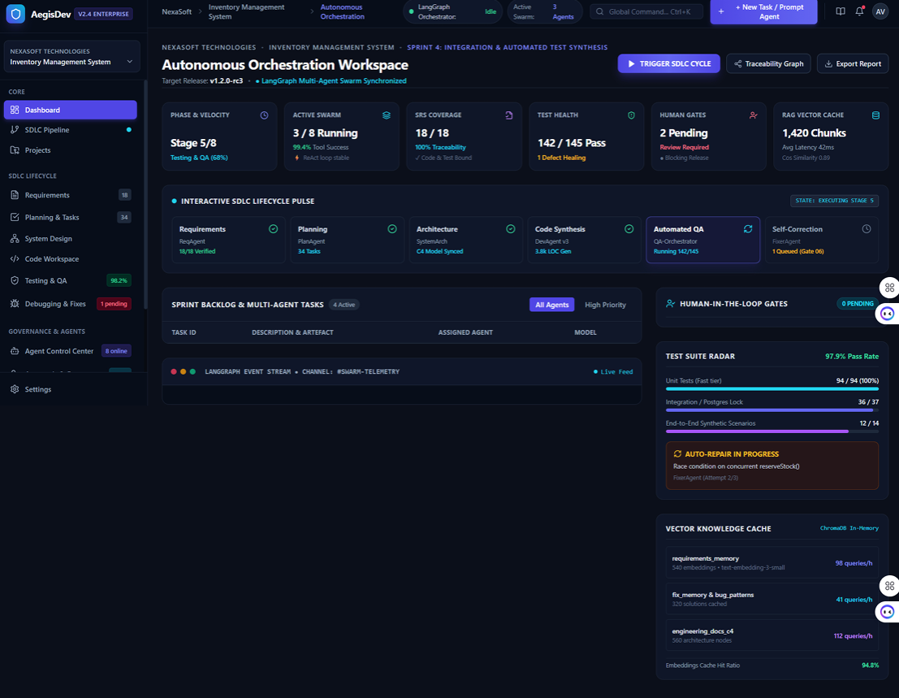

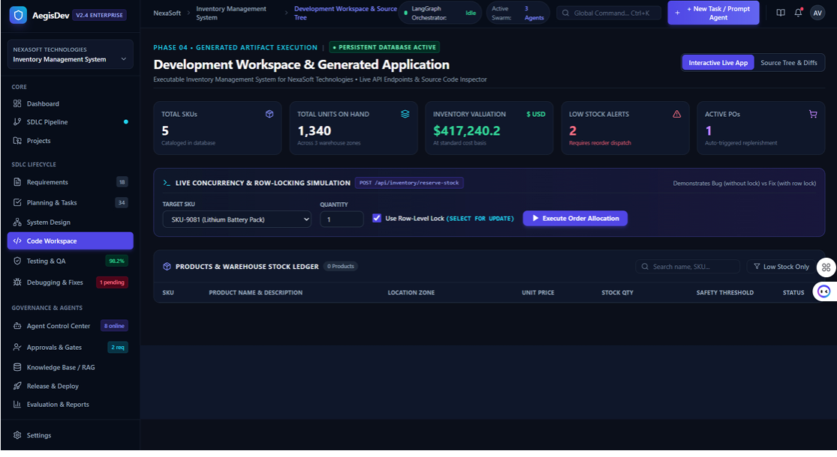

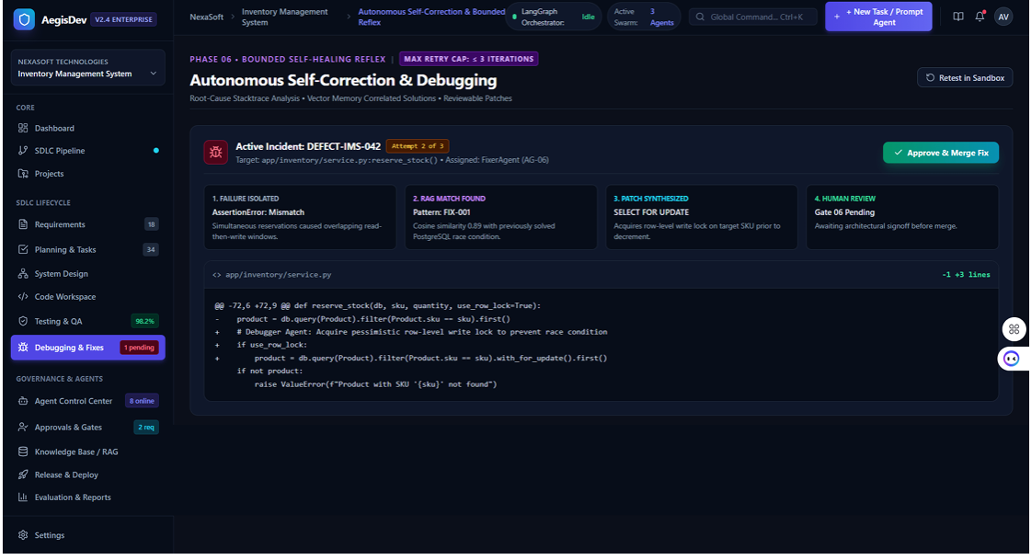

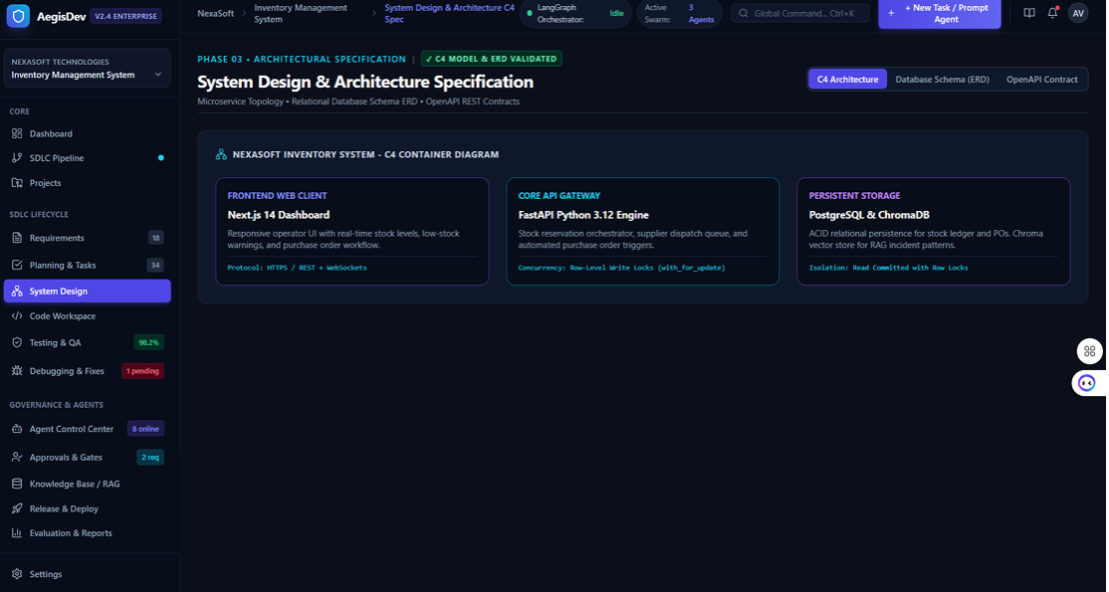

EXPERIMENTAL EVALUATION AND RESULTS

EVALUATION METRICS

Evaluation is conducted across multiple dimensions to rigorously measure repair effectiveness, operational efficiency, reasoning quality, retrieval accuracy, and system governance. Accuracy is evaluated through the fix success rate, reflecting the proportion of runs where the full test suite passes after the agent run, alongside the regression-free rate ensuring no previously passing tests are broken. Operational efficiency is quantified by tracking the number of repair iterations, total wall-clock time to achieve a passing build, token usage and cost per run, and step-level execution latency logged by the orchestrator. Reasoning quality and consistency are evaluated using a 1–5 scoring rubric assessing root-cause diagnosis, explanation coherence, patch minimality, and diagnostic consistency across repeated runs. Retrieval performance is isolated using Precision@k, Recall@k, Mean Reciprocal Rank (MRR), decision accuracy across retrieval strategies (memory, documentation, or none), citation correctness, and faithfulness against human-labeled ground truth. Finally, governance is tracked through escalation rates when the three-iteration repair cap is exceeded and human approval outcomes recorded in the structured audit trail

TESTING METHODOLOGY
The system is tested on the same set of benchmark defect tasks under six distinct configurations combining three retrieval modes (no retrieval, fixed RAG, and agentic RAG) across two LLM tiers (economy and premium), ensuring differences are attributable directly to the configuration under test rather than variations in the data or environment. Each run executes against identical repository snapshots and test suites inside isolated Docker sandboxes, recording fix success rate, iterations to fix, execution latency, and token consumption. A rubric-based evaluation then rates the proposed patches and rationales on a 1–5 scale for root-cause correctness, explanation coherence, and patch minimality. The evaluation isolates the specific contribution of retrieval strategies and underlying reasoning models by comparing runs across identical seeded bugs, with each configuration repeated at least three times to measure output consistency and repair efficiency.

PERFORMANCE RESULTS
Preliminary verified results confirm that the baseline unit test suite of the Inventory Management System executed successfully within the project environment (Python 3.12.7) using PyTest, passing all 5 test cases in 0.90 seconds. These unit tests verified key application functions, including seed data loading, stock deduction logic, insufficient stock rejections, automatic low-stock purchase order triggers, and summary metric computations.
For the comparative evaluation, the system executes 5 to 8 seeded benchmark defects across six configurations (no retrieval, fixed RAG, and agentic RAG across both economy and premium LLMs), with each configuration repeated across multiple runs. End-to-end repair effectiveness is captured via the fix success rate, mean repair iterations, wall-clock time to fix, token usage, and execution latency, populated directly from the SQLite evaluation logs. Simultaneously, retrieval performance is isolated by measuring Precision@k, Recall@k, Mean Reciprocal Rank (MRR), decision accuracy across retrieval targets, citation correctness, and reasoning scores on a 1–5 rubric. Only measured empirical results from verified test and benchmark runs are logged in the performance

COMPARISON, INNOVATION AND SCALABILITY

COMPARISON WITH BASELINE
Compared with manual software workflows, AegisDev automates planning, test execution, failure diagnosis, and repair formulation. Compared with single-LLM coding assistants, it adds real test execution, isolated Docker execution, past-fix memory retrieval, and structured human approval checkpoints. Compared with standard multi-agent systems without RAG, it introduces an agent-driven retrieval strategy that selectively consults memory and technical documentation. The quantitative comparison is presented in Section 11 and covers fix success rate, repair iterations, time to fix, token usage, latency, and reasoning quality.

INNOVATION

Agent-driven retrieval strategy — The Debugging Agent dynamically decides between memory, documentation, or no retrieval based on the failure signature.

Verified-fix memory — The vector store writes back only patches that pass real tests and receive human sign-off, preventing hallucinated fixes from contaminating future runs.

Least-privilege multi-agent design — Distinct agents handle testing, diagnosis, and code modification with restricted tool permissions.

Integrated benchmark harness — Built-in evaluation runner that measures pass rate, time-to-fix, token consumption, and latency across configurations within the platform.

Isolated tool execution via MCP — Standardized tool execution via Model Context Protocol inside a secure, non-root Docker sandbox.

SCALABILITY
The modular architecture supports scaling across several dimensions. The vector store can migrate from local Chroma to client–server Chroma, pgvector, or managed vector databases with tenant-specific collections. The relational store and checkpointer can scale from SQLite to high-availability PostgreSQL for multi-user state persistence. Execution sandboxes can scale using queue-based workers managing on-demand Docker containers with resource quotas. Organization-level multi-tenancy and cost-aware model routing between economy and premium LLM tiers allow the platform to support larger teams while managing inference expenses.

REAL-WORLD APPLICABILITY
The system mirrors how small and medium development teams already operate—plan, code, test, debug, review, and approve—making it directly adoptable without disrupting organizational roles. It serves project managers tracking delivery, developers automating repetitive debugging, and QA teams validating acceptance criteria. Because every change is subject to human review and backed by a complete audit trail, developers retain full accountability over the codebase while eliminating repetitive manual effort.

CONCLUSION AND FUTURE WORK

CONCLUSION

This project presented AegisDev, an agentic AI system that converts a natural-language client brief into tested, reviewed, and release-ready software. By dividing the SDLC among eight specialized agents—Requirements, Planning, Design, Development, QA, Debugging, Documentation, and Release—and orchestrating them with LangGraph over a shared typed state, the system addresses the critical shortcomings of single-pass AI coding assistants: lack of real test validation, absence of past-fix memory, and runaway execution loops. Real tool execution via MCP, bounded self-correction, Agentic RAG, and six human approval gates together establish an accountable, assistive engineering platform.

LIMITATIONS
The current implementation of AegisDev exhibits several operational boundaries that frame its immediate scope. The evaluation benchmark remains small and centered exclusively on a single application—the Inventory Management System—which restricts generalizing these empirical findings across diverse commercial codebases. The platform's automated tooling, runtime sandboxes, and defect-resolution workflows are currently limited to Python and FastAPI ecosystems. Furthermore, retrieval effectiveness remains directly tied to the completeness and quality of the indexed past-fix memory and documentation. Model reasoning also exhibits inherent non-determinism, and the platform does not automate cloud infrastructure provisioning or external production deployment.

FUTURE WORK
Future development will address these constraints by broadening evaluation to standard public benchmarks, including SWE-bench tasks, and adding runtime support for languages such as TypeScript, Go, and Java. Integration will be extended natively into enterprise CI/CD pipelines, GitHub pull requests, and automated regression-testing frameworks. Additional planned improvements include deep observability integration via tracing platforms like LangSmith, multi-tenant fix memory with strict workspace isolation, cost-aware model routing and prompt caching, and demonstration across other business subjects such as an Employee Leave Management System

